Purpose: This class helps prepare you for Network+ certification, which is a valued credential. To prepare you further, CNIT now has an online practice test. This project gets you into the system and guides you through taking a practice exam.
Requirements: You need a Windows computer with Internet Explorer (any version) connected to the Internet. You cannot do this with Firefox, Chrome, or Safari. This project should be harmless.
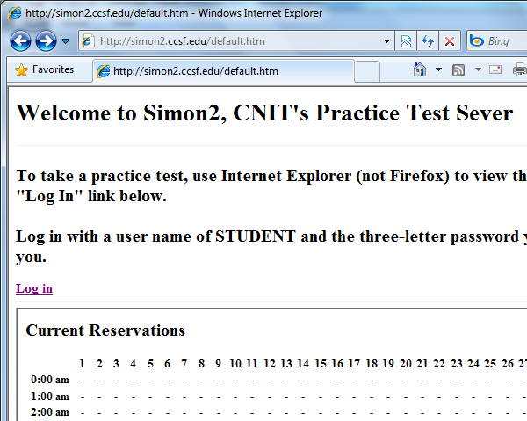
Activating Your Account
- Open Internet Explorer (NOT Firefox) and go to one of these two servers:
http://simon.ccsf.cc.ca.us
or
http://simon2.ccsf.cc.ca.us
- If this is the first time you have used the system, you need to activate your account. To do that, scroll to the bottom of the page and enter your CCSF ID. Select an Action of "Activate new user". Enter your desired password in both the Password boxes. Click the Submit button.

Reserving a Time

- Look at the chart and find an available time. YOU MUST RESERVE A TIME IN THE FUTURE! If it is 1:05 PM, you must reserve a time of 2 PM that day or later.
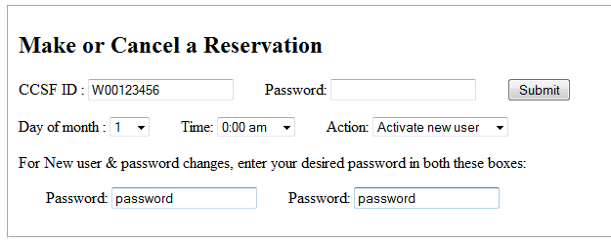
Scroll to the bottom of the page and fill in the form to reserve a time. Select an Action of "Reserve a time".
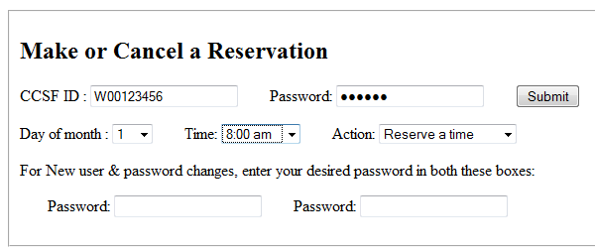
Your user name is your CCSF ID (it starts with W or A or B or @, usually).
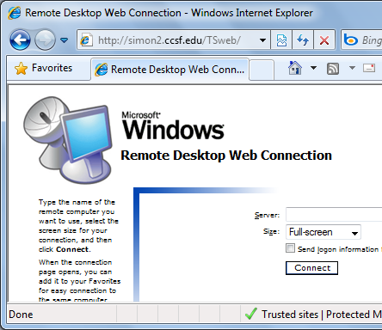
Your password is the password you chose when activating your account.
Logging in to Take a Practice Exam
- When your reserved time comes, click the "log in" link at the top of the page. On the next screen, leave the "Server" field empty and click the "Connect" button.
You must use Internet Explorer, not Firefox. You will be prompted to download and install an ActiveX control the first time you use the system.

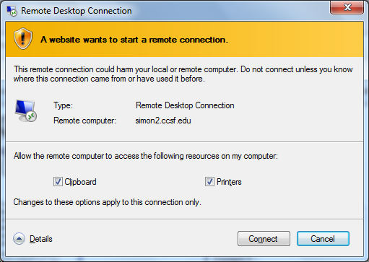
- A "Remote Desktop Connection" box pops up. Click the "Connect" button.

- Log in with a user name of STUDENT and the same password you used to make the reservation.
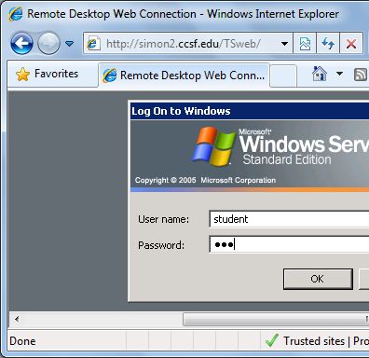
NOTE: You use your CCSF ID number to make the reservation, but when taking a practice exam you always log in as STUDENT.
- A Windows desktop appears within your Internet Explorer browser. You are remotely accessing a server.

Taking a Practice Exam
- On the desktop, double-click the "Transcender" icon.
- On the "CompCert Security+" row, click the Start button, as shown below on this page. (Note: The Certified Ethical Hacker exam would more closely match the content of this course, but we don't have that practice exam available yet. Security+ is the closest available match to the course content.)
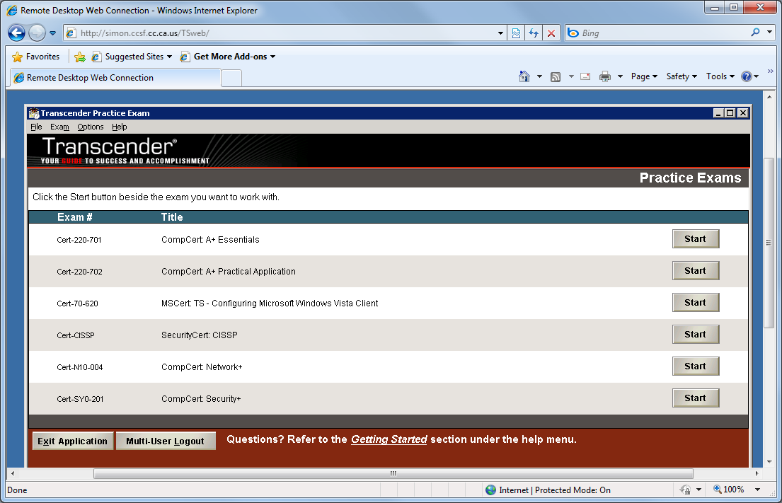

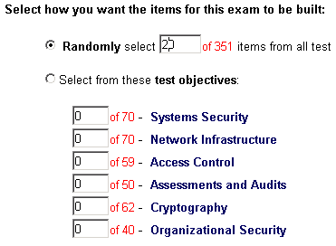
- On the next screen, click the "Optimize Exam Experience" button.
- On the next screen, you can choose which topics the test covers. You may select any topics you like, but you must have a total of at least 20 questions, as shown to the right on this page. Click Start.
- Answer the questions as well as you can. After answering each question, click "Grade Item" to see the correct answer and a complete explanation. Keep an eye on the time--if another student has reserved the hour after yours, you will be booted off when your hour ends with no warning!
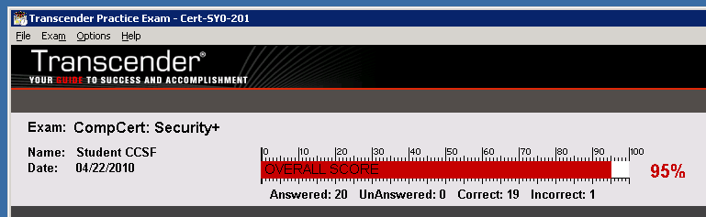
- After answering all the questions, click the "End Exam" button. A box pops up asking if you are sure--click Yes. Your score appears, as shown below on this page.

Saving the Screen Image
- Click outside the Internet Explorer window to make your computer listen to the keyboard, rather than the remote server.
- Make sure the "Transcender" window is visible, showing your score, as shown above on this page.
- Press the PrntScn key to copy whole screen to the clipboard.
- Open Paint and paste in the image. Save it as a PNG or JPEG, with the filename Your Name Proj 4x.
Turning in your Project
- Email the image to me as an email attachment. Send the message to: cnit.123@gmail.com with a subject line of Proj 4x From Your Name, replacing Your Name with your own first and last name. Send a Cc to yourself.

Last modified 4-27-10

