What You Need for This Project

LEGAL WARNING!
Only spy on machines you own, or machines you have permission to soy on. Using keyloggers machines permission is a crime! Don’t do it! If you do illegal things, you may be arrested and go to jail, and I will be unable to save you. These instructions are intended to train computer security professionals, not to help criminals.
- A computer of any sort, as long as it has a keyboard plug that fits into the keylogger (PS/2 or USB).
- An ID card you can give your instructor in exchange for one of the keyloggers.

Plug in the Keylogger
- Unplug the keyboard in the back of your computer and insert the hardware keylogger Plug the keyboard back in.
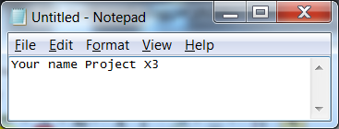
- To activate the Keylogger, you need to open Notepad and type in a secret word. The exact word depends on the model of Keylogger--look at the documentation in the box. For some models the word is menu, sometimes keykatch, sometimes something different. When you enter the correct word, instructions will appear on the screen--follow them to start the Keylogger capturing.

Enter Text to Capture
- Open Notepad and type in your name and project X3, as shown to the right on this page.
- Open a browser and go to Gmail.com. Enter a user name of JoeUser and a password of TopSecretPassword. Don't log in with your real password! Your keystrokes are being recorded!

Entering the Password to View the Menu
- Open another Notepad window and type in the keylogger's secret word. Follow the on-screen instructions to dump the captured keystrokes.

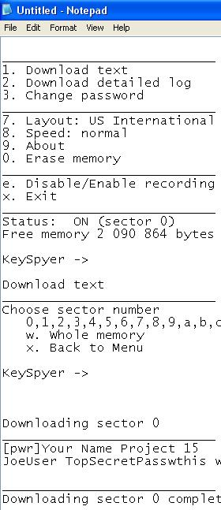
- The captured text appears, as shown to the right on this page. Make sure the password TopSecretPassword is visible in the screen, as shown in near the bottom of the image on the right on this page. (This screen may look somewhat different for other keyloggers. Also, the project number will be different than shown in this image.)

Saving a Screen Image
- Press the PrintScrn key in to copy the whole desktop to the clipboard.
- Open Paint and paste in the image. Save it Your Name Proj X3.
Note: If you cannot type in the file name, that means the keylogger is locking the keyboard. Go back to Notepad and type in x to exit the keylogger, or menu to see the menu again, and then x.. If all else fails, physically disconnect the keylogger and plug the keyboard back in without it to make your keyboard respond.

Return the Keylogger to Your Instructor
- Give the keylogger back, and reclaim your ID card.

Turning in Your Project
- Email the JPEG image to me as an attachment to an email message. Send it to: cnit.123@gmail.com with a subject line of Proj X3 From Your Name, replacing Your Name with your own first and last name. Send a Cc to yourself.
Last Modified 8-1-11

