What You Will Need
Warning: Only use this on networks you own. Cracking into networks without permission is a crime—don’t do it!
- A wireless access point
- A computer running any OS with any wireless NIC to be the client
- An Eee PC--I used the EEE PC 1005HA
- A bootable BackTrack 4 Pre-Final USB stick or SD card

Set up a WEP-Protected Wireless LAN
- Use any router that is available.

Attach a Wireless Client to the Wireless LAN
- Use any laptop or other computer with a wireless NIC that is available.

Booting the Eee PC from the BackTrack 4 Final SD Card
- Your Eee should have the SD card already inserted.
- Power on the EEE PC.
- During bootup, press F2 to enter the BIOS settings page. Use the right-arrow to select the Boot menu, and press the down-arrow to highlight "Hard Disk Drives". Press the Enter key. The "1st Drive" line appears, highlighted. Press the Enter key. Press the down-arrow to highlight "USB: Single Flash Reader" and press the Enter key. Press the F10 key to save changes. Press the Enter key to confirm.
- A blue screen appears asking you which mode to start BackTrack in. Just wait and let it accept Default.
- A message appears saying "Undefined video mode number: 317". Just ignore it and wait.
- When you see the root@bt:~# prompt, type in this command and press the Enter key:
startx
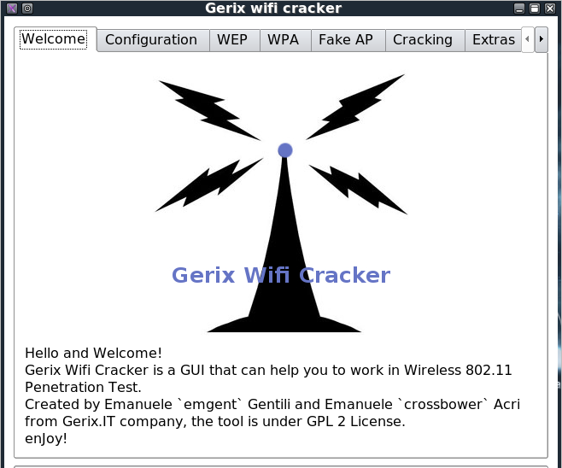
- A graphical desktop should appear.

Launching Gerix Wifi Cracker
- Click the Start button, in the lower left corner of the desktop. It has a stylized dragon head on it.
- Using the keyboard arrow keys, point to Backtrack, "Radio Network Analysis", 80211, Cracking, "Gerix-Wifi-Cracker-NG". Press the Enter key.
- Gerix launches, as shown to the right on this page.

Scanning for the Target Network
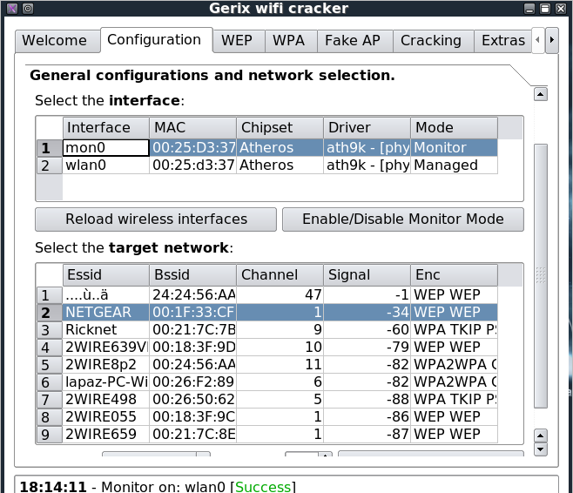
- In the Gerix window, click the Configuration tab. In the center of this window, click "Enable/Disable Monitor Mode". In the center section, interface 1 changes to mon0. Click the mon0 interface to select it.
- Scroll to the bottom of the window and click the "Rescan networks" button. A list of networks should appear, as shown to the right on this page. Click the name of your target network to select it. Note: don't click the number on the left, that won't really select the right network.

Attacking WEP
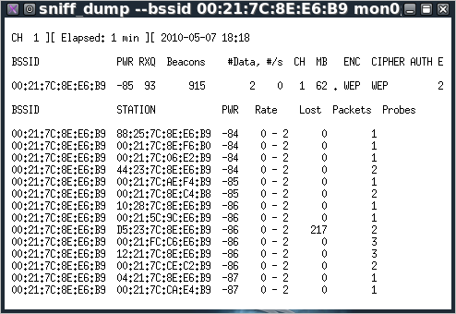
- In the Gerix window, click the WEP tab. Click the "Start Sniffing and Logging" button. A little window opens showing the captured packets, as shown to the right on this page. Check to make sure the ENC shows WEP, as shown. If it does not, you are attacking the wrong network.

- In the bottom section of the Gerix window, click "WEP Attacks (with clients)". A list of attacks appears. Click the "ARP request replay" button. A little window opens showing the ARP replay.
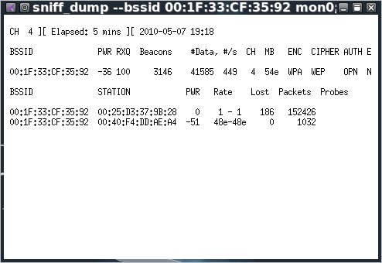
- Go to your wireless client machine (probably a Windows machine). Disconnect it from the wireless network and reconnect it. This will create the ARP packet you need to start the injection.
- The # Data should be increasing rapidly, so you can get quickly to the 50,000 you need for the attack. If it is not rising quickly, the injection is not working. The image at the right shows an attack that has 41585 packets--this attack is nearly complete.
- If the injection doesn't work (it sometimes fails for no apparent reason), try pinging IP addresses near the router from the Windows machine. If it still doesn't work, go to the Windows client and open 30 command prompt windows, each with this command running:
ping -t -l 65500 192.168.0.1
(Replace 192.168.0.1 with the IP address of your router). That will make enough traffic to let you crack the WEP key even without injection.

Cracking the Key
- Once you have 50,000 or more #Date values, it's time to start the crack. In the Gerix window, click the Cracking tab. Click the "Aircrack-ng - Decrypt WEP password" button. It should find the key within a few minutes, as shown below on this page.
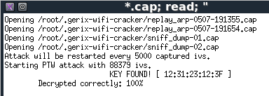

Saving the Screen Image on the Desktop
- On the attacking EEE PC, Start, KSnapshot.
- In the KSnapshot window, click the "Save As…" button.
- In the "Save as – KSnapshot " window, on the left side, click Desktop.
- In the "Save as – KSnapshot" window, in the Location: box, type in a filename of
Yourname-ProjX5.jpg
- Click the Save button. Your file should appear on the desktop.

Connecting the EEE PC to the Wired LAN
- Use an Ethernet cable to connect the EEE PC to the wired LAN.
- In the "Shell – Konsole" window, type in this command, and then press the Enter key:
ifconfig eth0 up
- In the "Shell – Konsole" window, type in this command, and then press the Enter key:
dhclient
- That will give it access to the Internet.

Starting Firefox
- On the EEE PC, at the lower left of the desktop, click the red Firefox icon.
Turning in your Project
- Firefox opens. Email the JPEG image to me as an attachment. Send the message to cnit.123@gmail.com with a subject line of Proj X4 From Your Name. Send a Cc to yourself.

Last modified 7-6-10

