What You Will Need
- A portable computer with Wi-Fi. The instructions below assume you are using a laptop or netbook running Windows 7, but students have also used Win XP, Linux, Macs, and even iPhones to wardrive.
- Wardriving software that records the encryption status of the access points. I recommend these programs:
For Windows 7: Vistumbler from vistumbler.net/
For Windows XP: InSSIDer from http://www.metageek.net/products/insider
For Mac OS X: kismac-ng from http://trac.kismac-ng.org
For Linux: kismet
- These instructions assume you are using Windows 7. For other operating systems, you will have to figure out how to collect data and export it to a plain text file.

Downloading and Installing Vistumbler
- Open a Web browser and go to vistumbler.net
- Download the EXE and install it with the default options

Running Vistumbler
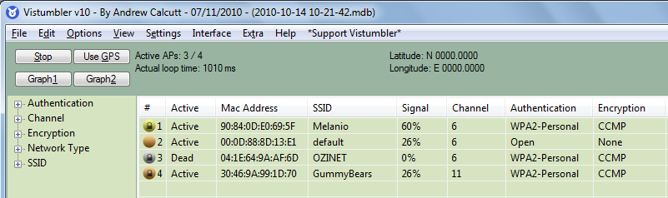
- Click Start, type in VIS, and click Vistumbler. If you see a User Account Control box, allow the software to make changes to your computer.
- In the Visstumbler window, click the "Scan APs" button. You should see some wireless networks detected, as shown below on this page. If you don't, you may need to move to a location where there are Wi-Fi networks, such as the CCSF campus. If you still see no networks, there may be a problem with your wireless card or other hardware on your laptop. You may have to use a different computer.

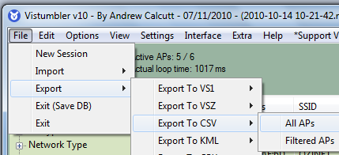

Saving the Data
- In Vistumbler, click File, Export, "Export to CSV", "All APs", as shown to the right on this page.

- In the "Export to CSV" box, leave the path unchanged, but change the name to YourNameWardrive, as shown below on this page. Accept the default selection of Summary. Click the OK button.
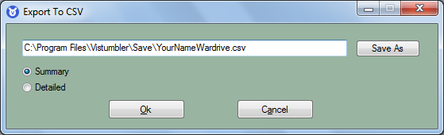

- In the "Done" box. click OK.
Finding the File
- Click Start, Computer. Navigate to C:\Program Files\Vistumbler\Save. Right-click the YourNameWardrive.csv file, click "Open with…", and select Notepad. You should see a text file, as shown below on this page.
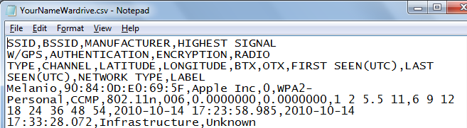
Turning in your Project
- Don't turn in any images this time. The file to turn in is the CSV text file itself.
- E-mail the YourNameWardrive.csv file to me as an attachment. Send the message to the correct email address for your class, such as cnit.123@gmail.com or cnit.106sam.com with a subject line of Proj X20 From Your Name. Send a Cc to yourself.
Come to the Wardrive
- Bring your computer to the wardrive, at the time and location announced in class. You will get 20 additional points for coming to the wardrive. You don't need a computer, you can participate in other ways, as explained in class.

Last modified 10-14-10

