Preparing
- If you are using the S214 lab at CCSF, everything is ready to go. If you are working at home, you need to have at least 30 GB available on a separate partition of a machine with Vista-capable hardware.
Booting from the Windows 7 DVD
- Insert the Windows 7 DVD.
- Restart your machine. When you see the message "Press any key to boot from CD or DVD", press the Enter key.
- When you see the "Install Windows" box, accept the default "Language to install","Time and currency format", and "Keyboard or input method" settings and click Next.
- In the next screen, click "Install now".
- Check the “I accept the license terms” box and click Next.
- Click Custom (advanced).
Choosing the Installation Partition
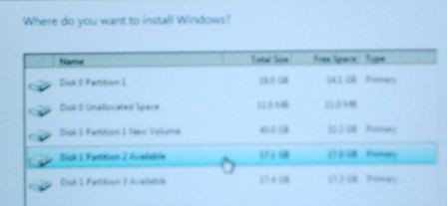
- If you are working in the S214 lab at CCSF, find a partition marked Available as shown to the right on this page and click on it. Note the Disk number and Partition number you chose. In the figure to the right on this page, “Disk 1 Partition 2” is selected. If you are working at home, you should know what partition you want to use.
- After you have clicked an available partition, click Next.
- Now wait – it will take a while to copy the files. Your computer will restart one or more times. When it restarts, don't touch the keyboard—just let it boot from the default hard disk partition. When I did it, it took about 10 minutes.
Setting Up Windows
- A "Set Up Windows" box appears, asking you to enter a user name and computer name. Use your own name as the user name, and use the computer name written on the front panel label, which should be something like S214-01. Click Next.
- The next box asks for a password. I recommend that you use a password of P@ssw0rd. Put anything in the hint box.
- When it asks for a product key, clear the "Automatically activate Windows when I'm online" box, leave the product key blank, and click Next.
- At the "Help protect and improve Windows automatically" screen, click "Use recommended settings".
- At the "Review your time and date settings" screen, click Next.
- If a "Select your computer's current location" screen appears, click "Home network". This will make it possible for you to set up a homegroup later.
- If a "Do you want to create a homegroup?" box appears now, click Skip.
- Your desktop appears.
Installing Firefox
- Open Internet Explorer and go to getfirefox.com. Download and install Firefox.
Installing Clamwin Antivirus
- Open Firefox and go to clamwin.com. On the left side, click Download. Download and install Clamwin.

Determining the System Drive Letter
- Click Start. In the Search box, type in CMD. Press the Enter key. A Command Prompt window opens.
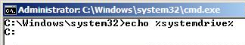
- Type this command into the Command Prompt window, then press the Enter key.:
echo %systemdrive%
The response should tell you your system drive letter. It should be C:.

Changing the System Drive Label
- Click Start, Computer. Find your system drive in the list—it should be labeled “Available (C:)”. You need to change this name, so that later students in the lab don’t see your partition as “Available” and install another OS on the same partition.
- Right-click your system drive icon and click Rename. Type in a new name of "Your Name Win 7" and press the Enter key.

Changing the Operating System Label with BCDEDIT
- Click Start. In the Search box, type in CMD. Press Shift+Ctrl+Enter. An Administrator Command Prompt window opens.
- Type this command into the Administrator Command Prompt window, then press the Enter key.:
bcdedit /set description "Your Name Win 7" {current}
Replace Your Name with your own name. If you see a message saying "The boot configuration data store could not be opened. Access is denied.", you aren't in an Administrator Command Prompt window. Close the window and carefully repeat the "Changing the Operating System Label with BCDEDIT" steps above.
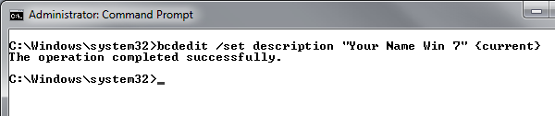

Creating a Student Account
- Click Start, "Control Panel". In the "User Accounts and Family Safety" section, click "Add or remove user accounts".
- In the "Choose the account you would like to change" screen, click "Create a new account".
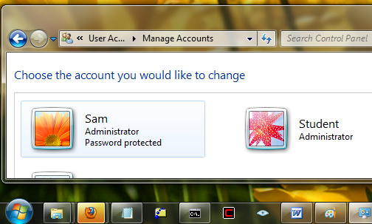
- In the "Name the account and choose the account type" screen, enter a name of Student, click "Administrator", and click "Create a new account".
- Your screen should now look like the image below.

Saving the Screen Image
- Make sure the Student account is visible, showing its Administrator status, and no “Password protected” message.
- Make sure the Windows 7 Taskbar is visible at the bottom of the screen, showing the new Mac-style icons. Your icons will probably be different, including such worthless stuff as Internet Explorer or Windows Media Player, at first.
- Press the PrintScrn key in the upper-right portion of the keyboard. That will copy the whole desktop to the clipboard.
- Press the Logo key on the keyboard. Type PAI into the Search box. When Paint is highlighted, press the Enter key.
- Click in the untitled - Paint window. Type Ctrl+V to paste the image in.
- Type Ctrl+S to save the file. Save the document in the default location of Locations ► Pictures with the filename Your Name Proj 1x. Select a Save as type of JPEG.

Turning in your Project
- Open Firefox, and use it to email the JPEG image to me as an email attachment. Send the message to: cnit.335@gmail.com with a subject line of "Proj 1x From Your Name", replacing Your Name with your own first and last name. Send a Cc to yourself.

Activating Windows
You can’t activate this version, until you have a product key. I will show you how to get your product keys in class later—about two weeks into the semester.
Last Modified: 8-18-09

