Downloading and Installing the Microsoft Baseline Security Analyzer (MBSA)
- You can do this project on a Windows XP virtual machine, but I recommend doing it on Vista. Start any Vista computer in S214 and log in as Student with no password, or with any other account in the Administrators group.
- Open a browser and go to http://www.microsoft.com/technet/security/tools/mbsahome.mspx
- Click the latest version – at the time I wrote this, it was MBSA 2.1 Beta.
- At the next screen, click Download now. Follow the instructions on your screen to go to the Download Center, validate your Windows copy, and download MBSA. The exact steps vary.
- Install it with all the default selections.
Scanning Your Computer with MBSA
- Click Start, All Programs, Microsoft Baseline Security Analyzer 2.1. If a "User Account Control" box pops up, press Alt+C or click Continue.
- In the Microsoft Baseline Security Analyzer window, click Scan a computer.
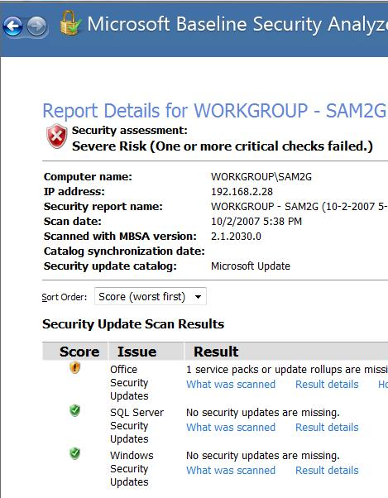
- In the Pick a computer to scan screen, notice that you can scan more than one computer with this tool, and that you can scan for many different problems. We will use the default selection to scan the local computer, and to scan for all the vulnerabilities. The only items not checked by default are "Configure computers for Microsoft Update and scanning prerequisites" and "Advanced Update Services Options" which are not relevant when you are scanning a single machine.
- Click Start Scan. Wait until the scan completes.
Saving the Screen Image
- When you see the View Security Report header, the scan is complete. Make sure the Windows Security Updates line is visible, as shown to the right on this page. Press Alt+PrtScn to copy this window to the clipboard.
- On the Start menu, click Run. Enter the command mspaint and press the Enter key. Paint opens.
- Press Ctrl+V on the keyboard to paste the image into the Paint window. Save the document in the Shared Documents folder with the filename Your Name Proj X6. Select a Save as type of JPEG. Close Paint.
Reading the Security Report
- Read the Security Report and answer the questions in the box below.
A: What version of the MBSA are you using? ____________________________________

B: In the Administrative Vulnerabilities section, what did it say about your File System?
_________________________________________________________________________
C: What was the result of the Password Expiration test?
_________________________________________________________________________

Turning in your Project
- Email the JPEG image to me as an attachment to an e-mail message. Answer the questions in the box in the body of the e-mail message. Send the message to: cnit.123@gmail.com or cnit.335@gmail.com with a subject line of "Proj X6 From Your Name", replacing Your Name with your own first and last name. Send a Cc to yourself.

Last modified 10-2-07

