Downloading and Installing Winfingerprint
- Start your Windows XP virtual machine and log in as usual.
- Open a browser and go to winfingerprint.sourceforge.net
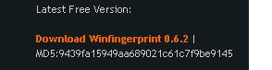
- Scroll down and click the latest free version – at the time I wrote this, it was winfingerprint 0.6.2. Note the MD5 hash value, as shown to the right on this page.
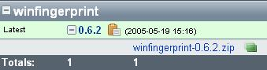
- In the next page, scroll down and find the blue winfingerprint-0.6.2.zip link, as shown to the right on this page. Download the zip file and save it on your desktop.
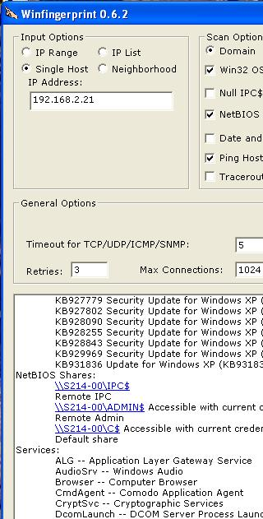
- Click Start, All Programs, Hashcalc, Hashcalc. Drag the zip file from your desktop into the Data: box and drop it there. The hash should calculate immediately. Compare the MD5 hash value to the value you saw on the Winfingerprint web page. They should agree—if they don’t, something is wrong.
- Double-click the Zip file to open it. Double-click the Setup file. Install it with all the default selections. When the installer asks you for permission to make three minor changes on your computer (port numbers and connection timeouts), click Yes.
Scanning the Local Computer
- If Winfingerprint did not open automatically, click Start, All Programs, Winfingerprint, Winfingerprint.
- In the Winfingerprint window, in the upper left, click Single Host. Verify that the IP address shown is your own XP machine.
- Look through the scan options: they are impressive, like Nmap or Nessus. Accept the default selections and click the Scan button. If a firewall warning pops up, allow the traffic.
- Scroll down and examine the report. It shows every service pack and patch on the machine, and all the running processes. I was able to see the brand of firewall and antivirus software too—very valuable information to an intruder.
Saving a Screen Image
- Make sure the Services: section is showing in the Winfingerprint screen.
- Press Alt+PrtScn to copy this window to the clipboard.
- On the Windows XP virtual machine’s desktop, click Start, Run. Enter the command mspaint and press the Enter key. Paint opens.
- Press Ctrl+V on the keyboard to paste the image into the Paint window. Save the document in the Shared Documents folder with the filename Your Name Proj X7a. Select a Save as type of JPEG. Close Paint.
Locating a Target Computer
- Let’s call the machine you have been using your Trusted Computer.
- Find another Windows XP virtual machine in the room that you can use for a while. This will be your Target Computer. If necessary, copy a fresh one from the V:\Hacking folder.
- Start that machine up and log in as usual. Click Start, Run and enter the CMD command. In the Command Prompt window, enter the IPCONFIG command to find its IP address. Write your Target IP address in the box below.

Target IP: ___________________________

Turning Off the Firewall on the Target Computer
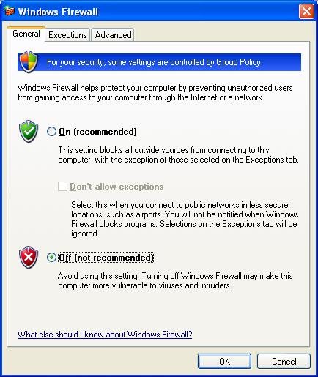
- On the Target machine, click Start, Control Panel. If necessary, click Switch to classic view. Double-click Windows Firewall.
- In the Windows Firewall box, click Off (not recommended) as shown to the right on this page. Click OK.
Scanning the Target Computer From Your Trusted Computer
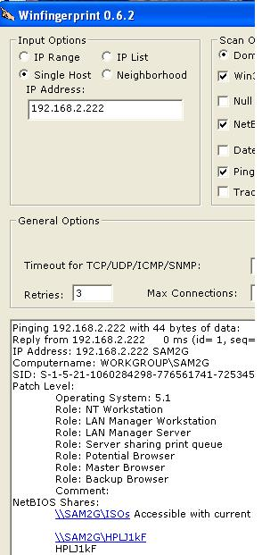
- On your Trusted Computer, in the Winfingerprint window, in the upper right, click the Clear button.
- In the Winfingerprint window, in the upper left, click Single Host. Enter the IP address of your Target Computer. Click the Scan button. If a firewall warning pops up, allow the traffic.
- Scroll down and examine the report. It shows much less information—the service packs and services are not shown. But you can still see information about the computer’s name, patch level, and shares.
Turning On the Firewall on the Target Computer
- On the Target machine, click Start, Control Panel. If necessary, click Switch to classic view. Double-click Windows Firewall.
- In the Windows Firewall box, click On and also check the Don’t allow exceptions box, as shown below on this page. Click OK.
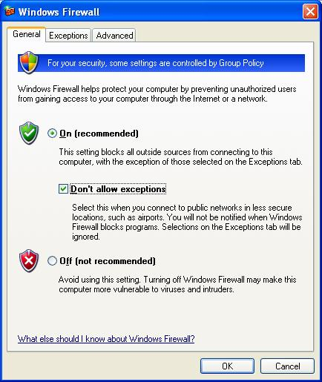
Scanning the Target Computer From Your Trusted Computer
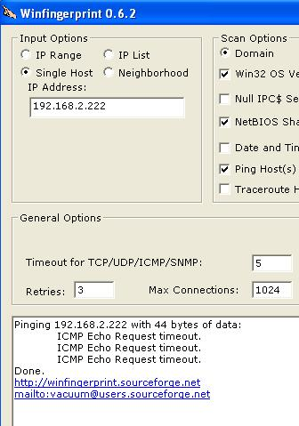
- On your Trusted Computer, in the Winfingerprint window, in the upper right, click the Clear button.
- In the Winfingerprint window, in the upper left, click Single Host. Enter the IP address of your Target Computer. Click the Scan button. If a firewall warning pops up, allow the traffic.
- Now you get no information at all, not even a PING response, as you would expect.
Saving a Screen Image
- Press Alt+PrtScn to copy this window to the clipboard.
- On the Windows XP virtual machine’s desktop, click Start, Run. Enter the command mspaint and press the Enter key. Paint opens.
- Press Ctrl+V on the keyboard to paste the image into the Paint window. Save the document in the Shared Documents folder with the filename Your Name Proj X7b. Select a Save as type of JPEG. Close Paint.
Turning in your Project
- Email the JPEG images to me as attachments to one e-mail message. Send the message to: cnit.123@gmail.com with a subject line of Proj X7 From Your Name, replacing Your Name with your own first and last name. Send a Cc to yourself.

Last modified 6-4-07

