"The network bridge on device VMnet0 is temporarily down"
If VMware gives the "The network bridge on device VMnet0 is temporarily down" message in S214:
- Shut down the Ubuntu VM
- Edit virtual machine settings
- In the "Virtual Machine Settings" box, on the left, click "Ethernet" to select it. On the right, set the "Network connection" to "Custom - VMnet2".
- Start the Ubuntu VM again.

No Internet Connection With Address 169.254.x.y
If VMware has no network connection, and ifconfig shows an address starting with 169.254, or an extra network adapter line showing eth0:avah, that means that DHCP has failed. Here is the cure:
- Click Start, Accessories, Terminal
- In the Terminal window, type this command and press the Enter key:
sudo dhclient
- This will repeat the DHCP process to get a fresh IP address.

Network Adapter is eth1 Instead of eth0
- This happens when a virtual machine is copied. It's a problem because many hacking tools are sloppily written and assume that you are using eth0. The cure is simple—you need to correct the MAC address in the /etc/iftab file, as explained below:
- Start the Ubuntu virtual machine and log in as usual.
- Click Start, Accessories, Terminal
- In the Terminal window, type this command and press the Enter key:
ifconfig
- You should see your Ethernet adapter information, as shown below on this page. If you see information for an eth0 adapter, you don't have this problem and you don't need to do the steps below. If your adapter shows up as eth1 and there is no eth0 line at all, as shown above, you need to perform the following steps:
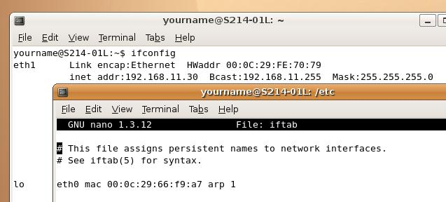
- Find the HWaddr in the eth1 section of the ifconfig output. Leave this Terminal window open so you can see the address.
- Click Start, Accessories, Terminal to open a second Terminal window. Move it so you can see the HWaddr in the other window, as shown above on this page.
- In the Terminal window, type this command and press the Enter key:
cd /etc
- In the Terminal window, type this command and press the Enter key:
sudo cp iftab iftab.bak
Enter your password when you are prompted to. This command makes a backup copy of the iftab file, just in case something goes wrong.
- In the Terminal window, type this command and press the Enter key:
sudo pico iftab
- Change the eth0 mac value to match the HWaddr address for eth1.
- Save your changes with Ctrl+X, Y, Enter
- Click System, Quit. Click Restart.
Last modified 9-13-08

