What You Need
- A computer running Windows XP or Vista, with at least 512 MB of RAM and several GB of storage available. Each virtual machine is 2-4 GB, or even larger if you install a lot of software on the virtual machine
- A broadband Internet connection so you can download large files

VMware Player
- Open a browser and go to vmware.com. Click Products, Desktop Virtualization Products. On the right side, click "VMware Player". Follow the instructions on the screen to download the latest version.
- Double-click the downloaded file and install VMware player. You can now use virtual machines at home, but you cannot create them with the player. To create virtual machines, see the next section.

VMmanager
- VMmanager allows you to create VMware virtual machines, and the modify existing ones. It is a completely different product than Microsoft’s VM Manager – don’t confuse the two!
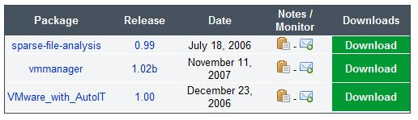
- Open a browser and go to vmmanager.sourceforge.net. Click Download. Click Download VMmanager.
- The next screen shows three packages, as shown to the right on this page. The package we want is vmmanager—the one in the middle. In the middle row, click the Download button.
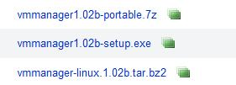
- The next screen again shows a choice of three files. The one we want is in the middle again. Click the vmmanager1.02b-setup.exe link. Save the file.
- Double-click the downloaded file to start the installer. In the Installer Language box, accept the default selection of English and click OK.
- In the VMmanager v1.02b Setup box, click Next.
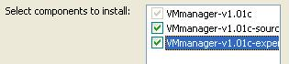
- Accept the agreement.
- The next box asks you to select which components to install. Check all three boxes, as shown to the right on this page! VMmanager won’t work unless you do this. Then click Next. Click Install.

Creating a New Virtual Machine with VMmanager
- First install both VMWare Player and VMmanager, as explained on the previous page.
- Click Start, "All Programs", VMmanager, VMmanager.
- In the VMmanager window, click the New button.
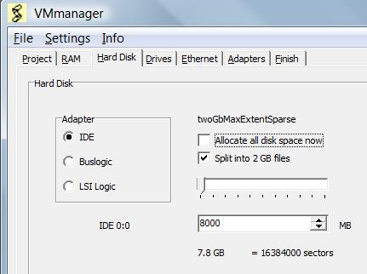
- In the VMmanager window, on the Project tab, select the operating system you plan to install. If you aren't sure, choose Windows XP Professional. That works for most operating systems.
- In the VMmanager window, click the RAM tab. It will show the minimum recommended RAM for that operating system. If you have only 1 GB or less on the host machine, leave the RAM alone. If you have 2 GB, I recommend increasing this value to 512 MB for better performance.
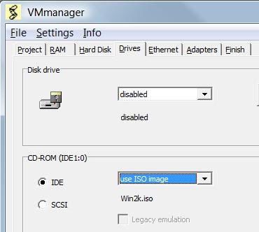
- In the VMmanager window, click the Hard Disk tab. I recommend using 8000 MB of hard disk space, not allocating it all now, and breaking it into 2 GB files, as shown to the right on this page.
- In the VMmanager window, click the Drives tab. In the CD-ROM section, select "use ISO image". In the Open box, navigate to your installer ISO file and click Open. The ISO filename should now appear in the CD-ROM section, as shown to the right on this page.
- In the VMmanager window, click the Ethernet tab. By default, there is no networking enabled, which is very rude. In the Ethernet 0 section, click Bridged. That will share your host operating system's physical NIC with the virtual machine, so the VM appears on your network with its own IP address in the same subnet.
- In the VMmanager window, click the Adapters tab. Here you can enable USB or sound if you want to, but for most projects, those things are unnecessary.
- In the VMmanager window, click the Finish tab. Click the OK button. In the Save As box, navigate to a drive and folder you want your VM to live in. I recommend creating a separate folder for each VM, and labeling it with the OS name. Make sure it's on a drive with enough space—each VM will need 4 GB or so. Click Save. In the VM Manager box, click OK.

Installing an Operating System on the New Virtual Machine
- Click Start, "All Programs", VMware, VMware Player.
- In the "VMware Player" box, click Open.
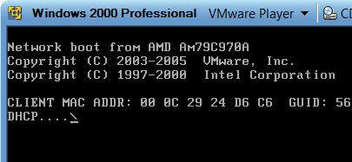
- In the "Open Virtual Machine" box, navigate to the machine you made and click Open.
- Your machine should boot from the installation ISO file, so you can install the operating system. If it doesn't boot from the ISO, you will see the screen shown to the right on this page showing a failed "Network boot". If that happens, do the following steps to adjust the BIOS boot device order:
  - To adjust the BIOS settings, you need to press an F2 during the text phase of bootup. You need to wait till the virtual machine starts, click in the black window to get the focus to the virtual machine, and press the F2 key, all within 3 seconds. It takes a little practice to do it.
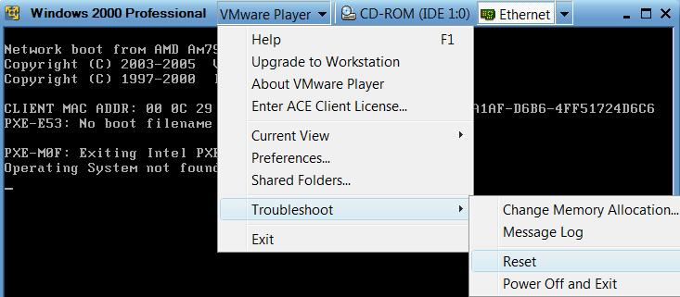
  - To restart your virtual machine, press Ctrl+Alt to release the mouse from the VM. Then click "VMware Player", "Troubleshoot", Reset, as shown below on this page.

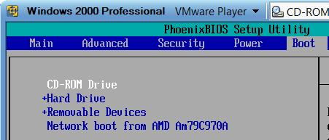
  - When the machine restarts, click in the black VMware Player window and press F2. The BIOS adjustment screen appears.
  - Press the right-arrow key on the keyboard four times to select the Boot tab. Use the down-arrow key to highlight the "CD-ROM Drive" entry and then press the + key to move it to the top of the list, as shown to the right on this page.
  - Press the F10 key. Press the Enter key.
- Your VM should now boot from the ISO file. Follow the on-screen prompts to install the operating system.
Last Modified: 8-5-08

