What You Need for This Project
Warning! "Ethical Hacking and Network Defense" students will capturing passwords in room S214. Don't do online shopping, personal e-mailing, or any other private computer work in that lab. Make up a new password just for that lab. Nothing you do in that lab is private!
- A trusted computer running any version of Windows, preferably Windows XP, with Internet access. This can be either a real or virtual machine.
- You need administrator privileges on the trusted machine.
- The trusted machine must have Firefox and antivirus software installed on it.
- The instructions below assume you are working in the S214 lab. If you are working at home, you will have to adapt the steps to match your situation.

Start Your Host Machine
- Power on a computer and log on with this name and password:
User name: Your CCSF Student ID, unless it starts with @. If your ID starts with @, replace the @ with X.
Password: changeme

Change Your Password
- Once you get logged in, press Ctrl+Alt+Delete and click the Change Password… button. Change your password to something you can remember. Do NOT use a password that you use anywhere else, however!

Making Your VM (Virtual Machines) Folder
- Click Start, My Computer. Double-click the VMs (V:) drive to open it. (If you have a portable hard drive, that’s an even better place to store your VMs.)
- In the VMs (V:) window, right-click the empty space and click New, Folder. Name the folder YOUR NAME VMs replacing YOUR NAME with your own name.

Copying a Windows XP Virtual Machine into Your VM Folder
- In the VMs (V:) window, double-click Hacking folder to open it. Right-click the Win XP Pro for Hacking folder and click Copy.
- In the Hacking window, click the Up button on the toolbar. Right-click the YOUR NAME VMs folder and click Paste. Wait until the copy is finished. This will be your personal Trusted Machine.

Starting VMware
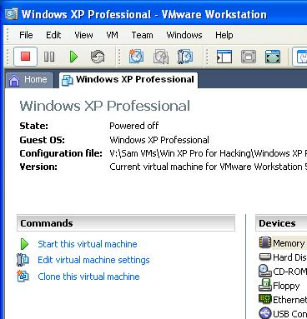
- Double-click the VMware Workstation icon on the desktop. In the VMware Workstation window, from the menu bar, click View, Go to Home Tab.
- On the Home tab, click the Open Existing VM or Team icon. Navigate to the V: drive, open your folder, open the Win XP Pro for Hacking folder, and double-click the Windows XP Professional.vmx file. You should see a Windows XP Professional VM in the Powered Off state, as shown to the right on this page.

Starting Your Virtual Machine
- In the Windows XP Professional – VMware Workstation window, on the left side, click the Start this virtual machine link.
- If you see a message saying “The location of this virtual machine’s configuration file has changed…,” accept the default selection of Create and click OK.
- When your machine starts up, click the Student account to log in. There is no password, and the Student account has Administrative privileges.
Making Sure you Have Antivirus Software Running
- Every machine on a network needs antivirus software. This applies to virtual machines as well as physical ones—VMware does not protect the virtual machine from viruses. If a virtual PC becomes infected with a virus, it can spread to you host system and to other computers on your network.
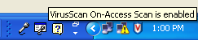
- Look at the Notification Area on the lower right of your desktop, next to the clock. You should see a shield icon with a red V on it. Hover the mouse over that icon and wait a few seconds. You should see the message “VirusScan On-Access Scan is enabled”, as shown to the right on this page. That shows that McAfee Antivirus is running. If you are using some other antivirus product, such as Norton or AVG or Avast, you should see some icon there indicating that it is protecting you.
- If you don’t have any antivirus software running, do these steps:

Installing avast! Free Antivirus
- Open a browser and go to avast.com
- In the upper left of the page, point to Products. In the drop-down menu, point to "Free software". Click "avast! 4 Home Edition". Scroll down and click the orange "avast! 4 Home Download" link. In the next page, click the green "Download Now!" button. In the c|net page, click the green "Download Now!" button. Save the file on your desktop.
- Double-click the file on your desktop. Click through the installer, accepting all the default selections. Accept the agreement. When it asks Do you wish to schedule a boot-time antivirus scan…, click No. Then click Finish to restart your machine.
Testing Your Antivirus Software
- Open a Web browser and go to eicar.com
- At the upper right of the page, click the “AntiMalware Testfile” box.
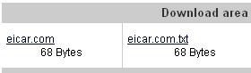
- The next page explains what the antivirus test file is – glance through it. It’s a harmless program that is used to test virus scanners. It is not a real virus, but it will set off virus scanners.
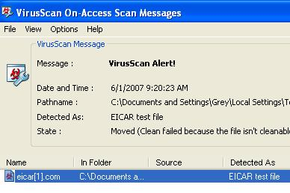
- Scroll to the bottom of this page and find the "Download area using the standard protocol http:". In the left box, click the eicar.com link, as shown to the right on this page.
- You should see a VirusScan Alert appear, as shown to the right on this page. If you are not using McAfee, the alert box will look different, but it should still say EICAR somewhere on it.

Capturing a Screen Image
- You need to turn in an image of this screen to get full credit for this portion of the project. Note the hand symbol on the previous page—that indicates screen images that you must capture and turn in.
- Press Ctrl+ Alt on the keyboard to release the cursor from within the Virtual Machine window. Move the mouse pointer out of the VMWare Workstation window. Click an empty portion of the host Windows XP desktop.
- Press the PrintScrn key in the upper-right portion of the keyboard. That will copy the whole desktop to the clipboard. On some laptops, the Print Screen key does not work. If that happens, try Fn Insert to capture the screen image.
- Click Start, Programs, Accessories, Paint. In the untitled - Paint window, select Edit, Paste from the menu bar. The desktop appears in the Paint window (only a corner of it will be visible).

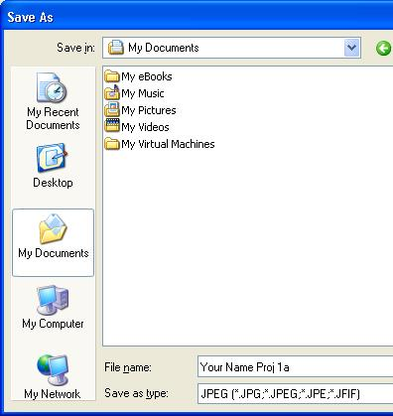
- In the untitled - Paint window, click File, Save. Save the document in the My Pictures folder (or any other place you wish, such as a floppy disk) with the filename Your Name Proj 1a. Select a Save as type of JPEG, as shown in the figure to the right on this page.

Verifying that Firefox is Installed
- Click Start, "All Programs", and look for "Mozilla Firefox". If it's not there, you will need to open Internet Explorer, go to getfirefox.com, download and install the latest version.

Changing Your Virtual Machine’s Name
- All the virtual machines now have the same name. This will cause warning messages to appear on the desktops, and it’s confusing. So you should change your machine’s name to contain the station number and your name, with the following steps:
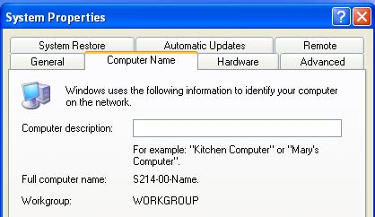
- Click the Start button on your virtual machine’s desktop, right-click My Computer, and click Properties. Click the Computer Name tab. Click the Change button. Enter the name of your station followed by your name, which will be something like this S214-01-YOURNAME. Click OK. When a Computer Name Changes box appears saying “You must restart…”, click OK. In the System Properties box, click OK. In the System Settings Change box, click Yes. Wait while your virtual computer restarts. Log in as you did before.
- Click the Start button on your virtual machine’s desktop, right-click My Computer, and click Properties. Click the Computer Name tab. The "Full computer name:" should contain your station number and your name, as shown to the right on this page.

Saving a Screen Image
- You have now completed Project 1. The only thing that remains is to turn it in. To do that, you need to make a JPEG image of the screen and email it to me, as explained below. Note the hand symbol just below this text: that indicates screen images that you must capture and turn in.
- Press Ctrl+ Alt on the keyboard to release the cursor from within the Virtual Machine window. Move the mouse pointer out of the VMWare Workstation window. Click an empty portion of the host Windows XP desktop.
- Press the PrintScrn key in the upper-right portion of the keyboard. That will copy the whole desktop to the clipboard.
- Click Start, Programs, Accessories, Paint. In the untitled - Paint window, select Edit, Paste from the menu bar. The desktop appears in the Paint window (only a corner of it will be visible).
- In the untitled - Paint window, click File, Save. Save the document in the My Pictures folder (or any other place you wish, such as a floppy disk) with the filename Your Name Proj 1b. Select a Save as type of JPEG.
- Email the JPEG images to me as attachments to one e-mail message. Send it to: cnit.123@gmail.com with a subject line of Proj 1 From Your Name, replacing Your Name with your own first and last name. Send a Cc to yourself.
Last Modified: 1-1-08

