What You Need for This Project

LEGAL WARNING!
Use only machines you own, or machines you have permission to hack into. Hacking into machines without permission is a crime! Don’t do it! If you do illegal things, you may be arrested and go to jail, and I will be unable to save you. These instructions are intended to train computer security professionals, not to help criminals.
- A trusted computer running any version of Windows, with Internet access. You need administrator privileges. This can be either a real or virtual machine.
- A victim computer running Windows 2000 Professional Service Pack 2. This can be either a real or virtual machine.

Start Your Host Machine
- Log in as usual with your CCSF ID and the password you chose in project 1.

Copying a Windows 2000 Virtual Machine into Your VM Folder
- In the VMs (V:) window, double-click Hacking folder to open it. Right-click the "Win 2000 Pro SP2" folder and click Copy.
- In the Hacking window, click the Up button on the toolbar. Right-click the YOUR NAME VMs folder and click Paste. Wait until the copy is finished. This will be your personal Victim Machine.

Starting Your Windows 2000 Virtual Machine
- Double-click the VMware Workstation icon on the desktop. In the VMware Workstation window, from the menu bar, click View, Go to Home Tab.
- On the Home tab, click the Open Existing VM or Team icon. Navigate to the V: drive, open your folder, open the Win 2000 Pro SP2 folder, and double-click the Windows 2000 Professional.vmx file. On the left side, click the Start this virtual machine link.
- If you see a message saying “The location of this virtual machine’s configuration file has changed…,” accept the default selection of Create and click OK.
- When your machine starts up, log in as Administrator with no password.

Changing Your Windows 2000 Virtual Machine’s Name
- On the Windows 2000 virtual machine’s desktop, right-click My Computer, and click Properties. Click the Network Identification tab. Click the Properties button. Enter the name of your station followed by your name and then “2”, which will be something like this S214-01-YOURNAME2. The maximum length allowed is 15 characters, so you may have to abbreviate your name. Click OK. When a Computer Name Changes box appears saying “You must restart…”, click OK. In the System Properties box, click OK. In the System Settings Change box, click Yes. Wait while your virtual computer restarts. Log in as you did before.

Testing Your Windows 2000 Virtual Machine’s Internet Connection
- On the Windows 2000 virtual machine, open Internet Explorer and verify that you can reach the Internet. If you cannot, try restarting the virtual machine. If that doesn’t fix it, call your instructor over to help solve the problem before going to the next step.

Finding Your Windows 2000 Virtual Machine’s IP Address
- Click Start, Run. Type in command and press the Enter key. In the Command Prompt screen, type in IPCONFIG and press the Enter key. If you have two network adapters, find the one with an IP address that starts with 192. Write that address in the box to the right on this page.

Victim’s IP Address: ________________________

Starting your Trusted Machine
- If you are using VMware Workstation, close the unused tabs in the VMware window that is running your Windows 2000 virtual machine. This will unlock your trusted machine.
- Double-click the VMware Workstation icon on the desktop. In the VMware Workstation window, from the menu bar, click View, Go to Home Tab.
- On the Home tab, click the Open Existing VM or Team icon. Navigate to the V: drive, open your folder, open the Win XP Pro for Hacking folder, and double-click the Windows XP Professional.vmx file. You should see a Windows XP Professional VM in the Powered Off state.
- In the Windows XP Professional – VMware Workstation window, on the left side, click the Start this virtual machine link.
- When your machine starts up, click the Student account to log in. There is no password, and the Student account has Administrative privileges.

Examining the Metasploit Website
- Open a browser (Firefox, preferably) and go to metasploit.com
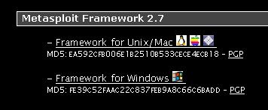
- Click Framework. Click Downloads.
- Scroll down until you see the Windows installer for latest version of Metasploit, as shown to the right on this page. Notice that there is an MD5 value below the link for each version.

Verifying the MD5 Hash
- Never trust anything you get from the Internet, especially hacking tools! The purpose of the MD5 hash is to make sure the file you actually get has not been altered.
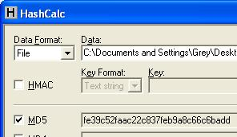
- I have already downloaded the metasploit installer and saved it on your virtual machine’s desktop, so you don’t need to download it again. To make sure it’s OK we will use a free MD5 calculator named Hashcalc. (If you are working at home, get Hashcalc 2.01 from slavasoft.com/hashcalc)
- On the virtual machine’s desktop, click Start, All Programs, Hashcalc, Hashcalc. In the Hashcalc window, click the … button at the upper right. Navigate to the desktop and double-click framework-2.7. In the Hashcalc window, click the Calculate button. You should see a MD5 value that matches the value shown on the Metasploit webpage, as shown to the right on this page.

Installing Metasploit
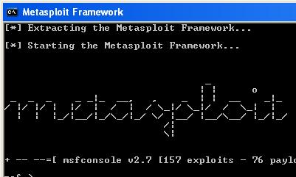
- Double-click the framework-2.7 file on your desktop and click through the installer, accepting all the default selections. You may see some virus warnings, but they won’t stop the exploit we are using from operating correctly. When the graphical installer is done, a command prompt window titled Metasploit Framework stays open. Wait until you see metasploit in ASCII art, as shown to the right on this page.
- Metasploit is most powerful when run from this command prompt window. But we are going to use the Web interface, which is much easier to use.
- Click the X button to close the Metasploit Framework window.

Starting MSFWeb
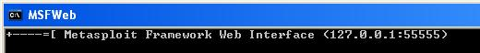
- Click Start, All Programs, Metasploit 2, MSFWeb. A command prompt window opens with a single line of text in it as shown below. Leave this window open – this is a little Web server running on your machine, which enables you to control Metasploit through a Web browser.

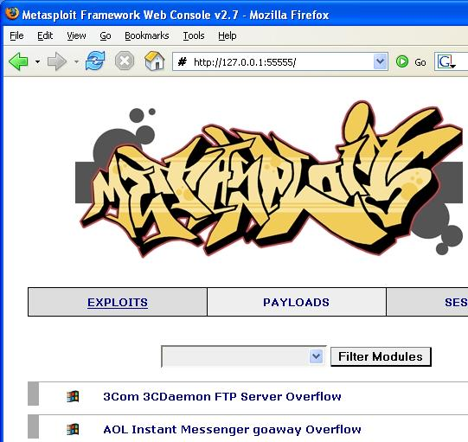
Launching the MS04-011 Exploit
- Open Firefox (IE does not work for this) and go to 127.0.0.1:55555
- If a security alert from your firewall pops up, unblock the program.
- You should see a graffiti-style Metasploit logo, with a long list of exploits, such as the ones shown to the right on this page targeting 3Com, AOL, and many more. Computers running these products can be attacked by Metasploit.

- Scroll down to Microsoft LSASS MSO4-011 Overflow and click it. This exploit can take over an unpatched Windows system—it does not depend on any additional vulnerable software.
- Scroll down to the Select Target section and click Windows 2000.
- In the Select Payload section, click win32_reverse – this is a common payload that opens a Command Prompt on the victim machine, so you can type in commands of your choice to do anything you like on that machine.
- Find the Victim’s IP Address you wrote in the box on a previous page. Type that number into the RHOST box in the next screen, as shown below. Don’t use the number 192.168.2.5 – that’s the number from my home network. Use your correct victim IP address instead. Then click the Exploit button near the bottom of the window. (Don’t bother with the Check button – it does not seem to work properly.)

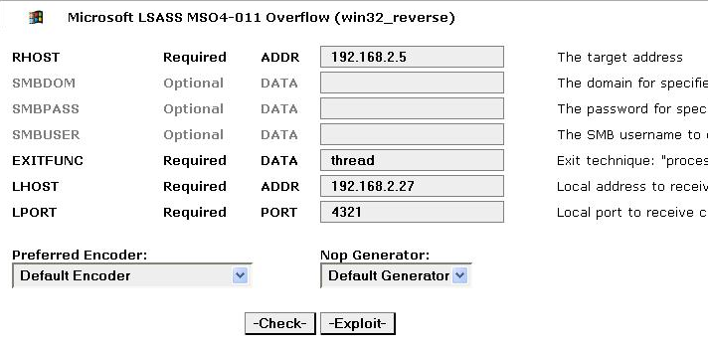
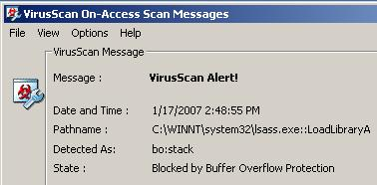
- You should see an Exploit Output that appears only briefly, followed by a page that says The connection was reset. The exploit failed.
- To see why, look at your Windows 2000 machine’s desktop. You should see a McAfee antivirus warning, as shown to the right on this page. (Sometimes the scanner fails to detect the buffer overflow, particularly if you have a different antivirus. If you don't see the message, just continue anyway.)

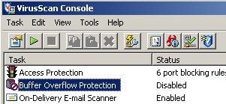
Disabling the Virus Scanner’s Buffer Overflow Protection
- In the Windows 2000 virtual machine, in the lower right corner, right-click the little shield icon and select VirusScan Console.
- In the VirusScan Console window, right-click Buffer Overflow Protection and select Disable. The Status line should change to Disabled as shown to the right on this page.

Launching the MS04-011 Exploit Again
- On your Windows XP virtual machine, in the Firefox window, type in the address 127.0.0.1:55555 and press the Enter key.
- Scroll down to Microsoft LSASS MSO4-011 Overflow and click it.
- Scroll down to the Select Target section and click Windows 2000.
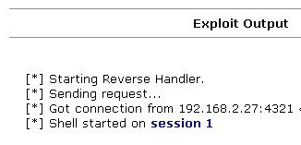
- In the Select Payload section, click win32_reverse.
- Type the Victim’s IP Address into the RHOST box. Then click the Exploit button.
- You should see an Exploit Output similar to the example to the right on this page, with different IP addresses and ports. If it works, you will see the line Shell started on session 1 (your session number will be larger). You may have to try the exploit more than once.
- When you get a connection, click the session link.

Using the Reverse Shell to Tag the Victim’s Desktop
- As shown below on this page, enter two commands to create a file on the victim’s desktop. This is a traditional way childish hackers scare victims, showing that you “own” their box.

cd \documents and settings\administrator\desktop

echo “ha ha” > YOURNAME_owns_your_computer.txt

(Replace YOURNAME with your own name in the second command.)
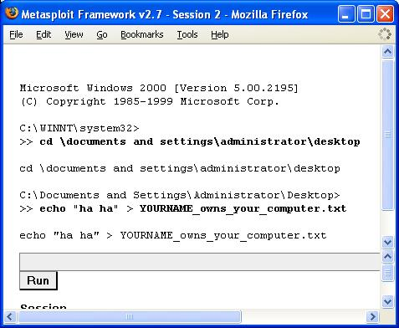

Saving a Screen Image
- Click outside the virtual machine to make the host machine’s desktop active.
- Press the PrintScrn key to copy the whole desktop to the clipboard.
- In the host machine, click Start, Programs, Accessories, Paint. In the untitled - Paint window, select Edit, Paste from the menu bar. The desktop appears in the Paint window, with only a corner of it visible.
- In the untitled - Paint window, click File, Save. Save the document in the My Pictures folder (or any other place you wish, such as a floppy disk) with the filename Your Name Proj 2. Select a Save as type of JPEG.
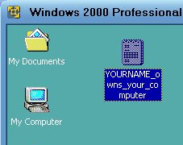
- You should be able to see the new file on the victim’s desktop, as shown to the right on this page. Imagine how you would feel if files started appearing on your computer from nowhere while you were using it!

Patching the Windows 2000 System
- In the Windows 2000 virtual machine, open Internet Explorer and go to this page:
microsoft.com/technet/security/bulletin/ms04-011.mspx
The page looks very strange, with the margins set very narrow, but it seems to work OK. It looks a lot better in Firefox than in Internet Explorer.
- Scroll down to the bulleted paragraph beginning Microsoft Windows Service Pack 2 and click the Download the update link.
- In the Security Update for Windows 2000 (KB835732) page, scroll down and click the gray Download button. Save the file on your desktop. Unfortunately. Microsoft does not provide MD5 hashes to confirm that the file is correct, so we can’t check.
- On the desktop of your Windows 2000 virtual machine, double-click the Windows-2000- KB835732-x86-ENU file. A wizard opens. Agree to the conditions and install the patch. Restart your virtual machine when prompted to.

Launching the MS04-011 Exploit Again
- On your Windows XP virtual machine, in the Firefox window, type in the address 127.0.0.1:55555 and press the Enter key.
- Scroll down to Microsoft LSASS MSO4-011 Overflow and click it.
- Scroll down to the Select Target section and click Windows 2000.
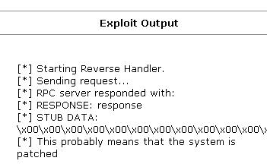
- In the Select Payload section, click win32_reverse.
- Type the Victim’s IP Address into the RHOST box. Then click the Exploit button.
- You should see an Exploit Output similar to the example to the right on this page, which quickly closes and shows a page saying The connection was reset. Your Windows 2000 machine is now patched and tested.

Enabling the Virus Scanner’s Buffer Overflow Protection
- In the Windows 2000 virtual machine, in the lower right corner, right-click the little shield icon and select VirusScan Console.
- In the VirusScan Console window, right-click Buffer Overflow Protection and select Enable.

Turning in Your Project
- Email the JPEG images to me as attachments to a single email message. Send it to: cnit.123@gmail.com with a subject line of Proj 2 From Your Name, replacing Your Name with your own first and last name. Send a Cc to yourself.

Last Modified: 1-1-08

