What You Need for This Project

LEGAL WARNING!
Use only machines you own, or machines you have permission to hack into. Hacking into machines without permission is a crime! Don’t do it! If you do illegal things, you may be arrested and go to jail, and I will be unable to save you. These instructions are intended to train computer security professionals, not to help criminals.
- A trusted computer running any version of Windows, with Internet access. You need administrator privileges. This can be either a real or virtual machine.
- A victim computer running any OS at all (even a Mac or Linux), networked to the trusted computer with either non-switched Ethernet or Wi-Fi. This can be either a real or virtual machine.
Packet Sniffing and Switched Ethernet
- This will only work on a non-switched network – that is, an Ethernet network using a hub. This attack can be done on a switched network, but you need to trick the switch with ARP poisoning, or another technique. We'll do that in a later project.
- The defect of non-switched Ethernet that we will exploit here is that every packet is sent to every device on the hub, so your computer is able to read what other computers send and receive. Most wired networks are now switched, but wireless networks naturally send signals to every computer nearby, so this sort of attack works well for them.
Installing the Wireshark Packet Sniffer
- Use your trusted virtual machine.
- Open a Web browser and go to WireShark.org
- Download and install the latest version of Wireshark. The installer will also install WinPCap.
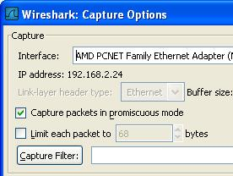
Starting a Capture in Promiscuous Mode
- Click Start, All Programs, Wireshark, Wireshark.
- From the Wireshark menu bar, click Capture, Interfaces. Find the Interface with an IP address starting with 192.168.1. That’s the interface that connects to the Internet in room S214. Click the Options button in that interface’s line.
- In the Wireshark Capture Options box, verify that the Capture packets in promiscuous mode box is checked, as shown to the right on this page. This means that your network interface will accept all the packets it receives, even the ones that are addressed to other machines. Click the Start button.
- If you see a message saying Save capture file before starting a new capture?, click Continue Without Saving.
Entering a Password in the CCSF WebMail Client
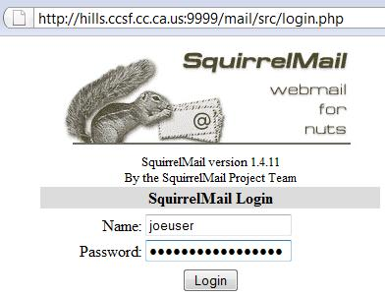
- In your virtual machine, open a browser and go to hills.ccsf.edu/mail
- In the Name box, enter joeuser
- In the Password box, enter topsecretpassword
- Do NOT put in your real user name and password! As you will see, this Web page is not secure. After this lab, you might not want to use it anymore!
- Click the LOG IN button. If you see a message asking whether to remember the password, click "Not Now". After a few seconds, a message appears saying Username/Password Failure.
- In the Wireshark: Capture box, click Stop.
Viewing the Password Captured From Your Own Computer
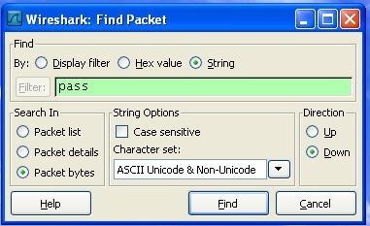
- Wireshark shows the captured packets. To find the packet containing the password, click Edit, "Find Packet". In the By line, click the String button. Enter a string of pass and click the Find button.
- Examine the data shown in the bottom pane, on the right-hand side. This is the text contained in the packet. In that data, you should find login_username and secretkey fields, revealing the username and password you typed in, as shown below on this page.
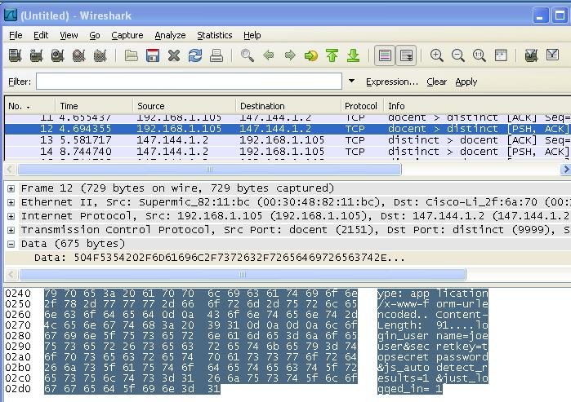
Saving the Screen Image
- Press the PrintScrn key in the upper-right portion of the keyboard.
- On the Start menu, click Run. Enter the command mspaint and press the Enter key. Paint opens.
- Press Ctrl+V on the keyboard to paste the image into the Paint window. Save the document with the filename Your Name Proj 3a. Select a Save as type of JPEG. Close Paint.
Capturing a Password from the Host Operating System
- On your virtual machine, Click Start, All Programs, Wireshark, Wireshark.
- From the Wireshark menu bar, click Capture, Interfaces. Find the Interface with an IP address starting with 192.168.1. That’s the interface that connects to the room’s LAN. Click the Start button in that interface’s line.
- If you see a message saying "Save capture file before starting a new capture?", click "Continue Without Saving".
- On the host machine, go to the hills.ccsf.edu/mail website. Log in with the fake name joeuser2 and password topsecretpassword2.
- On your virtual machine, stop the capture. To find the packet containing the password, click Edit, "Find Packet". In the By line, click the String button. Enter a string of pass and click the Find button. You should see the user name and password in the lower right portion of the screen, as shown below on this page.
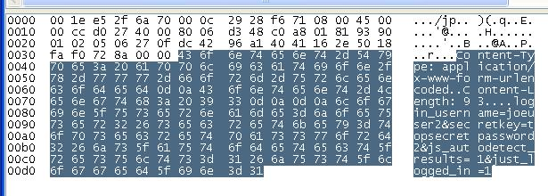

Saving the Screen Image
- Press the PrintScrn key in the upper-right portion of the keyboard.
- On the Start menu, click Run. Enter the command mspaint and press the Enter key. Paint opens.
- Press Ctrl+V on the keyboard to paste the image into the Paint window. Save the document with the filename Your Name Proj 3b. Select a Save as type of JPEG. Close Paint.
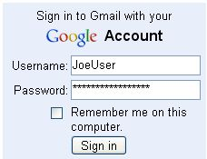
Observing a Secure Password Transmission
- On your own virtual machine, start another capture in promiscuous mode, as you did in steps 15-18 above.
- On your own virtual machine, open a browser and go to gmail.com. Log in with the fake name JoeUser and password topsecretpassword, as shown to the right on this page.
- Stop the capture. Click Edit, "Find Packet". In the By line, click the String button. Enter a string of pass and click the Find button. No match is found—the string pass does not appear in the packets at all.
- Look in the Info column and find Client Hello, then Server Hello, then Certificate, as shown below. Those exchanges are parts of the SSL Handshake that prepared an encrypted layer to send your username and password.
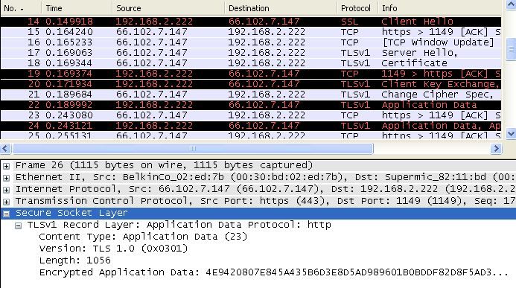
- Look at the packets that appear below "Server Hello". Find a packet labeled "SSLv3 Application Data" or "TLSv1 Application Data", like packet 22 in the image below on this page, and click on it in the top pane to select it. Details about the packet will appear in the middle pane. Click the + sign to expand Secure Socket Layer. Expand the layer inside (labeled "SSLv3 Record Layer" or "TLSv1 Record Layer"), so that the Encrypted Application Data is visible, as shown at the bottom of the image below on this page. Your user name and password are concealed in that encrypted data. Even though the packet sniffer can see the data go by, it cannot be read. This is how SSL protects you--all Web logons should use SSL.

Saving the Screen Image
- Make sure Encrypted Application Data is visible in your screen image.
- Press the PrintScrn key in the upper-right portion of the keyboard.
- On the Start menu, click Run. Enter the command mspaint and press the Enter key. Paint opens.
- Press Ctrl+V on the keyboard to paste the image into the Paint window. Save the document with the filename Your Name Proj 3c. Select a Save as type of JPEG. Close Paint.
Turning in your Project
- Email the JPEG images to me as attachments to one e-mail message to cnit.123@gmail.com with a subject line of Proj 3 From Your Name. Send a Cc to yourself.

Last modified 9-1-08

