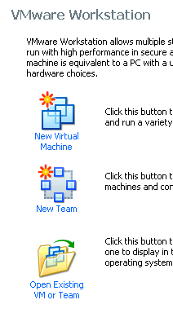
Using VMWare Workstation to Create a New Virtual Machine
- We are using VMware Workstation in the S214 lab, but it’s not a free program. If you are working at home, use VMmanager to create the virtual machine instead.
- Double-click the VMWare Workstation icon on the desktop.
- A VMWare Workstation window opens as shown to the right on this page. Click the New Virtual Machine icon.
- At the Welcome to the New Virtual Machine Wizard screen, click Next.
- At the Select the Appropriate Configuration screen, accept the default selection of Typical and click Next.
- At the Select a Guest Operating System screen, make sure that the Linux radio button is selected and in the Version box, select Ubuntu. Click Next.
- At the Name the Virtual Machine screen, enter a Virtual machine name of Your Name Ubuntu. Click the Browse button to choose the drive and folder to save the VM in. Navigate to V:\YOURNAME_VMs. Create a new subfolder named Ubuntu and click it to select it. Click Next.
- At the Network Type screen, accept the default selection of Use Bridged Networking and click Next.
- At the Select the Appropriate Configuration screen, accept the default selection and click Next.
- At the Specify Disk Capacity screen, change the size to 7 GB. Do not check either of the boxes. Click Finish.
- You should now see a window with Your Name Ubuntu in large gray letters near the top.

Adjusting Network Settings
- The Ethernet settings on VMware Workstation are set to match the two physical network interfaces on our lab machines, so you will need to adjust network settings. This only has to be done once for each virtual machine. If you are working at home, this probably won’t be necessary.
- In the Your Name Ubuntu – Vmware Workstation window, on the left side, click the Edit virtual machine settings link.

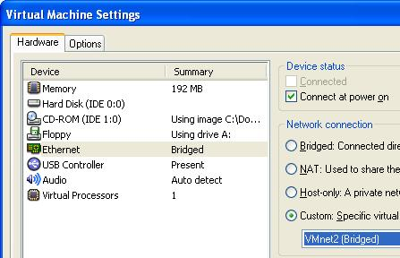
- In the Virtual Machine Settings box, on the Hardware tab, click the Ethernet item to select it. On the right side, click the Custom radio button and select VMnet2 (Bridged) as shown to the right on this page. Click the Add button.
- In the Welcome to the Add Hardware Wizard screen, click Next.
- In the Hardware Type screen, click Ethernet Adapter and click Next.
- In the Network Type screen, on the right side, click the Custom radio button and select VMnet0 (default Bridged). Click Finish.
- In the Virtual Machine Settings screen, click OK.

Starting the Virtual Machine with No Operating System
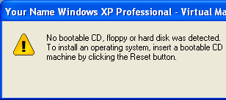
- In the Commands section in the middle of the window, click Start this virtual machine.
- A Your Name Ubuntu – Virtual Machine opens saying The keyboard hook timeout value …. Click OK to close the box.
- The virtual machine starts, and attempts to boot up, but there is no operating system installed, so it ends with the message shown on to the right on this page.
- Click OK to close the dialog box.

Connecting the Virtual Machine to the Ubuntu CD Image
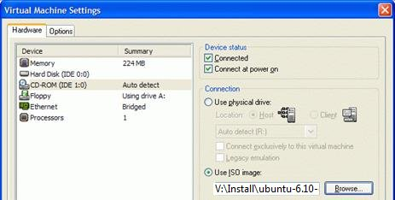
- From the Menu bar, select VM, Settings.
- In the Virtual Machine Settings box, click CD-ROM in the left pane. In the right pane, click Use ISO Image. Click the Browse button and navigate to V:\Install\ubuntu-7.04-desktop-i386.iso as shown to the right on this page. (The Ubuntu version number in the image is different.)
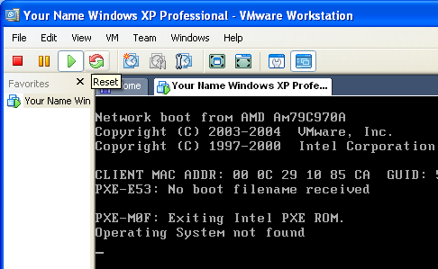
- Click OK to close the Virtual Machine Settings box
- Click the Reset button as shown to the right on this page. If a VMWare Workstation box opens asking Are you sure that you want to restart the guest operating system? click OK. In the next box, click OK.

Adjusting the Virtual BIOS Boot Order
- As soon as the startup text appears in the window, click in the window and press the F2 key to edit the BIOS settings. You have to be fast – you have only about 2 seconds to click and press F2.
- Adjust the Boot Order so that "CD-ROM" is first. Press F10 to Save and Exit, and Enter to confirm.

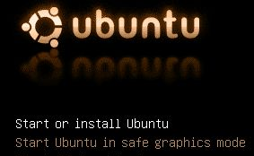
Starting Linux from the CD Image
- The virtual machine should boot from the ISO image, and show you the ubuntu starting screen shown to the right on this page.
- Press the Enter key to Start or Install Ubuntu, as shown to the right on this page.

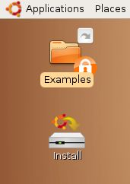
- Ubuntu will launch from the ISO file, and show a brown desktop with an Install icon on it, as shown to the right on this page.
- At this point, Ubuntu is running from the virtual CD. This “Live CD” mode is intended to let people try Linux on a Windows machine without changing the hard disk. The problem with it is that you cannot install software, save files, or customize it. Besides, we are using VMware, which protects the Windows XP host system anyway—we don’t need the Live CD feature. So we will install Ubuntu onto the virtual hard disk.

Installing Ubuntu Linux on the Virtual Hard Disk
- Double-click the Install icon.
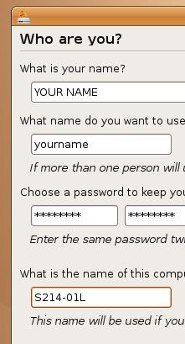
- In the first Linux install screen, labeled "Step 1 of 7" in the lower left corner, accept the default selection of English and click the Forward button.
- In"Step 2 of 7", click on the map to select Los Angeles for a time zone, and click the Forward button.
- In"Step 3 of 7", accept the default keyboard layout selection of "U.S. English" and click the Forward button.
- Step 4 of 7 is preparing the disk space. Accept the default selections of "Guided – use entire disk" and "IDE1 master (hda)" and click the Forward button.
- In"Step 5 of 7", "Migrating User Settings", don't change anything and click the Forward button.
- Step 6 of 7 is the Who are you? Screen. Type in your name and a logon name of your choice. Enter a password you can remember – I recommend P@ssw0rd. Name your computer after the station number on the front panel, adding an L (for Linux) to the end, as shown to the right on this page. Click the Forward button.
- Step 7 of 7 is the "Ready to install" screen. Click the Install button.
- Wait while Linux installs – it will take about 30 minutes. When you see an Installation Complete box, click Restart now.

Removing the Virtual CD
- Ubuntu shuts down, leaving a black screen with small blue letters at the bottom saying "please remove the disc". If you are working in S214, do the following steps. (If you are working at home, press Ctrl+Alt to release the cursor and click the CD button at the top of the VMware Player window to remove it.)
  - Click the lower X button in the upper right of the Ubuntu screen to shut down the virtual machine without completely closing VMware Workstation.
  - You should now see a window with Your Name Ubuntu in large gray letters near the top.
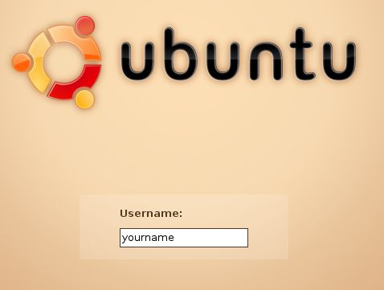
  - From the Menu bar, select VM, Settings.
  - In the Virtual Machine Settings box, click CD-ROM in the left pane. In the right pane, click Use physical drive.
  - Click OK to close the Virtual Machine Settings box
  - Click Start this virtual machine.
- You should see a GRUB LOADING message, and when Ubuntu boots up, you will see the login screen shown to the right on this page. Type in your user name and press the Enter key. Then type in your password and pres the Enter key.

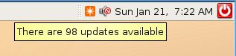
Concerning Updates
- At the upper right of the screen, you will see a clock with some icons near it. The leftmost icon is an orange square with a white star on it. Point to that icon and you should see that updates are available – 98 updates, when I did it, as shown to the right on this page.
- Just like Windows, Ubuntu has vulnerabilities and a constant stream of updates. But the updates are not as important, because Linux is a lot more secure in the first place. Also, in my experience, Ubuntu updates are much more likely to break a working machine than Windows updates (see link Ch 1q on my Web page). So my recommendation is to not bother updating during this class unless there is a specific new feature you want.

Examining the Package Repositories
- Ubuntu is a Debian Linux distribution, and one of the great things about Debian is that it has online repositories of applications which you can download and install easily. They are ready to go, just like updates, and they are all free!
- From the menu bar, click System, Administration, "Synaptic Package Manager". Enter your password when you are prompted to.
- Read the "Quick Introduction" box, then click the Close button.
- From the "Synaptic Package Manager" menu bar, click Settings, Repositories. A "Software Sources" box appears, as shown below. Make sure that the first four items are all checked, as shown below. These are all the repositories that contain commonly used programs. They are separated into these groups based on how open-source and free they are—they are not all supported by Ubuntu, and they are not all necessarily legal in all countries.
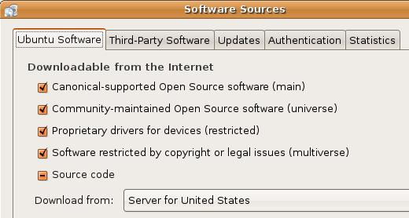
- Click the Close button.
- In the "Synaptic Package Manager" box, click the Reload button.
- Close the "Synaptic Package Manager" box.

Installing Nessus
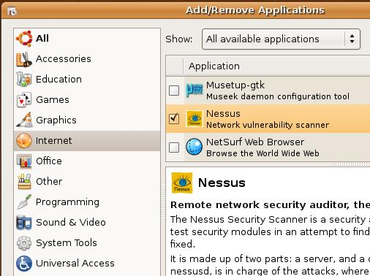
- From the menu bar, click Applications, Add/Remove….
- In the upper right of this window, click in the Show: box and select "All available applications".
- In the left column of the "Add/remove Applications" box, click Internet. Scroll down to find Nessus and check it. When a box pops up saying “Enable the installation of community maintained software?,” click Enable.
- In the "Add/remove Applications" box , click the "Apply Changes" button. A box pops up saying "Apply the following changes?". Click Apply. Type in your password when prompted to. Wait while software downloads and progress bars move across the screen.
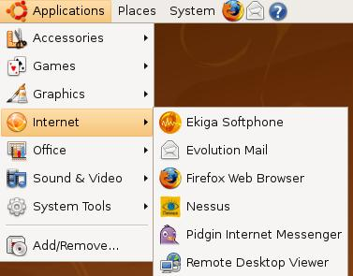
Saving the Screen Image
- From the Ubuntu menu bar, click Applications, Internet. You should see the Nessus applications on the list, as shown to the right on this page.
- Click on the host Windows XP desktop taskbar. Press the PrntScn key to copy whole screen to the clipboard.
- On the host Windows XP desktop, open Paint and paste in the image. Save it as a JPEG, with the filename Your Name Proj 4.

Adjusting the Virtual BIOS Boot Order
- You should correct the boot order, so your new Ubuntu virtual machine starts up from the hard disk, not from the CD-ROM image.
- From the Ubuntu desktop menu bar, click System, Quit. Click the Reset button.
- As soon as the startup text appears in the window, click in the window and press the F2 key to edit the BIOS settings. You have to be fast – you have only about 2 seconds to click and press F2.
- Adjust the Boot Order so that "Hard Drive" is first. Press F10 to Save and Exit, and Enter to confirm

Shutting Down the Ubuntu Machine
- When your Ubuntu machine restarts, click System, Quit. Click the "Shut Down" button.
Turning in your Project
- Email the JPEG image to me as an attachment. Send the message to cnit.123@gmail.com with a subject line of Proj 4 From Your Name. Send a Cc to yourself.
Last modified 12-28-08
Note: link Ch 7r has more about packages in Ubuntu.

