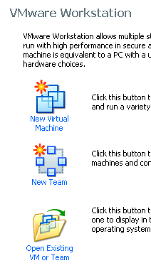
Using VMWare Workstation to Create a New Virtual Machine
- If you are working at home, get your free copy of VMware Workstation before starting this project.
- Double-click the VMWare Workstation icon on the desktop.
- A VMWare Workstation window opens as shown to the right on this page. Click the New Virtual Machine icon.
- A "Welcome to the New Virtual Machine Wizard" screen appears. Select "Typical (recommended)" and click Next.
- In the "Guest Operating System Installation" screen, click "I will install the operating system later" and click Next.
- At the Select a Guest Operating System screen, make sure that the Linux radio button is selected and in the Version box, select Ubuntu. Click Next.
- At the Name the Virtual Machine screen, enter a Virtual machine name of Your Name Ubuntu. Click the Browse button to choose the drive and folder to save the VM in. Navigate to V:\YOURNAME_VMs. Create a new subfolder named Ubuntu and click it to select it. Click Next.
- Insert the Ubuntu 8.04 installation disk into the CD drive.
- At the Specify Disk Capacity screen, accept the default size of 8 GB. Click the "Split virtual disk into 2 GB files" button. Click Next.

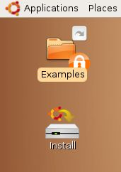
Starting Linux from the CD
- The virtual machine should boot from the CD. After 30 seconds or so, you should see the a brown desktop with an Install icon on it, as shown to the right on this page.
- At this point, Ubuntu is running from the virtual CD. This “Live CD” mode is intended to let people try Linux on a Windows machine without changing the hard disk. The problem with it is that you cannot install software, save files, or customize it. Besides, we are using VMware, which protects the Windows host system anyway—we don’t need the Live CD feature. So we will install Ubuntu onto the virtual hard disk.

Installing Ubuntu Linux on the Virtual Hard Disk
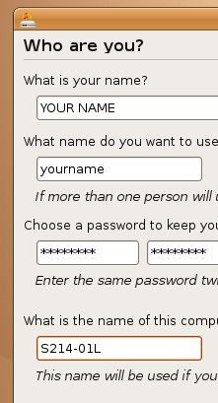
- Double-click the Install icon.
- In the first Linux install screen, labeled "Step 1 of 7" in the lower left corner, accept the default selection of English and click the Forward button.
- In"Step 2 of 7", click on the map to select Los Angeles for a time zone, and click the Forward button.
- In"Step 3 of 7", accept the default keyboard layout selection of "USA" and click the Forward button.
- Step 4 of 7 is preparing the disk space. Accept the default selections of "Guided – use entire disk" and "SCSI3 (0,0,0) (sda)" and click the Forward button.
- Step 5 of 7 is the Who are you? Screen. Type in your name and a logon name of your choice. Enter a password you can remember – I recommend P@ssw0rd. Name your computer after the station number on the front panel, adding an L (for Linux) to the end, as shown to the right on this page. Click the Forward button.
- There is no step 6.
- Step 7 of 7 is the "Ready to install" screen. Click the Install button.
- Wait while Linux installs – it will take about 20 minutes. When you see an Installation Complete box, click Restart now.

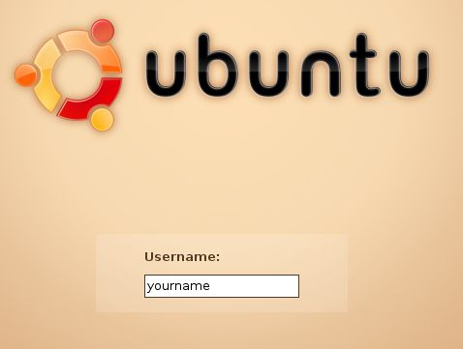
Removing the CD
- Ubuntu shuts down, leaving a black screen with small blue letters at the bottom saying "please remove the disc". Remove the CD and press the Enter key.
- You should see a GRUB LOADING message, and when Ubuntu boots up, you will see the login screen shown to the right on this page. Type in your user name and press the Enter key. Then type in your password and pres the Enter key.

Concerning Updates
- At the upper right of the screen, you will see a clock with some icons near it. The leftmost icon is an orange square with a white star on it. Point to that icon and you should see that updates are available – 98 updates, when I did it, as shown to the right on this page.
- Just like Windows, Ubuntu has vulnerabilities and a constant stream of updates. But the updates are not as important, because Linux is a lot more secure in the first place. Also, in my experience, Ubuntu updates are much more likely to break a working machine than Windows updates (see link Ch 1q on my Web page). So my recommendation is to not bother updating during this class unless there is a specific new feature you want.

Examining the Package Repositories
- Ubuntu is a Debian Linux distribution, and one of the great things about Debian is that it has online repositories of applications which you can download and install easily. They are ready to go, just like updates, and they are all free!
- From the menu bar, click System, Administration, "Synaptic Package Manager". Enter your password when you are prompted to.
- Read the "Quick Introduction" box, then click the Close button.
- From the "Synaptic Package Manager" menu bar, click Settings, Repositories. A "Software Sources" box appears, as shown below. Make sure that the first four items are all checked, as shown below. These are all the repositories that contain commonly used programs. They are separated into these groups based on how open-source and free they are—they are not all supported by Ubuntu, and they are not all necessarily legal in all countries.
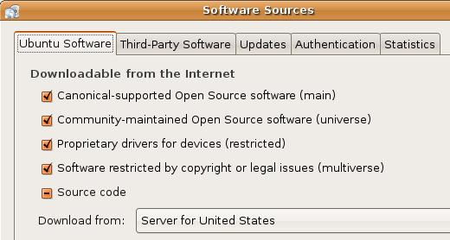
- Click the Close button.
- In the "Synaptic Package Manager" box, click the Reload button.
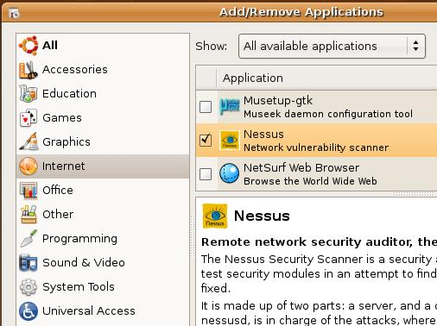
- If the packages cannot load, test your Internet connection. If you are connected to the Internet, and the packages still won't load, that is a problem with the Ubuntu repositories, which is very common. The only thing to do is to wait and try again later. If this makes you late on the project, explain that to your instructor.
- Close the "Synaptic Package Manager" box.

Installing Nessus
- From the menu bar, click Applications, Add/Remove….
- In the upper right of this window, click in the Show: box and select "All available applications".

- In the left column of the "Add/remove Applications" box, click Internet. Scroll down to find Nessus and check it. When a box pops up saying “Enable the installation of community maintained software?,” click Enable.

- In the "Add/remove Applications" box , click the "Apply Changes" button. A box pops up saying "Apply the following changes?". Click Apply. Type in your password when prompted to. Wait while software downloads and progress bars move across the screen.
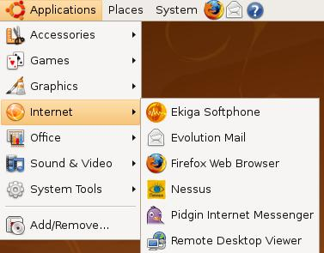
Saving the Screen Image
- From the Ubuntu menu bar, click Applications, Internet. You should see the Nessus applications on the list, as shown to the right on this page.
- Click on the host Windows XP desktop taskbar. Press the PrntScn key to copy whole screen to the clipboard.
- On the host Windows XP desktop, open Paint and paste in the image. Save it as a JPEG, with the filename Your Name Proj 4.

Adjusting the Virtual BIOS Boot Order
- You should correct the boot order, so your new Ubuntu virtual machine starts up from the hard disk, not from the CD-ROM image.
- From the Ubuntu desktop menu bar, click System, Quit. Click the Reset button.
- As soon as the startup text appears in the window, click in the window and press the F2 key to edit the BIOS settings. You have to be fast – you have only about 2 seconds to click and press F2.
- Adjust the Boot Order so that "Hard Drive" is first. Press F10 to Save and Exit, and Enter to confirm

Shutting Down the Ubuntu Machine
- When your Ubuntu machine restarts, click System, Quit. Click the "Shut Down" button.
Turning in your Project
- Email the JPEG image to me as an attachment. Send the message to cnit.123@gmail.com with a subject line of Proj 4 From Your Name. Send a Cc to yourself.
Last modified 9-8-09
Note: link Ch 7r has more about packages in Ubuntu.

