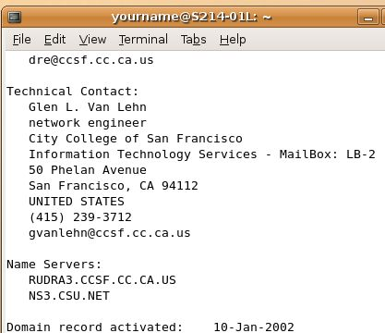
What You Need for This Project
- A trusted computer running Ubuntu or any other version of Linux, with Internet access. This can be either a real or virtual machine.
Using whois in a Terminal Window
- Use your Ubuntu Linux virtual machine.
- From the menu bar, click Accessories, Applications, Terminal.
- Enter the following command, followed by the Enter key:
whois ccsf.edu
- You should see a lot of information about the CCSF domain, ending in the information shown to the right on this page, showing two Name Servers: RUDRA3.CCSF.CC.CA.US and another one at CSU.
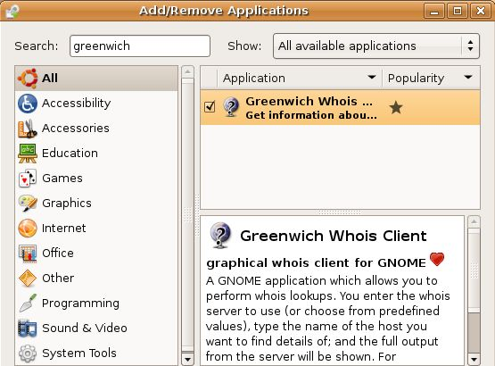
Installing Greenwich
- Greenwich is a graphical front-end for the whois command.
- From the main Ubuntu menu bar, click Applications, Add/Remove…. In the Search box, enter Greenwich and press the Enter key.
- In the right pane of the Add/Remove Applications box, click the box next to Greenwich Whois… as shown to the right on this page. A check mark appears in the box.
- At the bottom of the Add/Remove Applications box, click the Apply button.
- In the Apply the following changes? box, click Apply. Enter your password when you are prompted to.
- Another Apply the following changes? box appears warning you that this software can't be authenticated. Click Apply. Wait while packages download and install. If they install correctly, you can skip the next step (#11) , and all the lettered sub-steps (a, b, c …).
Changing the Mirror for Package Sources
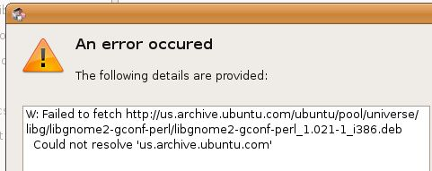
- If you see error messages saying Could not resolve 'us.archive.ubuntu.com' as shown to the right on this page, that means the mirror is down. You can fix it by editing the sources.conf file to point to the main Ubuntu server at archive.ubuntu.com instead of the US mirror at us.archive.ubuntu.com, with these steps:
    - Enter this command, then press the Enter key:
cd /etc/apt
    - Enter this command, then press the Enter key:
sudo cp sources.list sources.list.bak2
(Enter your password at the prompt)
    - Enter this command, then press the Enter key:
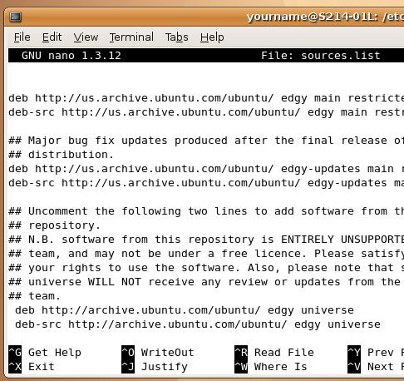
sudo pico sources.list
This command starts the pico text editor.
    - You will now see a file in the terminal window, as shown to the right on this page.

    - Find these two lines at the bottom of your screen:
deb http://us.archive.ubuntu.com/ubuntu/ edgy universe
deb-src http://us.archive.ubuntu.com/ubuntu/ edgy universe
    - Delete the us. characters before the archive in each of those lines, so your screen looks like the image on the previous page. That tells your Ubuntu system to use the main servers instead of the US mirror.
    - Hold down the Ctrl key and press the O key to save your file. A message appears saying File name to write: sources.list. Press the Enter key.
    - Hold down the Ctrl key and press the X key to exit from pico. You should see a $ prompt again.
    - Repeat the Installing Greenwich steps above. When I did it, I saw a message about a duplicate archive, but it worked anyway/
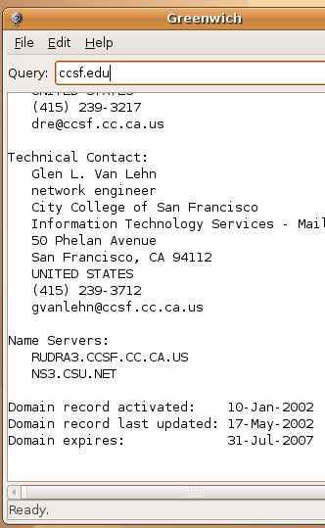
Using the Greenwich Whois Client
- From the menu bar, click Accessories, Internet, Greenwich Whois Client.
- In the Query box, enter ccsf.edu. Press the Enter key:
- Scroll down until you see the same information you saw before, showing RUCDA3.CCSF.CC.CA.US, as shown to the right on this page.
Saving the Screen Image
- Click outside the virtual machine window to make the host Windows XP operating system receive your keystrokes. Then press the PrtScn button to capture the screen image.
- On the host Windows XP desktop, click Start, Run. Enter the command mspaint and press the Enter key. Paint opens.
- Press Ctrl+V on the keyboard to paste the image into the Paint window. Click File, Save. Save the document with the filename Your Name Proj 5a. Select a Save as type of JPEG.
What Use is This?
- Greenwich may seem pointless to you—if it does, that is a good sign. As Linux users get more accustomed to the command line, they develop more and more contempt for graphical tools. Eventually, they use Linux without a GUI at all, completely from the command line, so it runs fast even on small machines like cheap laptops. They may also develop great contempt for Windows and Windows users, and an irritating sense of superiority. I recommend abstaining from that tradition—it is not as fashionable as it used to be.
Turning in your Project
- Email the JPEG image to me as an attachment. Send it to cnit.123@gmail.com with a subject line of Proj 5 From Your Name. Send a Cc to yourself.
Last modified 6-2-07

