Start Your Ubuntu 8.04 Virtual Machine
Warning! Unexpected port scans are rude, and possibly even illegal! Port scans can set off intrusion detection systems and get us all into trouble. Don’t scan other people’s servers, just scan machines you have permission to scan. The only machines you should scan in this project are machines in S214, or on your own network at home.
- Open VMware Player or VMware Workstation. Launch your Ubuntu 8.04 virtual machine.
- When your machine starts up, log in as with the name and password you chose in the previous project.

Ensuring that You Have an Internet Connection
- From the menu bar in the upper left corner of the Ubuntu desktop, click Applications, Accessories, Terminal.
- In the Terminal window, after the $ prompt, enter this command, then press the Enter key:
ping ubuntu.com
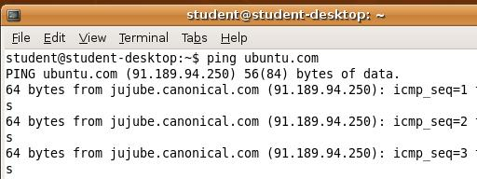
- You should see lines starting "64 bytes from…", as shown to the right on this page. Press Ctrl+C to stop the pinging.
- If you don't see any replies, your virtual machine is not connected to the Internet. You need to be connected to the Internet to proceed with this project. Try troubleshooting it with the instructions titled "Fixing Problems with Ubuntu on VMware", which is in the printed lecture notes and homework, and available on my Web page samsclass.info on the CNIT 123 Page in the Projects section.

Installing nmap, zenmap, and wireshark
- If you don't have a Terminal window open, open one by clicking Applications, Accessories, Terminal.
- In the Terminal window, after the $ prompt, enter this command, then press the Enter key:
sudo apt-get update
Enter your password when you are prompted to. This command updates your software repository lists, so your system can find all the software packages that are available.
- In the Terminal window, after the $ prompt, enter this command, then press the Enter key:
sudo apt-get –y install nmap zenmap wireshark
Wait while software downloads and installs.

- This installs the three programs we need
  - nmap: the most famous port scanning software in the world
  - zenmap: the graphical front end to the nmap port scanner
  - wireshark: the excellent graphical packet sniffer

Port Scanning Your Own Ubuntu Machine With zenmap
- If you don't have a Terminal window open, open one by clicking Applications, Accessories, Terminal.
- In the Terminal window, after the $ prompt, enter this command, then press the Enter key:
sudo zenmap
Enter your password if you are prompted to.
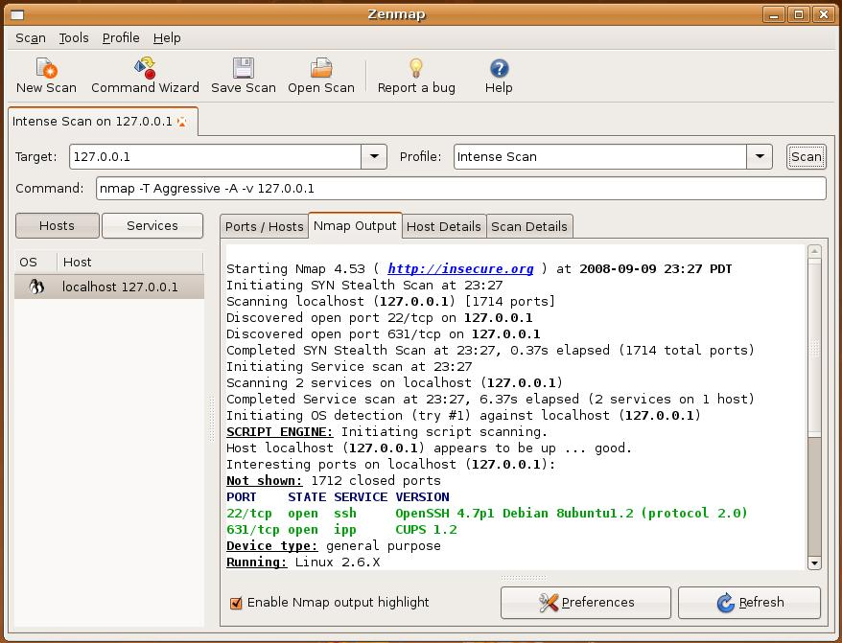
- In the Zenmap window, enter a Target: 127.0.0.1. Accept the default Profile: of Intense Scan, as shown below on this page. Click the Scan button.

- In the lower portion of the results pane, you should see a chart showing the open ports. Your Ubuntu machine should have port 631/tcp open, and it may have other ports open too, such as 22/tcp as shown in the figure on the previous page. These open ports show listening processes on the Ubuntu machine. Port 631 is used for printer sharing, and it's open by default on a freshly installed Ubuntu machine.

Finding the IP Address of Your Host Machine
- In the Windows XP host machine (not the Ubuntu virtual machine), click Start, Run. In the Run box, enter cmd and press the Enter key. In the Command Prompt window, enter the IPCONFIG command and press the Enter key. Several IP addresses appear. Find the one that starts with 192.168.1 and write it in the box to the right on this page.

Host IP: ____________________

Port Scanning Your Own Host Machine
- In the Zenmap window, enter the IP address of your host machine. Click the Scan button.

- If your host machine has the normal firewall settings, you will get results as shown below on this page, showing ports 135, 139, and 445 open. If you show no ports open at all, your host machine may have its firewall set to block all unsolicited incoming traffic. Nmap tries to guess the operating system from the responses—but it isn’t very accurate. It identified my Win XP Service Pack 3 machine as either Win XP SP2 or Win 2003 Server.
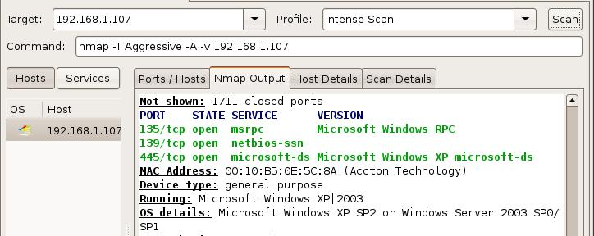

Starting your Windows XP Virtual Machine
- Open another instance of VMware Player or VMware Workstation. Launch your Windows XP virtual machine. Log in with your usual account, which is probably Student with no password.

Finding the IP Address of Your Windows XP Virtual Machine
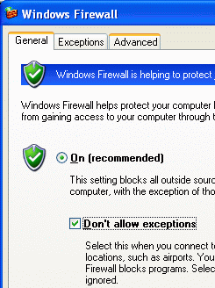
- In your Windows XP virtual machine, click Start, Run. In the Run box, enter cmd and press the Enter key. In the Command Prompt window, enter the IPCONFIG command and press the Enter key. Several IP addresses appear. Find the one that starts with 192.168.1 and write it in the box to the right on this page.

Win XP VM IP: ____________________

Setting Your Windows XP Virtual Machine's Firewall to No Exceptions
- In your trusted Windows XP virtual machine, click Start, Control Panel. If you see a heading of Pick a category in the right pane, click the Switch to Classic View link in the left pane.
- Double-click Windows Firewall. In the Windows Firewall box, on the General tab, click the "On (recommended)" radio button. Check the "Don’t allow exceptions" box, as shown to the right on this page. Click the OK button.

Port Scanning Your Windows XP Virtual Machine With the Firewall On – No Exceptions
- In the Zenmap window, enter the IP address of your Windows XP virtual machine. Click the Scan button.
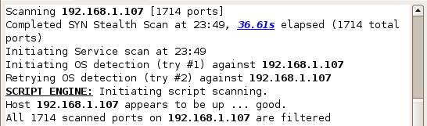
- You should get results as shown below on this page, saying "All 1714 scanned ports … are filtered". That’s what the firewall does—blocks all responses to unexpected SYN packets, on all ports.

Saving a Screen Image
- Click outside the virtual machine to make the host machine’s desktop active.
- Press the PrintScrn key to copy the whole desktop to the clipboard.
- In the host machine, click Start, Programs, Accessories, Paint. In the untitled - Paint window, select Edit, Paste from the menu bar. The desktop appears in the Paint window, with only a corner of it visible.
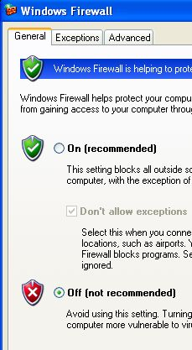
- In the untitled - Paint window, click File, Save. Save the document in the My Pictures folder (or any other place you wish, such as a floppy disk) with the filename Your Name Proj 5a. Select a Save as type of JPEG.

Setting Your Windows XP Virtual Machine's Firewall to Off
- In your Windows XP virtual machine, click Start, Control Panel. If you see a heading of Pick a category in the right pane, click the Switch to Classic View link in the left pane.
- Double-click Windows Firewall. In the Windows Firewall box, on the General tab, check the Off (not recommended) box, as shown to the right on this page. Click the OK button.

Port Scanning Your Windows XP Virtual Machine With the Firewall Off
- In the Zenmap window, verify that the IP address of your Windows XP virtual machine is still in the Target: box. Click the Scan button.
- You should get results as shown below on this page, showing a few open ports: 135, 139, and 445. With the firewall off, several ports respond to the SYN packets.
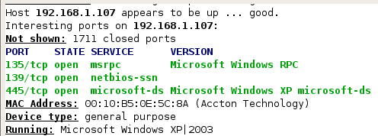

Saving a Screen Image
- Click outside the virtual machine to make the host machine’s desktop active.
- Press the PrintScrn key to copy the whole desktop to the clipboard.
- In the host machine, click Start, Programs, Accessories, Paint. In the untitled - Paint window, select Edit, Paste from the menu bar. The desktop appears in the Paint window, with only a corner of it visible.
- In the untitled - Paint window, click File, Save. Save the document in the My Pictures folder (or any other place you wish, such as a floppy disk) with the filename Your Name Proj 5b. Select a Save as type of JPEG.

Turning in Your Project
- Email the JPEG images to me as attachments to a single email message. Send it to: cnit.123@gmail.com with a subject line of Proj 5 From Your Name, replacing Your Name with your own first and last name. Send a Cc to yourself.

Last Modified: 12-28-08

