What You Will Need
- An Ubuntu 8.04 virtual machine
- A Windows machine with the firewall off to scan. The instructions assume you are using a Windows XP virtual machine.

Starting your Windows XP Virtual Machine
- Open VMware Player or VMware Workstation. Launch your Windows XP virtual machine. Log in with your usual account, which is probably Student with no password.

Finding the IP Address of Your Windows XP Virtual Machine
- In your Windows XP virtual machine, click Start, Run. In the Run box, enter cmd and press the Enter key. In the Command Prompt window, enter the IPCONFIG command and press the Enter key. Several IP addresses appear. Find the one that starts with 192.168.1 and write it in the box to the right on this page.

Win XP VM IP: ____________________

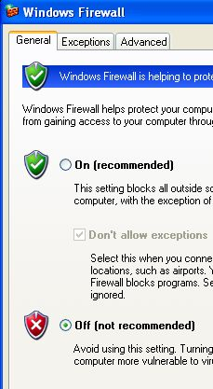
Setting Your Windows XP Virtual Machine's Firewall to Off
- In your Windows XP virtual machine, click Start, Control Panel. If you see a heading of Pick a category in the right pane, click the Switch to Classic View link in the left pane.
- Double-click Windows Firewall. In the Windows Firewall box, on the General tab, check the Off (not recommended) box, as shown to the right on this page. Click the OK button.

Start Your Ubuntu 8.04 Virtual Machine
- Open VMware Player or VMware Workstation. Launch your Ubuntu 8.04 virtual machine.
- When your machine starts up, log in as with the name and password you chose in the previous project.

Pinging the Windows XP Virtual Machine From the Ubuntu Machine
- From the menu bar in the upper left corner of the Ubuntu desktop, click Applications, Accessories, Terminal.
- In the Terminal window, after the $ prompt, enter this command, then press the Enter key:
PING ip-address
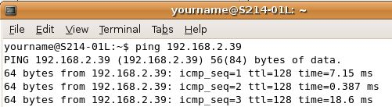
Do not type the literal letters "ip-address" – replace them with the Win XP VM IP address you wrote on the first page of these instructions.
- You should see lines saying 64 bytes from…, as shown above on this page, indicating that you do have a working network connection between the two machines. If you see the message Destination host unreachable, something is wrong. Try opening a Web browser on both machines to make sure they are both connected to the Internet, and check the IP addresses. You need to get the two machines connected properly before you can proceed with this project.
- When the ping is working properly, type Ctrl+C to stop the pinging.

Starting The Wireshark Network Analyzer
- If you don't have a Terminal window open, open one by clicking Applications, Accessories, Terminal.
- In the Terminal window, after the $ prompt, enter this command, then press the Enter key:
sudo wireshark
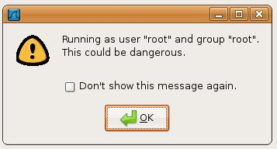
Enter your password when you are prompted to.
- If the screen seems to freeze, try moving the windows arou nd to reveal a box warning you that wireshark is running as root, as shown to the right on this page. Check the "Don't show this message again" box and click the OK button.

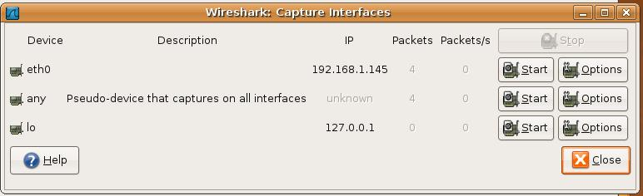
- In the The Wireshark Network Analyzer window, click Capture, Interfaces. A list of interfaces appears, as shown below.

- Find the device that connects to the Internet—usually eth0 or eth1. That device will show some packets detected (3 in the figure above), and an IP address starting with 192.168.1.

Ubuntu IP: ________________________
- Write your IP address in the box to the right on this page.
- In the Wireshark: Capture Interfaces box, in the eth0 or eth1 line that is capturing packets, click the Options button.
- In the Wireshark: Capture Options box, click the Capture Filter button.
- In the Wireshark: Capture Filter box, click the IP address 192.168.0.1 button. Click OK.
- In the Wireshark: Capture Options box, in the Capture Filter box, edit the IP address to match the Ubuntu IP address you wrote in the box on the previous page. This will limit your capture to packets sent to or from your Ubuntu machine.
- Click the Start button.
- If you see a message saying Save capture file before starting a new capture?, click Continue without saving.

Starting zenmap
- From the menu bar in the upper left corner of the Ubuntu desktop, click Applications, Accessories, Terminal.
- In the Terminal window, after the $ prompt, enter this command, then press the Enter key:
sudo zenmap
Enter your password if you are prompted to.

Performing a Ping Sweep of the 192.168.1.0/24 Network
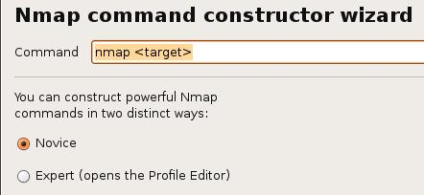
- In the upper left of the zenmap window, click the "Command Wizard" button.
- In the "Nmap command constructor wizard" box, accept the default selection of Novice, as shown to the right on this page. Click the Forward button.

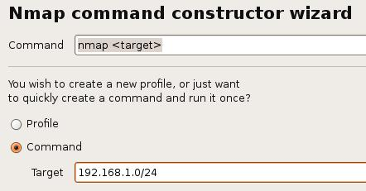
- In the next box, click Command and enter a Target of 192.168.1.0/24. (If you are working at home, you might be on a different subnet, so change these numbers as necessary to scan your own home subnet.) Then click the Forward button.

- In the next box, make these selections, as shown below on this page:
- TCP scan: None
- Special scans: Ping scanning
- Timing: Aggressive
- Services version detection: Unchecked
- Operating system detection: Unchecked
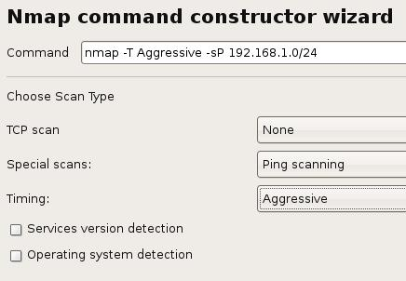

- Click the Forward button.
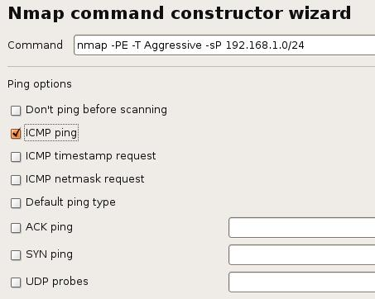
- In the next box, click the "ICMP ping" box, as shown to the right on this page. Then click the Forward button.
- In the next box, leave all the Target options unchecked and click the Forward button.
- In the next box, leave all the Source options unchecked and click the Forward button.
- In the next box, leave all the Other options unchecked and click the Forward button.
- In the next box, click the Apply button.
- The scan starts automatically. It will now ping every IP address in your subnet. This specifies the range 192.168.1.0 through 192.168.1.255 – we will scan through the whole LAN (every real or virtual machine in S214).
- When the sweep completes, you should see a list of the hosts that were found, as shown below. The IP addresses and the total number of hosts may be different, but you should detect at least two hosts—your Ubuntu and Windows XP machines.
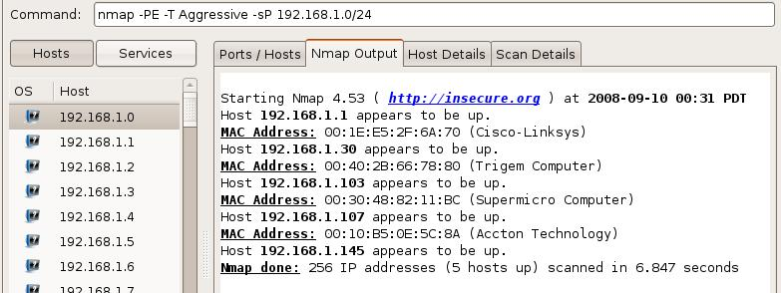

Saving the Screen Image
- Make sure you can see the message shown above on the screen, showing at least two hosts that appear to be up.
- Press Ctrl+Alt to release the mouse, and click on the host Windows XP desktop. Press the PrntScn key to copy whole screen to the clipboard.
- On the host Windows XP desktop, open Paint and paste in the image. Save it as a JPEG, with the filename Your Name Proj 6a.

Using Wireshark to Analyze the Ping Sweep
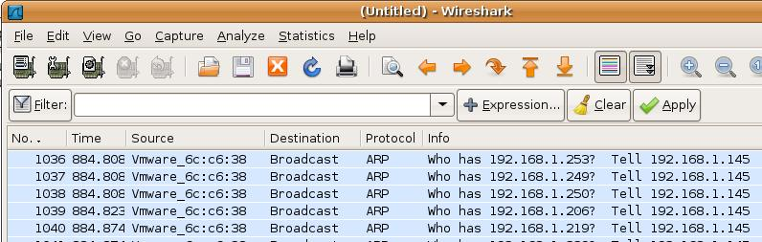
- In the Wireshark: Capture Window, click Capture, Stop. You should see a lot of ARP requests, as shown below on this page. Because you are scanning your own LAN, Nmap uses ARP broadcasts rather than ICMP packets to find hosts.

Performing a Connect Scan of the Windows XP Virtual Machine
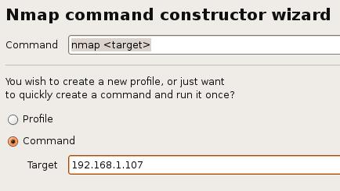
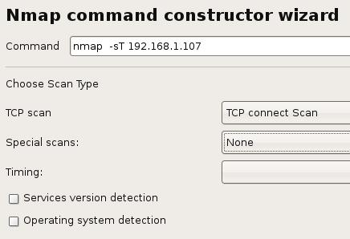
- In the upper left of the zenmap window, click the "Command Wizard" button.
- In the "Nmap command constructor wizard" box, accept the default selection of Novice, and click the Forward button.
- In the next box, click Command and enter the IP address of your Windows XP Virtual Machine into the Target box, as shown to the right on this page. Then click the Forward button.
- In the next box, make these selections, as shown to the right on this page:
- TCP scan: TCP connect scan
- Special scans: None
- Timing: Aggressive
- Services version detection:
Unchecked
- Operating system detection:
Unchecked
- Click the Forward button.

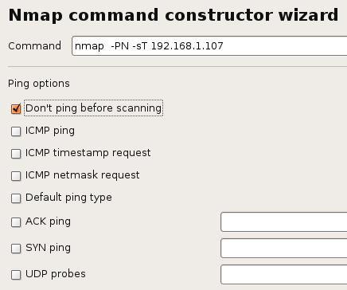
- In the next box, click the "Don't ping before scanning" box, as shown to the right on this page. Then click the Forward button.
- In the next box, leave all the Target options unchecked and click the Forward button.
- In the next box, leave all the Source options unchecked and click the Forward button.
- In the next box, leave all the Other options unchecked and click the Forward button.
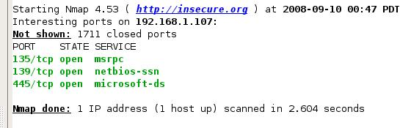
- In the next box, click the Apply button.
- The scan starts automatically. When the scan completes, you should see a list of open ports including 135/tcp open as shown to the right on this page.

Starting a New Wireshark Capture
- In the The Wireshark Network Analyzer window, click Capture, Start. .
- If you see a message saying Save capture file before starting a new capture?, click Continue without saving.

Performing a Connect Scan of Port 135 only
- In the upper left of the zenmap window, click the "Command Wizard" button.
- In the "Nmap command constructor wizard" box, accept the default selection of Novice, and click the Forward button.
- In the next box, click Command and enter the IP address of your Windows XP Virtual Machine into the Target box, as shown to the right on this page. Then click the Forward button.

- In the next box, make these selections, as shown below on this page:
- TCP scan: TCP connect scan
- Special scans: None
- Timing: Aggressive
- Services version detection:
Unchecked
- Operating system detection:
Unchecked
- Click the Forward button.
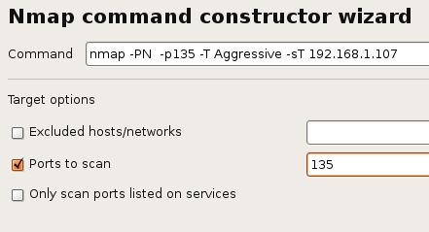
- In the next box, click the "Don't ping before scanning" box. Then click the Forward button.
- In the next box, click the "Ports to scan" box. Enter 135 into the box on that same line, as shown to the right on this page. Then click the Forward button.
- In the next box, leave all the Source options unchecked and click the Forward button.
- In the next box, leave all the Other options unchecked and click the Forward button.
- In the next box, click the Apply button.
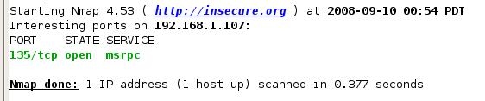
- The scan starts automatically. When the scan completes, you should see one port open: 135/tcp open as shown to the right on this page.

Using Wireshark to Analyze the Connect Scan
- In the Wireshark Window, click Capture, Stop.
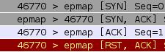
- You should see this pattern of four packets, as shown to the right on this page:
- [SYN]
- [SYN, ACK]
- [ACK]
- [RST, ACK]
This is a complete TCP three-way handshake, followed by a RST to end the session.

Saving the Screen Image
- Make sure the four packets are all visible: [SYN], [SYN, ACK], [ACK], [RST, ACK].
- Press Ctrl+Alt to release the mouse, and click on the host Windows XP desktop. Press the PrntScn key to copy whole screen to the clipboard.
- On the host Windows XP desktop, open Paint and paste in the image. Save it as a JPEG, with the filename Your Name Proj 6b.

Performing a SYN Scan of the Windows XP Virtual Machine
- In the upper left of the zenmap window, click the "Command Wizard" button.
- In the "Nmap command constructor wizard" box, accept the default selection of Novice, and click the Forward button.
- In the next box, click Command and enter the IP address of your Windows XP Virtual Machine into the Target box. Then click the Forward button.
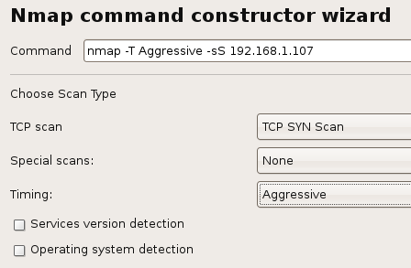
- In the next box, make these selections, as shown to the right on this page:
- TCP scan: TCP SYN scan
- Special scans: None
- Timing: Aggressive
- Services version detection:
Unchecked
- Operating system detection:
Unchecked
- Click the Forward button.
- In the next box, click the "Don't ping before scanning" box and click the Forward button.
- In the next box, leave all the Target options unchecked and click the Forward button.
- In the next box, leave all the Source options unchecked and click the Forward button.
- In the next box, leave all the Other options unchecked and click the Forward button.
- In the next box, click the Apply button.
- When the scan completes, you should see the same list of open ports you saw in the Connect scan, including 135/tcp open as shown below on this page. The SYN scan is stealthier, but it still works.
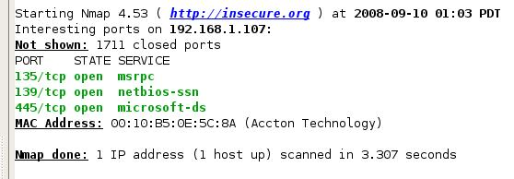

Performing a NULL Scan of the Windows XP Virtual Machine
- In the upper left of the zenmap window, click the "Command Wizard" button.
- In the "Nmap command constructor wizard" box, accept the default selection of Novice, and click the Forward button.
- In the next box, click Command and enter the IP address of your Windows XP Virtual Machine into the Target box. Then click the Forward button.
- In the next box, make these selections:
- TCP scan: Null scan
- Special scans: None
- Timing: Aggressive
- Services version detection: Unchecked
- Operating system detection: Unchecked
- Click the Forward button.
- In the next box, click the "Don't ping before scanning" box and click the Forward button.
- In the next box, leave all the Target options unchecked and click the Forward button.
- In the next box, leave all the Source options unchecked and click the Forward button.
- In the next box, leave all the Other options unchecked and click the Forward button.
- In the next box, click the Apply button.
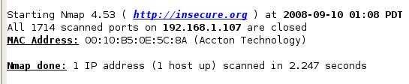
- When the scan completes, you should see All 1714 scanned ports … are closed, as shown to the right on this page. The NULL scan is stealthy, but it fails on Windows machines.

Performing a SYN Scan of the Ubuntu Machine
- In the upper left of the zenmap window, click the "Command Wizard" button.
- In the "Nmap command constructor wizard" box, accept the default selection of Novice, and click the Forward button.
- In the next box, click Command and enter an IP address of 127.0.0.1 into the Target box. Then click the Forward button.
- In the next box, make these selections:
- TCP scan: TCP SYN scan
- Special scans: None
- Timing: Aggressive
- Services version detection: Unchecked
- Operating system detection: Unchecked
- Click the Forward button.
- In the next box, click the "Don't ping before scanning" box and click the Forward button.
- In the next box, leave all the Target options unchecked and click the Forward button.
- In the next box, leave all the Source options unchecked and click the Forward button.
- In the next box, leave all the Other options unchecked and click the Forward button.
- In the next box, click the Apply button.
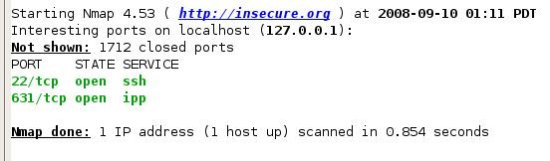
- When the scan completes, you should see port 631/tcp open, as shown to the right on this page. SYN scans work fine on Linux machines.

Performing a NULL Scan of the Ubuntu Machine
- In the upper left of the zenmap window, click the "Command Wizard" button.
- In the "Nmap command constructor wizard" box, accept the default selection of Novice, and click the Forward button.
- In the next box, click Command and enter an IP address of 127.0.0.1 into the Target box. Then click the Forward button.
- In the next box, make these selections:
- TCP scan: Null scan
- Special scans: None
- Timing: Aggressive
- Services version detection: Unchecked
- Operating system detection: Unchecked
- Click the Forward button.
- In the next box, click the "Don't ping before scanning" box and click the Forward button.
- In the next box, leave all the Target options unchecked and click the Forward button.
- In the next box, leave all the Source options unchecked and click the Forward button.
- In the next box, leave all the Other options unchecked and click the Forward button.
- In the next box, click the Apply button.
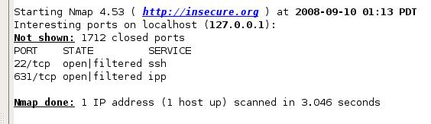
- When the scan completes, you should see the same port(s) open, as shown to the right on this page—the NULL scan works on a Linux machine.

Starting a New Wireshark Capture of the lo Device
- In the The Wireshark Network Analyzer window, click Capture, Interfaces.
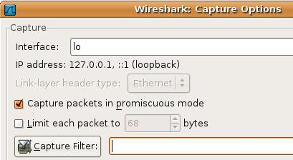
- In the Wireshark: Capture Interfaces box, in the lo line, click the Options button. Be careful – use the lo line, NOT the eth0 line. We want to capture "localhost" traffic.
- In the "Wireshark: Capture Options" box, delete all the text in the "Capture filter:" box, as shown to the right on this page. Then click the Start button.
- If you see a message saying "Save capture file before starting a new capture?", click Continue without saving.

Performing a NULL Scan of Ports 631-632 on the Ubuntu Linux Machine
- In the upper left of the zenmap window, click the "Command Wizard" button.
- In the "Nmap command constructor wizard" box, accept the default selection of Novice, and click the Forward button.
- In the next box, click Command and enter an IP address of 127.0.0.1 into the Target box. Then click the Forward button.
- In the next box, make these selections:
- TCP scan: Null scan
- Special scans: None
- Timing: Aggressive
- Services version detection: Unchecked
- Operating system detection: Unchecked
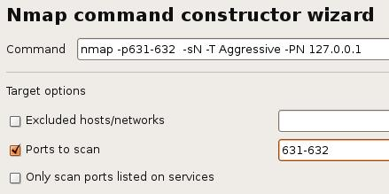
- Click the Forward button.
- In the next box, click the "Don't ping before scanning" box and click the Forward button.
- In the next box, click the "Ports to scan" box. Enter 631-632 into the box on that same line, as shown to the right on this page. Then click the Forward button.
- In the next box, leave all the Source options unchecked and click the Forward button.
- In the next box, leave all the Other options unchecked and click the Forward button.
- In the next box, click the Apply button.
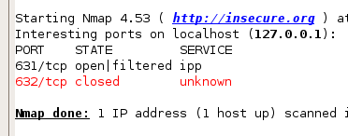
- When the scan completes, you should see port 631/tcp open|filtered, and port 632/tcp closed, as shown to the right on this page. The NULL scan can tell a closed from an open port on a Linux machine.

Using Wireshark to Analyze the NULL Scan
- In the Wireshark Window, click Capture, Stop.
- You should see a packet sent to > ipp [ ] which is port 631, as shown below on this page. The empty brackets [ ] indicate that none of the status bits were set—this is a NULL packet. The NULL packet sent to > ipp (port 631) caused no reply, but the Null packet sent to > bmpp (port 632) was answered with a [RST, ACK] packet, indicating that port 632 is closed.
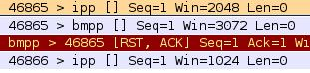

Saving the Screen Image
- Make sure you can see the three packets:
> ipp [ ]
> bmpp [ ]
[RST, ACK]
- Press Ctrl+Alt to release the mouse, and click on the host Windows XP desktop. Press the PrntScn key to copy whole screen to the clipboard.
- On the host Windows XP desktop, open Paint and paste in the image. Save it as a JPEG, with the filename Your Name Proj 6c.
Turning in your Project
- Email the JPEG images to me as an attachment. Send the message to cnit.123@gmail.com with a subject line of Proj 6 From Your Name. Send a Cc to yourself.

Last modified 12-28-08

