Starting Your Windows 2000 Virtual Machine
- Double-click the VMware Workstation icon on the desktop. In the VMware Workstation window, from the menu bar, click View, Go to Home Tab.
- On the Home tab, click the Open Existing VM or Team icon. Navigate to the V: drive, open your folder, open the Win 2000 Pro SP2 folder, and double-click the Windows 2000 Professional.vmx file. On the left side, click the Start this virtual machine link.
- If you see a message saying “The location of this virtual machine’s configuration file has changed…,” accept the default selection of Create and click OK.
- When your machine starts up, log in as Administrator with no password.
- The IP addresses for all the network adapters should appear on the desktop of the Windows 2000 machine. Find your IP address and write it in the box to the right on this page. In S214, your IP address should start with 192.168.1.

Win 2000 IP: ________________________

Start Your Ubuntu Virtual Machine
- Double-click the VMware Workstation icon on the desktop. In the VMware Workstation window, from the menu bar, click View, Go to Home Tab.
- On the Home tab, click the Open Existing VM or Team icon. Navigate to the V: drive, open your folder, open the Your Name Ubuntu folder, and double-click the Your Name Ubuntu.vmx file. On the left side, click the Start this virtual machine link.
- If you see a message saying “The location of this virtual machine’s configuration file has changed…,” accept the default selection of Create and click OK.
- When your machine starts up, log in as with the name and password you chose in the previous project.

Installing The Wireshark Network Analyzer
- From the Ubuntu Linux menu bar, click Applications, Add/Remove.
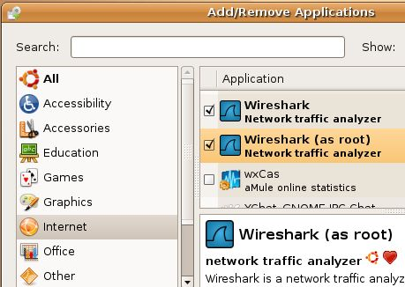
- In the Add/Remove Applications window, in the upper right corner, make sure that the Show: is set to "All available applications".
- in the left pane, click Internet. In the upper right pane, scroll down and click "Wireshark (as root)".
- In the "Install Wireshark (as root) and bundled applications?" box, click "Install All". The "Add/Remove Applications" window now shows both Wireshark items checked, as shown to the right on this page. Click OK.

- In the Apply the following changes? box, click Apply. Enter your password when prompted to. Wait while software downloads and installs. When a Changes applied box appears, click Close.

Pinging the Windows 2000 Machine From the Ubuntu Machine
- From the menu bar in the upper left corner of the Ubuntu desktop, click Applications, Accessories, Terminal.
- In the Terminal window, after the $ prompt, enter this command, then press the Enter key:
PING ip-address
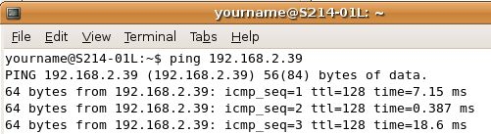
Do not type the literal letters "ip-adsress" – replace them with the Win 2000 IP address you wrote on the first page of these instructions.

Ubuntu IP: ________________________
- You should see lines saying 64 bytes from…, as shown above on this page, indicating that you do have a working network connection between the two machines. If you see the message Destination host unreachable, something is wrong. Try opening a Web browser on both machines to make sure they are both connected to the Internet, and check the IP addresses. You need to get the two machines connected properly before you can proceed with this project.
- When the PING is working properly, close the window showing the PINGs by clicking on the X in the upper right corner.

Starting The Wireshark Network Analyzer
- From the Ubuntu Linux menu bar, click Applications, Internet, Wireshark (as root).
- In the The Wireshark Network Analyzer window, click Capture, Interfaces. A list of interfaces appears, as shown below.
- Find your IP address and write it in the box to the right on this page. In S214, your IP address should start with 192.168.1, not 192.168.2 as shown in the figure below.
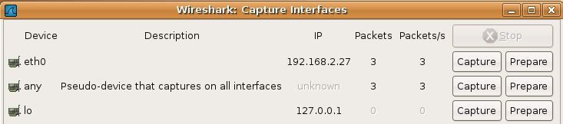

- In the Wireshark: Capture Interfaces box, in the eth0 line, click the Prepare button.
- In the Wireshark: Capture Options box, click the Capture Filter button.
- In the Wireshark: Capture Filter box, click the IP address 192.168.0.1 button. Click OK.
- In the Wireshark: Capture Options box, in the Capture Filter box, edit the IP address to match the Ubuntu IP address you wrote in the box on the previous page. Click the Start button.
- If you see a message saying Save capture file before starting a new capture?, click Continue without saving.

Starting NmapFE as root
- From the menu bar in the upper left corner of the Ubuntu desktop, click Applications, Accessories, Terminal.
- In the Terminal window, after the $ prompt, enter this command, then press the Enter key:
sudo nmapfe
This command starts the Nmap Front End. The sudo at the start elevates your privileges to root (administrative) temporarily.
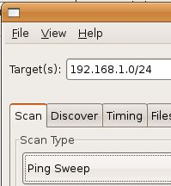
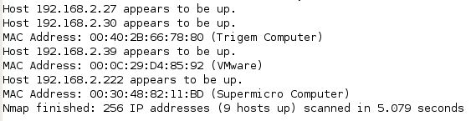
- At the Password: prompt, enter your password and press the Enter key:
Your password is required to elevate your privileges.

Performing a Ping Sweep of the 192.168.1.0/24 Network
- In the Nmap Front End window, in the Target(s): box, enter 192.168.1.0/24 as shown to the right on this page. This specifies the range 192.168.1.0 through 192.168.1.255 – we will scan through the whole LAN (every real or virtual machine in S214). In the Scan Type list, select Ping Sweep. Click the Scan button.
- When the sweep completes, you should see a list of hosts as shown below. The IP addresses and the total number of hosts will be different.

Saving the Screen Image
- Make sure you can see the message shown above on the screen, listing the hosts that appear to be up.
- Press Ctrl+Alt to release the mouse, and click on the host Windows XP desktop. Press the PrntScn key to copy whole screen to the clipboard.

- On the host Windows XP desktop, open Paint and paste in the image. Save it as a JPEG, with the filename Your Name Proj 7a.

Using Wireshark to Analyze the Ping Sweep
- In the Wireshark: Capture Window, click Stop. You should see a lot of ARP requests lines, as shown below on this page. Because you are scanning your own LAN, Nmap uses ARP broadcasts rather than ICMP packets to find hosts.
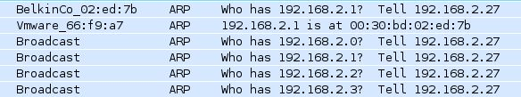

Performing a Connect Scan of the Windows 2000 Machine
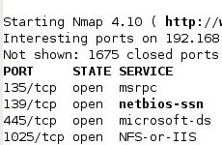
- In the Nmap Front End window, in the Target(s): box, enter the IP address of your Windows 2000 machine—the number you wrote in the box on the first page of these instructions. In the Scan Type list, select Connect Scan. Click the Scan button.
- When the sweep completes, you should see a list of open ports including 135/tcp open as shown to the right on this page.

Starting a New Wireshark Capture
- In the The Wireshark Network Analyzer window, click Capture, Start. .
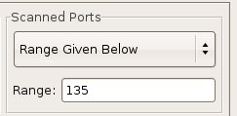
- If you see a message saying Save capture file before starting a new capture?, click Continue without saving.

Performing a Connect Scan of Port 135 only
- In the Nmap Front End window, on the Scan tab, on the right side, find the Scanned Ports section. Select the Range Given Below option and type in 135 for the Range, as shown to the right on this page. This will scan only port 135, which will make it easier to understand packet capture.
- In the Nmap Front End window, cl ick the Scan button.

Using Wireshark to Analyze the Connect Scan
- Click on the Wireshark: Capture Window to make it active. Wait until you see several packets captured – I captured 48 packets, but it took a few seconds to capture them. When you have captured the packets, click Stop.

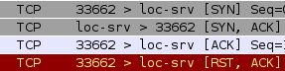
- You should see the pattern of four packets in this order: [SYN], [SYN, ACK], [ACK], [RST, ACK], as shown to the right on this page. This is a complete TCP three-way handshake, followed by a RST to end the session.

Saving the Screen Image
- Make sure the four packets are all visible: [SYN], [SYN, ACK], [ACK], [RST, ACK].
- Press Ctrl+Alt to release the mouse, and click on the host Windows XP desktop. Press the PrntScn key to copy whole screen to the clipboard.
- On the host Windows XP desktop, open Paint and paste in the image. Save it as a JPEG, with the filename Your Name Proj 7b.

Performing a SYN Scan of the Windows 2000 Machine
- In the Nmap Front End window, verify that the Target(s): box contains the IP address of your Windows 2000 machine. In the Scan Type list, select SYN Stealth Scan. In the Scanned Ports section, select Default, as shown below on this page. Click the Scan button.
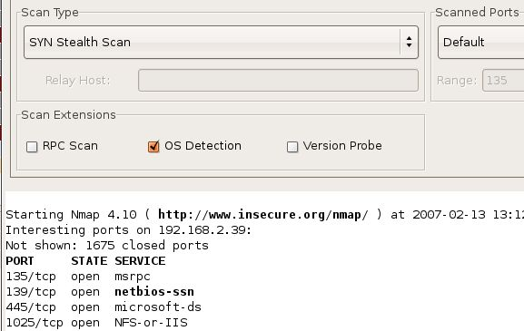
- When the scan completes, you should see the same list of open ports you saw in the Connect scan, including 135/tcp open as shown below on this page. The SYN scan is stealthier, but it still works.

Performing a NULL Scan of the Windows 2000 Machine
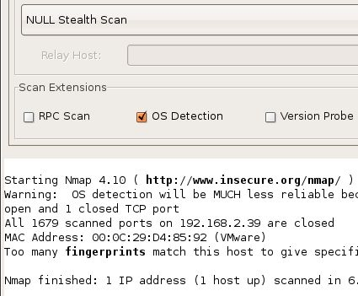
- In the Nmap Front End window, verify that the Target(s): box contains the IP address of your Windows 2000 machine. In the Scan Type list, select NULL Stealth Scan. In the Scanned Ports section, verify that Default is selected. Click the Scan button.
- When the scan completes, you should see All 1679 scanned ports … are closed, as shown to the right on this page. The NULL scan is stealthy, but it fails on Windows machines.

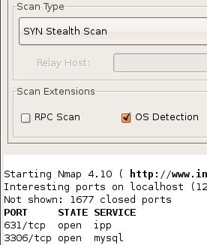
Performing a SYN Scan of the Ubuntu Machine
- In the Nmap Front End window, in the Target(s): box, enter 127.0.0.1, the loopback address, so you can scan your own Ubuntu Linux machine. In the Scan Type list, select SYN Stealth Scan. In the Scanned Ports section, verify that Default is selected. Click the Scan button.
- When the scan completes, you should see port 631/tcp open, as shown to the right on this page—this is for printer sharing. If you installed Ruby on Rails with MySQL on this machine, port 3306 will also be open.

Performing a NULL Scan of the Ubuntu Machine
- In the Nmap Front End window, verify that the Target(s): box contains 127.0.0.1. In the Scan Type list, select NULL Stealth Scan. In the Scanned Ports section, verify that Default is selected. Click the Start button.
- When the scan completes, you should see the same port(s) open—the NULL scan works as well as the SYN scan on a Linux machine.

Starting a New Wireshark Capture of the lo Device
- In the The Wireshark Network Analyzer window, click Capture, Interfaces.
- In the Wireshark: Capture Interfaces box, in the lo line, click the Capture button, as shown below on this page. Be careful – use the lo line, NOT the eth0 line. We want to capture "localhost" traffic.
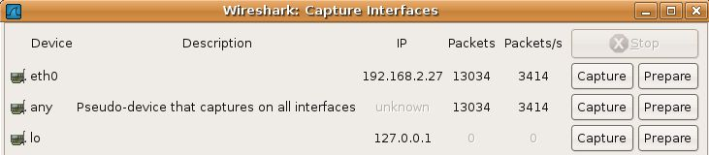
- If you see a message saying "Save capture file before starting a new capture?", click Continue without saving.

Performing a NULL Scan of Ports 631-632 on the Ubuntu Linux Machine
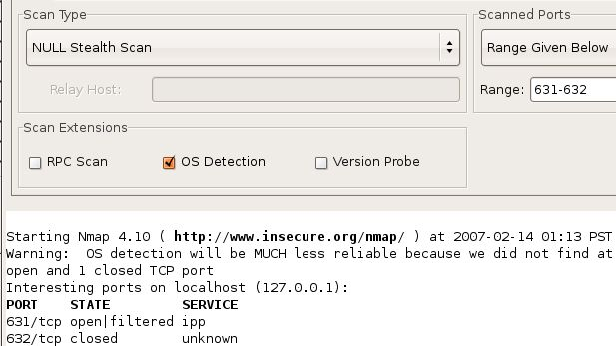
- In the Nmap Front End window, verify that the Target(s): box contains 127.0.0.1. In the Scan Type list, select NULL Stealth Scan. In the Scanned Ports section, select Range Given Below and enter a Range: of 631-632, as shown below on this page. This will make the Wireshark capture small and easier to understand. Click the Scan button.
- When the scan completes, you should see 631/tcp open/filtered and 632/tcp closed, as shown to the right on this page.

Using Wireshark to Analyze the NULL Scan
- In the Wireshark: Capture Window, click Stop.
- You should see a packet sent to > ipp [ ] which is port 631, as shown below on this page. The empty brackets [ ] indicate that none of the status bits were set—this is a NULL packet. The NULL packet sent to port 631 (ipp) caused no reply, but the Null packet sent to port 632 (labelled > 632) was answered with a [RST, ACK] packet, indicating that port 632 is closed.
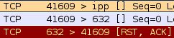

Saving the Screen Image
- Make sure you can see the three packets:
> ipp [ ]
> 632 [ ]
[RST, ACK]
- Press Ctrl+Alt to release the mouse, and click on the host Windows XP desktop. Press the PrntScn key to copy whole screen to the clipboard.
- On the host Windows XP desktop, open Paint and paste in the image. Save it as a JPEG, with the filename Your Name Proj 7c.
Turning in your Project
- Email the JPEG images to me as an attachment. Send the message to cnit.123@gmail.com with a subject line of Proj 7 From Your Name. Send a Cc to yourself.

Last modified 9-16-07

