What You Will Need
Warning! Intruding on Networks is illegal! The only machines you should use in this project are machines in S214, or on your own network at home.
- A Ubuntu machine to perform the Nmap scans
- A Windows machine to enumerate

Starting Your Ubuntu Virtual Machine
- Double-click the VMware Workstation icon on the desktop. In the VMware Workstation window, from the menu bar, click View, Go to Home Tab.
- On the Home tab, click the Open Existing VM or Team icon. Navigate to the V: drive, open your folder, open the Your Name Ubuntu folder, and double-click the Your Name Ubuntu.vmx file. On the left side, click the Start this virtual machine link.
- If you see a message saying “The location of this virtual machine’s configuration file has changed…,” accept the default selection of Create and click OK.
- When your machine starts up, log in as usual.

Installing NBTscan on Ubuntu Linux
- From the menu bar, click Applications, Accessories, Terminal.
- In the terminal window, enter this command, then press the Enter key:
sudo apt-get install nbtscan
This command downloads and installs NBTscan.
- When I did it, I got warnings about "Duplicate sources" with a recommendation to "run apt-get update to fix these problems." Even if you didn't get that message, it should be harmless to run an update. So, in the terminal window, enter this command, then press the Enter key:
sudo apt-get update
This command downloads and installs the latest Ubuntu updates.

Running a NBTscan of your LAN
- In the terminal window, enter this command, then press the Enter key:
nbtscan 192.168.1.1-254
(That's the range of IP addresses in S214. If your LAN uses a different range of subnet addresses, enter the correct range.)
- You should see a list of all the Windows machines on your LAN, as shown below. (Your machines will have different names and addresses than shown in the figure.) Notice that Linux machines are absent, because they don't use NetBIOS, and NBTscan only detects NetBIOS.
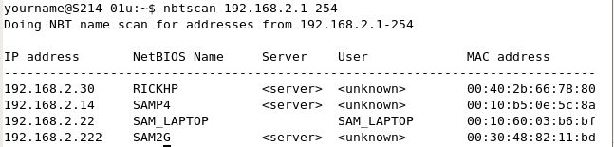

Saving the Screen Image
- Make sure the NBTscan results are visible, as shown in the figure on the previous page.
- Press Ctrl+Alt to release the mouse, and click on the host Windows XP desktop. Press the PrntScn key to copy whole screen to the clipboard.
- On the host Windows XP desktop, open Paint and paste in the image. Save it as a JPEG, with the filename Your Name Proj 9a.

Shutting Down Your Ubuntu Virtual Machine
- Shut down the Ubuntu machine. You won't need it any more for this project.

Starting Your Windows 2000 Pro Virtual Machine
- Start your Windows 2000 Pro virtual machine and log in as Administrator with no password.
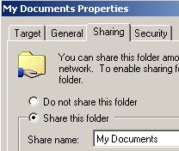
- Find your IP address (using IPCONFIG or any other technique you like) and write it in the box to the right on this page. In S214, your IP address should start with 192.168.1.

Win XP VM IP: ________________________

Sharing a Folder From Your Windows 2000 Pro Virtual Machine
- On the desktop of your Windows 2000 machine, right-click the My Documents folder and select Properties. In the My Documents Properties box, click the Sharing tab. Click Share this folder, as shown to the right on this page. Click OK.
- This makes your Windows 2000 machine a File Server. Remember, it's a "server" because of the job it is performing, even though it is not running an operating system with the word "server" in it.

Using NET VIEW to Open a Null Session from the Host System
- In the host Windows XP machine, click Start, Run. Type in CMD and press the Enter key.
- In the Command Prompt window, type in this command and then press the Enter key:
NET VIEW \\ip-address
replacing ip-address with the IP address you wrote in the box above on this page. This command is intended to show a list of the available shared folders on the virtual Windows XP machine.
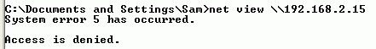
- Instead, you see an Access is denied error, as shown to the right on this page. This is because you are not authenticated at the server with a valid user name and password.

- In the Command Prompt window, type in this command and then press the Enter key:
NET USE \\ip-address\IPC$ "" /u:""
replacing ip-address with the IP address you wrote in the box above on this page. This command sends an empty string for your username and password, creating a Null session.
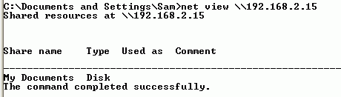
- You should see a message saying The command completed successfully, as shown below on this page.

- In the Command Prompt window, type in this command and then press the Enter key:
NET VIEW \\ip-address
replacing ip-address with the IP address you wrote in the box above on this page.

- The command works, showing the shared folder on your Windows 2000 file server, as shown to the right on this page. It trusts you now that you have given it a user name of "" and proven your identity with a password of "". Does this make any sense at all? This is the kind of thing that makes Linux users laugh at Microsoft.

Observing the Null Session from the Windows 2000 File Server
- On the Windows 2000 file server, click Start, Run. Type in CMD and press the Enter key.
- In the Command Prompt window, enter the net session command and press the Enter key. You should see a session from Windows 2002 Server as shown below – that's how Windows 2000 identifies Windows XP. Notice that the User name is blank—this is a Null session. If you see "There are no entries in the list," go back to the Windows XP host system and repeat the NET VIEW command.
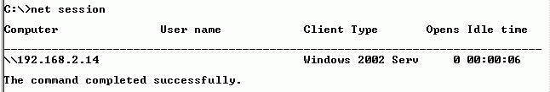

Saving the Screen Image
- Make sure the net session command's results are visible in the Windows 2000 virtual machine, as shown above on this page.
- Press Ctrl+Alt to release the mouse, and click on the host Windows XP desktop. Press the PrntScn key to copy whole screen to the clipboard.
- On the host Windows XP desktop, open Paint and paste in the image. Save it as a JPEG, with the filename Your Name Proj 9b.

Downloading Winfo
- In the host Windows XP machine, open a browser and go to ntsecurity.nu/toolbox/winfo
- In the upper left, click the Download link
- Save the file on your desktop, or any other folder you can find.

Using Winfo to Enumerate the Windows 2000 File Server
- Click Start, Run. Type in CMD and press the Enter key.
- In the Command Prompt window, type in this command and then press the Enter key:
cd desktop
- In the Command Prompt window, type in this command and then press the Enter key:
winfo
You should see the Winfo instructions, as shown below on this page.
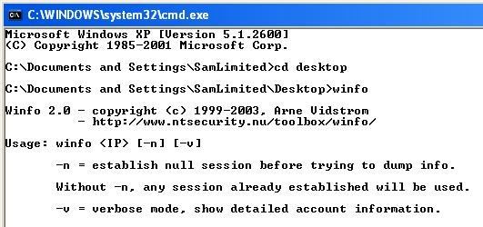

- In the Command Prompt window, type in this command and then press the Enter key:
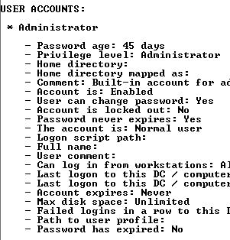
winfo ip-address –n -v
replacing ip-address with the IP address of your Windows 2000 file server, which you wrote in the box on a previous page.
- You should see a lot of information, including information about the Administrator account, as shown to the right on this page. the Winfo instructions, as shown to the right on this page.

Saving the Screen Image
- Make sure the Administrator account information is visible, as shownabove on this page.
- Press the PrntScn key to copy whole screen to the clipboard.
- On the host Windows XP desktop, open Paint and paste in the image. Save it as a JPEG, with the filename Your Name Proj 9c.

Disabling NetBIOS Null Sessions on the Windows 2000 File Server
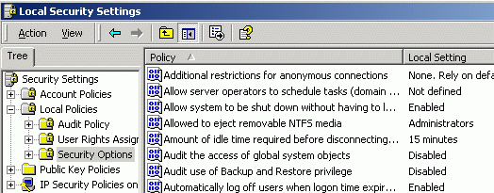
- In the Windows 2000 virtual machine, click Start, Settings, Control Panel.
- Double-click Administrative Tools. Double-click Local Security Policy.
- In the Local Security Settings window, in the left pane, expand Local Policies and click Security Options, as shown to the right on this page.
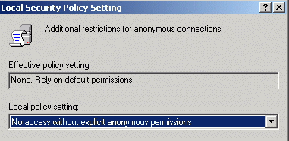
- Double-click the top item in the right page: "Additional restrictions of anonymous connections".
- From the pull down menu labeled "Local policy setting," select: "No access without explicit anonymous permissions," as shown to the right on this page.
- Click OK.
- Restart the Windows 2000 machine.

Using Winfo Again
- On the Windows XP host machine, click Start, Run. Type in CMD and press the Enter key.
- In the Command Prompt window, type in this command and then press the Enter key:
cd desktop
- In the Command Prompt window, type in this command and then press the Enter key:
winfo ip-address –n -v
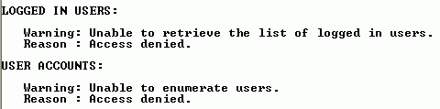
replacing ip-address with the IP address of your Windows 2000 file server, which you wrote in the box on a previous page.
- You should see a lot of Access denied messages, like the ones shown to the right on this page, and no useful information..

Saving the Screen Image
- Make sure the USER ACCOUNTS message saying Access denied is visible, as shown to the right on this page.
- Press the PrntScn key to copy whole screen to the clipboard.
- On the host Windows XP desktop, open Paint and paste in the image. Save it as a JPEG, with the filename Your Name Proj 9d.
Turning in your Project
- Email the JPEG images to me as attachments to a single message. Send the message to cnit.123@gmail.com with a subject line of Proj 9 From Your Name. Send a Cc to yourself.

Credit: I got this from www.brown.edu/Facilities/CIS/CIRT/help/netbiosnull.html (link Ch 6b)
Last modified 6-4-07

