What You Need for This Project

LEGAL WARNING!
Use only machines you own, with passwords you created, or machines with accounts you have permission to hack into. Stealing passwords, or even possession of them without permission from the owners, is a crime! Don’t do it! If you do illegal things, you may be arrested and go to jail, and I will be unable to save you. These instructions are intended to train computer security professionals, not to help criminals.
- A computer running Windows XP (any version). This can be either a real or virtual machine.
- You don’t need administrator privileges—you don’t need any login account at all on the Windows XP machine.
- You need physical access to the Windows XP machine, and the ability to boot from a CD.
- Ophcrack--if you use the most recent version from the Web, you will need 1 GB of RAM on your Windows XP machine, which is not possible in S214. If you are working with less RAM, such as 256MB, you need to get the older version: ophcrack-livecd-1.1.3.iso from the VMs\Install folder in S214.

Start Your Host Machine
- Log in as usual with your CCSF ID and the password you chose in project 1.

Starting your Windows XP Machine
- Double-click the VMware Workstation icon on the desktop. In the VMware Workstation window, from the menu bar, click View, Go to Home Tab.
- On the Home tab, click the Open Existing VM or Team icon. Navigate to the V: drive, open your folder, open the Win XP Pro for Hacking folder, and double-click the Windows XP Professional.vmx file. You should see a Windows XP Professional VM in the Powered Off state.
- In the Windows XP Professional – VMware Workstation window, on the left side, click the Start this virtual machine link.
- When your machine starts up, click the Student account to log in. There is no password, and the Student account has Administrative privileges.

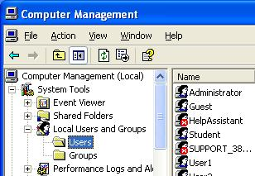
Creating Passwords to Crack
- Click Start, right-click My Computer, and click Manage. In Computer Management, in the left pane, expand the Local Users and Groups container.
- In the left pane of Computer Management, click the Users container. You should see some accounts in the right pane, as shown to the right on this page.

Deleting Unused Accounts
- If you are using the Windows XP image in the S214 lab, there are some extra accounts named User1, User2, User3, etc. Those accounts are not important, and it’s best to get them out of the way to avoid confusion.
- In the right pane of Computer Management, right-click User1 and click Delete. In the Local Users and Groups box, click Yes.
- Repeat the process for all the accounts with names starting with User.
- Be careful! Don’t delete the Student account or you won’t be able to get back into your own virtual machine easily.

Creating Test Passwords
- Fill in the table below with passwords to test. Don’t just use my examples, which are very weak, scramble the letters and numbers to make passwords that are hard to remember and hard to guess. The only exception is Test15a – for that account, use the exact password I have given – fifteen a characters.

Testa6 Six letters like abcdef: _______________________________

Testa12 Twelve letters like abcdefghijkl: _______________________________

Testan6 Six letters and numbers like abc123: _______________________________

Testan12 Twelve letters and numbers like abcdef: _______________________________

Testas6 Six letters with symbols like abc!@#: _______________________________

Testas12 Twelve letters with symbols like abcdef!@#$%^: _______________________________

Test15a Fifteen letter as: aaaaaaaaaaaaaaa

Testx A password you think is reasonably secure: _______________________________

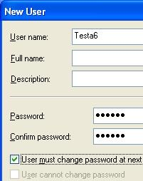
Creating Test Accounts
- In the left pane of Computer Management, right-click Users and click New User.
- In the NewUser box, enter user name of Testa6 and the password you wrote down above, and click Create. The check boxes in the lower section of the New User box don’t matter, because no one will really be using these accounts.
- Repeat the process to create all the accounts in the box above.

Shutting Down Your Machine
- Click Start, Turn Off Computer, Turn Off.

Getting the Ophcrack CD Image
- You need the Ophcrack CD image, or a bootable CD. If you are working in the S214 lab, the image is already there in the V:\Install folder. If you are working at home, you can either copy it from there onto a large storage device, or burn a bootable CD in the lab, or download it yourself from http://ophcrack.sourceforge.net/

Setting the Virtual CD to Use the Ophcrack CD Image
- If you are working at home, use VMmanager to direct the virtual CD to the Ophcrack ISO image. If you are working in S214, do the steps below:
  - Make sure your virtual machine is powered down. You cannot change these settings while it’s on.
  - In the VMware Workstation window, from the menu bar, click View, Go to Home Tab.
  - On the Home tab, click the Open Existing VM or Team icon. Navigate to the V: drive, open your folder, open the Win XP Pro for Hacking folder, and double-click the Windows XP Professional.vmx file. You should see a Windows XP Professional VM in the Powered Off state.
  - From the Menu bar, select VM, Settings.
  - In the Virtual Machine Settings box, click CD-ROM in the left pane. In the right pane, click Use ISO Image. Click the Browse button and navigate to
V:\Install\ophcrack-livecd-1.1.3.iso
  - Click OK to close the Virtual Machine Settings box.
  - Click Start this virtual machine.

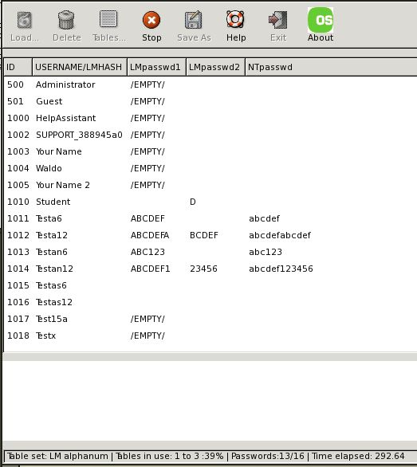
Booting from the Ophcrack CD Image
- The virtual machine should boot from the CD. If it doesn’t, you may have to click in the blank window, press F2, and adjust the boot order in the BIOS.
- Ophcrack loads Slackware Linux and automatically runs the Ophcrack rainbow table cracker. A window should appear, with the user accounts listed, and passwords slowly filling in one-by-one as Ophcrack finds them.
- Wait until the Time elapsed shown in the lower right corner reaches at least 200 seconds. By then, Ophcrack should have found several of your passwords. Then capture this screen image.

Saving a Screen Image
- Click outside the virtual machine to make the host machine’s desktop active.
- Press the PrintScrn key to copy the whole desktop to the clipboard.
- In the host machine, click Start, Programs, Accessories, Paint. In the untitled - Paint window, select Edit, Paste from the menu bar. The desktop appears in the Paint window, with only a corner of it visible.
- In the untitled - Paint window, click File, Save. Save the document in the My Pictures folder (or any other place you wish, such as a floppy disk) with the filename Your Name Proj 12a. Select a Save as type of JPEG.

Learning about LM Hashes
- Windows XP passwords are very insecure! With Ophcrack, anyone could easily crack almost any password of the usual length (8 characters or so). This is because Windows XP uses LM Hashes. To learn about LM Hashes, open a browser and read this brief article:
http://en.wikipedia.org/wiki/LM_hash
- Find the answers to the two questions in the box to the right on this page. You will need to send these answers in with the images at the end of this project.

A: Microsoft replaced LM hashes with NTLM hashes. What operating systems used LM hashes only?

_____________________________________________________

B: Does Windows Vista still use LM Hashes?

_____________________________________________________

Shutting Down Ophcrack and Restarting Windows XP
- Your virtual machine is still running Ophcrack. To stop it, right-click a blank part of the desktop and click Logout.
- When your virtual machine has shut down, do these steps to disconnect the virtual CD from the OPhcrack ISO image file:
- From the Menu bar, select VM, Settings.
- In the Virtual Machine Settings box, click CD-ROM in the left pane. In the right pane, click Use physical drive.
- Click OK to close the Virtual Machine Settings box.
- Click Start this virtual machine. Windows XP should start. Log in as Student.

Setting a Restore Point
- LM hashes are not a bug in Windows XP—they are a deliberate feature. So turning them off is just a matter of adjusting Windows XP with a single Registry key. Before changing the Registry, it is a good practice to create a Restore Point, so you can recover if you make a mistake.
- Click Start, Help and Support. In Help and Support Center window, in the Pick a Task section, click Undo changes to your computer with System Restore. In the next screen, select Create a Restore Point and click Next. In the next screen enter a Restore Point Description of Your Name Restore Point for Project 12 and click Create

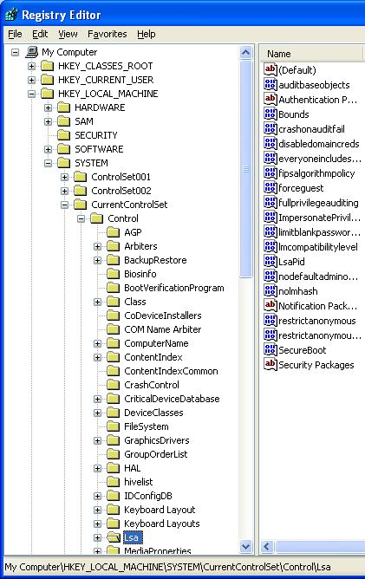
Hardening Windows XP: Removing LM Hashes
- Click Start, Run. Enter REGEDIT and press the Enter key.
- In the left pane of the Registry Editor window, click the + sign to expand the HKEY_LOCAL_MACHINE key. Then expand these keys:
SYSTEM
CurrentControlSet
Control
- Click the Lsa key to select it. Your Registry Editor window should look like the example shown to the right on this page.
- If the nolmhash key is present, right-click it and click Modify. If it's not already there, do this:
  - On the Edit menu, point to New, and then click DWORD Value.
  - A new value appears in the right pane, with its name highlighted. Type in the name NoLMHash, and then press Enter.
  - On the Edit menu, click Modify.

- In the Edit DWORD Value box, enter a Value data: of 1, and then click OK.
- Restart your computer. Log in as Student.

Changing the Password for the Testa6 Account
- Click Start, right-click My Computer, and click Manage. In Computer Management, in the left pane, expand the Local Users and Groups container. Click the Users container to select it.
- Right-click the Testa6 account in the right pane and select Set password.
- In the Set password for Testa6 box, click Proceed.
- In the Set password for Testa6 box, enter a new password of any length in both boxes. Click OK.

Running Ophcrack Again
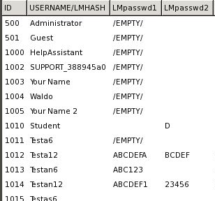
- Repeat the steps you did previously, under the headings “Setting the Virtual CD to Use the Ophcrack CD Image” and “Booting from the Ophcrack CD Image.”
- You should see results as shown to the right on this page–the Testa6 account shows /EMPTY/ because there is no LM Hash and Ophcrack cannot crack its password. Notice that the unchanged passwords are still vulnerable, because the previously created LM Hashes are still present.

Saving a Screen Image
- Click outside the virtual machine to make the host machine’s desktop active.
- Press the PrintScrn key to copy the whole desktop to the clipboard.
- In the host machine, click Start, Programs, Accessories, Paint. In the untitled - Paint window, select Edit, Paste from the menu bar. The desktop appears in the Paint window, with only a corner of it visible.
- In the untitled - Paint window, click File, Save. Save the document in the My Pictures folder (or any other place you wish, such as a floppy disk) with the filename Your Name Proj 12b. Select a Save as type of JPEG.

Turning in Your Project
- Email the JPEG images to me as attachments to a single email message. Answer the questions in the body of the email message. Send it to: cnit.123@gmail.com with a subject line of Proj 12 From Your Name, replacing Your Name with your own first and last name. Send a Cc to yourself.

Last Modified: 1-2-10

