Copying Your Ubuntu Virtual Machine
- DO NOT DO THIS PROJECT ON YOUR ORIGINAL UBUNTU LINUX MACHINE! Rootkits are very dangerous. I killed two machines developing this project. If you do everything correctly, you will clean the rootkit off, but if you do anything wrong, including shutting the machine down with the rootkit installed, your Ubuntu machine will be seriously damaged, to the point that it should just be discarded.
- On the host Windows XP system, click Start, My Computer. Double-click the V: drive to open it, and double-click the YOURNAME_VMs folder to open it. Right-click the Ubuntu folder, hold down the right mouse button, move the mouse to the side about ½ inch, and release the mouse button. Select "Copy Here" from the context menu. Wait until the copy completes—it should take about 3-5 minutes.

Start Your Freshly Copied Ubuntu Virtual Machine
- Start your copied Ubuntu virtual machine and log in as usual.

Downloading the Rootkit
- From the Ubuntu menu bar, click Applications, Internet, Firefox Web Browser. Go to http://samsclass.info/123/proj/fk.tgz
- In the Opening fk.tkz box, click the Save to disk radio button. Click the OK button. The file saves on your desktop.

Extracting the Rootkit
- Close all windows. On the desktop, double-click the fk.tgz file.
- In the fk.tkz window, click the Extract button.
- In the Extract box, click the Extract button. A fk-0.4 folder appears on the desktop.

Installing the Rootkit
- From the Ubuntu menu bar, click Applications, Accessories, Terminal.
- In the terminal window, enter this command, then press the Enter key:
cd Desktop
This changes the working directory to the Desktop, where you extracted the installation files.
fk-0.4.
- In the terminal window, enter this command, then press the Enter key:
cd fk-0.4
This changes the working directory to the fk-0.4 folder.
- In the terminal window, enter this command, then press the Enter key:
ls
You should see several files, including install and README.

- In the terminal window, enter this command, then press the Enter key:
pico README
You should see the features and installation instructions, as shown below on this page. After reading the installation instructions, press Ctrl+X to exit pico.
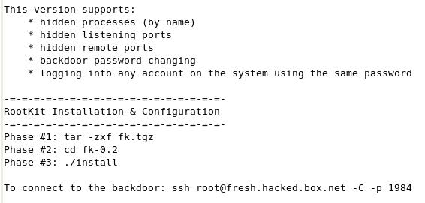

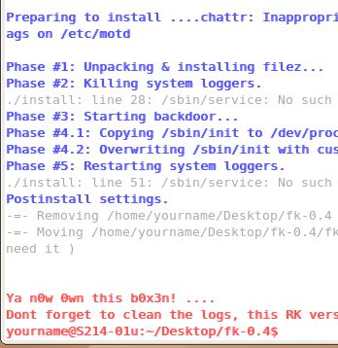
- In the terminal window, enter this command, then press the Enter key:
sudo ./install
If you are prompted for your password, enter it. You should see blue messages as the installation proceeds, followed by red messages saying you now own the box., and warning you to go clean the logs to hide your activities from the administrator, as shown to the right on this page.

Using netstat to View Active Connections
- From the Ubuntu menu bar, click Applications, Internet, Firefox Web Browser. Go to www.ccsf.edu
- In the terminal window, enter this command, then press the Enter key:
netstat --protocol=inet
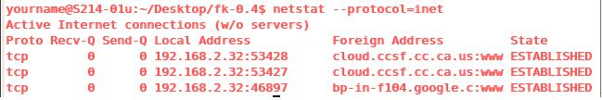
You should see the network connections, as shown below, showing one or more connections to ccsf addresses, with :www added to the end, showing that they are connecting to port 80, the usual World Wide Web port.

- Close Firefox.

Configuring the Rootkit to Hide Connections to Port 80
- In the terminal window, enter this command, then press the Enter key:
cd /dev/proc/fuckit/config
This changes the working directory to the process directory, where the rootkit does its work.
- In the terminal window, enter this command, then press the Enter key:
ls
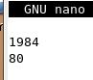
Note these files: lports shows the local ports to hide, progs shows the programs to hide, and rports shows the remote ports to hide.
- In the terminal window, enter this command, then press the Enter key:
sudo pico rports
If you are prompted for your password, enter it. In the pico text editor, add 80 to the end of the file, as shown to the right on this page. Press Ctrl+O and Enter to save the file. Press Ctrl+X to exit pico.

Using netstat to View Active Connections With the Rootkit Hiding Port 80
- From the Ubuntu menu bar, click Applications, Internet, Firefox Web Browser. Go to www.ccsf.edu

- In the terminal window, enter this command, then press the Enter key:
netstat --protocol=inet
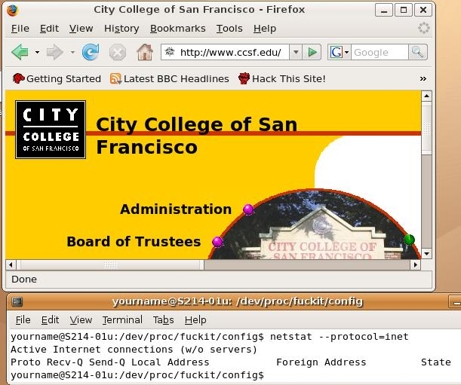
You should see no www connections, even though the browser is clearly visible, as shown to the right on this page. The rootkit is hiding them.

Saving the Screen Image
- Make sure the two windows are both visible, shown the browser and the netstat output.
- Press Ctrl+Alt to release the mouse, and click on the host Windows XP desktop.

- Press the PrntScn key to copy whole screen to the clipboard.
- On the host Windows XP desktop, open Paint and paste in the image. Save it as a JPEG, with the filename Your Name Proj 14a.

Installing the rkhunterRootkit Detector
- In the terminal window, enter this command, then press the Enter key:
sudo apt-get install rkhunter

Running the rkhunterRootkit Detector
- In the terminal window, enter this command, then press the Enter key:
sudo rkhunter -c
If you are prompted for your password, enter it.
- You should see a long list of binaries scroll by, and then the message “[Press <ENTER> to continue]”. Press Enter. rkhunter did not find anything wrong with the binary files on the hard disk.

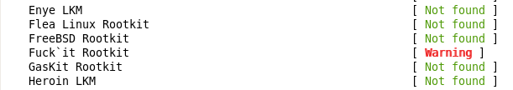
- Now rkhunter looks for known rootkits one-by-one in alphabetical order. When it gets up to F, it should find the rootkit. You will see a Warning message next to the rootkit's name, as shown below on this page.

Saving the Screen Image
- Make sure the message saying Found parts of this rootkit/trojan is visible.
- Press Ctrl+Alt to release the mouse, and click on the host Windows XP desktop.
- Press the PrntScn key to copy whole screen to the clipboard.
- On the host Windows XP desktop, open Paint and paste in the image. Save it as a JPEG, with the filename Your Name Proj 14b.

Completing the rkhunter Scan
- When you see the message “[Press <ENTER> to continue]”, press Enter. rkhunter will do a lot of tests, and find a few more problems, all apparently connected with the rootkit you installed.

Removing the Rootkit
- The rootkit does not crash the Ubuntu machine while it’s running, but it won’t restart, not even in Recovery mode. You can use the infected machine, and you can close VMware, saving the machine’s running state, and restore that state, but you cannot shut it down normally.
Starting the Clean Machine
- Do NOT shut down the infected Ubuntu machine. Just minimize its VMware window.
- Open a new VMware Wodkstation window. Start your clean Ubuntu virtual machine and log in as usual.
Downloading the fix-fu Archive
- In your clean Ubuntu machine, open Firefox and go to samsclass.info
- Click the CNIT 123 link. On the next page, click Projects. Scroll down to "Project 14". Find the fix-fu link next to "Project 14".
- Right-click the fix-fu link. Click Save link as. Click Save to save the file on your desktop.
- Close Firefox.
- On your Ubuntu desktop, double-click the fix-fu.tar.gz file. Click Extract. Click Extract. A folder named fix-fu should appear on your desktop. Close all windows.

Examining the backup-fu Script in the Clean Machine
- In your clean machine, from the Ubuntu menu bar, click Applications, Accessories, Terminal.
- In the terminal window, enter this command, then press the Enter key:
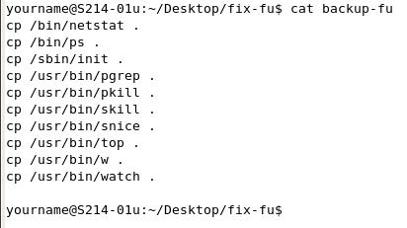
cd Desktop/fix-fu
This changes the working directory to folder containing the scripts.
- In the terminal window, enter this command, then press the Enter key:
cat backup-fu
You should see the script, as shown to the right on this page. All it does is copy ten files into the fix-fu folder.

Saving the Screen Image
- Make sure the Terminal window is visible, showing the ten cp commands.
- Press Ctrl+Alt to release the mouse, and click on the host Windows XP desktop.
- Press the PrntScn key to copy whole screen to the clipboard.
- On the host Windows XP desktop, open Paint and paste in the image. Save it as a JPEG, with the filename Your Name Proj 14c.

Running the backup-fu Script in the Clean Machine
- In the terminal window, enter this command, then press the Enter key:
sudo ./backup-fu
Enter your password when you are prompted to. This executes the script, copying the files.
- In the terminal window, enter this command, then press the Enter key:
ls
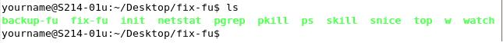
You should see the names of the files appear in green print, as shown below on this page.

Compressing fix-fu Folder on the Clean Machine
- On the Clean Machine Ubuntu desktop, right-click the fix-fu folder. In the context menu, click "Create Archive".
- In the "Create Archive" box, click Create. A file named fix-fu.tar.gz appears on the desktop—this is a compressed archive, like a Windows Zip file.

Emailing the fix-fu.tar.gz Archive to Yourself
- On the Clean Machine Ubuntu desktop, click the red Firefox icon at the top left of the screen.
- Open an email account, and email the fix-fu.tar.gz archive to yourself as an attachment.

Shutting Down the Clean Ubuntu Virtual Machine
- In the clean Ubuntu machine, click System, Quit, Shut down.

Copying the fix-fu.tar.gz Archive to the Infected Ubuntu Machine
- From the Infected Ubuntu machine’s menu bar, click the red Firefox icon at the top left of the screen.
- Open your email, and download the fix-fu.tar.gz archive to your desktop.
- On the Infected Machine Ubuntu desktop, right-click fix-fu.tar.gz archive. In the context menu, click "Open with "Archive Manager"".
- In the fix-fu.tar.gz box, click Extract. In the Extract box, click Extract.
- A folder named fix-fu appears on the desktop.

Examining the fix-fu Script in the Infected Machine
- In your infected machine, from the Ubuntu menu bar, click Applications, Accessories, Terminal.
- In the terminal window, enter this command, then press the Enter key:
cd Desktop/fix-fu
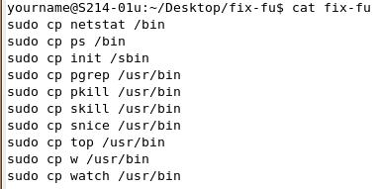
This changes the working directory to folder containing the scripts.
- In the terminal window, enter this command, then press the Enter key:
cat fix-fu
You should see the script, as shown to the right on this page.

Saving the Screen Image
- Make sure the Terminal window is visible, showing the ten cp commands.
- Press Ctrl+Alt to release the mouse, and click on the host Windows XP desktop.
- Press the PrntScn key to copy whole screen to the clipboard.
- On the host Windows XP desktop, open Paint and paste in the image. Save it as a JPEG, with the filename Your Name Proj 14d.

Running the fix-fu Script in the Infected Machine
- In the terminal window, enter this command, then press the Enter key:
sudo ./fix-fu
Enter your password when you are prompted to. This executes the script, copying the files.
- You should now be able to shut down and restart your previously infected machine normally. As far as I know, this completely fixes it.
Turning in your Project
- Email the JPEG images to me as attachments to a single email message Send the message to cnit.123@gmail.com with a subject line of Proj 14 From Your Name. Send a Cc to yourself.
Notes—How I Created the Fix
- Here are the steps I used to create this fix. They may be helpful in fixing other rootkit infections.
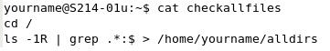
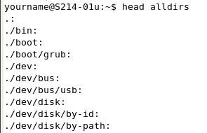
- First I used the script shown to the right to create a file listing all the directories in the Ubuntu file system.

- Here’s what the alldirs file looks like – it’s very long, this is just the first ten records. It lists every directory.

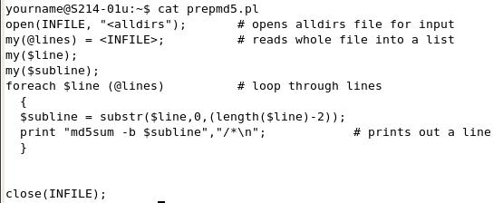
- Then I used this perl script to create another file with md5sum commands for each directory.

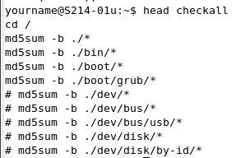

- This is the result—it’s a long file, but here are the first ten lines. When I ran it, some of the directories made it crash, like the /dev ones, because the things in there are not exactly files. I just commented out the lines that made it crash, which were mostly in /dev or /proc directories, until the script ran without crashing. This means some files were not tested.

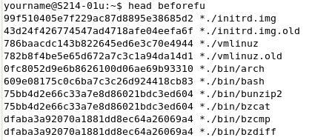
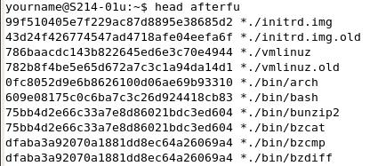
- This is the result of running the script before installing the rootkit—it’s a long file, but here are the first ten lines. This is a very useful file, showing the MD5 hash for every file on a clean Ubuntu machine, except for the /dev and /proc directories I excluded in the previous step.

- Then I installed the rootkit and immediately ran the md5 script again. This is the result. The first ten files match, but there are many thousands of files here.

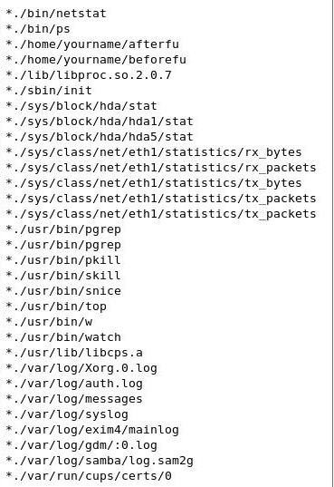
- To compare them, all I used was this command:
diff beforefu afterfu
- The results are shown to the right. I cleaned it up a bit, but this is a complete list of all the files that changed. Not a very long list at all!
- All I did was remove files that did not matter, such as log files, files I created during testing, and network and hard disk statistics files.
- There were three library files that were not present on my clean system, so I ignored them. It might have been a more complete fix to delete them on the infected system, but the fix seemed to work without worrying about them.
- That left the ten files to be copied and replaced.

Last modified 1-2-10

