What You Need
- A Windows XP machine with administrator access (real or virtual). I recommend using the Win XP SP3 Virtual machine.

Creating Passwords to Crack
- Click Start, right-click My Computer, and click Manage. In Computer Management, in the left pane, expand the Local Users and Groups container.
- In the left pane of Computer Management, click the Users container. You should see some accounts in the right pane, as shown below on this page.
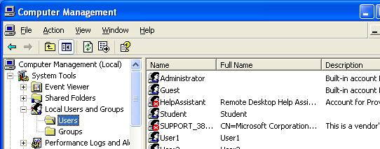

Creating Test Accounts
- In the left pane of Computer Management, right-click Users and click New User.
- In the NewUser box, enter user name of P3 and a password of abc, and click Create. The check boxes in the lower section of the New User box don’t matter, because no one will really be using these accounts.
User name Password
P3 abc
P5 abcde
P7 abcdefg
- Repeat the process to create the three accounts in the box to the right on this page.

Installing Cain
- On the virtual machine's desktop, open a browser and go to www.oxid.it
- In the upper left, click Projects.
- Scroll down past the disclaimer and click "Cain & Abel".
- Scroll down and click "Download Cain & Abel v4.9.35 for Windows NT/1000/XP". (The version number may be higher now.) Save the installer on your desktop.
- Double-click the installer. Install the software with the default options. It will install WinPCap as well as Cain & Abel.

Collecting Password Hashes With Cain
- Double-click the Cain icon on the desktop. Click the Cracker tab.
- In the center of the window, right-click and click "Add to list".
- In the "Add NT Hashes from" box, click Next.

- The password hashes appear, as shown in the figure below.
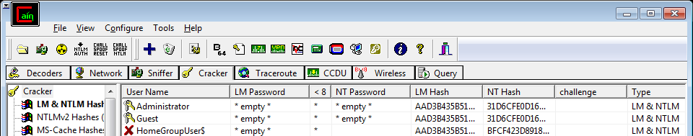

Cracking Passwords
- In the right pane, right-click P3, point to "Brute-Force Attack", and click "NTLM Hashes", as shown below on this page. Note: we are cracking the NTLM hashes, not the old, weak LM hashes. The NTLM hashes are much more difficult to crack, so it will only work for short passwords.
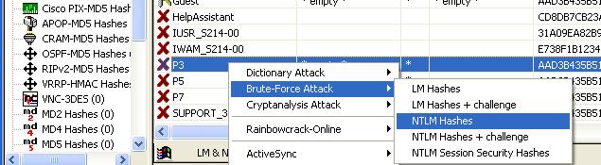

- In the "Brute-Force Attack" box, click the Start button. It should find the three-letter password immediately. Close the "Brute-Force Attack" box.
- In the right pane, right-click P5, point to "Brute-Force Attack", and click "NTLM Hashes".
- In the "Brute-Force Attack" box, click the Start button. It should find the five-letter password within a few seconds. Close the "Brute-Force Attack" box.
- In the right pane, right-click P7, point to "Brute-Force Attack", and click "NTLM Hashes".
- In the "Brute-Force Attack" box, click the Start button. The seven-letter password is hard to crack, however– no answer appears immediately. It might take a long time to crack, so we'll give up. Click the Stop button. Click the Exit button.

- You should see the two passwords you found, abc and abcde, in the NT Password column of the Cain window, as shown below.
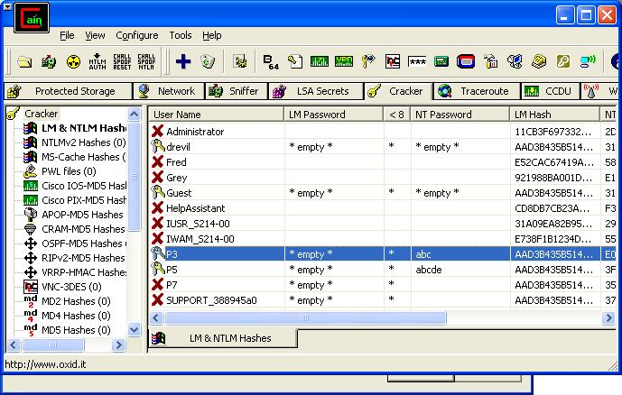

Saving the Screen Image
- Press the PrntScn key to copy whole screen to the clipboard. Open Paint and paste in the image. Save it as a JPEG, with the filename Your Name Proj 18.
Turning in your Project
- Email the JPEG image to me as an attachment. Send the message to cnit.123@gmail.com with a subject line of Proj 18 From Your Name. Send a Cc to yourself.
Last modified 12-27-09

