What You Will Need
Warning! Vulnerability scans can be dangerous! The only machines you should scan in this project are machines in S214, or on your own network at home.
- A Ubuntu machine to act as the Nessus server and client
- A Windows XP machine to act as a Nessus client
- Both machines may be real or virtual
- You need administrative privileges on both machines

Starting Your Windows XP Virtual Machine
- Double-click the VMware Workstation icon on the desktop. In the VMware Workstation window, from the menu bar, click View, Go to Home Tab.
- On the Home tab, click the Open Existing VM or Team icon. Navigate to the V: drive, open your folder, open the Win XP Pro for Hacking folder, and double-click the Windows XP Professional.vmx file. You should see a Windows XP Professional VM in the Powered Off state.
- In the Windows XP Professional – VMware Workstation window, on the left side, click the Start this virtual machine link.
- When your machine starts up, click the Student account to log in. There is no password, and the Student account has Administrative privileges.

Finding the Windows XP Machine's IP Address
- On the Windows XP desktop, click Start, Run. Type in CMD and press the Enter key.
- In the "Command Prompt" window, type in this command and then press the Enter key:
IPCONFIG

Win XP IP: ________________________
- Find your IP address and write it in the box to the right on this page. In S214, your IP address should start with 192.168.1.

Downloading the Nessus Client onto the Windows XP Machine
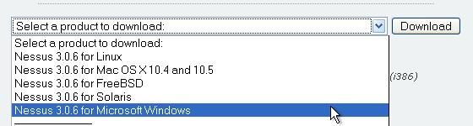
- In the Windows XP machine, open a browser and go to nessus.org/download
- Near the bottom of the page, in the drop-down list box, select the latest version of Nessus for Microsoft Windows, as shown to the right on this page. Click the Download button.
- If a security box pops up asking you to confirm the download, allow it.
- At the bottom of the next screen, you will see the "SOFTWARE LICENSE AGREEMENT". Click "I accept".

- At the bottom of the next screen there is a form asking for your name, email address, etc. Fill in the information and check the "Do not contact me" box. I don't think you need to tell them the truth about anything other than the e-mail address. Click Submit.
- At the bottom of the next screen, click the "Nessus-3.0.6.1.exe" link, as shown below on this page. Save the file on your desktop.
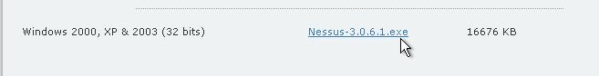

Installing the Nessus Client on the Windows XP Machine
- On your Windows XP machine's desktop, double-click the Nessus-3.0.6.1. Click Next as needed through the installer, agreeing to the license and accepting all the default selections.
- A Question box pops up, asking about product registration. Click No.
- A "Nessus Plugin Update Wizard" opens, and a progress bar shows the installation of plugins. This process will take about 10-15 minutes, so while it proceeds, you should configure your Ubuntu machine with the following steps.

Starting Your Ubuntu Virtual Machine
- Start your Ubuntu machine and log in as usual.

Finding Your Ubuntu Machine's IP Address
- From the Ubuntu menu bar, click Applications, Accessories, Terminal.
- In the Terminal window, after the $ prompt, enter this command, then press the Enter key:
ifconfig

Ubuntu IP: ________________________
Find the IP address for your eth0 interface and write it in the box to the right on this page.

Installing the Nessus Server
- In the Terminal window, after the $ prompt, enter this command, then press the Enter key:
sudo apt-get install nessusd nessus nessus-plugins
Enter your password when you are prompted to. This command installs Nessus. If you already installed Nessus in a previous project, you will see messages saying "nessusd is already the latest version" and so on. That's fine.
- In the Terminal window, after the $ prompt, enter this command, then press the Enter key:
sudo update-rc.d nessusd defaults
This command updates Nessus. Once again, you will probably just see messages telling you that you already have the latest version.

Starting the nessusd Daemon
- Use the mouse to widen the Terminal window as much as possible.
- In the Terminal window, after the $ prompt, enter this command, then press the Enter key:
sudo /etc/init.d/nessusd start
This command starts the Nessus daemon nessusd which listens for connections from the clients.
- In the Terminal window, after the $ prompt, enter this command, then press the Enter key:
ps aux
This command lists the processes running on your Ubuntu machine. Near the end of the list you should see a line starting with root, and showing "nessusd: waiting for incoming connection" on the right side, as shown below.

Creating the Nessus User
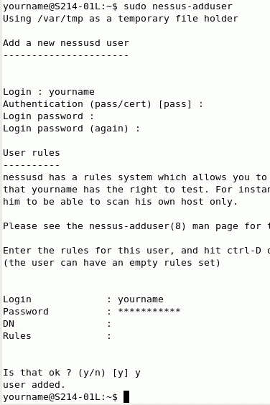
- The Nessus client will need to log in to the Nessus server with an account. Now we need to create that account.
- In the Terminal window, after the $ prompt, enter this command, then press the Enter key:
sudo nessus-adduser
- You should see "Add a new nessusd user" as shown to the right on this page.
- At the Login : prompt, enter your name. I recommend that you use the same login name you used for your Ubuntu login, just so you remember it.
- At the Authentication (pass/cert) : prompt, press Enter to accept the default selection of pass. The other alternative is to authenticate using a certificate, which is more secure, but harder to set up.
- At the Login password : prompt, enter your password. I recommend that you use the same password you used for your Ubuntu password, just so you remember it.
- Below the message "Enter the rules for this user", there is an empty line where you can enter rules. These rules can be used to limit the power of the nessus user, to prevent that person from doing unauthorized scans. But we don't want to limit the scans now, so just hold down the Ctrl key and press D to continue with no rules.
- At the Is that ok ? (y/n) [y] prompt, enter y and press the Enter key. You should see the message user added..

Restarting the nessusd Daemon
- In the Terminal window, after the $ prompt, enter this command, then press the Enter key:
sudo /etc/init.d/nessusd restart
This command restarts the Nessus daemon nessusd, so it will include the new user. This is a common thing in Linux—after making changes, you often need to restart a process. However, you almost never have to restart the whole computer, the way Windows makes you do.
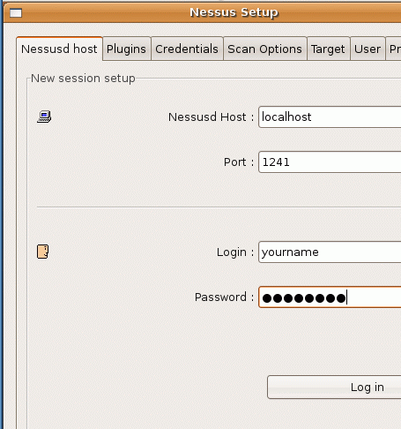

Launching Nessus
- In the Terminal window, after the $ prompt, enter this command, then press the Enter key:
nessus
- A Nessus Setup window opens, as shown to the right on this page. In the Password: box, enter your password. Click the Log in button.
- A "SSL Setup" box opens asking you to "Please choose your level of SSL paranoia." Accept the default selection of "Display and remember the server certificate, do not care about the CA" and click OK.

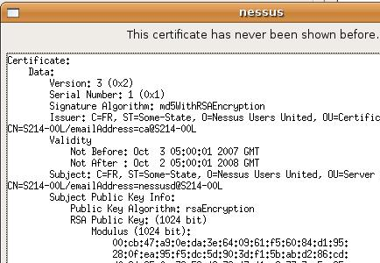
- A nessus window opens showing you a certificate, as shown to the right on this page. Click the Yes button to accept it. This certificate identifies the Nessus server.

- A Warnings box appears, saying that "The plugins that have the ability to crash remote services or hosts have been disabled". Click OK.

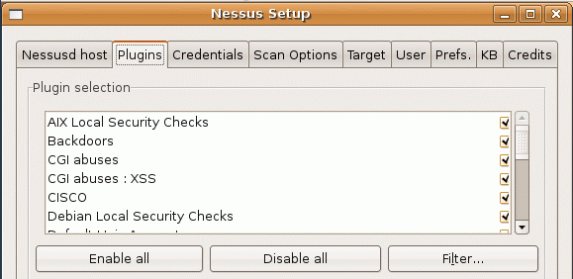
- A Nessus Setup box appears, as shown to the right on this page. This box shows the plugins that have been enabled.

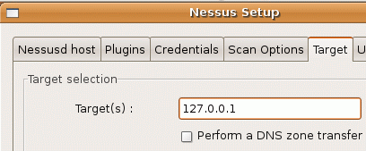
Scanning the Loopback Address
- In the Nessus Setup box, click the Target tab. In the Target(s) : field, enter 127.0.0.1, as shown to the right on this page. That way you will scan your own computer.
- At the lower left of the Nessus Setup box, click the Start the scan button.
- Wait a minute or two for the scan to complete.

Viewing the Vulnerability Report for the Local Host
- In the Nessus "NG" Report window, in the Subnet section, click on 127.0.0.
- In the Host section, click on 127.0.0.1.
- In the Port section, click on nessus (1241/tcp).
- In the Severity section, click on Security Warning.

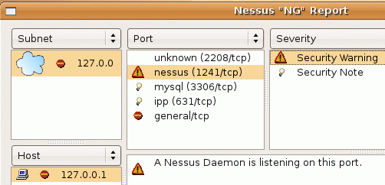
- You should see the message A Nessus Daemon is listening on this port as shown to the right on this page.

Saving the Screen Image
- Press Ctrl+Alt to release the mouse, and click on the host Windows XP desktop. Press the PrntScn key to copy whole screen to the clipboard.
- On the host Windows XP desktop, open Paint and paste in the image. Save it as a JPEG, with the filename Your Name Proj 18a. Select a Save as type of JPEG.

Reading the Rest of the Vulnerability Report for the Local Host
- Click through all the ports and severity options, and see what vulnerabilities you have. There aren't likely to be many vulnerabilities, because we haven't got many services running on these Ubuntu machines. It's good for you to be familiar with the typical number of results you can expect to see on a Linux machine, and compare it with the results from a Windows machine below.

Starting the Nessus Client on the Windows XP Machine
- On the Windows XP desktop, double-click the "Tenable Nessus" icon.
- In the "Welcome to the Nessus Vulnerability Scanner" box, in the left pane, click the "Start Scan Task" link.

Scanning the Ubuntu Machine from the Windows XP Machine
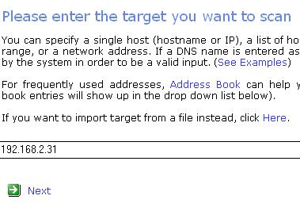
- In the "Please enter the target you want to scan" box, enter the IP address of your Ubuntu machine, as shown to the right on this page. Don't use the exact IP address shown in the figure, use the Ubuntu IP address you wrote in a box on a previous page of thes instructions. Click Next.
- In the "Please choose the plugins set you want to use" box, accept the default selection of "Enable all but dangerous plugins with default settings (Recommended)". Click Next.
- In the "Choose a Nessus server" box, accept the default selection of "Scan from the localhost". Click "Scan now".

Reading the Security Report
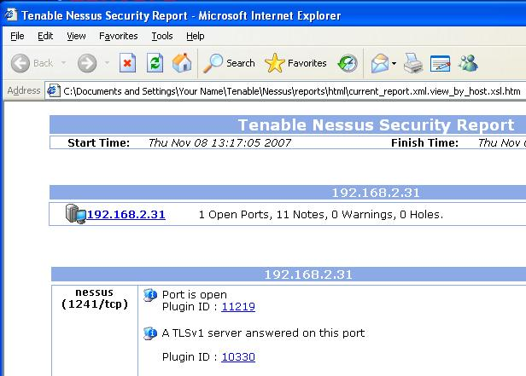
- A "Tenable Nessus Security Report" should appear, as shown to the right on this page. Read through it and compare it to the report the Ubuntu machine gave you.

Saving the Screen Image
- Make sure the "Tenable Nessus Security Report" is showing the "nessus (1241/tcp)" port open, as shown above on this page.
- Press Ctrl+Alt to release the mouse, and click on the host Windows XP desktop. Press the PrntScn key to copy whole screen to the clipboard.
- On the host Windows XP desktop, open Paint and paste in the image. Save it as a JPEG, with the filename Your Name Proj 18b. Select a Save as type of JPEG.
Turning in your Project
- Email the JPEG images to me as attachments to a single email message. Send the message to cnit.123@gmail.com with a subject line of Proj 18 From Your Name. Send a Cc to yourself.
Credits:
I got a lot of this from http://www.ubuntuforums.org/archive/index.php/t-27674.html (link Ch 5j2)

Last modified 11-9-07

