Installing Cain and Abel
- Use a Virtual Windows XP machine.
- Open a Web browser. Go to http://www.oxid.it/cain.html
- Download Cain & Abel for Windows XP, install it. It will also install WinPCap.
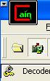
Sniffing for Passwords
- Double-click the Cain icon on the desktop to launch Cain.
- From the top menu, click Configure.
- In the upper left of the Cain window, click the “Start/Stop Sniffer” button (the second button from the left), as shown to the right on this page.
- At the top of the screen, click the Sniffer tab. Click the Passwords tab at the bottom.

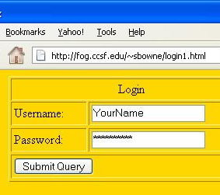
Logging in to a Simple HTTP Login Form
- Open Firefox and go to:
tinyurl.com/fakelogin
- Type in a fake name and password. Click the “Submit Query” button.
- When a box pops up asking whether you want Firefox to remember this password, click “Not now”. After a few seconds, you will see a message saying OK, Login approved.
- In Cain, in the left pane, click HTTP. You should see the captured password, as shown below.

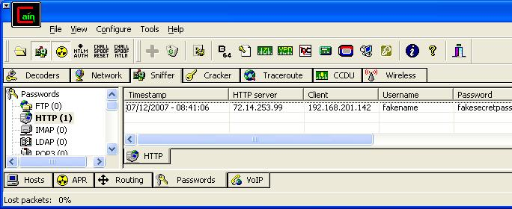

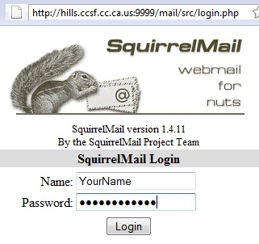
Logging in to a CCSF's Email
- In Firefox, go to:
hills.ccsf.edu/mail
- Type in a fake name and password, as shown to the right on this page. Click the Login button.
- When a box pops up asking whether you want Firefox to remember this password, click “Not now”. After a few seconds, you will see a message saying "ERROR – Unknown user or password incorrect".
- Look at the Cain window—it did not capture this password.

Adjusting Cain's HTTP Settings
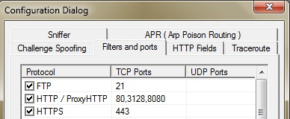
- Is the SquirrelMail login secure? The URL doesn't show HTTPS, so it's probably not encrypted. Let's examine how Cain's password sniffer works.
- From the Cain menu bar, click Configure. In the "Configuration Dialog" box, click the "Filters and ports" tab. The HTTP sniffer looks only on ports 20, 3128, and 8080, as shown to the right on this page. But you can see from the URL of the SquirrelMail page that it operates on port 9999.
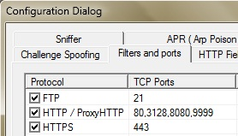
- In the "Configuration Dialog" box, on the "Filters and ports" tab, right-click "80,3128,8080" in the list of TCP ports for the HTTP protocol. In the context menu, click "Change TCP Ports".
- In the "HTTP / ProxyHTTP (TCP)" box, change the ports listed to 80,3128,8080,9999 and then click OK.
- You should now see 9999 included in the list of ports, as shown to the right on this page.
- In the "Configuration Dialog" box, click OK.

Logging in to a CCSF's Email
- In Firefox, go to:
hills.ccsf.edu/mail
- Type in a fake name and password, as shown to the right on this page. Click the Login button.
- When a box pops up asking whether you want Firefox to remember this password, click “Not now”. After a few seconds, you will see a message saying "ERROR – Unknown user or password incorrect".
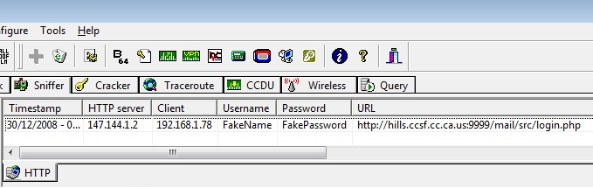
- Look at the Cain window—you should see the captured password, as shown below.

Saving the Screen Image
- Click outside the virtual machine to make its title bar dim. Press the PrntScn key to copy whole screen to the clipboard in the host Windows XP machine. Open Paint and paste in the image. Save it as a JPEG, with the filename Your Name Proj 19.
Turning in your Project
- Email the JPEG image to me as an attachment. Send the message to cnit.123@gmail.com with a subject line of Proj 19 From Your Name. Send a Cc to yourself.
Last modified 12-27-09

