What You Will Need
Warning: Only use this on networks you own. Cracking into networks without permission is a crime—don’t do it!
- A wireless access point
- A computer running any OS with any wireless NIC to be the client
- An Eee PC--I used the EEE PC 900HA
- A bootable BackTrack 4 Pre-Final USB stick

Set up a WEP-Protected Wireless LAN
- Use any router that is available.

Attach a Wireless Client to the Wireless LAN
- Use any laptop or other computer with a wireless NIC that is available.

Booting the Eee PC from the BackTrack 4 Pre-Final USB Stick
- Insert the USB stick and power on the EEE PC.
- During bootup, press F2 to enter the BIOS settings page. Use the right-arrow to select the Boot menu, and press the down-arrow to highlight "Hard Disk Drives". Press the Enter key. The "1st Drive" line appears, highlighted. Press the Enter key. Press the down-arrow to highlight "USB: Kingston DT" and press the Enter key. Press the F10 key to save changes. Press the Enter key to confirm.
- When you see a page with a root@bt:~# prompt, type in this command and press the Enter key:
startx
- A graphical desktop should appear. On the taskbar, at the lower left, click the fifth icon, which should show a black terminal window with a > sign in it. This opens a terminal window. Maximize this window.

Observing the wlan0 Device
- In the "Shell – Konsole" window, type in this command, and then press the Enter key:
iwconfig
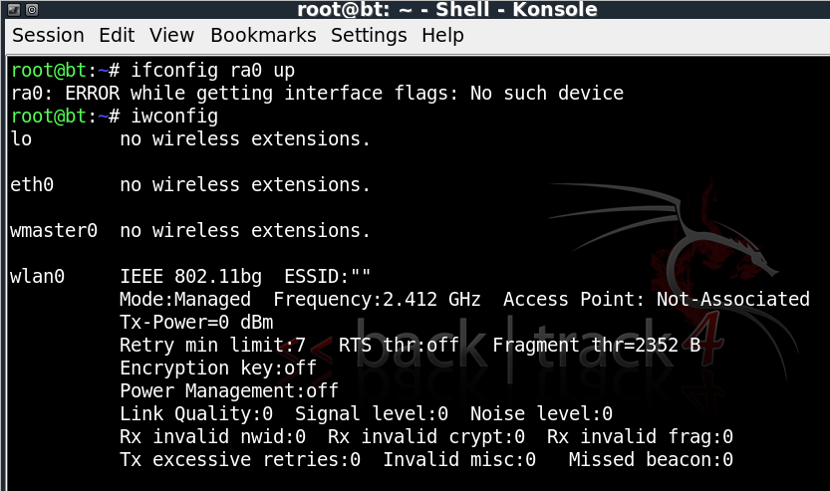
- You should see the wlan0 device, as shown below on this page. It is in Mode:Managed, which is the normal mode for wireless networking. We need to get the card out of that mode, so we will first disable it.

- In the "Shell – Konsole" window, type in this command, and then press the Enter key:
ifconfig wlan0 down
A lot of blank lines will scroll by. That is normal.

Starting the wifi-0 Device in Monitor Mode
- In the "Shell – Konsole" window, type in this command, and then press the Enter key:
airmon-ng start wifi0
We have now stopped the wireless card and restarted it with the special MadWiFi drivers, which are necessary for cracking WEP. Now the card is monitoring on all channels.

Capturing Packets to View the Available Networks
- In the "Shell - Konsole" window, press Shift+Ctrl+N. This opens a new Konsole tab, labeled "Shell No. 2" at the bottom of the window.
- In the "Shell No.2" window, type in this command, and then press the Enter key:
airodump-ng –w test wlan0
This command opens a window showing all local networks, as shown below on this page. The captured packets are going to a file named test, which isn't important right now. The columns in the output are explained below:
BSSID The MAC address of the access point
PWR Power level
Beacons The number of beacon packets captured
#Data The number of packets containing Initialization Vectors (IVs) – these are the packets we need to crack WEP.
CH The channel (1 through 11 are used in the USA)
MB The speed of the network in Mbps
ENC, CIPHER, AUTH These values specify the encryption method
ESSID The name of the network
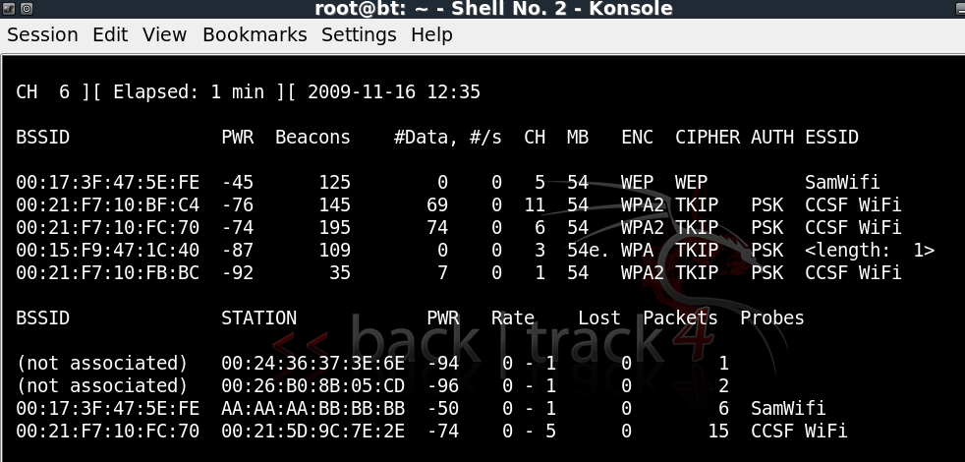

- Write the BSSID, CH, and ESSID of the access point you want to crack into in the box to the right on this page. In the lower section, find the STATION Mac address that is associated with the access point you want to crack, and write it in the box to the right on this page.

BSSID: _________________________________

CH: __________

ESSID: _________________________________

STATION: _________________________________

- Press Ctrl+C to stop the Airodump capture.

Restarting Monitoring on the Correct Channel
- Click the "Shell" tab at the lower left of your screen to make it active—this is the window you used for the airmon-ng commands.
- In the "Shell – Konsole" window, type in this command, and then press the Enter key:
airmon-ng stop wifi0
- In the "Shell – Konsole" window, type in this command, and then press the Enter key:
airmon-ng start wifi0 11
Replace 11 with the CH number you wrote in the box above on this page. Now the card is monitoring only the channel we are interested in.

Resuming Packet Capture
- Click the "Shell No. 2" tab to make it active—this is the Konsole window you used for the airodump-ng command.
- In the "Shell No. 2" window, type in this command, and then press the Enter key:
airodump-ng –c 11 –w output wlan0
Replace 11 with the CH number you wrote in the box above on this page. Now the card is monitoring only the channel we are interested in. This captures packets on the desired channel, and dumps into the file output.cap. Notice that the #Data are not rising quickly—you may not even see any data being captured at all. Leave this capture running.

Performing an ARP Replay Attack
- Now we will capture an ARP request, and replay it to force the Access Point to pump out a lot of IVs.
- In the "Shell" window, type in this command, and then press the Enter key:
aireplay-ng -3 –b 00:11:50:1E:43:87 –h 00:16:B6:5B:A3:D6 rausb0
Replace 00:11:50:1E:43:87 with the BSSID you wrote in the box on a previous page of these instructions (the access point's hardware address).
Replace 00:16:B6:5B:A3:D6 with the MAC you wrote in the box on a previous page of these instructions (the Wi-Fi NIC card's MAC address).

The last line in your "Shell – Konsole" window should show the number of packets read, the number of ARP requests captured, and the number of packets sent, as shown below on this page. Within a few seconds, all three of these numbers should start rising rapidly. That means the ARP replay attack is successfully pumping IV values out of the access point, gathering data that can be used to crack the WEP encryption quickly.
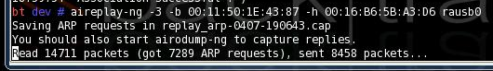

If the number of ARP requests stalls at zero, disconnect the wireless client and reconnect it.
- Look at the "Shell – Konsole <2>" window. The # Data value should be rising very rapidly, as shown below on this page.
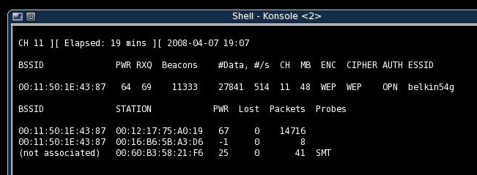

Cracking the Key
- In the "Shell - Konsole" window, press Shift+Ctrl+N. This opens a new Konsole tab, labeled "Shell No. 3" at the bottom of the window.
- In the "Shell No. 3" window, type in this command, and then press the Enter key:
aircrack-ng –a 1 –n 64 output*.cap
It should find the key within a few minutes, as shown below on this page.
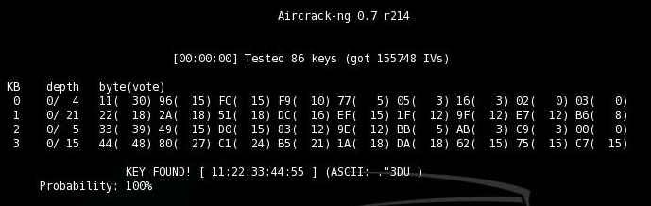

Saving the Screen Image on the Desktop
- On the attacking EEE PC, Start, KSnapshot.
- In the KSnapshot window, click the "Save As…" button.
- In the "Save as – KSnapshot " window, on the left side, click Desktop.
- In the "Save as – KSnapshot" window, in the Location: box, type in a filename of
Yourname-Proj20.jpg
- Click the Save button. Your file should appear on the desktop.

Connecting the EEE PC to the Wired LAN
- Use an Ethernet cable to connect the EEE PC to the wired LAN.
- In the "Shell – Konsole" window, type in this command, and then press the Enter key:
ifconfig eth0 up
- In the "Shell – Konsole" window, type in this command, and then press the Enter key:
sudo dhclient
- That will give it access to the Internet.

Starting Firefox
- On the EEE PC, at the lower left of the desktop, click the red Firefox icon.
Turning in your Project
- Firefox opens. Email the JPEG image to me as an attachment. Send the message to cnit.123@gmail.com with a subject line of Proj 20 From Your Name. Send a Cc to yourself.

Credits
I got a lot of this from "Wireless Vulnerabilities and Cracking with the Aircrack Suite", by Stephen Argent, in the magazine hakin9, Issue 1/2008. There is a lot more information about cracking WEP and WPA in that article, it's great!

Last modified 11-16-09

