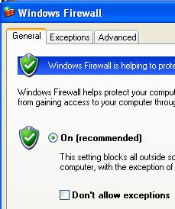
What You Need for This Project
- A trusted computer running Windows XP with Service Pack 2 (or any other version of Windows), with Internet access. You need administrator privileges. This can be either a real or virtual machine.
Turning on the Windows Firewall
- Use your virtual Windows XP machine.
- Click Start, Control Panel. If necessary, click "Switch to Classic View." Double-click "Windows Firewall." (If you are working at home and you don't have Service Pack 2, you won't have Windows Firewall. Pick a different firewall to test for this first section, anything other than Comodo, and install it.)
- Set the firewall to "On (recommended)" as shown to the right on this page. Click OK.
Downloading Leak Test1: LeakTest
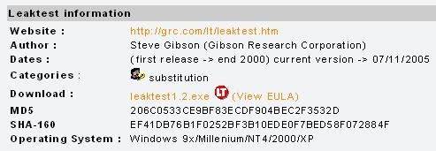
- Open Firefox and go to firewallleaktester.com
- In the left column, click on Leak Test1: LeakTest.
- In the next page, scroll down to the "Leaktest information" section, as shown to the right on this page. Notice the MD5 hash value. In the Download: line, click the yellow "leaktest1.2.exe" link.
- In the "Opening leaktest1.2.exe" box, click "Save File" and save the file on your desktop.
- If your antivirus stops the download, turn off your virus scanner. Some of these tests set off virus scanners, but as far as I know they are all harmless. But remember, don't do anything you are not comfortable with—if you don't want to do this test at home, you can use the lab, or a virtual machine.
Verifying the MD5 Hash
- Never trust anything you get from the Internet, especially hacking tools! The purpose of the MD5 hash is to make sure the file you actually get has not been altered.
- You will need a hash calculator. If you don't already have one, download and install Hashcalc from slavasoft.com/hashcalc

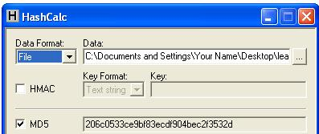
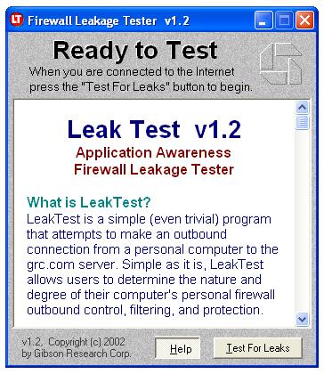
- Click Start, All Programs, Hashcalc, Hashcalc. Drag the leaktest1.2.exe file from your desktop into the Data: box and drop it there. You should see the MD5 hash, as shown to the right on this page—compare it to the hash shown on the download page. This should be a habit—don't trust anything you download unless you can check a hash to make sure it is what it claims to be.
Running Leak Test1: LeakTest
- Double-click the leaktest1.2.exe file on your desktop. In the "LeakTest v1.2 – First Time Help" box, click OK.
- A box saying "Ready to Test" opens, as shown to the right on this page. Click "Test for Leaks".
- In the "LeakTest v1.2 – First Time Help" box, click OK.
- You should see a "Firewall Penetrated!" message, as shown below on this page.
Saving the Screen Image
- Make sure the "Firewall Penetrated!" message is visible.
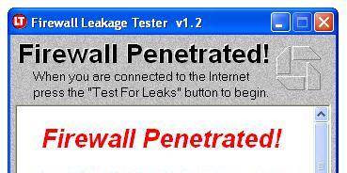
- Press the PrntScn key to copy the desktop to the clipboard.
- On the Start menu, click Run. Enter the command mspaint and press the Enter key. Paint opens.
- Press Ctrl+V on the keyboard to paste the image into the Paint window. Save the document in the Shared Documents folder with the filename Your Name Proj 22a. Select a Save as type of JPEG. Close Paint.
Downloading the Free Comodo Firewall
- Obviously. The Windows XP Service 2 firewall is not protecting your machine very well. Let's try a stronger firewall.
- Open a browser and go to personalfirewall.comodo.com
- In the upper left of the window, click "Download Comodo Firewall Pro Free." Save the file on your desktop. Notice the MD5 hash value on the Web page.
Verifying the MD5 Hash
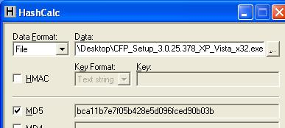
- If Hashcalc is not still open, click Start, All Programs, Hashcalc, Hashcalc. Drag the CFP_Setup_3.0.25.378_XP_Vista_x32.exe file from your desktop into the Data: box and drop it there. Compare the MD5 hash to the value shown on the webpage. It should agree.
- Note: if you have a later version of the firewall, your hash will not agree with the figure to the right on this page, but it should still agree with the value on the Comodo Web page.
Saving the Screen Image
- Make sure both the Hashcalc window is visible, showing the MD5 hash value.
- Press the PrntScn key to copy the desktop to the clipboard.
- On the Start menu, click Run. Enter the command mspaint and press the Enter key. Paint opens.
- Press Ctrl+V on the keyboard to paste the image into the Paint window. Save the document in the Shared Documents folder with the filename Your Name Proj 22b. Select a Save as type of JPEG. Close Paint.
Creating a Modified File
- How much can we trust an MD5 hash? It's not perfect, but we can easily see what adding something to the file does.
- On the desktop, right-click the CFP_Setup_3.0.25.378_XP_Vista_x32.exe, hold down the right mouse button, and drag it a small distance on the desktop. Release the mouse button. In the context menu, click Copy here.
- Right-click on the Copy of CFP_Setup_3.0.25.378_XP_Vista_x32.exe file and select Rename. Type in the name x and press the Enter key. Now you have a duplicate of the file named x. (If you are displaying file extensions, change the name to x.exe.)
Modifying the 'x' File
- Click Start, All Programs, Accessories, Command Prompt. In the Command Prompt window, type in this command and then press the Enter key:
cd desktop
This command changes the working directory to the desktop folder, where the x.exe file is.
- In the Command Prompt window, type in this command and then press the Enter key:
echo "a" >> x.exe
This command adds an ASCII character 'a' to the end of the x.exe file.

- In the Command Prompt window, type in this command and then press the Enter key:
dir
This command displays a directory of files on the desktop, with their sizes, as shown below on this page. As you can see, the x.exe file is now a few bytes larger than the original CFP_Setup_3.0.25.378_XP_Vista_x32.exe file.

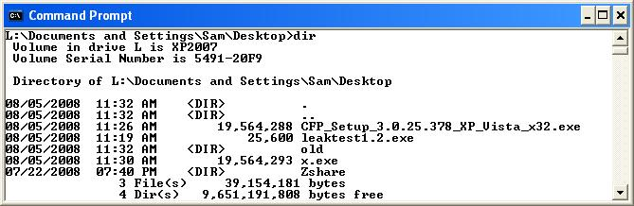
- Close the Command Prompt window.
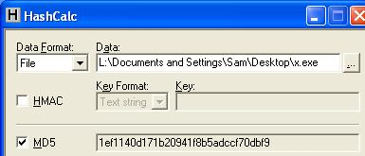
Examining the MD5 Hash of the Modified File
- If Hashcalc is not still open, click Start, All Programs, Hashcalc, Hashcalc. Drag the x file from your desktop into the Data: box and drop it there. The MD5 value should be different from the hash value of the original Comodo installer file, as shown to the right on this page.
Saving the Screen Image
- Make sure both the Hashcalc window is visible, showing the MD5 hash value of the x.exe file. It should be different from the hash value of the original Comodo installer file.
- Press the PrntScn key to copy the desktop to the clipboard.
- On the Start menu, click Run. Enter the command mspaint and press the Enter key. Paint opens.
- Press Ctrl+V on the keyboard to paste the image into the Paint window. Save the document in the Shared Documents folder with the filename Your Name Proj 22c. Select a Save as type of JPEG. Close Paint.
Installing the Comodo Firewall
- Double-click the CFP_Setup_3.0.25.378_XP_Vista_x32.exe file on your desktop.
- In the COMODO Firewall Pro Installer box warning you to uninstall other firewalls, click Yes. (You cannot uninstall Windows Firewall.)
- In the "Comodo Firewall Pro Installer" box, click Next.
- At the "License Agreement" screen, click "I Accept".
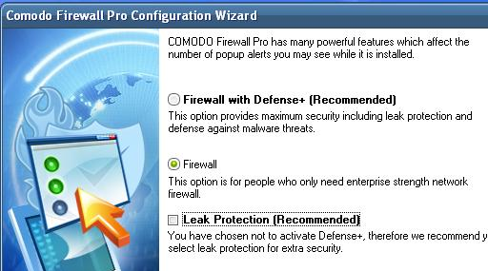
- At the "Choose Destination Folder" screen, click Next.
- In the "Welcome to the Comodo Firewall Configuration Wizard" screen, click Next.
- In the next screen, click Firewall. Clear the "Leak Protection (Recommended)" box, as shown to the right on this page. Click Next.
- In the next screen, clear all the check boxes offering "ComodoSafeSurf" and other browser options. Click Next.
- In the next screen, leave the "Email Address (Optional)" field empty and click Next.
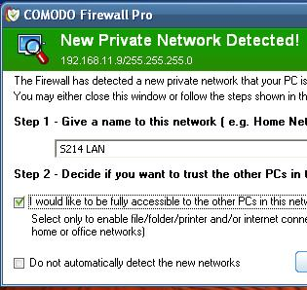
- At the next screen, clear the "Scan my system for malware (Recommended)" box and click Finish.
- When you are prompted to, restart your computer.
Handling a Firewall Alert
- When you log in again, a "COMODO Firewall Pro" box appears. COMODO wants you to name your LAN and decide whether to trust it. Give it a name of "S214 LAN" and check the "I would like to be fully accessible…" box, as shown to the right on this page. Click OK.
- These warning boxes are the cost of filtering outgoing traffic. This more powerful firewall will annoy you more, but also protect you more.
Running Leak Test1: LeakTest
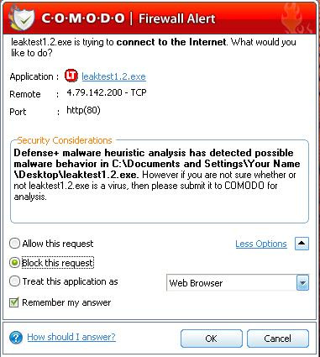
- Double-click the leaktest1.2.exe file on your desktop.
- A box saying "Ready to Test" opens. Click "Test for Leaks".
- A box with a red "COMODO Firewall Alert" pops up, as shown to the right on this page. This is COMODO protecting you, but it only works if you understand how to respond to the alert. Click the "Block this request" radio button, and click OK.
- You should see a "Firewall Leakage Tester v1.2" box with the message "Unable to Connect", as shown below on this page.
Saving the Screen Image
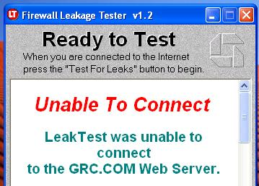
- Make sure the "Unable to Connect" message is visible.
- Press the PrntScn key to copy the desktop to the clipboard.
- On the Start menu, click Run. Enter the command mspaint and press the Enter key. Paint opens.
- Press Ctrl+V on the keyboard to paste the image into the Paint window. Save the document in the Shared Documents folder with the filename Your Name Proj 22d. Select a Save as type of JPEG. Close Paint.
Turning in your Project
- Email the JPEG images to me as attachments to one e-mail message to cnit.123@gmail.com with a subject line of Proj 22 From Your Name. Send a Cc to yourself.

Last modified 8-5-08

