Purpose
Cain performs the whole Man-in-the-middle attack, including creating a spoofed digital certificate. It easily steals passwords and traffic off the wire, even in HTTPS sessions.
Installing Cain and Abel
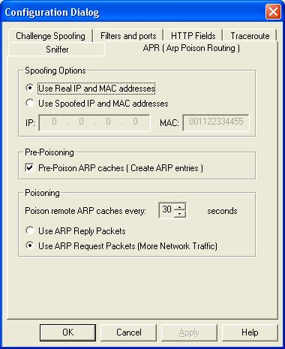
- Use your Virtual Windows XP machine
- Open a Web browser. Go to http://www.oxid.it/cain.html
- Download Cain & Abel for Windows XP, install it. It will also install WinPCap.
Sniffing for Targets
- Double-click the Cain icon on the desktop to launch Cain.
- From the top menu, click Configure.
- In the “Configuration Dialog” box, on the Sniffer tab, verify that the interface with the IP address that goes to the Internet is highlighted.
- In the “Configuration Dialog” box, on the APR tab, click the “Use ARP Request Packets (More Network Traffic)” radio button at the bottom, as shown to the right on this page. Click OK.
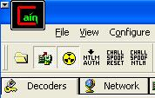
- In the upper left of the Cain window, click the “Start/Stop Sniffer” button (the second button from the left), and the “Start/Stop APR” button (third from the left) so they are both depressed, as shown to the right on this page.
- At the top of the screen, click the Sniffer tab. On the toolbar, click the+ icon.
- In the “Mac Address Scanner” box, check the “All Tests” box. Click OK. Wait while several progress bars move across the screen.
- Click the APR tab at the bottom. Click in the empty upper right hand table. Click the + icon on the toolbar.

Starting the ARP Poison Routing
- In the “New APR poison Routing” box, click the gateway IP in the left pane. Then click the target IP in the right pane, as shown below on this page. Click OK.
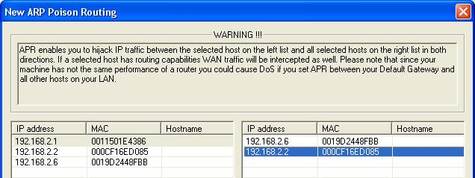
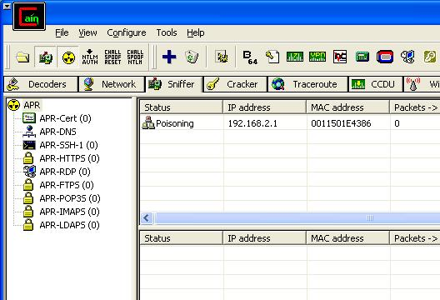
- Wait 30 seconds. You should see a Status of Poisoning, as shown to the right on this page. If you see a status of "Idle", toggle the the “Start/Stop Sniffer” button and the “Start/Stop APR” buttons, leaving them both depressed.

Opening Gmail on the Target Machine
- On the target machine, open Internet Explorer and go to Gmail.com
- You should see connections appearing in the lower portion of the Cain window.
- Enter a fake user name and password into the Gmail login screen and try to log in. You should see warnings about the security certificate. Agree to connect anyway.
- On the bottom of the Cain window, click the Passwords tab. In the left pane, click the HTTP item to select it. Your Gmail password should be visible, as shown below on this page.
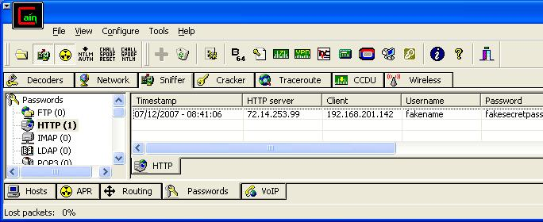

Saving the Screen Image
- Click outside the virtual machine to make its title bar dim. Press the PrntScn key to copy whole screen to the clipboard in the host Windows XP machine. Open Paint and paste in the image. Save it as a JPEG, with the filename Your Name Proj 22.
Turning in your Project
- Email the JPEG image to me as an attachment. Send the message to cnit.123@gmail.com with a subject line of Proj 22 From Your Name. Send a Cc to yourself.
Last modified 12-30-08

