What You Need for This Project
- A computer running Windows XP, with Internet access. You need administrator privileges. This can be either a real or virtual machine.
Downloading and Installing ActivePython
- Start a browser and go to activestate.com
- On the left side, click ActivePython.
- Click the blue Get ActivePython button.
- In the line labeled Download and Free, click the blue Download button.
- The next page asks you for optional information; your name and email. Leave it blank and click Continue.
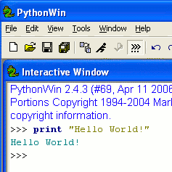
- At the next page, find the latest version (ActivePython 2.4.3.11 when I did it). Find the Windows (x86) version and click the blue MSI link.
- Save the file on your desktop and run it. Install the software with all the default selections.
Starting ActivePython
- Click Start, All Programs, ActiveState ActivePython 2.4, Pythonwin IDE.
“Hello World” in Python
- A PythonWin window opens, with an Interactive Window open inside it. At the >>> prompt, type in this command, then press the Enter key:
print “Hello World!”
The result is to print “Hello World!” on the next line in green text, as shown to the right on this page.
Making a Customized Greeting in Interactive Python
- At the >>> prompt, type in this command, then press the Enter key:
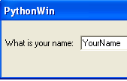
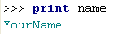
name = raw_input("What is your name: ")
- A box pops up asking for your name, as shown to the right on this page. Type your name into the box, then press the Enter key:
- The box vanishes and you are back at the original screen, with a >>> prompt. Your name has now been stored in the variable name. To see that, at the >>> prompt, type in this command, then press the Enter key:
print name
You should see your name printed in green text, as shown to the right on this page.

- The variable name persists until you change it, or close PythonWin. You can use it again. To see that, at the >>> prompt, type in this command, then press the Enter key:
print “Hello”, name
You should see your customized greeting.
Making hello.py: a Customized Greeting Python Script
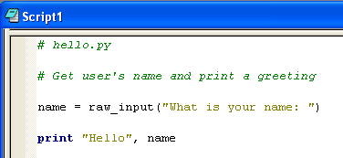
- The interactive window is good for simple, short actions, but it’s not a good way to make a long script. To create a script, from the PythonWin menu bar, click File, New. In the New box, accept the default selection of “Python Script” and click OK.
- Type in the script shown to the right on this page. The first two lines are comments, indicated by the # sign.
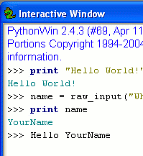
- After typing in your script, from the PythonWin menu bar, click File, Save. Save it in the My Documents folder with the name hello. PythonWin will add the file extension .py to the file name.
- To run the script, from the PythonWin menu bar, click File, Run. In the Run Script box, verify that it shows the hello.py script, and click OK.
- When a box pops up asking for your name, type your name and press the Enter key.
- Drag the hello.py window out of the way so you can see the Interactive Window. You should see >>> Hello YourName in black letters at the bottom, as indicated by the box in the figure to the right on this page.
Saving the Screen Image
- Press the PrntScn key to copy the desktop to the clipboard.
- On the Start menu, click Run. Enter the command mspaint and press the Enter key. Paint opens.
- Press Ctrl+V on the keyboard to paste the image into the Paint window. Save the document in the Shared Documents folder with the filename Your Name Proj X5a. Select a Save as type of JPEG. Close Paint.
Starting a Netcat Listener in Ubuntu Linux
- Now we’ll open a socket from Python on Windows to Netcat on Linux, and transfer data both ways.
- Start your Ubuntu Linux machine and log in as usual.
- From the Ubuntu menu bar, click Applications, Accessories, Terminal.
- In the Terminal window, after the $ prompt, enter this command, then press the Enter key:
ifconfig

Ubuntu IP: ________________________
Find the IP address for your eth0 interface and write it in the box to the right on this page.

- In the Terminal window, after the $ prompt, enter this command, then press the Enter key:
nc -h
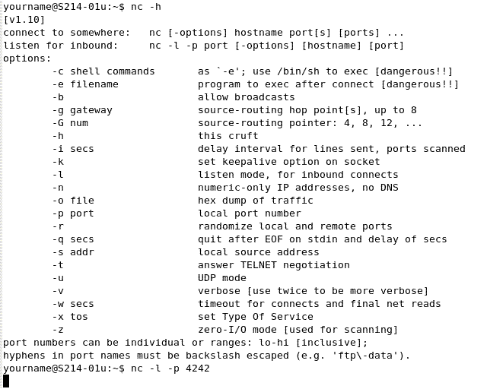
The help page for the nc command appears, as shown below on this page. Netcat is the full name of this networking utility—it is very useful (see link Ch 7o).

- For now, all we want to do is listen for inbound data. After the $ prompt, type in this command, then press the Enter key:
nc –l –p 4242
Note that the first switch is a lowercase L, not the numeral 1. This will start a process listening on port 4242 on the Linux machine.
Displaying the Listening Sockets on the Ubuntu Machine
- Leave the terminal window showing the nc command alone, and from the Ubuntu menu bar, click Applications, Accessories, Terminal to open a second Terminal window.
- In the new Terminal window, after the $ prompt, enter this command, then press the Enter key:
netstat –l --protocol=inet
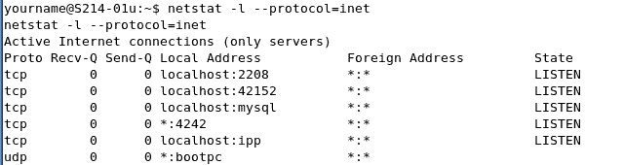
You should see a list of network connections that are listening, as shown below on this page. Look for the line that shows *:4242 – that’s the netcat listener, waiting for any incoming connections on port 4242.

Establishing a TCP Socket in Python on Windows
- From the PythonWin menu bar, click File, New. In the New box, accept the default selection of “Python Script” and click OK.
- Type in the script shown below on this page. Put your Ubuntu machine’s IP address in the second line—that’s the number you wrote in the box on a previous page of these instructions.
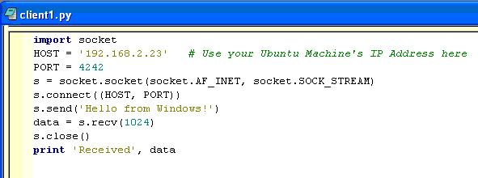

- After typing in your script, from the PythonWin menu bar, click File, Save. Save it in the My Documents folder with the name client1. PythonWin will add the file extension .py to the file name.
- Drag the hello.py window out of the way so you can see the Interactive Window.
- To run the script, from the PythonWin menu bar, click File, Run. In the Run Script box, verify that it shows the client1.py script, and click OK.
- Nothing happens on the Windows machine, unless you have made a typographical error in the script.
Observing the Session Established on the Windows Machine
- Leave the PythonWin windows alone for now.
- From the Windows desktop, click Start, Run. Type in CMD and press the Enter key.
- In the Command Prompt window, enter this command and press the Enter key:
netstat -n
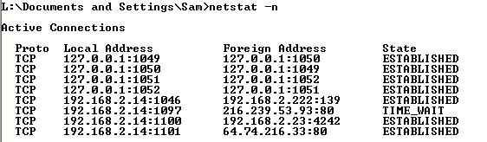
You should see a list of network connections. Look for the line that shows a Foreign Address ending with :4242 (second from the bottom in the figure below). The connection should show a State of ESTABLISHED.

Saving the Screen Image
- Press the PrntScn key to copy the desktop to the clipboard.
- On the Start menu, click Run. Enter the command mspaint and press the Enter key. Paint opens.
- Press Ctrl+V on the keyboard to paste the image into the Paint window. Save the document in the Shared Documents folder with the filename Your Name Proj X5b. Select a Save as type of JPEG. Close Paint.
Receiving and Sending Data With the Ubuntu Linux Machine
- Leave the PythonWin windows alone on the Windows XP machine.
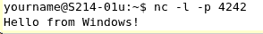
- Return to the Ubuntu machine. Look at the Terminal window that is running the netcat listener. You should see the text sent from the Windows machine on it: “Hello from Windows!” as shown to the right on this page.

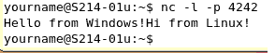
- Click in the Terminal window, and type in the message “Hi from Linux!” Then press the Enter key. Your Terminal window should now look like the figure to the right on this page.
Observing the Received Data on the Windows Machine
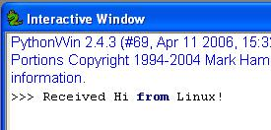
- Go back to the Windows machine. In the Interactive Window, you should see the message “received Hi from Linux!” as shown to the right on this page.
Saving the Screen Image
- Press the PrntScn key to copy the desktop to the clipboard.
- On the Start menu, click Run. Enter the command mspaint and press the Enter key. Paint opens.
- Press Ctrl+V on the keyboard to paste the image into the Paint window. Save the document in the Shared Documents folder with the filename Your Name Proj X5c. Select a Save as type of JPEG. Close Paint.
Turning in your Project
- Email the JPEG images to me as attachments to one e-mail message to cnit.123@gmail.com with a subject line of Proj 16 From Your Name. Send a Cc to yourself.
Credits
richarddooling.com/index.php/2006/03/14/python-on-xp-7-minutes-to-hello-world/ (Link Ch 7l),
coolnamehere.com/geekery/python/pythontut.html (Link Ch 7n),
aspn.activestate.com/ASPN/docs/ActivePython/2.4/python/lib/socket-example.html (Link Ch 7p), and
The book Gray Hat Hacking : The Ethical Hacker's Handbook (2004) by Shon Harris, Allen Harper, Chris Eagle, Jonathan Ness, and Michael Lester.
Last modified 6-4-07

