What You Will Need
Warning: Only use this on networks you own. Cracking into networks without permission is a crime—don’t do it!
- Any computer that can boot from CD. This is the "Hacker Computer"
- A BackTrack 2 Bootable CD
- A wireless Access Point/Router
- A "Wireless Client" computer running Windows, Linux, OS X, or any operating system with a wireless NIC (any kind)
- A Linksys WUSB54G ver. 4 NIC, or another one compatible with BackTrack. It is hard to find compatible NICs—I highly recommend this particular one for this purpose.

Choose Your Access Point/Router
- There are three Access Point/Routers available: Linksys, D-Link, and Belkin. Choose one and use the corresponding instructions below to set up a secure Wireless Local Area Network (WLAN).
Linksys Router

Restoring the Access Point to Factory Default Settings
- Get the blue Linksys BEFW11S4 router from the closet. Plug in the power cord. Do not plug in any Ethernet cables yet.
- Press the little red RESET button on the back and hold it in for ten seconds. This resets the router back to its factory default settings.

Connecting a “Wired Client” Computer to the Router
- Choose one computer to be the Wired Client. Disconnect the blue Ethernet cable from the back of the Wired Client. Take another cable and connect the Wired Client to port 1 on the router. Check the front panel of the router: the light under number 1 should light up, but the Internet light should be dark.
- On the Wired Client, click Start, All Programs, Accessories, Command Prompt. Type in this command and press the Enter key.
IPCONFIG
You should see an IP address starting with 192.168.1, as shown below. There are other network adapters present with other IP addresses, but one of them should start with 192.168.1. If you don’t have an IP address like that, restart the Wired Client computer.
Ethernet adapter Local Area Connection 2:

Connection-specific DNS Suffix . :
IP Address. . . . . . . . . . . . : 192.168.1.101
Subnet Mask . . . . . . . . . . . : 255.255.255.0
Default Gateway . . . . . . . . . : 192.168.1.1

- On the Wired Client, in the Command Prompt window, type in this command and press the Enter key.
PING 192.168.1.1
You should see replies, and you should see the front panel lights on the router blink. The Wired Client is now connected to the router as a client.

Changing the Subnet on the Router
- The LAN in S214 uses the 192.168.1.0 subnet, which is the same as the default subnet for the Linksys router. The router won’t be able to connect to the LAN unless it uses a different subnet for its clients, so we need to change the router to a different subnet.
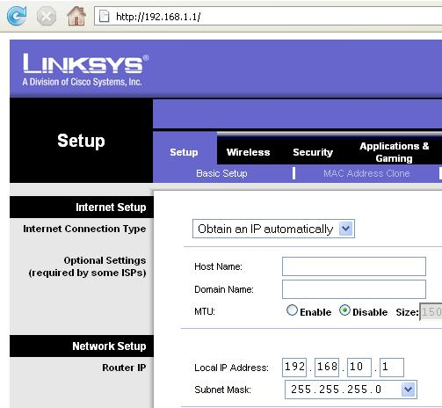
- On the Wired Client. open a browser and go to this address: 192.168.1.1
- A box pops up asking for a user name and password. Leave the User Name blank and enter a password of admin
- In the Linksys page, on the Setup tab, change the Local IP Address to 192.168.10.1, as shown to the right on this page.
- Scroll to the bottom of the page and click the Save Settings button.
- A popup box appears saying “Next time, log in the router with the new IP address”. Click OK.
- Now that the router has a new address, the Wired Client needs a new IP address too to connect to it. To force a DHCP renew, unplug the network cable from port 1 on the router, wait a couple of seconds, and plug it in again.

- On the Wired Client , in the Command Prompt window, type in this command and press the Enter key.
IPCONFIG
You should see an IP address starting with 192.168.10. If you don’t have an IP address like that, restart the Wired Client computer.
- On the Wired Client, in the Command Prompt window, type in this command and press the Enter key.
PING 192.168.10.1
You should see replies, and you should see the front panel lights on the router blink. The Wired Client is now connected to the router again as a client.

Setting the SSID and Channel on the Access Point/Router
- Make up a new SSID to be your network’s name. Write it in the box to the right on this page. Don't use any spaces in the name.

SSID: _______________________

Channel: 1

- On the Wired Client. open a browser and go to this address: 192.168.10.1
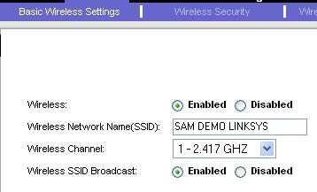
- A box pops up asking for a user name and password. Leave the User Name blank and enter a password of admin
- In the Linksys page, click the Wireless tab. Click the blue “Basic Wireless Settings” tab. In the “Wireless” line, click Enable. Enter your SSID in the “Wireless Network Name(SSID):” box.
- Select a “Wireless Channel” of “1 – 2.417 GHZ”, as shown to the right on this page. At the bottom of the page, click “Save settings”.

Setting WEP Security on the Access Point/Router

WEP Key: ________________________
- Make up a ten-digit hexadecimal WEP key and write it in the box to the right on this page. Each digit can be a numeral 0 through 9, or a letter from A through F.
- On the Wired Client, a browser should still be open, showing address 192.168.10.1
  - If the browser window is not still open, open a new one, go to 192.168.10.1, and log in with User Name blank and a password of admin

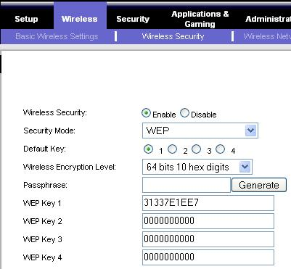
- In the Linksys page, click the Wireless tab. Click the blue “Wireless Security” tab. In the “Wireless Security” line, click Enable. Select a “Security Mode:” of WEP. Enter the WEP Key you wrote in the box on this page into the “WEP Key 1” field. At the bottom of the page, click “Save settings”.

Connecting the Router to the Room’s LAN
- Find the blue cable attached to the wall that used to be plugged into the Wired Client. Plug it into the WAN port on the router. The Internet front panel light should come on.
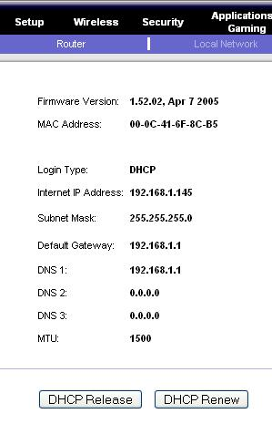
- On the Wired Client, a browser should still be open, showing address 192.168.10.1
  - If the browser window is not still open, open a new one, go to 192.168.10.1, and log in with User Name blank and a password of admin
- In the Linksys page, at the upper right, click the Status tab. At the bottom of the screen, click the “DHCP Renew” button. The router should now show an “Internet IP Address” starting with 192.168.1 as shown to the right on this page. If it does not, click the the “DHCP Renew” button again.
- On the Wired Client, in the Command Prompt window, type in this command and press the Enter key.
PING YAHOO.COM
You should see replies, and you should see the front panel lights on the router blink. The Wired Client is now connected to the Internet through the router.

Skip ahead to the “Connecting a “Wireless Client” to the Access Point/Router” section.

Belkin Router

Restoring the Access Point to Factory Default Settings
- Get the gray Belkin router from the closet. Plug in the power cord. Do not plug in any Ethernet cables yet.
- Use a pin or paper clip to press the little RESET button on the back and hold it in for ten seconds. This resets the router back to its factory default settings.

Connecting a “Wired Client” Computer to the Router
- Choose one computer to be the Wired Client. Disconnect the blue Ethernet cable from the back of the Wired Client. Take another cable and connect the Wired Client to port 1 on the router. Check the front panel of the router: the light under number 1 should light up, but the WAN light should be dark.
- On the Wired Client, click Start, All Programs, Accessories, Command Prompt. Type in this command and press the Enter key.
IPCONFIG
You should see an IP address starting with 192.168.2, as shown below. There are other network adapters present with other IP addresses, but one of them should start with 192.168.2. If you don’t have an IP address like that, restart the Wired Client computer.
Ethernet adapter Local Area Connection 2:

Connection-specific DNS Suffix . :
IP Address. . . . . . . . . . . . : 192.168.2.2

- On the Wired Client, in the Command Prompt window, type in this command and press the Enter key.
PING 192.168.2.1
You should see replies, and you should see the front panel lights on the router blink. The Wired Client is now connected to the router as a client.

SSID: _______________________

Channel: 11

Setting the SSID and Channel on the Access Point/Router
- Make up a new SSID to be your network’s name. Write it in the box to the right on this page. Don't use any spaces in the name.
- On the Wired Client. open a browser and go to this address: 192.168.2.1
- A Belkin page opens. In the upper right, click the “Log in” button.
- A Login screen appears. Leave the Password box empty and click the Submit button. If the browser displays a “Security Warning” box, click Continue.

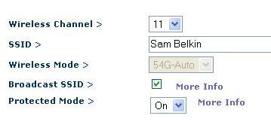
- On the left side of the screen, click “Channel and SSID”.
- In the “Wireless > Channel and SSID” page, enter your SSID in the SSID box.
- Select a “Wireless Channel” of “11”, as shown to the right on this page. At the bottom of the page, click “Apply Changes”.

Setting WEP Security on the Access Point/Router
- Make up a ten-digit hexadecimal WEP key and write it in the box to the right on this page. Each digit can be a numeral 0 through 9, or a letter from A through F.

WEP Key: ________________________
- On the Wired Client, a browser should still be open, showing address 192.168.2.1
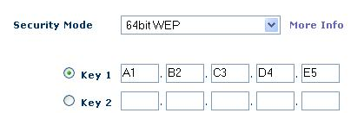
- In the left pane, in the Wireless section, click Security. In the “Security Mode” box, select “64-bit WEP”. Enter the WEP Key you wrote in the box on this page into the “Key 1” field, as shown to the right on this page. At the bottom of the page, click “Apply Changes”.

Connecting the Router to the Room’s LAN
- Find the blue cable attached to the wall that used to be plugged into the Wired Client. Plug it into the “Connection to Modem” port on the router. The WAN front panel light should come on.
- On the Wired Client, a browser should still be open, showing address 192.168.2.1
- In the Belkin page, on the left side, in the “Internet WAN” section, click “Connection Type”.
- In the “WAN > Connection Type” screen, accept the default selection of Dynamic and click the Next button.
- In the “WAN > Connection Type > Dynamic IP” screen, leave the “Host Name” box empty and click the “Apply Changes” button.
- On the Wired Client, in the Command Prompt window, type in this command and press the Enter key.
PING YAHOO.COM
You should see replies, and you should see the front panel lights on the router blink. The Wired Client is now connected to the Internet through the router.

Skip ahead to the “Connecting a “Wireless Client” to the Access Point/Router” section.

D-Link Router

Restoring the Access Point to Factory Default Settings
- Get the gray D-Link router from the closet. Plug in the power cord. Do not plug in any Ethernet cables yet.
- Use a pin or paper clip to press the little RESET button on the back and hold it in for ten seconds. This resets the router back to its factory default settings.

Connecting a “Wired Client” Computer to the Router
- Choose one computer to be the Wired Client. Disconnect the blue Ethernet cable from the back of the Wired Client. Take another cable and connect the Wired Client to port 1 on the router. Check the front panel of the router: the light under number 1 should light up, but the WAN light should be dark.
- On the Wired Client, click Start, All Programs, Accessories, Command Prompt. Type in this command and press the Enter key.
IPCONFIG
You should see an IP address starting with 192.168.0, as shown below. There are other network adapters present with other IP addresses, but one of them should start with 192.168.0. If you don’t have an IP address like that, restart the Wired Client computer.
Ethernet adapter Local Area Connection 2:

Connection-specific DNS Suffix . :
IP Address. . . . . . . . . . . . : 192.168.0.100

- On the Wired Client, in the Command Prompt window, type in this command and press the Enter key.
PING 192.168.0.1
You should see replies, and you should see the front panel lights on the router blink. The Wired Client is now connected to the router as a client.

Setting the SSID and Channel on the Access Point/Router
- Make up a new SSID to be your network’s name. Write it in the box to the right on this page. Don't use any spaces in the name.

SSID: _______________________

Channel: 6

- On the Wired Client. open a browser and go to this address: 192.168.0.1
- A box pops up asking for a user name and password. Enter a user name of admin and leave the password blank. Click the OK button.

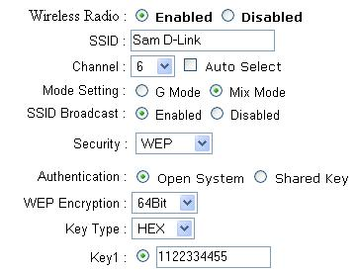
- On the left side of the screen, click “Wireless”.
- Enter your SSID in the SSID box, as shown to the right on this page.
- Select a “Wireless Channel” of “6”, as shown to the right on this page.

Setting WEP Security on the Access Point/Router

WEP Key: ________________________
- Make up a ten-digit hexadecimal WEP key and write it in the box to the right on this page. Each digit can be a numeral 0 through 9, or a letter from A through F.
- In the “Security:” box, select “WEP”. In the “WEP Encryption:” box, select “64-bit”. In the “”Key1:” box, enter the WEP Key you wrote in the box on this page.
- At the bottom of the page, click “Apply”. A message appears saying “The device is restarting”. Click “Continue”.

Connecting the Router to the Room’s LAN
- Find the blue cable attached to the wall that used to be plugged into the Wired Client. Plug it into the “WAN” port on the router. The WAN front panel light should come on.
- On the Wired Client, a browser should still be open, showing the D-Link page.
- On the Wired Client, in the Command Prompt window, type in this command and press the Enter key.
PING YAHOO.COM
You should see replies, and you should see the front panel lights on the router blink. The Wired Client is now connected to the Internet through the router.

Skip ahead to the “Connecting a “Wireless Client” to the Access Point/Router” section.

Finding the MAC Addresses of the Wireless Client and the Access Point/Router
- On the "Wireless Client", click Start, "All Programs", Accessories, "Command Prompt".
- On the "Wireless Client", in the Command Prompt window, type in this command and press the Enter key.
IPCONFIG /ALL
- Find the “Ethernet adapter Wireless Network Connection” section. In that section, find the "Physical Address" and write it on the "Wireless Client MAC Address" line in the box above on this page. Use colons to delimit the address, like this: 00:40:f4:dd:af:25

Wireless Client MAC Address: ____________________________

Wireless Default Gateway: ____________________________

Access Point MAC Address: ____________________________
- Find the “Default Gateway” and write it in the box above on this page.
- On the "Wireless Client", in the Command Prompt window, type in this command and press the Enter key.
ping Gateway
Replace Gateway with the “Wireless Default Gateway” you wrote in the box above. You should see replies.
- On the "Wireless Client", in the Command Prompt window, type in this command, and press the Enter key:
arp –a

- The result should show the "Internet Address" and "Physical Address" of the gateway, as shown to the right on this page. Write the "Physical Address" address on the "Access Point MAC Address" line in the box on the previous page. Use colons to delimit the address, like this: 00:0c:41:6f:8c:b4
L:\Documents and Settings\Sam>arp -a

Interface: 192.168.2.14 --- 0x2
Internet Address Physical Address
192.168.1.1 00-30-bd-02-ed-7b

Getting the BackTrack 2 CD
- You need a BackTrack 2 CD. Your instructor handed them out in class. If you are working at home, you can either copy the CD in the lab, or download it yourself from
http://www.remote-exploit.org/backtrack.html

Booting the Hacker Computer from the BackTrack 2 CD
- Insert the bt2 CD and restart your "Hacker Computer". If it won't boot from the CD, press F2 to enter the BIOS settings page and set it to boot from the CD. If it asks for a BIOS Password, press the Enter key.
- You should see a message beginning ISOLONUX. At the boot: prompt, press the Enter key. Several pages of text scroll by as Linux boots.
- When you see a page with a bt login: prompt, type in this username and press the Enter key:
root
- At the Password: prompt, type in this password and press the Enter key:
toor
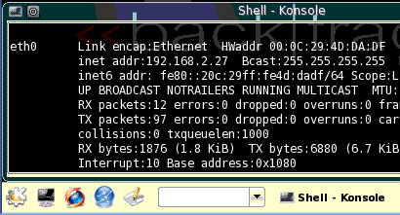
- At the bt ~ # prompt, type in this command and press the Enter key:
Start
button
xconf
- At the bt ~ # prompt, type in this command and press the Enter key:
startx
- A graphical desktop should appear, with a start button showing the letter K on a gear in the lower left, as shown to the right on this page. That K is the Start button.

Plugging in the USB NIC
- Connect the USB cable from the Linksys WUSB54G ver. 4 NIC and verify that the green light on the NIC comes on. There is no pop-up message telling you that the computer has detected it, but it's plug-and-play, just like it would be in Windows! And it has the advanced modes we need, unlike Windows.

Using Airodump to Collect Packets from the WLAN
- On the Hacker Computer, from the Backtrack 2 desktop, click Start, Backtrack, "Radio Network Analysis", 80211, All, Airodump.

- In the airodump window, type in this command and press the Enter key:
airodump-ng --ivs --write projX10 --channel 11 rausb0
This command starts the packet collection. If your WLAN is not operating on channel 11, change 11 to the correct number. Packets will be collected and the Initialization Vectors (IVs) will be stored in a file named projX10.
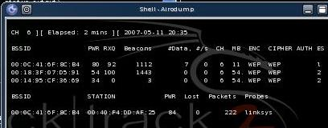

- The top section shows all the networks detected by the card. The lower section shows the network chosen for data collection. Verify that the BSSID in the lower section matches the "Access Point MAC Address" you wrote in the box on a previous page.

Using Aireplay to Inject Packets into the WLAN
- You need about 250,000 packets. As you can see, they are being gathered very slowly, because there is very little traffic on the network. We will use aireplay to speed things up.
- On the Hacker Computer, from the Backtrack 2 desktop, click Start, Backtrack, "Radio Network Analysis", 80211, All, "Air Replay".
- In the airreplay window, type in this command and press the Enter key:
aireplay-ng -3 -b 00:0c:41:6f:8c:b4 -h 00:40:f4:dd:af:25 rausb0
This command starts recording ARP packets and replaying them. Replace the first MAC address with the "Access Point MAC Address" you wrote in a box on a previous page. Replace the second MAC address with the "Wireless Client MAC Address" you wrote in a box on a previous page.
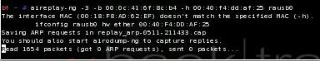

Using Aireplay to Force Disassociation of the Client
- On the Hacker Computer, from the Backtrack 2 desktop, click Start, Backtrack, "Radio Network Analysis", 80211, All, "Air Replay".
- In the airreplay window, type in this command and press the Enter key:
aireplay-ng -0 10 rausb0 -c 00:0c:41:6f:8c:b4 -a 00:40:f4:dd:af:25 rausb0
Replace the first MAC address with the "Access Point MAC Address" you wrote in a box on a previous page. Replace the second MAC address with the "Wireless Client MAC Address" you wrote in a box on a previous page.
This command breaks the connection between the client and the access point ten times, forcing it to re-associate. That creates some ARP packets for the other aireplay window to record and play back.
- After the ten disassociation attacks are over, you should see some ARP requests gotten in the other aireplay window, and the airodump window should show the Data packets coming in rapidly, as shown below. This is the hardest part—getting injection to work. You may have to try several times, and you may have to change the MAC addresses in some of the commands. Check to see that the MAC addresses in the commands match the MAC addresses shown by the Hacker Computer—sometimes they are off by one.

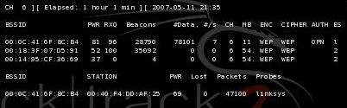

Using Aircrack to Find the WEP Key
- When the #Data rises to 100,000 or so, you can try cracking the key. Leave the airodump-ng window alone, so it continues to collect packets.
- On the Hacker Computer, from the Backtrack 2 desktop, click Start, Backtrack, "Radio Network Analysis", 80211, All, "Air Crack".
- In the “Air Crack” window, type in this command and press the Enter key:
ls -l
This command is lowercase LS –L. There are no numeral 1s in it.

- You should see a list of files, as shown below on this page. Find the file with a name starting with projX10 and a filename extension of .ivs with the largest size. In the figure below, it is projx13-02.ivs with a size of 500571 bytes (this project used to be numbered x13).
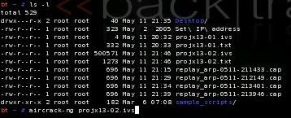
- In the “Air Crack” window, type in this command and press the Enter key:
aircrack-ng projX10-02.ivs -n 64
Replace projX10-02.ivs with the exact filename you found in the previous step – the largest .ivs file you have. The "–n 64" option tells it to look for 64-bit keys, which will make it a lot faster.
- Aircrack will show a chart of numbers, as shown below on this page. Now just wait – it might take as many as 250,000 IVs or even more to crack the key.
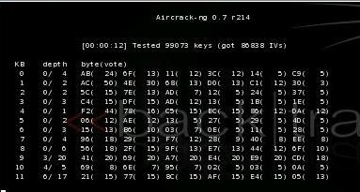

- When you have enough IVs captured (usually at least 100,000), the key will be found, as shown below on this page.
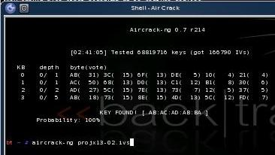

Saving the Screen Image on the Desktop
- On the Hacker Computer, from the Backtrack 2 desktop, click Start, Screenshot.
- In the Screenshot window, click the "Save As…" button.
- In the "Save as – Screenshot" window, in the unlabelled box on the upper right, click the arrow and select /root/desktop.
- In the "Save as – Screenshot" window, in the Location: box, type in a filename of
Yourname-ProjX10.jpg
Firefox
button
- Click the Save button. Your file should appear on the desktop.

Starting Firefox
- On the Hacker Computer, at the lower left of the desktop, click the "Firefox button", as shown to the right on this page.
Turning in your Project
- Firefox opens. Go to a Web-based email service you feel comfortable using in S214 – it should be one with a password you don't use anywhere else.
- Email the JPEG image to me as an attachment. Send the message to cnit.123@gmail.com with a subject line of Proj X10 From Your Name. Send a Cc to yourself.

Last modified 1-1-08

