What You Will Need
Warning: Only use this on networks you own. Cracking into networks without permission is a crime—don’t do it!
- A wireless access point
- A computer running any OS with any wireless NIC to be the client
- A different computer with a Linksys WUSB54G Wi-Fi card, or another Wi-Fi card that is compatible with the BackTrack 2 live CD operating system
- A Backtrack 2 Live CD

Choose Your Access Point/Router
- There are four Access Point/Routers available in S37: Linksys, D-Link, Belkin, and Buffalo. Choose one and use the corresponding instructions below to set up a secure Wireless Local Area Network (WLAN). If you are working at home, you can use any wireless router that supports WPA (they all do, unless your equipment is very old).
Linksys Router

Restoring the Access Point to Factory Default Settings
- Get the blue Linksys BEFW11S4 router from the closet. Plug in the power cord. Do not plug in any Ethernet cables yet.
- Press the little red RESET button on the back and hold it in for ten seconds. This resets the router back to its factory default settings.

Connecting a “Wired Client” Computer to the Router
- Choose one computer to be the Wired Client. Disconnect the blue Ethernet cable from the back of the Wired Client. Take another cable and connect the Wired Client to port 1 on the router. Check the front panel of the router: the light under number 1 should light up, but the Internet light should be dark.
- On the Wired Client, click Start, All Programs, Accessories, Command Prompt. Type in this command and press the Enter key.
IPCONFIG
You should see an IP address starting with 192.168.1, as shown below. There are other network adapters present with other IP addresses, but one of them should start with 192.168.1. If you don’t have an IP address like that, restart the Wired Client computer.
Ethernet adapter Local Area Connection 2:

Connection-specific DNS Suffix . :
IP Address. . . . . . . . . . . . : 192.168.1.101
Subnet Mask . . . . . . . . . . . : 255.255.255.0
Default Gateway . . . . . . . . . : 192.168.1.1

- On the Wired Client, in the Command Prompt window, type in this command and press the Enter key.
PING 192.168.1.1
You should see replies, and you should see the front panel lights on the router blink. The Wired Client is now connected to the router as a client.

Changing the Subnet on the Router
- The LAN in S214 uses the 192.168.1.0 subnet, which is the same as the default subnet for the Linksys router. The router won’t be able to connect to the LAN unless it uses a different subnet for its clients, so we need to change the router to a different subnet.
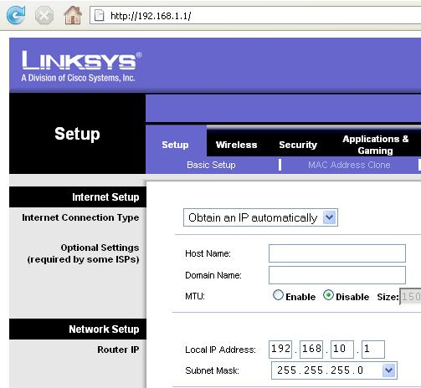
- On the Wired Client. open a browser and go to this address: 192.168.1.1
- A box pops up asking for a user name and password. Leave the User Name blank and enter a password of admin
- In the Linksys page, on the Setup tab, change the Local IP Address to 192.168.10.1, as shown to the right on this page.
- Scroll to the bottom of the page and click the Save Settings button.
- A popup box appears saying “Next time, log in the router with the new IP address”. Click OK.
- Now that the router has a new address, the Wired Client needs a new IP address too to connect to it. To force a DHCP renew, unplug the network cable from port 1 on the router, wait a couple of seconds, and plug it in again.

- On the Wired Client , in the Command Prompt window, type in this command and press the Enter key.
IPCONFIG
You should see an IP address starting with 192.168.10. If you don’t have an IP address like that, restart the Wired Client computer.
- On the Wired Client, in the Command Prompt window, type in this command and press the Enter key.
PING 192.168.10.1
You should see replies, and you should see the front panel lights on the router blink. The Wired Client is now connected to the router again as a client.

Setting the SSID and Channel on the Access Point/Router
- Make up a new SSID to be your network’s name. Write it in the box to the right on this page. Don't use any spaces in the name.

SSID: _______________________

Channel: 1

- On the Wired Client. open a browser and go to this address: 192.168.10.1
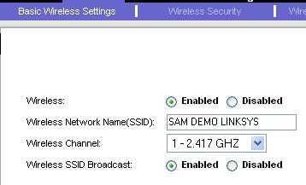
- A box pops up asking for a user name and password. Leave the User Name blank and enter a password of admin
- In the Linksys page, click the Wireless tab. Click the blue “Basic Wireless Settings” tab. In the “Wireless” line, click Enable. Enter your SSID in the “Wireless Network Name(SSID):” box.
- Select a “Wireless Channel” of “1 – 2.417 GHZ”, as shown to the right on this page. At the bottom of the page, click “Save settings”.

Setting WPA Security on the Access Point/Router
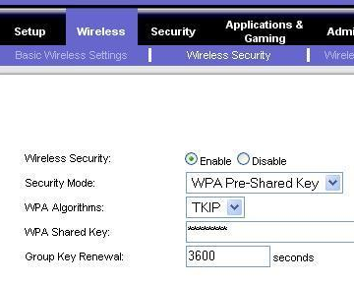
- On the Wired Client, a browser should still be open, showing address 192.168.10.1
  - If the browser window is not still open, open a new one, go to 192.168.10.1, and log in with User Name blank and a password of admin
- In the Linksys page, click the Wireless tab. Click the blue “Wireless Security” tab. In the “Wireless Security” line, click Enable. Select a “Security Mode:” of “WPA Pre-Shared Key”. Enter a “WPA Shared Key” of password as shown to the right on this page. At the bottom of the page, click “Save settings”.

Connecting the Router to the Room’s LAN
- Find the blue cable attached to the wall that used to be plugged into the Wired Client. Plug it into the WAN port on the router. The Internet front panel light should come on.
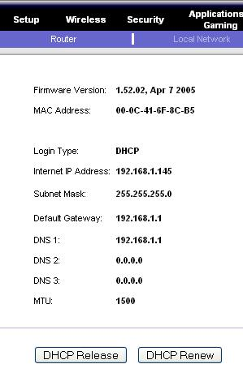
- On the Wired Client, a browser should still be open, showing address 192.168.10.1
  - If the browser window is not still open, open a new one, go to 192.168.10.1, and log in with User Name blank and a password of admin
- In the Linksys page, at the upper right, click the Status tab. At the bottom of the screen, click the “DHCP Renew” button. The router should now show an “Internet IP Address” starting with 192.168.1 as shown to the right on this page. If it does not, click the the “DHCP Renew” button again.
- On the Wired Client, in the Command Prompt window, type in this command and press the Enter key.
PING YAHOO.COM
You should see replies, and you should see the front panel lights on the router blink. The Wired Client is now connected to the Internet through the router.

Skip ahead to the “Connecting a “Wireless Client” to the Access Point/Router” section.

Belkin Router

Restoring the Access Point to Factory Default Settings
- Get the gray Belkin router from the closet. Plug in the power cord. Do not plug in any Ethernet cables yet.
- Use a pin or paper clip to press the little RESET button on the back and hold it in for ten seconds. This resets the router back to its factory default settings.

Connecting a “Wired Client” Computer to the Router
- Choose one computer to be the Wired Client. Disconnect the blue Ethernet cable from the back of the Wired Client. Take another cable and connect the Wired Client to port 1 on the router. Check the front panel of the router: the light under number 1 should light up, but the WAN light should be dark.
- On the Wired Client, click Start, All Programs, Accessories, Command Prompt. Type in this command and press the Enter key.
IPCONFIG
You should see an IP address starting with 192.168.2, as shown below. There are other network adapters present with other IP addresses, but one of them should start with 192.168.2. If you don’t have an IP address like that, restart the Wired Client computer.
Ethernet adapter Local Area Connection 2:

Connection-specific DNS Suffix . :
IP Address. . . . . . . . . . . . : 192.168.2.2

- On the Wired Client, in the Command Prompt window, type in this command and press the Enter key.
PING 192.168.2.1
You should see replies, and you should see the front panel lights on the router blink. The Wired Client is now connected to the router as a client.

SSID: _______________________

Channel: 11

Setting the SSID and Channel on the Access Point/Router
- Make up a new SSID to be your network’s name. Write it in the box to the right on this page. Don't use any spaces in the name.
- On the Wired Client. open a browser and go to this address: 192.168.2.1
- A Belkin page opens. In the upper right, click the “Log in” button.
- A Login screen appears. Leave the Password box empty and click the Submit button. If the browser displays a “Security Warning” box, click Continue.

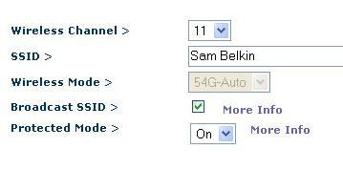
- On the left side of the screen, click “Channel and SSID”.
- In the “Wireless > Channel and SSID” page, enter your SSID in the SSID box.
- Select a “Wireless Channel” of “11”, as shown to the right on this page. At the bottom of the page, click “Apply Changes”.

Setting WPA Security on the Access Point/Router
- On the Wired Client, a browser should still be open, showing address 192.168.2.1
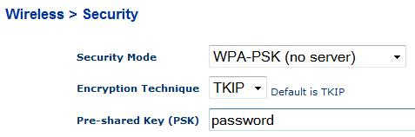
- In the left pane, in the Wireless section, click Security. In the “Security Mode” box, select “WPA-PSK (no server)”. Enter a "Pre-shared key (PSK)" of password as shown to the right on this page. At the bottom of the page, click “Apply Changes”.

Connecting the Router to the Room’s LAN
- Find the blue cable attached to the wall that used to be plugged into the Wired Client. Plug it into the “Connection to Modem” port on the router. The WAN front panel light should come on.
- On the Wired Client, a browser should still be open, showing address 192.168.2.1
- In the Belkin page, on the left side, in the “Internet WAN” section, click “Connection Type”.
- In the “WAN > Connection Type” screen, accept the default selection of Dynamic and click the Next button.
- In the “WAN > Connection Type > Dynamic IP” screen, leave the “Host Name” box empty and click the “Apply Changes” button.
- On the Wired Client, in the Command Prompt window, type in this command and press the Enter key.
PING YAHOO.COM
You should see replies, and you should see the front panel lights on the router blink. The Wired Client is now connected to the Internet through the router.

Skip ahead to the “Connecting a “Wireless Client” to the Access Point/Router” section.

D-Link Router

Restoring the Access Point to Factory Default Settings
- Get the gray D-Link router from the closet. Plug in the power cord. Do not plug in any Ethernet cables yet.
- Use a pin or paper clip to press the little RESET button on the back and hold it in for ten seconds. This resets the router back to its factory default settings.

Connecting a “Wired Client” Computer to the Router
- Choose one computer to be the Wired Client. Disconnect the blue Ethernet cable from the back of the Wired Client. Take another cable and connect the Wired Client to port 1 on the router. Check the front panel of the router: the light under number 1 should light up, but the WAN light should be dark.
- On the Wired Client, click Start, All Programs, Accessories, Command Prompt. Type in this command and press the Enter key.
IPCONFIG
You should see an IP address starting with 192.168.0, as shown below. There are other network adapters present with other IP addresses, but one of them should start with 192.168.0. If you don’t have an IP address like that, restart the Wired Client computer.
Ethernet adapter Local Area Connection 2:

Connection-specific DNS Suffix . :
IP Address. . . . . . . . . . . . : 192.168.0.100

- On the Wired Client, in the Command Prompt window, type in this command and press the Enter key.
PING 192.168.0.1
You should see replies, and you should see the front panel lights on the router blink. The Wired Client is now connected to the router as a client.

Setting the SSID and Channel on the Access Point/Router
- Make up a new SSID to be your network’s name. Write it in the box to the right on this page. Don't use any spaces in the name.

SSID: _______________________

Channel: 6

- On the Wired Client. open a browser and go to this address: 192.168.0.1
- A box pops up asking for a user name and password. Enter a user name of admin and leave the password blank. Click the OK button.

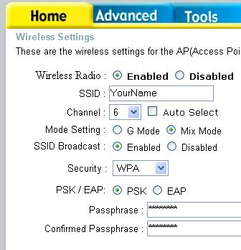
- On the left side of the screen, click “Wireless”.
- Enter your SSID in the SSID box, as shown to the right on this page.
- Select a “Wireless Channel” of “6”, as shown to the right on this page.

Setting WPA Security on the Access Point/Router

WEP Key: ________________________
- In the “Security:” box, select “WPA”.
- In the “Passphrase:” box, enter password
- In the “Confirmed Passphrase:” box, enter password
- At the bottom of the page, click “Apply”. A message appears saying “The device is restarting”. Click “Continue”.

Connecting the Router to the Room’s LAN
- Find the blue cable attached to the wall that used to be plugged into the Wired Client. Plug it into the “WAN” port on the router. The WAN front panel light should come on.
- On the Wired Client, a browser should still be open, showing the D-Link page.
- On the Wired Client, in the Command Prompt window, type in this command and press the Enter key.
PING YAHOO.COM
You should see replies, and you should see the front panel lights on the router blink. The Wired Client is now connected to the Internet through the router.

Buffalo Router with OpenWRT Firmware

Restoring the Access Point to Factory Default Settings
- Get the Buffalo router labeled "OpenWRT" from the closet. Plug in the power cord. Do not plug in any Ethernet cables yet.
- Use a pen to hold the little INIT button on the bottom. Unplug the power cord. Plug the power cord back in and hold the INIT button down for 30 seconds. This resets the router back to its default settings.

Connecting a “Wired Client” Computer to the Router
- Choose one computer to be the Wired Client. Disconnect the blue Ethernet cable from the back of the Wired Client. Take another cable and connect the Wired Client to port 1 on the router. Check the front panel of the router: the light under number 1 should light up, but the WAN light should be dark.
- On the Wired Client, click Start, All Programs, Accessories, Command Prompt. Type in this command and press the Enter key.
IPCONFIG
You should see an IP address starting with 192.168.11, as shown below. There are other network adapters present with other IP addresses, but one of them should start with 192.168.11. If you don’t have an IP address like that, restart the Wired Client computer.
Ethernet adapter Local Area Connection 2:

Connection-specific DNS Suffix . :
IP Address. . . . . . . . . . . . : 192.168.11.175

- On the Wired Client, in the Command Prompt window, type in this command and press the Enter key.
PING 192.168.11.1
You should see replies, and you should see the back panel lights on the router blink. The Wired Client is now connected to the router as a client.

Setting the SSID and Channel on the Access Point/Router
- Make up a new SSID to be your network’s name. Write it in the box to the right on this page. Don't use any spaces in the name.

SSID: _______________________

Channel: 6

- On the Wired Client. open a browser and go to this address: 192.168.11.1
- An "OpenWrt Admin Console" page opens. At the top, click Network. A box pops up asking for a user name and password. Enter a user name of root and type in a password of password
- Click the OK button.

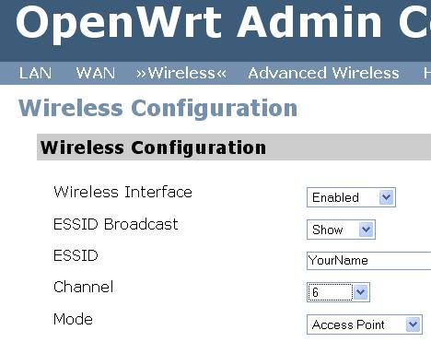
- In the light blue menu bar, below the "OpenWrt Admin Console" header, click “Wireless”.
- Enter your SSID in the ESSID box, as shown to the right on this page.
- Select a “Wireless Channel” of “6”, as shown to the right on this page.
- At the bottom of the page, click the "Save Changes" button. Click the "Apply Changes" link.

Setting WPA Security on the Access Point/Router
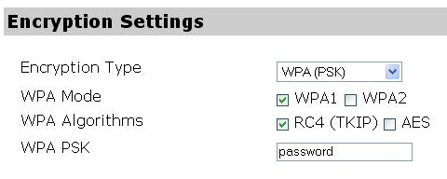
- In the “Encryption Settings:” section near the bottom of the page, select an "Encryption Type" of “WPA (PSK)”, as shown to the right on this page..
- In the “WPA PSK” box, enter password, as shown to the right on this page.
- At the bottom of the page, click the "Save Changes" button. Click the "Apply Changes" link.

Connecting the Router to the Room’s LAN
- Find the blue cable attached to the wall that used to be plugged into the Wired Client. Plug it into the “WAN” port on the router.
- On the Wired Client, in the Command Prompt window, type in this command and press the Enter key.
PING YAHOO.COM
You should see replies, and you should see the front panel lights on the router blink. The Wired Client is now connected to the Internet through the router.

Connecting a “Wireless Client” to the Access Point/Router
- Find a machine with a wireless NIC to use as the “Wireless Client” computer. Machines S214-15, 16, and 17 have wireless NICs, and there are also USB wireless NICs available that can be attached to other stations.
- Disconnect the blue Ethernet cable from the back of your “Wireless Client” computer to ensure that it uses only the wireless connection.
- In the lower right of the desktop, find the Wireless Network Connection icon, as shown to the right on this page. It shows a computer with radio waves coming from it. Right-click that icon and click “View available wireless networks”.
- Find your SSID in the list and click it, as shown to the right on this page. Click the Connect. button
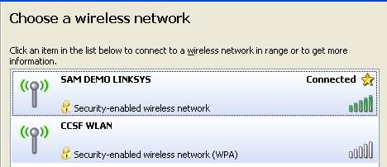
- In the “Wireless network connection” box, enter the WEP Key you wrote in the box on a previous page of these instructions. Put the same key in the second box and click Connect.
- Wait while your Wireless Client connects. When the connection is made, you should see the word “Connected” next to your SSID, as shown to the right on this page.
- On the Wireless Client, click Start, All Programs, Accessories, Command Prompt. Type in this command and press the Enter key.
IPCONFIG
You should see an IP address starting with 192.168.10
- On the Wireless Client, in the Command Prompt window, type in this command and press the Enter key.
PING 192.168.10.1
You should see replies, and you should see the front panel lights on the router blink. The Wireless Client is now connected to the router as a wireless client.

Getting the BackTrack 2 CD
- You need a BackTrack 2 CD. Your instructor handed them out in class. If you are working at home, you download it from
http://www.remote-exploit.org/backtrack.html

Plugging in the USB NIC
- Connect the USB cable from the Linksys WUSB54G ver. 4 NIC.

Booting the Hacker Computer from the BackTrack 2 CD
- Insert the bt2 CD and restart your "Hacker Computer". If it won't boot from the CD, press F2 to enter the BIOS settings page and set it to boot from the CD. If it asks for a BIOS Password, press the Enter key.
- You should see a message beginning ISOLONUX. At the boot: prompt, press the Enter key. Several pages of text scroll by as Linux boots.
- When you see a page with a bt login: prompt, type in this username and press the Enter key:
root
- At the Password: prompt, type in this password and press the Enter key:
toor
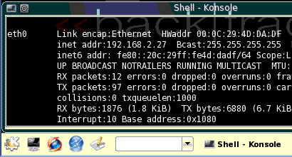
- At the bt ~ # prompt, type in this command and press the Enter key:
Konsole
button
Firefox
button
xconf
- At the bt ~ # prompt, type in this command and press the Enter key:
startx
- A graphical desktop should appear, with a start button showing the letter K on a gear in the lower left, as shown to the right on this page.

Downloading a Word List
- A dictionary attack uses a list of possible pre-shared keys. We'll use a simple, small list that will make the attack fast, although less thorough.
- Click the Firefox button, as shown to the right on this page.
- In Firefox, go to www.cotse.com/tools/wordlists.htm

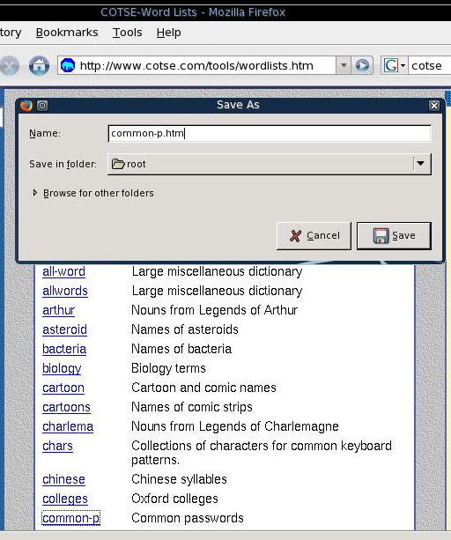
- A Web page with many wordlists appears, as shown to the right on this page. Right-click common-p and click "Save Link As…".
- In the "Save As" box, select a "Save in folder:" of root, as shown to the right on this page. Click the Save button.

Starting the wifi-0 Device
- Click the Konsole button, as shown above on this page.
- In the "Shell – Konsole" window, type in this command, and then press the Enter key:
airmon-ng stop rausb0
- In the "Shell – Konsole" window, type in this command, and then press the Enter key:
airmon-ng start wifi0
We have now stopped the wireless card and restarted it with the special MadWiFi drivers, which are necessary for cracking WEP. Now the card is monitoring on all channels.

Capturing Packets to View the Available Networks
- Click the Konsole button to open a new Konsole window, titled "Shell – Konsole <2>".
- In the "Shell – Konsole <2>" window, type in this command, and then press the Enter key:
airodump-ng –w test rausb0
This command opens a window showing all local networks, as shown below on this page. The columns in the output of immediate importance for cracking WPA are explained below:
BSSID The MAC address of the access point
CH The channel (1 through 11 are used in the USA)
ENC, CIPHER, AUTH These values specify the encryption method, and should say WPA, TKIP, PSK for the pre-shared key method we are cracking.
ESSID The name of the network
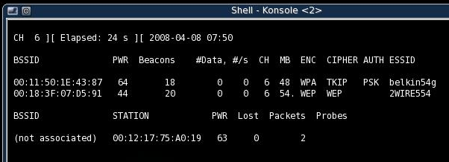

- Write the BSSID, CH, and ESSID of the access point you want to crack into in the box to the right on this page. Note that the BSSID, STATION, etc. information at the bottom of the screen refers to the client, not the Access Point.

BSSID: ______________________________________

CH: __________

ESSID: ______________________________________

- Press Ctrl+C to stop the Airodump capture. If it won't stop, use the mouse to close the "Shell – Konsole <2>" window. Then click the Konsole button to open a new "Shell – Konsole <2>" window.

Restarting Monitoring on the Correct Channel
- Click the "Shell – Konsole" window to make it active—this is the window you used for the airmon-ng commands.
- In the "Shell – Konsole" window, type in this command, and then press the Enter key:
airmon-ng stop rausb0
- In the "Shell – Konsole" window, type in this command, and then press the Enter key:
airmon-ng start wifi0 11
Replace 11with the CH number you wrote in the box above on this page. Now the card is monitoring only the channel we are interested in.

Resuming Packet Capture
- Click the "Shell – Konsole <2>" window to make it active—this is the Konsole window you used for the airodump-ng command.
- In the "Shell – Konsole <2>" window, type in this command, and then press the Enter key:
airodump-ng –c 11 –w output rausb0
Replace 11 with the CH number you wrote in the box above on this page. Now the card is monitoring only the channel we are interested in. This captures packets on the desired channel, and dumps into the file output.cap.
- At the top of the airodump-ng output, information about the access point is displayed. At the bottom is information about associated clients, as shown below on this page. Find the STATION address for a client associated with your access point, and write it in the box to the right on this page. If you don't have any associated station, go to your Wireless Client, disconnect, and reconnect to the access point.

STATION:____________________________________

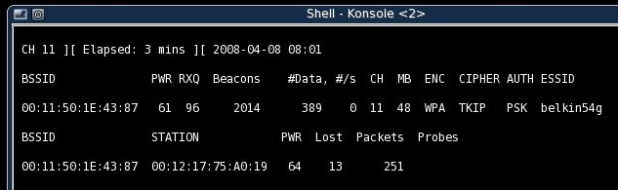

Performing a Deauthentication Attack
- We need to capture a four-way handshake from a client authenticating, to get the data we will use to crack WPA. We could just wait for a client to authenticate, but that might take a long time. The easier way is to force a deauthentication, after which the client will reauthenticate.
- Click the "Shell – Konsole" window to make it active—this is the window you used for the airmon-ng commands.
- In the "Shell – Konsole" window, type in this command, and then press the Enter key:
aireplay-ng –help
This shows a help message, explaining the options available for aireplay-ng. Notice the section at the bottom showing "Attack modes", as shown to below. The attack we will use now is deauthenticate, using the -0 10 switch, to send ten deauthentication frames.
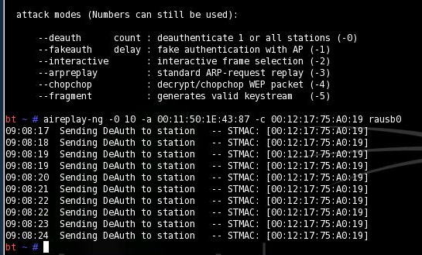

- In the "Shell – Konsole" window, type in this command, and then press the Enter key:
aireplay-ng -0 10 –a 00:11:50:1E:43:87 –c 00:12:17:75:A0:19 rausb0
Replace 00:11:50:1E:43:87 with the BSSID you wrote in the box on a previous page of these instructions (the access point's hardware address).
Replace 00:12:17:75:A0:19 with the STATION you wrote in the box on a previous page of these instructions (the Wireless Client's MAC address).
You should see an "Sending deauth to station" message, as shown above on this page.
- Go look at your Wireless Client. It may have automatically reconnected, or it may now be disconnected. If it is disconnected, reconnect it manually. But most people set their Wi-Fi networks to be remembered and automatically reconnect, so they won't even notice this attack in progress.

Performing a Dictionary Attack on the Captured Handshake
- Now we will capture an ARP request, and replay it to force the Access Point to pump out a lot of IVs.
- In the "Shell – Konsole" window, type in this command, and then press the Enter key:
aircrack-ng -w common-p.htm output*.cap
- You should see a list of BSSID values, and your target network should be labeled with "WPA (1 handshake)", as shown below on this page. If there is no captured handshake, repeat the deauthentication and reauthentication process.
- Enter the index number of your target network and press the Enter key. Aircrack simply tries each password on the list in alphabetical order, as shown below on this page.
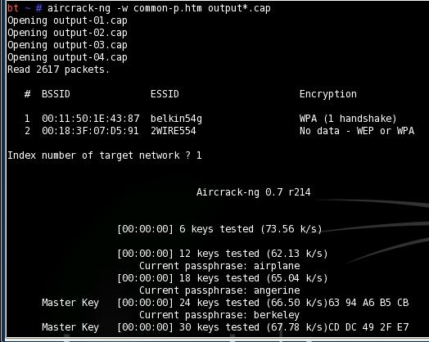

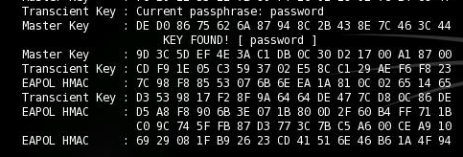
- When it finds your password, you should see the message "KEY FOUND! [ password ]", as shown below on this page.

Saving the Screen Image on the Desktop
- On the Hacker Computer, from the Backtrack 2 desktop, click Start, Screenshot.
- In the Screenshot window, click the "Save As…" button.
- In the "Save as – Screenshot" window, in the unlabelled box on the upper right, click the arrow and select /root/desktop.
- In the "Save as – Screenshot" window, in the Location: box, type in a filename of
Yourname-ProjX10.jpg
Firefox
button
- Click the Save button. Your file should appear on the desktop.

Starting Firefox
- On the Hacker Computer, at the lower left of the desktop, click the "Firefox button", as shown to the right on this page.
Turning in your Project
- Firefox opens. Go to a Web-based email service you feel comfortable using in S214 – it should be one with a password you don't use anywhere else.
- Email the JPEG image to me as an attachment. Send the message to cnit.123@gmail.com with a subject line of Proj X10 From Your Name. Send a Cc to yourself.

Credits
I got a lot of this from "Wireless Vulnerabilities and Cracking with the Aircrack Suite", by Stephen Argent, in the magazine hakin9, Issue 1/2008. There is a lot more information about cracking WEP and WPA in that article, it's great!

Last modified 4-7-08

