There is no need to do this project in S214. Only students who installed their own Windows 2000 virtual machine at home will need to do this project.

What You Will Need
  - A Windows 2000 virtual machine without VMware tools
  - VMware Player and VMmanager
  - An Ubuntu Linux machine

VMware Tools
- VMWare Tools is a software product which makes VMWare run better. The most obvious thing it does is improve the graphics on Windows 2000 virtual machines. It also makes it possible to move the mouse freely from the virtual PC to the host operating system, and also to drag-and-drop files from one machine to the other.

Checking Your Windows 2000 Virtual Machine
- Start your Windows 2000 virtual machine. Right-click the desktop and select New, Text Document. Press the Enter key to accept the default filename. Try to drag the file out of the virtual machine and drop it on the host Windows XP machine's desktop. If you cannot get the mouse to move out of the Virtual Machine's window, you don't have VMWare Tools installed and you need to do this project. If you can drag-and-drop from the virtual machine to the host machine, you already have VMware tools installed and there is no need to do this project.

Using Ubuntu Linux to Extract the VMware Tools ISO
- VMWare Tools is a software product which makes VMWare run better. The most obvious thing it does is improve the graphics on Windows 2000 virtual machines. It also makes it possible to move the mouse freely from the virtual PC to the host operating system, and also to drag-and-drop files from one machine to the other.
- Unfortunately, VMware does not provide the tools for users of the free VMware Player product. But it is possible to extract the tools from an "archived version" of VMware Workstation, without having an activation key to use it.
- Start your Ubuntu Linux machine and log in as usual.
- From the Ubuntu menu bar, click Applications, Accessories, Terminal.

Downloading VMware Workstation ("Archived Copy")
- In the Terminal window, after the $ prompt, enter this command, which will run over into two lines. Then press the Enter key:
wget http://download3.vmware.com/software/wkst/VMware-workstation-5.5.0-18463.tar.gz
This command downloads a VMware file to your local machine. It's a 99 MB download, so it will take a while, but there should be a progress indicator counting through percentages.

Extracting the windows.iso File
- In the Terminal window, after the $ prompt, enter this command, which will run over into two lines. Then press the Enter key:
tar ztvf VMware-workstation-5.5.0-18463.tar.gz | grep windows.iso
This command examines the compressed archive to see if it contains a windows.iso file. The response should be a line ending in the filename:
vmware-distrib/lib/isoimages/windows.iso
- In the Terminal window, after the $ prompt, enter this command, which will run over into two lines. Then press the Enter key:
tar zxvf VMware-workstation-5.5.0-18463.tar.gz vmware-distrib/lib/isoimages/windows.iso
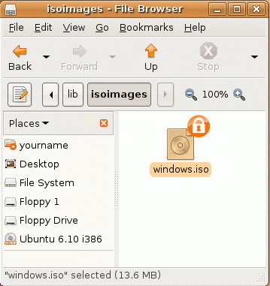
This command extracts the windows.iso file from the compressed archive.

Finding the Extracted windows.iso File
- From the Ubuntu menu bar, click Places, Home Folder.
- In the File Browser window, double-click the vmware-distrib folder to open it.
- Double-click the lib folder to open it.
- Double-click the isoimages folder to open it. You should see the windows.iso file in there, as shown to the right on this page.

Saving the Screen Image
- Make sure windows.iso file is visible.
- Press Ctrl+Alt to release the mouse, and click on the host Windows XP desktop. Press the PrntScn key to copy whole screen to the clipboard.
- On the host Windows XP desktop, open Paint and paste in the image. Save it as a JPEG, with the filename Your Name Proj X11a. Select a Save as type of JPEG.

Copying the windows.iso File to a Shared Folder on a Server
- From the Ubuntu menu bar, click Places, Connect to Server.
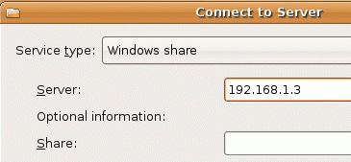
- In the Connect to Server box, select a Service type: of Windows share. In the Server: box, enter your server's IP address (in S214, it's 192.168.1.3 as shown to the right on this page). Click the Connect button.
  - In S214, you are prompted for a user name, workgroup, and password, which are Administrator, S214ccsf, and P@ssw0rd.
- On the desktop of the Ubuntu machine, a folder icon appears labeled 192.168.1.3. Double-click that icon to open it.
- In the Windows Network window, double-click the CNIT 123 folder to open it.
- Drag the windows.iso folder from the Ubuntu system to the CNIT 123 share on the Windows server. If you see a message saying "A file named windows.iso already exists," click Skip. If the file is already there, there's no reason to copy it again.

Shutting Down the Ubuntu Virtual Machine
- The Ubuntu machine won't be needed again in this project, so I recommend you shut it down to make your computer run faster.

Copying the windows.iso File to Your Host Machine
- From the desktop of your host operating system, click Start, Run. In the Run box, enter \\192.168.1.3 and press the Enter key. Open the CNIT 123 folder.
- From the desktop of your host operating system, click Start, My Computer. Open the V: drive. Open the Install folder.
- Drag the windows.iso file from the CNIT 123 folder on the server and drop it into the V:\Install folder. If a message appears telling you that the file already exists, cancel the operation.

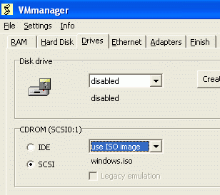
Connecting the Windows 2000 Virtual Machine to the windows.iso file
- On the desktop of your host operating system, double-click VMmanager.
- In the VMmanager window, click the Modify button. Open the V: drive, open your folder, navigate to your Windows 2000 virtual machine and open it.
- Click the Drives tab. In the CDROM section, select use ISO image. Navigate to V:\Install and double-click the windows.iso image, so your screen looks like the example to the right on this page.
- Click the Finish tab, and click the OK button. In the VMmanager box, click OK.

Starting Your Windows 2000 Virtual Machine
- Start your Windows 2000 virtual machine as usual. Log in as Administrator with no password.
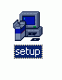
- On the Windows 2000 desktop, double-click My Computer.
- Double-click the VMware Tools (D:) volume to open it.
- Double-click the Setup application to run it. Don't use the icon with a picture of a jar full of pencils—that's not an installer. Use the icon that shows a box of floppy disks by a monitor, as shown to the right on this page.
- Install VMware tools, accepting the default options.

Adjusting Display Properties
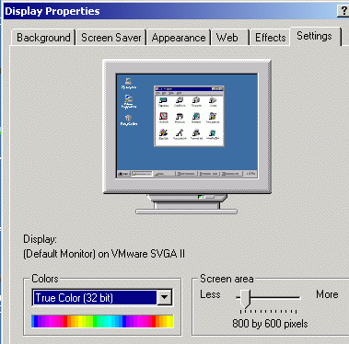
- On the Windows 2000 virtual machine's desktop, right-click and select Properties.
- In the Display Properties box, on the Settings tab, set the Colors to True Color (32 bit) and the Screen Area to 800 by 600 pixels, as shown to the right on this page.

Saving the Screen Image
- Make sure the Windows 2000 Display Properties is visible, as shown to the right on this page.
- Press Ctrl+Alt to release the mouse, and click on the host Windows XP desktop. Press the PrntScn key to copy whole screen to the clipboard.
- On the host Windows XP desktop, open Paint and paste in the image. Save it as a JPEG, with the filename Your Name Proj X11b. Select a Save as type of JPEG.
Turning in your Project
- Email the JPEG images to me as attachments to a single email message Send the message to cnit.123@gmail.com with a subject line of Proj X11 From Your Name. Send a Cc to yourself.

Last modified 6-4-07
Credits
I got a lot of this from http://www.brandonhutchinson.com/Installing_VMware_Tools_with_VMware_Player.html
(link Proj X11)

