What You Need for This Project
- A trusted computer running any version of Windows, with Internet access. You need administrator privileges. This can be either a real or virtual machine.

Introduction to Tor
Tor protects your privacy when you use the Internet by bouncing the packets through randomly-selected "Onion Routers." Tor comes with two related programs—Provixy, a proxy server, and Videlia, a graphical user interface for Tor.
Getting Firefox
- Use your Windows XP virtual machine.
- You need Firefox for this project. If you don't have it, open Internet Explorer and go to getfirefox.com, download it, and install it.
Installing The Onion Router (TOR)
- Open Firefox and go to tor.eff.org
- At the top center of the main page, click Download.
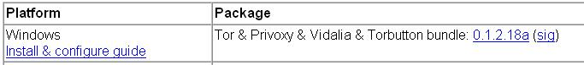
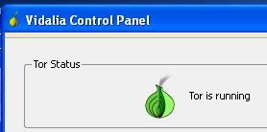
- Click the blue link in the Package column, in the Windows section, as shown below on this page. When I did it, the link name was 0.1.2.18a.
- Save the executable and run it. Click through the Vidalia Bundle Setup Wizard and install the software with the default options. After Tor is installed, you should see a "Vidalia Control Panel" window saying "Tor is running", as shown to the right on this page.
Configuring Firefox to Use FoxyProxy
- In Firefox, go to addons.mozilla.org
- At the top right of the page, enter foxyproxy in the search box and click the Search button.
- In the next page, click the FoxyProxy link. In the next page, click the green Install now link. In the Software Installation box, wait a few seconds, then click the Install Now button.
- Close all windows. Start Firefox again.
- A FoxyProxy box pops up asking "Would you like to configure FoxyProxy for use with Tor?" Click Yes.
- A FoxyProxy box pops up asking "Are you using Tor with Privoxy or without?" Click With.
- A FoxyProxy box pops up saying "…Privoxy is no longer needed…" Click Yes.
- A FoxyProxy box pops up saying "Please enter the port on which Privoxy is listening." Accept the default value of 8118 and click OK.

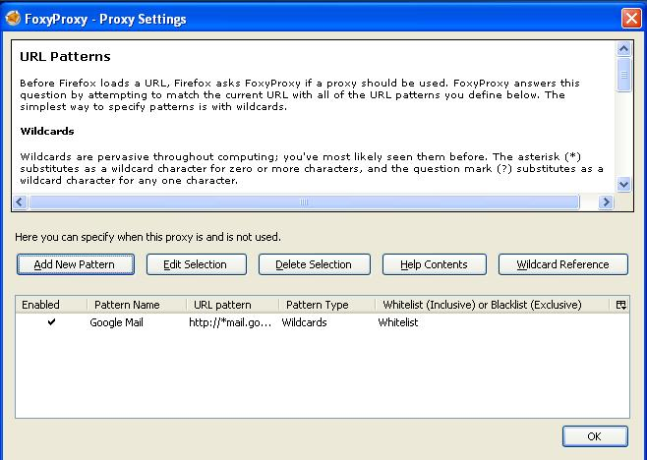
- A FoxyProxy box pops up saying "Would you like DNS requests to go through the Tor network?." Click Yes .
- A "FoxyProxy – Proxy Settings" box appears, as shown to the right on this page. This is asking which pages should use the proxy. Click OK.
- A FoxyProxy box pops up saying "Congratulations!" Click OK.
- A FoxyProxy box pops up saying "Firefox must restart…" Click Yes.
Finding Your IP Address Without Tor
- Look at the status bar in the lower right corner of your Firefox window. You should see "FoxyProxy: Disabled" in red letters.
- In the address bar of the Firefox window, enter the address whatismyipaddress.com and press the Enter key.

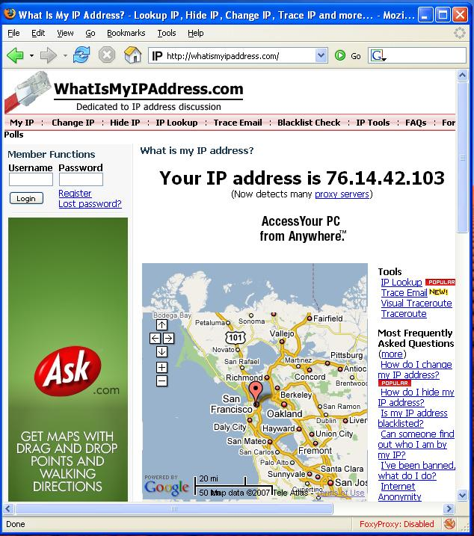
- You should see your IP address in the window, with a map showing your location, as shown to the right on this page. That's the problem—everyone you send packets to can tell who and where you are!

Saving the Screen Image
- Make sure you can see your IP address and the "FoxyProxy: Disabled" notation in the lower right corner of the Firefox window.
- Press the PrtScn button to capture the screen image.
- Click Start, Run. Enter the command mspaint and press the Enter key. Paint opens.
- Press Ctrl+V on the keyboard to paste the image into the Paint window. Click File, Save. Save the document with the filename Your Name Proj X4a. Select a Save as type of JPEG.
Using Tor to Protect Your Privacy
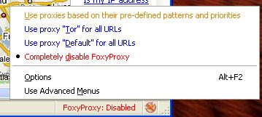
- In the lower right corner of your Firefox window, right-click the red letters saying "FoxyProxy: Disabled". In the context menu, click "Use proxy "Tor" for all URLs".
- The "FoxyProxy: Disabled".label changes to "FoxyProxy: Tor".
- Press the F5 key on the keyboard to refresh the page. The IP address should change to a different address, and the location will change, as shown below on this page.
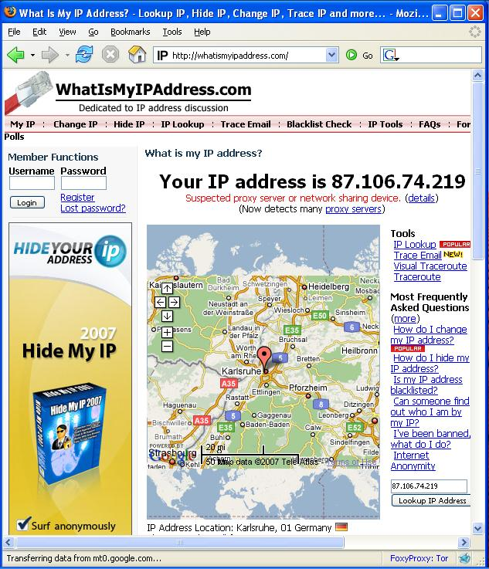
Saving the Screen Image
- Make sure the IP address is different, and that the "FoxyProxy: Tor" message is vusible in the lower right corner of the Firefox window.
- Press the PrtScn button to capture the screen image.

- Click Start, Run. Enter the command mspaint and press the Enter key. Paint opens.
- Press Ctrl+V on the keyboard to paste the image into the Paint window. Click File, Save. Save the document with the filename Your Name Proj X4b. Select a Save as type of JPEG.
Turning in your Project
- Email the JPEG images to me as attachments to one e-mail message to cnit.123@gmail.com with a subject line of Proj X4 From Your Name. Send a Cc to yourself.
Last modified 1-1-08

