Chapter 1

Footprinting

Google Hacking

Find sensitive data about a company from Google

Completely stealthy—you never send a single packet to the target (if you view the cache)

To find passwords:

intitle:"Index of" passwd passwd.bak

See links Ch 1a, 1b on my Web page (samsclass.info, click CNIT 124)

Other fun searches

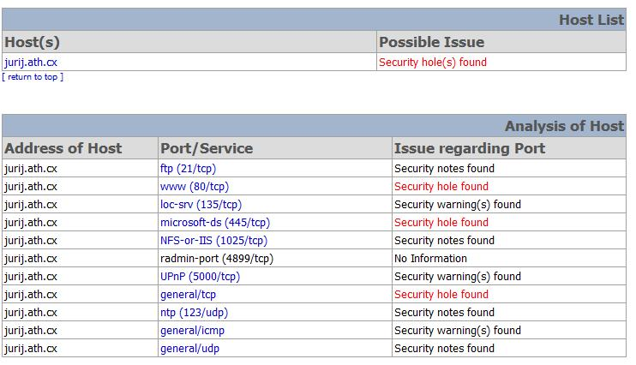
Nessus reports (link Ch 1c)

More passwords (link Ch 1d)

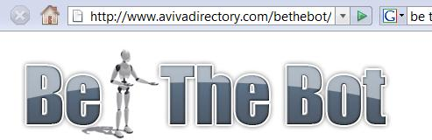

Be The Bot

See pages the way Google's bot sees them

Custom User Agents

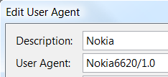
Add the "User Agent Switcher" Firefox Extension

Try this Nokia one for fun

More in Project 2

Footprinting

Gathering target information

"If you know the enemy and know yourself, you need not fear the result of a hundred battles. If you know yourself but not the enemy, for every victory gained you will also suffer a defeat. If you know neither the enemy nor yourself, you will succumb in every battle."

Sun Tzu on the Art of War

Environments and the Critical Information Attackers Can Identify

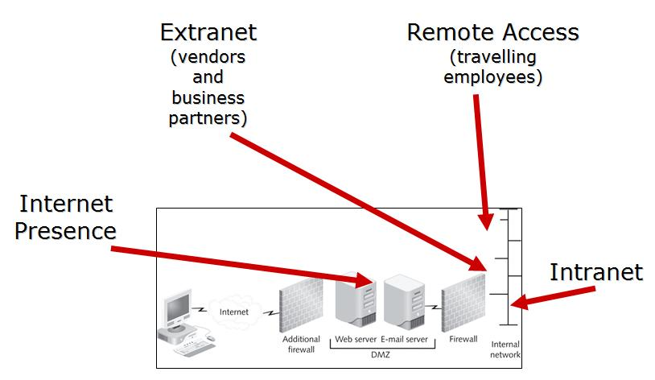
Internet

Domain name

Network blocks

Specific IP addresses of systems reachable via the Internet

TCP and UDP services running on each system identified

System architecture (for example, Sparc vs. x 86)

Access control mechanisms and related access control lists (ACLs)

Intrusion-detection systems (IDSs)

System enumeration (user and group names, system banners, routing tables, and SNMP information) DNS hostnames

Intranet

Networking protocols in use (for example, IP, IPX, DecNET, and so on)

Internal domain names

Network blocks

Specific IP addresses of systems reachable via the intranet

TCP and UDP services running on each system identified

System architecture (for example, SPARC vs. x 86)

Access control mechanisms and related ACLs

Intrusion-detection systems

System enumeration (user and group names, system banners, routing tables, and SNMP information)

Remote access

Analog/digital telephone numbers

Remote system type

Authentication mechanisms

VPNs and related protocols (IPSec and PPTP)

Extranet

Connection origination and destination

Type of connection

Access control mechanism

Internet Footprinting

Step 1: Determine the Scope of Your Activities

Step 2: Get Proper Authorization

Step 3: Publicly Available Information

Step 4: WHOIS & DNS Enumeration

Step 5: DNS Interrogation

Step 6: Network Reconnaissance

Step 1: Determine the Scope of Your Activities

Entire organization

Certain locations

Business partner connections (extranets)

Disaster-recovery sites

Step 2: Get Proper Authorization

Ethical Hackers must have authorization in writing for their activities

"Get Out of Jail Free" card

Criminals omit this step

Image from www.blackhatseo.fr

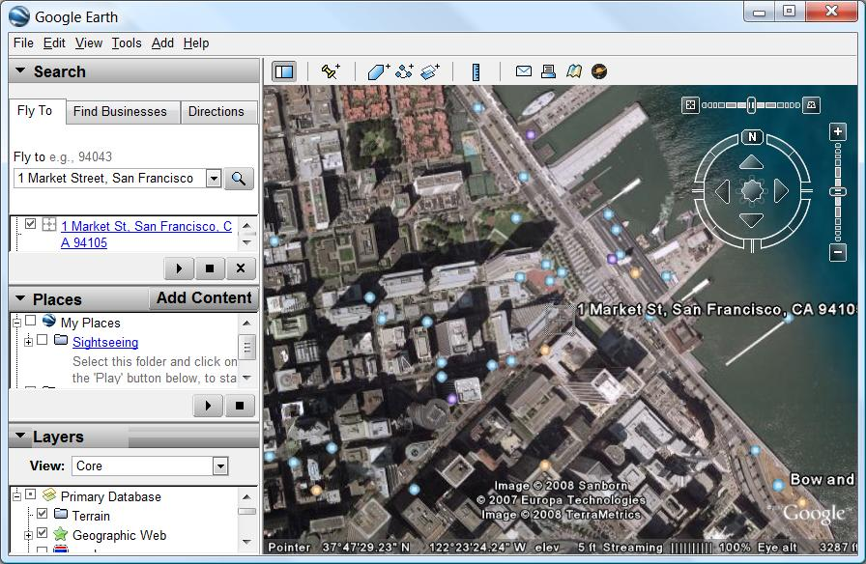
Step 3: Publicly Available Information

Company web pages

Wget and Teleport Pro are good tools to mirror Web sites for local analysis (links Ch 1o & 1p)

Look for other sites beyond "www"

Outlook Web Access

https://owa.company.com or https://outlook.company.com

Virtual Private Networks

http://vpn.company.com or http://www.company.com/vpn

Related Organizations

Physical Address

Dumpster-diving

Surveillance

Social Engineering

Tool: Google Earth (link Ch 1q)

Phone Numbers, Contact Names, E-mail Addresses, and Personal Details

Current Events

Mergers, scandals, layoffs, etc. create security holes

Privacy or Security Policies, and Technical Details Indicating the Types of Security Mechanisms in Place

Archived Information

The Wayback Machine (link Ch 1t)

Google Cache

Disgruntled Employees

Search Engines

SiteDigger seems to be out of date—I tried to get it to work with a Google AJAX key but it doesn't

Wikto is an alternative that might still work (link Ch 1u)

Usenet

Groups.google.com

Resumes

Step 4: WHOIS & DNS Enumeration

Two organizations manage domain names, IP addresses, protocols and port numbers on the Internet

Internet Assigned Numbers Authority (IANA; http://www.iana.org)

Internet Corporation for Assigned Names and Numbers (ICANN; http://www.icann.org)

IANA still handles much of the day-to-day operations, but these will eventually be transitioned to ICANN

Domain-Related Searches

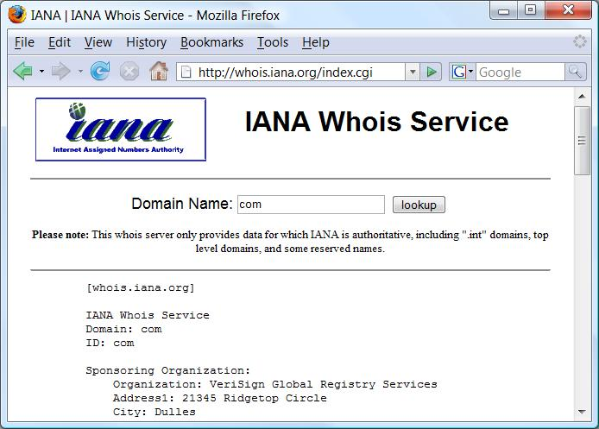
Every domain name, like msn.com, has a top-level domain - .com, .net, .org, etc.

If we surf to http://whois.iana.org, we can search for the authoritative registry for all of .com

.com is managed by Verisign

Verisign Whois (link Ch 1v)

Search for ccsf.edu and it gives the Registrar

Whois.educause.net

Three steps:

Authoritative Registry for top-level domain

Domain Registrar

Finds the Registrant

Automated tools do all three steps

Whois.com

Sam Spade

Netscan Tools Pro

They are not perfect. Sometimes you need to do the three-step process manually.

Once you've homed in on the correct WHOIS server for your target, you may be able to perform other searches if the registrar allows it

You may be able to find all the domains that a particular DNS server hosts, for instance, or any domain name that contains a certain string

BUT a court decision in South Dakota just declared this illegal (link Ch 1o)

How IP addresses are assigned:

The Address Supporting Organization (ASO http://www.aso.icann.org) allocates IP address blocks to

Regional Internet Registries (RIRs), which then allocate IPs to organizations, Internet service providers (ISPs), etc.

ARIN (http://www.arin.net) is the RIR for North and South America

IP-Related Searches

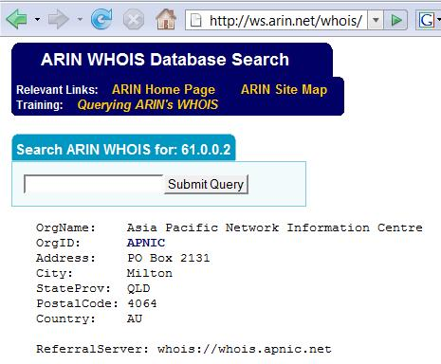
To track down an IP address:

Use arin.net (link Ch 1x)

It may refer you to a different database

Examples:

147.144.1.1

61.0.0.2

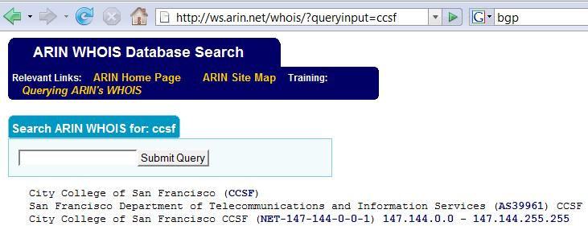

Search by company name at arin.net to find IP ranges, and AS numbers

AS numbers are used by BGP (Border Gateway Protocol) to prevent routing loops on Internet routers (link Ch 1y)

Examples: Google, CCSF

Administrative contact gives you name, voice and fax numbers

Useful for social engineering

Authoritative DNS Server can be used for Zone Transfer attempts

But Zone Transfers may be illegal now (link Ch 1s)

Public Database Security Countermeasures

When an administrator leaves an organization, update the registration database

That prevents an ex-employee from changing domain information

You could also put in fake "honeytrap" data in the registration

eBay's domain was hijacked (link Ch 1z1)

Step 5: DNS Interrogation

Zone Transfers

Gives you a list of all the hosts when it works

Usually blocked, and maybe even illegal now

Demonstration (with Ubuntu)

dig soa hackthissite.org

ANSWER shows SOA is dns1.nettica.com

dig @ dns1.nettica.com hackthissite.org axfr

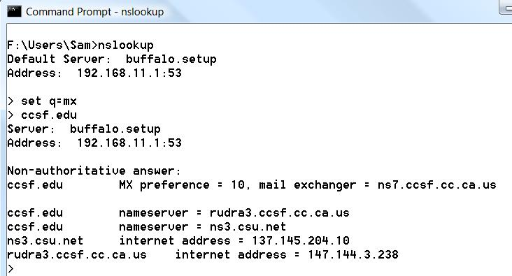
Determine Mail Exchange (MX) Records

You can do it on Windows with NSLOOKUP in Interactive mode

DNS Security Countermeasures

Restrict zone transfers to only authorized servers

You can also block them at the firewall

DNS name lookups are UDP Port 53

Zone transfers are TCP Port 53

Attackers could still perform reverse lookups against all IP addresses for a given net block

So, external nameservers should provide information only about systems directly connected to the Internet

Step 6: Network Reconnaissance

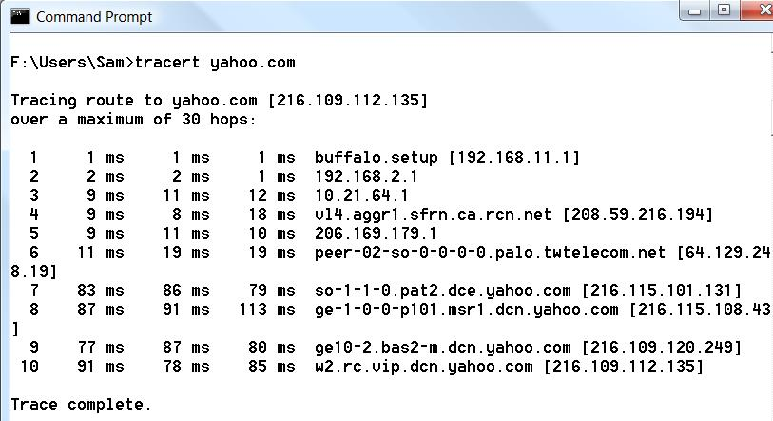
Traceroute

Can find route to target, locate firewalls, routers, etc.

Windows Tracert uses ICMP

Linux Traceroute uses UDP by default

Tracert

NeoTrace
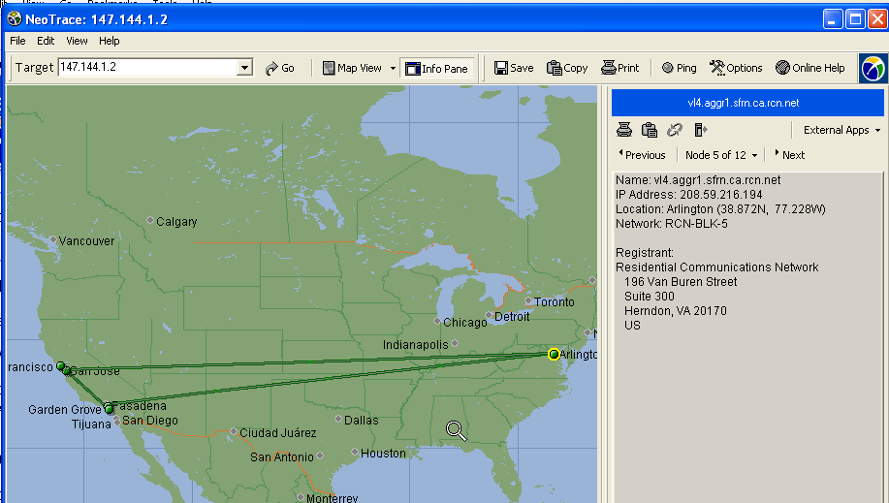

NeoTrace combines Tracert and Whois to make a visual map (link Ch 1z2)

Cain & Abel has a customizable Traceroute function that lets you use any TCP or UCP port, or ICMP

Link Ch 1z4

But it didn't work when I tried it on XP or Vista

Firewalk uses traceroute techniques to find ports and protocols that get past firewalls

We will discuss Firewalk later (Chapter 11)

Countermeasures

Many of the commercial network intrusion-detection systems (NIDS) and intrusion prevention systems (IPS) will detect this type of network reconnaissance

Snort – the standard IDS(link Ch 1z5)

RotoRouter – Detects traceroutes and sends fake responses (link Ch 1z6)

Countermeasures

You may be able to configure your border routers to limit ICMP and UDP traffic to specific systems, thus minimizing your exposure

Last modified 1-21-08

