Determining If The System Is Alive

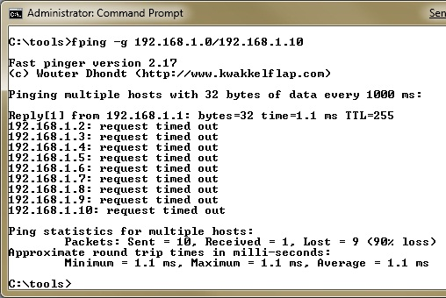
Summary

Ping Sweeps

Fping

Nmap

SuperScan

Ping Sweep from SolarWinds

Hping2

Icmpenum

Countermeasures

ICMP Queries

Determining If The System Is Alive

Network Ping Sweeps

Ping is traditionally used to send ICMP ECHO (Type 8) packets to a target system

Response is ICMP ECHO_REPLY (Type 0) indicating the target system is alive

fping

fping is a fast PING scanner, because it doesn't wait for a response from one system before moving on to the next one

Available for Linux and Windows

Link Ch 2b for Windows version (slower than Linux version)

Ping Sweep With Nmap

Use the –sP option
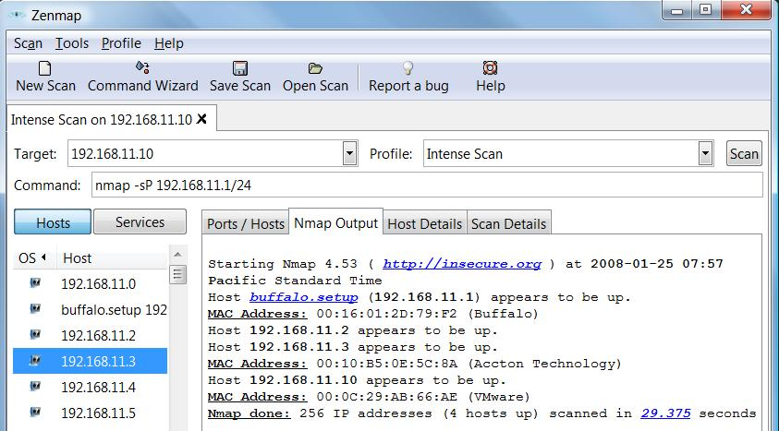

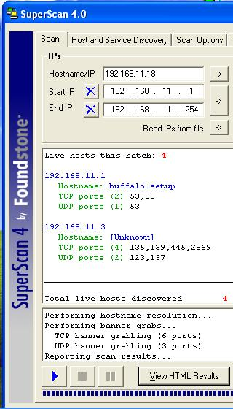
SuperScan

Does PING scanning, using several types of ICMP packets

Also does port scanning, banner grabbing, whois, and enumeration

Superscan Enumeration

To run SuperScan, you need Win 2000 or Win XP before SP 2

Great tool

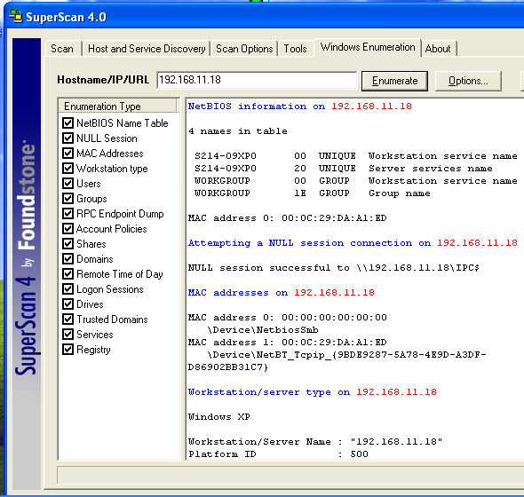
Link Ch 2c

ICMP Packet Types

Message Type: 0 - Echo Reply

Message Type: 3 - Destination Unreachable

Message Type: 4 - Source Quench

Message Type: 5 - Redirect

Message Type: 8 - Echo

Message Type: 11 - Time Exceeded

Message Type: 12 - Parameter Problem

Message Type: 13 - Timestamp

Message Type: 14 - Timestamp Reply

Message Type: 15 - Information Request

Message Type: 16 - Information Reply

Ping Sweep from SolarWinds

Scans really fast, which can saturate a network

Commercial tool, but there's a 30-day trial available

Ch 2d

icmpenum

Unix utility that sends the traditional ICMP ECHO packets as well as

ICMP TIME STAMP REQUEST and

ICMP INFO requests

Similar to SuperScan

ICMP Blocking

ICMP is often blocked these days

Blocked by default in Win XP SP2, Win 2003 SP 1, and Vista

If ICMP is blocked, use port scanning

Slower than ping sweeping

SuperScan for Win 2000 or XP without SP2

Nmap for Linux, Unix, or Windows

Hping2 for Unix (can fragment packets)

Nmap

TCP Ping Scan uses TCP ACK packets instead of ICMP

Zenmap GUI runs on Vista (as Administrator) – very pretty

Use –PT 80 to get through many firewalls

Link Ch 2i

Other Ports to Use

Email ports

SMTP (25)

POP (110)

IMAP (143)

AUTH (113)

IDENT service – determines remote user of a network connection (link Ch 2g)

Ping Sweeps Countermeasures

Detecting Ping Sweeps

Network-based Intrusion Detection Systems like Snort detect ping sweeps

Ping scans will be in the host logs

Firewalls can detect ping scans

Ping Sweep Detection Tools

For Unix

Scanlogd, Courtney, Ippl, Protolog
For Windows

Snort could be used (link Ch 2z9)

Blocking ICMP

Routers may require some ICMP packets, but not all types

Safest procedure would be to allow ICMP only from your ISP, and only to public servers on your DMZ

Other ICMP Threats

ICMP can be used for a Denial of Service attack

ICMP can be used as a covert channel with Loki

Allowing unauthorized data transfer

Such as control signals for a back-door trojan

Links Ch 2l, Ch 2m

ICMP Queries

icmpquery uses ICMP type 13 (TIMESTAMP) to find the system time, which shows its timezone

ICMP type 17 (ADDRESS MASK REQUEST) shows the subnet mask

Link Ch 2n

Determining Which Services Are Running Or Listening

Summary

Port Scanning

Scan Types

Identifying TCP and UDP Services Running

Windows-Based Port Scanners

Port Scanning Breakdown

Port Scan Types

We covered these ones in CNIT 123

TCP Connect scan

TCP SYN scan

TCP FIN scan

TCP Xmas Tree scan (FIN, URG, and PUSH)

TCP Null scan

TCP ACK scan

UDP scan

TCP Header
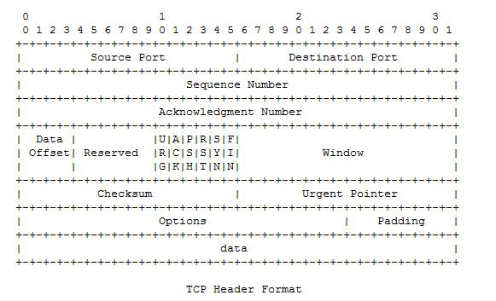

WINDOW indicates the amount of data that may be sent before an acknowledgement is required

TCP Window Scan

Sends ACK packets

Both open and closed ports reply with RST packets

But on some operating systems, the WINDOW size in the TCP header is non-zero for open ports, because the listening service does sometimes send data

Link Ch 2x

RPC Scan

SunRPC (Sun Remote Procedure Call) is a common UNIX protocol used to implement many services including NFS (Network File System)

The RPC scan works on Unix systems, including Solaris

Enumerates RPC services, which are rich in exploitable security holes

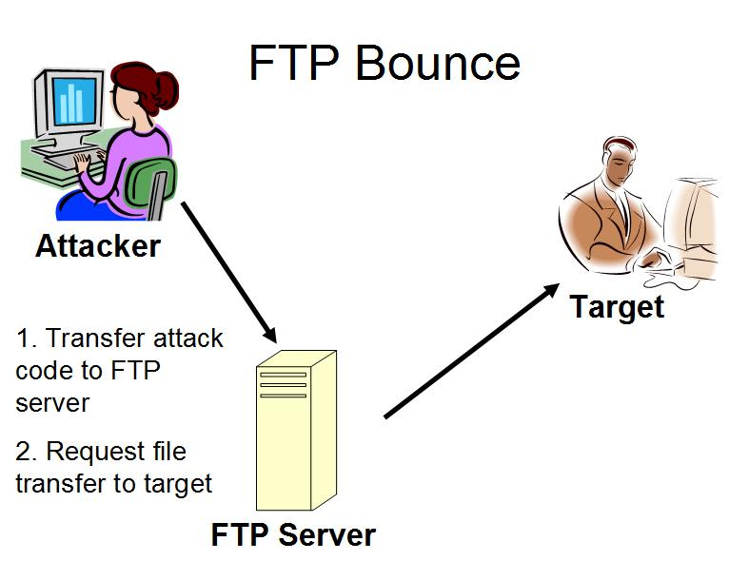
See link Ch 2y

Nmap

Interesting options

-f fragments packets

-D Launches decoy scans for concealment

-I IDENT Scan – finds owners of processes (on Unix systems)

-b FTP Bounce (see next slide)

FTP Bounce

Old FTP servers allowed a request for a file transfer to a third IP address

This could be used to send email or other data to the third computer from the FTP server

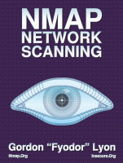
Nmap Book Out

Available from Amazon
Highly recommended

Older Port Scanning Tools

strobe – fast TCP scanner

udp_scan – UDP scanner

netcat – can do port scanning

Amap (not in book)

Application scanner – finds applications even if they are running on unusual ports

Steps to use amap:

Create a folder C:\amap

Download amap from link Ch 2h & extract it there

Run an nmap scan with this option, to save the output file:

–oM c:\amap\filename.nmap
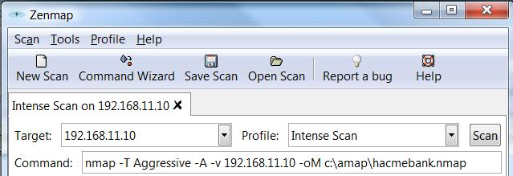

At Command Prompt in C:\amap

amap –bqv –i hackmebank.nmap

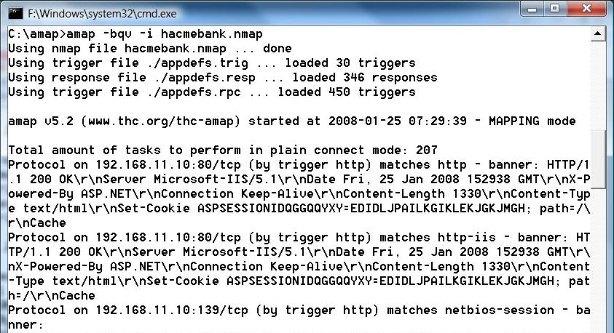

Windows-Based Port Scanners

SuperScan

Four different ICMP host-discovery techniques

Accurate UDP scan sending "nudge strings"

Banner grabbing

Many other tools

Nmap with the Zenmap GUI

Powerful, runs on Vista
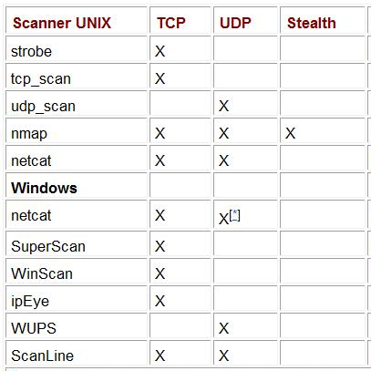

Popular Scanning Tools and Features

Add Nmap with Zenmap in the Windows group

Port Scanning Countermeasures

Snort (http://www.snort.org) is a great free IDS (Intrusion Detection System)

[**] spp_portscan: PORTSCAN DETECTED from 192.168.1.10 [**] 05/22-18:48:53.681227 [**] spp_portscan: portscan status from 192.168.1.10: 4 connections across 1 hosts: TCP(0), UDP(4) [**] 05/22-18:49:14.180505 [**] spp_portscan: End of portscan from 192.168.1.10 [**] 05/22-18:49:34.180236

Other Detection Tools

Scanlogd

Detects TCP port scans on Unix

Firewalls can detect port scans

Use threshold logging to limit the volume of email alerts sent by your firewall
That groups similar alerts into a single email

Preventing Port Scans

You can't stop the scans from coming in, but you can mimimize your attack surface

Disable unnecessary services
Detecting the Operating System

Banner-Grabbing

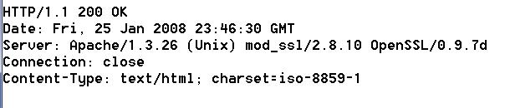
Many services announce what they are in response to requests

Banner grabbers just collect those banners

But they could be spoofed

Active Stack Fingerprinting

Details of the TCP Packets are used to identify the operating system

Nmap does this, using these probes:

FIN probe

Bogus Flag probe

Initial Sequence Number (ISN) sampling

"Don't fragment bit" monitoring

TCP initial window size

And many others

Operating System Detection Countermeasures

IDS can detect operating system detection scans

Hacking the OS to change its TCP stack is dangerous, and not recommended

Best policy: Accept that your firewalls and proxy servers will be scanned and fingerprinted, and harden them against attackers who know the OS

Passive Operating System Identification

Sniff traffic and guess the OS from that

Examine these features

TTL (time-to-live)

Window size

DF (Don't fragment bit)

siphon was the first tool to do this, it's out of date

p0f is a newer one (link Ch 2z6)

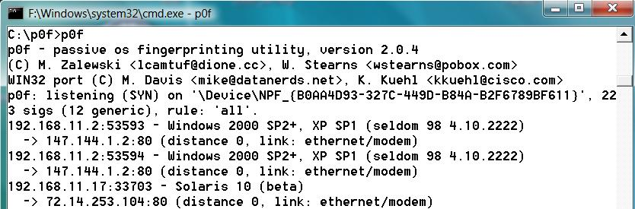
p0f on Vista

Run p0f in a Command Prompt Window

Open a Web page

It fingerprints any OS it can see on the LAN

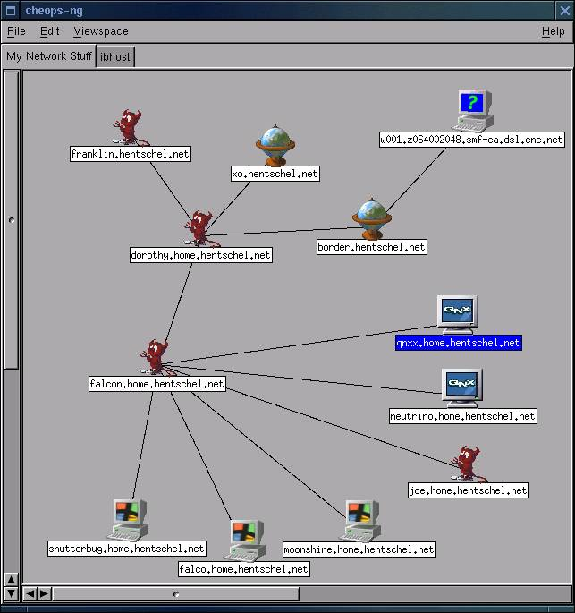
Automated Discovery Tool: Cheops-ng

Combines Ping, Traceroute, Port Scans, and OS Detection to draw a network map

Link Ch 2z7

Vista's "Network Map" is worth a look

Last modified 1-23-09

