Reasons for Windows Security Problems

Popularity

Default insecure configurations

Perceived simplicity, so administrators leave settings at defaults

Legacy Support

Proliferation of features

Unauthenticated Attacks

Proprietary Windows networking protocols

Server Message Block (SMB)

Microsoft Remote Procedure Call (MSRPC)

NetBIOS Session Service

NetBIOS Names Service (NBNS)
Remote Password Guessing

Attack the Windows file and print sharing service

Uses Server Message Block (SMB)

SMB uses TCP ports 139 and 445

Attempt to connect to an enumerated share (such as IPC$ or C$)

Try username/password combinations until you find one that works

Getting Usernames

As covered in chapter 3, these techniques give you the usernames

Null sessions

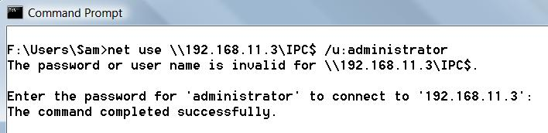
DumpACL/DumpSec

sid2user/user2sid

Password Guessing from the Command Line

Accounts may lock out after too many guesses

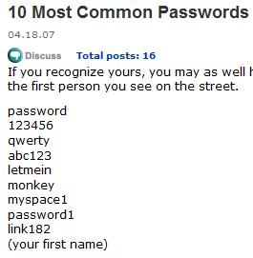
Common Passwords

Link Ch 4a

Windows Internet service implementations

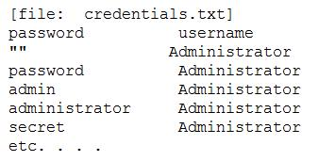
HTTP, SMTP, POP3, and NNTP

All within IIS (Internet Information Services)

A Password Guessing Script

Put password – user name pairs in a file named credentials.txt

Other tools: Legion, NetBIOS Auditing Tool (NAT) , SMBGrind

Password-Guessing Countermeasures

Use a network firewall to restrict access to SMB services on TCP 139 and 445

Use host-resident features of Windows to restrict access to SMB

IPSec filters (Restricts by source IP – link Ch4b)

Windows Firewall

Disable SMB services (on TCP 139 and 445)

Enforce the use of strong passwords using policy

Set an account-lockout threshold and ensure that it applies to the built-in Administrator account

Enable audit account logon failures and regularly review Event Logs

Security Policy

SECPOL.MSC at a Command Prompt
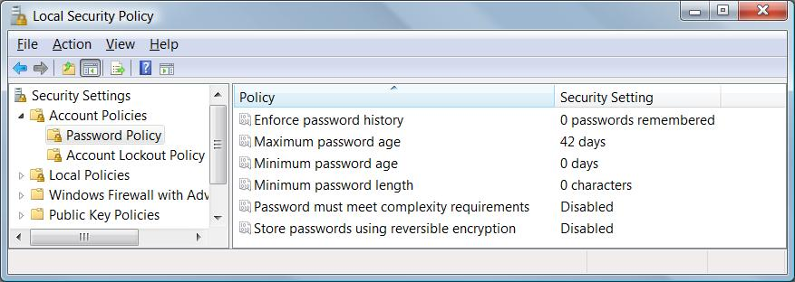

Real-Time Burglar Alarms: Intrusion Detection/Prevention

For more, see links Ch 4c, 4d
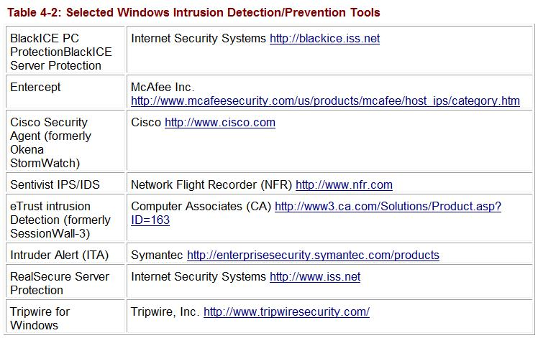

Eavesdropping on Network Password Exchange

L0phtcrack was renamed LC5, and was discontinued by Symantec in 2006

You can sniff password challenge-response hashes with ettercap, or Cain

Follow the Proj X2 procedure

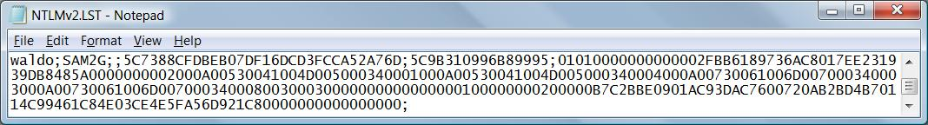
Captured hash appears in C:\Program Files\Cain, in the NTLMv2LST file

Use NTLM, not LM

The old LM Hashes are easily cracked

The newer NTLM hashes are harder to crack, although they can be broken by dictionary attacks

Elcomsoft has a new tool that cracks NTLM hashes by brute force, clustering many computers together

See link Ch 4f
Microsoft Remote Procedure Call (MSRPC) vulnerabilities

The MSRPC port mapper is advertised on TCP and UDP 135 by Windows systems

It cannot be disabled without drastically affecting the core functionality of the operating system

MSRPC interfaces are also available via other ports, including TCP/UDP 139, 445 or 593, and can also be configured to listen over a custom HTTP port via IIS or COM Internet Services

RPC DOM Buffer Overflow

Very serious, from 2003

Used by the Blaster worm and more

In the Metasploit database

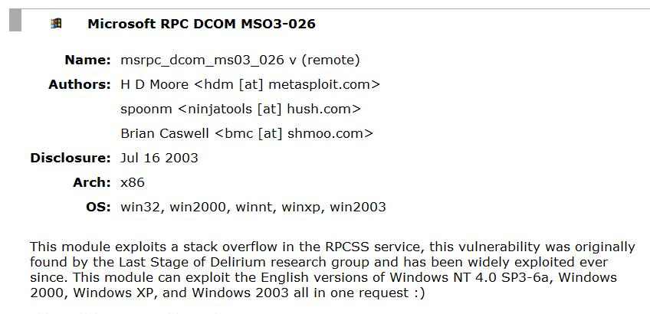
See links Ch 4g, 4h

MSRPC Countermeasures

Filter these ports

TCP ports 135, 139, 445, and 593

UDP ports 135, 137, 138, and 445

All unsolicited inbound traffic on ports greater than 1024

Any other specifically configured RPC port

If installed, COM Internet Services (CIS) or RPC over HTTP, which listen on ports 80 and 443
Local Security Authority Service (LSASS) Buffer Overflow

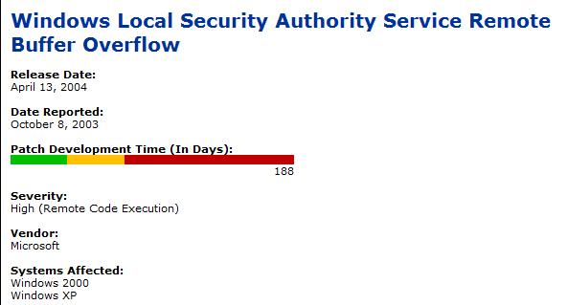
Very serious, used in Sasser work

Microsoft took 188 days to patch it

In Metasploit database; links Ch 4i, 4j

LSASS Buffer Overflow Countermeasures

Filter access to TCP ports 139 and 445

Apply the MS04-011 patch to your systems

Modern antivirus products like McAfee also protect you

see project 2 (Metasploit) in CNIT 123
Internet Information Services (IIS) Exploits

IIS was installed by default in Win 2000, but not in Win 2003

IIS exploits use three major attack vectors

Information disclosure

Directory traversal

Buffer overflows

Buffer Overflows

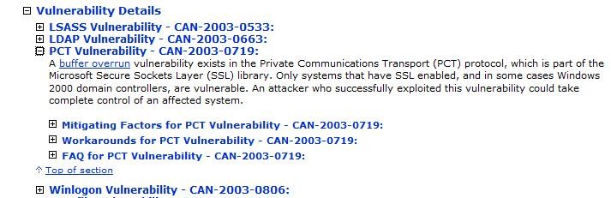
The MS04-011 patch addressed many vulnerabilities (link Ch 4j)

PCT (Private Communications Transport)

PCT was an early method of securing HTTP

Made obsolete by SSL long ago

Legacy code still exists in Windows 2000 and 2003 SSL libraries

To disable it, see link Ch 4k

Lesson – remove legacy code promptly!

IIS Attack Countermeasures

Network Ingress—and Egress!—Filtering

Web servers should never be initiating connections to external parties

But some newer XML-based services require servers to initiate connections

See links Ch 4l, 4m

Keep Up with Patches!

Even patch the services you aren't using

Disable Unused ISAPI Extension and Filters!

These handle requests for special file types (for example, .printer or .idq files)

All of the serious IIS buffer overflows to date could be completely avoided if the vulnerable ISAPIs were unmapped

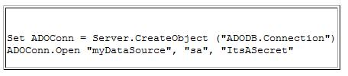
No Sensitive Data in Source Code

ASP scripts often contain user names and passwords in the clear

See links Ch 4n and 4o (a Google Code search for real examples)

Deploy Virtual Roots on Separate Volume

Put public Web page files on a separate volume, that doesn't contain

Private files

System executables

That way even if an attacker can traverse directories(../ attack), there's less for them to find

Use NTFS

FAT has no security

Disable Unnecessary Services

Other IIS Security Resources

Link Ch 4q

Consider IIS Lockdown and URLScan

Implemented in IIS 6 by default

Enable Logging

Tighten Web App Security, Too!

Last modified 2-8-08

