Authenticated Attacks

Privilege Escalation

Pilfering

Grabbing the Password Hashes

Cracking Passwords

LSADump

Previous Logon Cache Dump

Remote Control and Back Doors

Port Redirection

Countermeasures

Covering Tracks
Privilege Escalation

Once a user can log on to a Windows machine as a Guest or Limited User, the next goal is to escalate privileges to Administrator or SYSTEM

Getadmin was an early exploit (link Ch 4r)

There have been many others, including a buffer overrun MS03-013 (link Ch 4s)

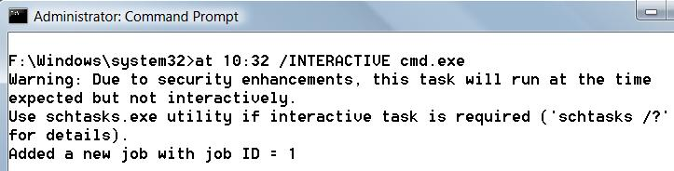
SYSTEM status

The SYSTEM account is more powerful than the Administrator account

The Administrator can schedule tasks to be performed as SYSTEM

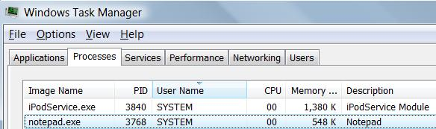
It's more complicated in Vista, but still possible

Making a SYSTEM Task in Vista

Start, Task Scheduler

Action, Create Task

Change User or Group, select SYSTEM

Fill in wizard, notepad.exe

You can see it in Task Manager, but it's not interactive (see link Ch 4t)

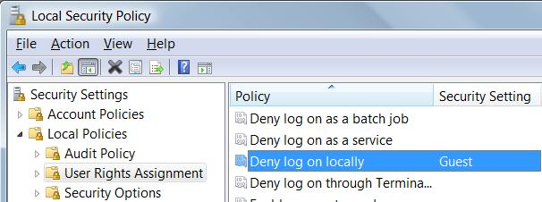
Preventing Privilege Escalation

Keep machines patched

Restrict interactive logon to trusted accounts

Start, secpol.msc

Deny log on locally

Pilfering

Once Administrator-equivalent status has been obtained on one machine

Attackers try to gather important information – pilfering

Common Targets

Password hashes

LSA Secrets

Previous Logon Cache

Grabbing the Password Hashes

Stored in in the Windows Security Accounts Manager (SAM) under NT4 and earlier, and

In the Active Directory on Windows 2000 and greater domain controllers (DCs)

The SAM contains the usernames and hashed passwords of all users

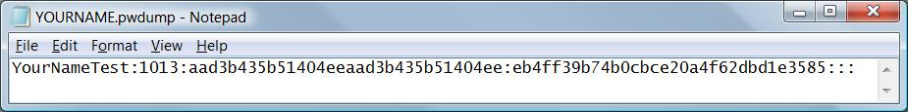
The counterpart of the /etc/passwd file from the UNIX world

Obtaining the Hashes

NT4 and earlier stores password hashes in %systemroot%\system32\config\SAM

It's locked as long as the OS is running

It's also in the Registry key HKEY_LOCAL_MACHINE\ SAM

On Windows 2000 and greater domain controllers, password hashes are kept in the Active Directory

%windir%\WindowsDS\ntds.dit

How to Get the Hashes

Boot the target system to an alternate OS and copy the files to removable media

Copy the backup of the SAM file created by the Repair Disk Utility

But this file is protected by SYSKEY encryption, which makes it harder to crack (perhaps impossible)

Note: SYSKEY also protects the original SAM

But if you have Administrator access, SYSKEY can be cracked, unless you have moved the key off the computer

Links Ch 4u, 4v, 4w

How to Get the Hashes

Sniff Windows authentication exchanges

Extract the password hashes from a running system with pwdump2

Can bypass SYSKEY protection

Injects a DLL into a highly privileged process in a running system

Link Ch 4x

We'll use Ophcrack to do it

pwdump2 Countermeasures

There is no defense against pwdump2, 3, 4, …

But the attacker needs local Administrative rights to use them

Cracking Passwords

The hash is supposed to be really difficult to reverse

NTLM hashes are really hard to break

But Windows still uses LM Hashes for backwards compatibility

They are turned off by default in Vista

Brute Force v. Dictionary

There are two techniques for cracking passwords

Brute Force

Tries all possible combinations of characters

Dictionary

Tries all the words in a word list, such as able, baker, cow…

May try variations such as ABLE, Able, @bl3, etc.

Password-Cracking Countermeasures

Strong passwords – not dictionary words, long, complex

Add non-printable ASCII characters like (NUM LOCK) ALT255 or (NUM LOCK) ALT-129

LSADump

Local Security Authority (LSA) Secrets

Contains unencrypted logon credentials for external systems

Available under the Registry subkey of HKEY_LOCAL_MACHINE\SECURITY\Policy\Secrets

Encrypted when the machine is off, but decrypted and retained in memory after login

Contents of LSA Secrets

Service account passwords in plaintext.

Accounts in external domains

Cached password hashes of the last ten users to log on to a machine

FTP and web-user plaintext passwords

Remote Access Services (RAS) dial-up account names and passwords

Computer account passwords for domain access

Scary Demo

Boot Win XP, log in with your usual Admin acct

Change your password

Use Cain to dump the LSA Secrets – your password is just right there in the DefaultPassword

Log in as a different Administrator user

The LSA Secrets show your other account's password!

Link Ch 4z01

Win XP Password in LSA Secrets
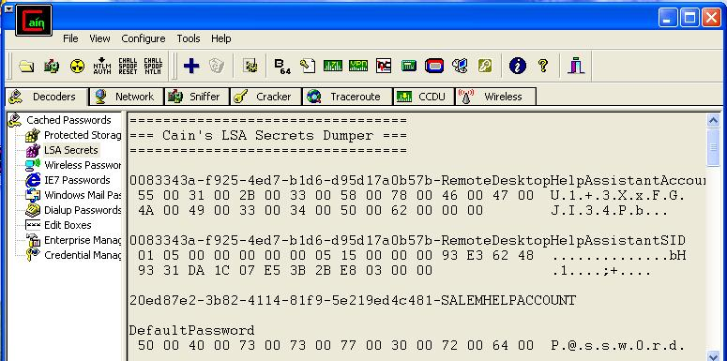

LSA Secrets Countermeasures

There's not much you can do—Microsoft offers a patch but it doesn't help much

Microsoft KB Article ID Q184017 (link Ch 4z02)

Vista seems far less vulnerable

Local Admin rights can lead to compromise of other accounts that machine has logged in to

Previous Logon Cache Dump

If a domain member cannot reach the domain controller, it performs an offline logon with cached credentials

The last ten domain logons are stored in the cache, in an encrypted and hashes form

The tool CacheDump can reverse the encryption and get the hashed passwords

Download it at link Ch 4z03

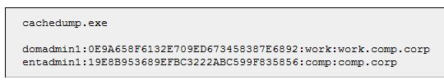
More info at links Ch 4z04, 4z05

CacheDump Results

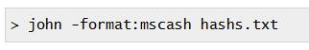
John the Ripper can crack these hashes with brute-force and dictionary attacks

Another cracking tool is cachebf (link Ch z06)

Previous Logon Cache Dump Countermeasures

You need Administrator or SYSTEM privileges to get the hashes

You can also adjust the Registry to eliminate the cached credentials

But then users won't be able to log in when a when a domain controller is not accessible
Remote Control and Back Doors

Command-line Remote Control Tools

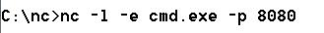
Netcat for Windows

Download it at link Ch 3d

Use this syntax to listen on port 8080, and execute cmd

Add –d for stealth mode (no interactive console)

Obviously this is very dangerous—remote control with no logon

Connecting to the nc Listener

On another machine connect with

TELNET IP 8080

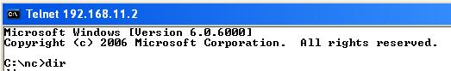
You get a shell on the other machine

Works on Vista

PsExec

From SysInternals (now part of Microsoft)

Allows remote code execution (with a username and password)

Link Ch 4z07

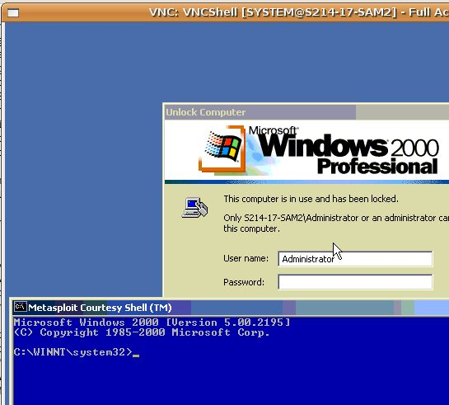
Graphical Remote Control

The Windows Built-in Terminal Services (aka Remote Desktop) listens on port 3389

VNC as used in MetaSploit

It's not on by default

VNC is free and very commonly used for graphic remote control

Can easily be installed remotely

Link Ch 4z08

Remote Access Trojans

There are a lot of them, including

Poison Ivy (link Ch 4z09)

GoToMyPC (link Ch 4z10)

LogMeIn Hamachi (link Ch 4z11)

Remote Control Countermeasures

Prevent attackers from gaining administrator rights on your machine

You can find and stop running remote control clients with malware scans, looking for unusual network connections or traffic

It can be very hard if the connections are hidden by a rootkit

Port Redirection
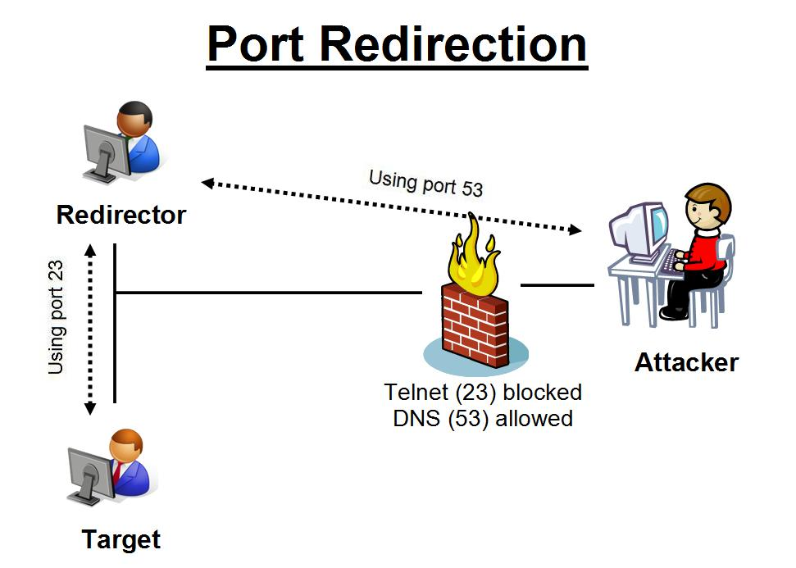

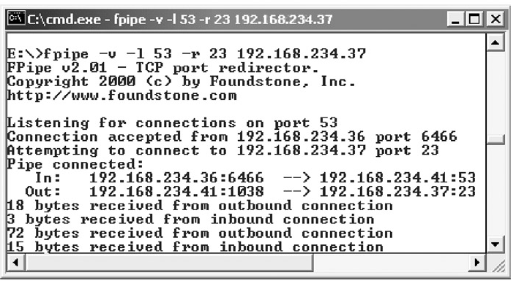
Fpipe is a port redirection tool from Foundstone

Link Ch 4z12

General Countermeasures to Authenticated Compromise

Once a system has been compromised with administrator privileges, you should just reinstall it completely

You can never be sure you really found and removed all the backdoors

But if you want to clean it, here are techniques:

Suspicious Files

Known dangerous filenames like nc.exe

Run antivirus software

Use Tripwire or other tools that identify changes to system files

Link Ch 4z13

Suspicious Registry Entries

Look for registry keys that start known backdoors like"

HKEY_USERS\.DEFAULT\Software\ORL\WINVNC3

HKEY_LOCAL_MACHINE\SOFTWARE\Net Solutions\NetBus Server

A Back-Door Favorite: Autostart Extensibility Points (ASEPs)
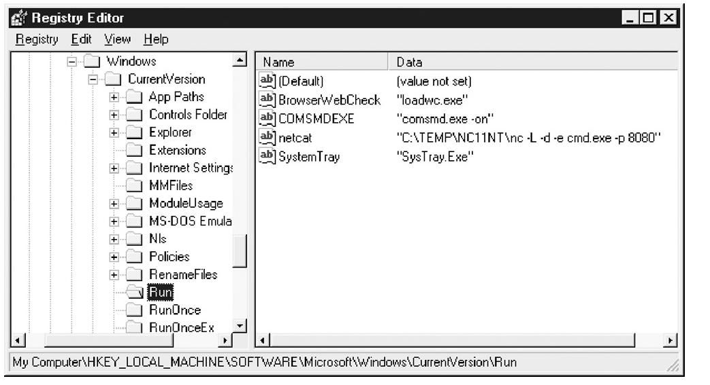

Ways to Make a Program Run at Startup in Vista

Registry keys

Run or RunOnce or Policies\Explorer\Run

Load value

RunServices or RunServicesOnce

Winlogon or BootExecute

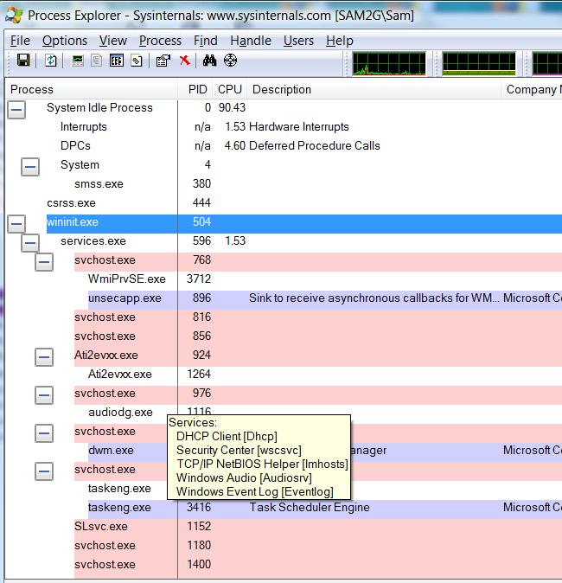
Scheduled Tasks

Win.ini

Group Policy

Shell service objects

Logon scripts

Suspicious Processes

Process Explorer

Link Ch 4z14

Suspicious Ports

Use netstat -aon to view network connections
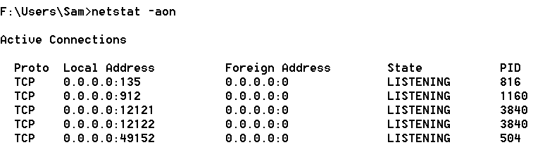

FPORT Process Mapper

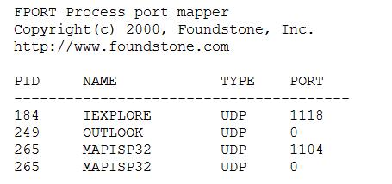
Doesn't work on Vista

Software Explorer

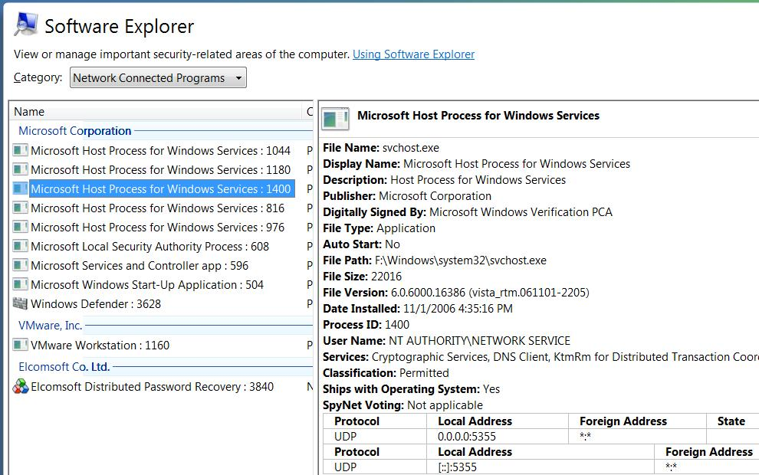
Part of Windows Defender in Vista

Covering Tracks

Once intruders have Administrator or SYSTEM-equivalent privileges, they will:

Hide evidence of intrusion

Install backdoors

Stash a toolkit to use for regaining control in the future and to use against other systems

Disabling Auditing

The auditpol /disable command will stop auditing

Auditpol /enable will turn it back on again

Auditpol is included in Vista

Part of the Resource Kit for earlier versions (XP, NT, 2000 Server)

Clearing the Event Log

ELsave – command-line log clearing tool

Written for Windows NT

Link Ch 4z15

Hiding Files

Attrib +h filename

Sets the Hidden bit, which hides files somewhat

Alternate Data Streams

Hide a file within a file

A NT feature designed for compatibility with Macintosh

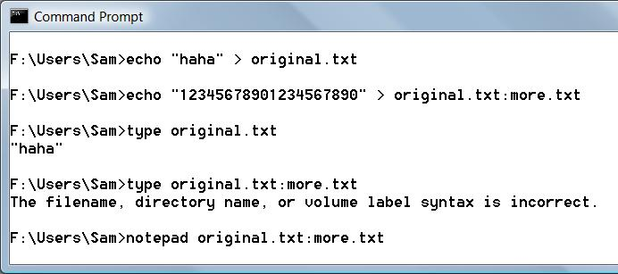
Demonstration of ADS

ADS With Binary Files

You need the cp command (supposedly in the Resource Kit, although I can't find it available free online)

To detect alternate data streams, use LADS (link Ch 4z16)

Rootkits

Rootkits are the best way to hide files, accounts, backdoors, network connections, etc. on a machine

More on rootkits in a later chapter
Windows Security Features

Keep Up with Patches

Group Policy

Allows customized security settings in domains

IPSec filters can be used to block unwanted network traffic

Windows Firewall is easier to use

Windows Firewall With Advanced Security is greatly enhanced in Vista

Least Privilege

Most Windows users use an Administrative accout all the time

Very poor for security, but convenient

For XP, 2003, and earlier: log on as a limited user, use runas to elevate privileges as needed

For Vista and Server 2008, this process is automated by User Account Control

Encrypting File System (EFS)

Can encrypt files or folders

This protects critical files from intruders

In Vista, BitLocker Drive Encryption is much stronger

Only on Enterprise and Ultimate Edition

BUT: there is a way to crack BitLocker by taking the key out of RAM (link Ch 4z17)

Video: Hacking BitLocker

Last modified 2-22-08

