Analog Dial-up Hacking

The public switched telephone network (PSTN) is still a popular network connection

Most large companies are more vulnerable through poorly inventoried modem lines than via firewall-protected Internet gateways
War-Dialing

War-dialers automate the process: footprint, scan, enumerate, exploit

Programmatically dial large banks of phone numbers

Log valid data connections (called carriers )

Attempt to identify the system on the other end of the phone line

Optionally attempt a log on by guessing common usernames and passphrases

Preparing to Dial Up

Phone Number Footprinting

Phone directories

War-dial a whole exchange

CCSF's exchange is 415-239-XXXX

Using 4 modems, a four-digit exchange can be war-dialed in a day or two

Of course, don't war-dial anyone without permission

Other Ways to Find Phone Numbers

Social engineering phone company reps

Corporate websites

Whois at http://www.arin.net will provide primary administrative, technical, and billing contact information

Leaks Countermeasures

Limit publication of phone numbers

Work closely with your telecommunications provider to ensure

Proper numbers are being published

Establish a list of valid personnel authorized to perform account management

Require a password to make any inquiries about an account

Staff should be suspicious of unidentified callers requesting information

War-Dialing

Freeware tools run in DOS

A basic PC with two standard COM ports and a serial card to add two more is recommended

A multiport card, sometimes referred to as a "digiboard" card, can allow for four or eight modems on one system

Standard time-out is 46 to 60 seconds

10,000 numbers will take 7 days of 24-hour calling

Legitimate pen-tests typically only take place on evenings and weekends

Several modems make it a lot faster

Legal Issues

In some localities, it is illegal to dial large quantities of numbers in sequence, and local phone companies will take a very dim view of this activity, if their equipment allows it at all

Randomizing numbers won't make it legal

Obtain written legal permission

ToneLoc

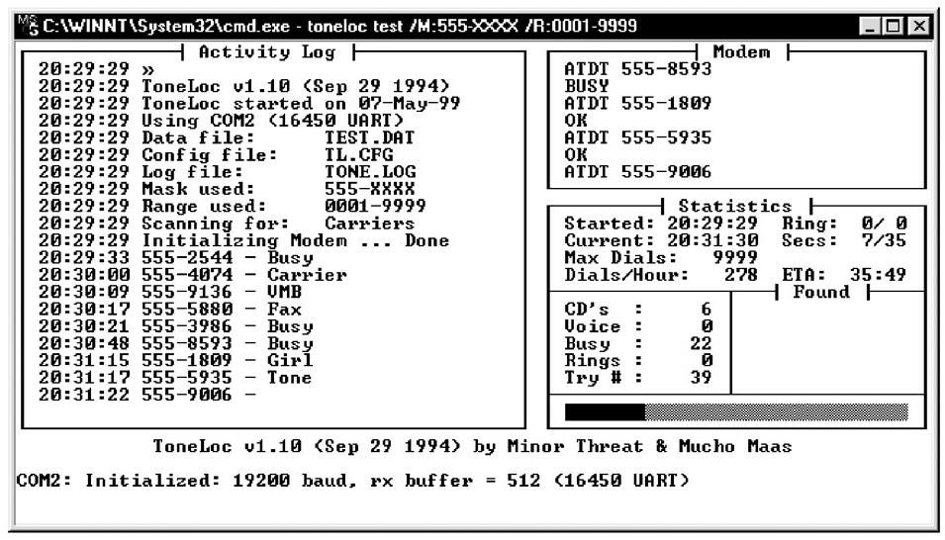
Free DOS tool

THC-Scan

Another free DOS tool

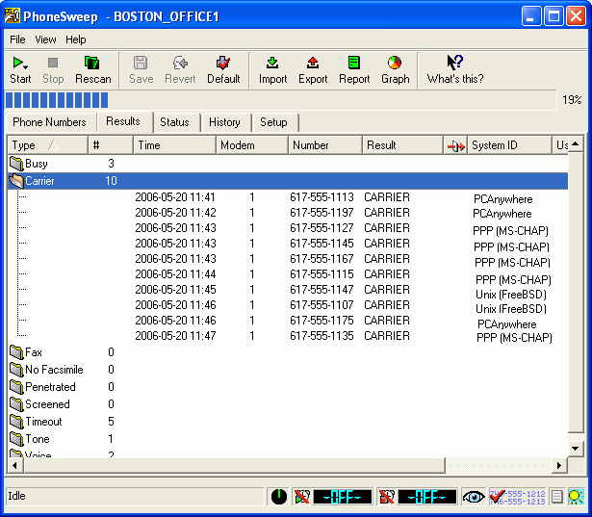

PhoneSweep

Commercial product, costs $1200 or more (link Ch 601)

Things to Find by Wardialing

Remote control services like pcAnywhere

Dial-up connections to servers

PBX and voicemail systems

Much more info at link Ch 605

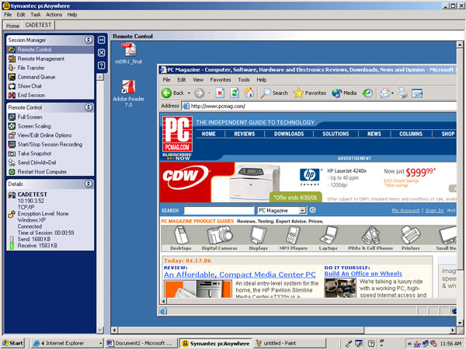
pcAnywhere

Remote control via modem

Still popular, often used insecurely

Links Ch 602-604

Brute-Force Scripting

War-Dialing Penetration Domains

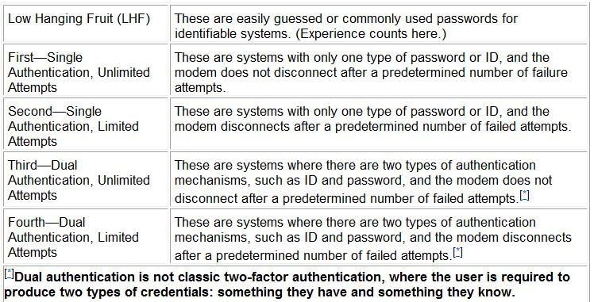

Default Password List

Link Ch 606

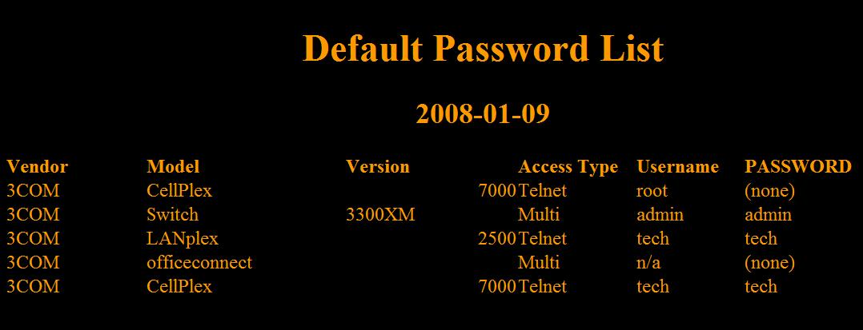
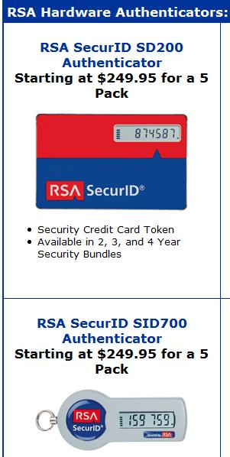

ProComm Plus and ASPECT

ProComm Plus emulates a terminal

ASPECT is the scripting language

Old tools intended for Windows 2000 and earlier versions

Very useful, but no longer supported by Symantec

Links Ch 609 & 610

Dial-Up Security Measures

Inventory existing dial-up lines

By war-dialing every six months

Consolidate all dial-up connectivity

Put it in the DMZ

Add intrusion detection and firewall technology

Limit connections to trusted subnets

Monitor connections

Make analog lines harder to find

Use a different phone number range

Don't publish the numbers

Ensure physical security of telecommunications equipment closets

Regularly monitor existing log features within your dial-up software

Look for failed login attempts, late-night activity, and unusual usage patterns

Use Caller ID to store all incoming phone numbers

Disable any banner information presented upon connect

Require two-factor authentication systems for all remote access

Link Ch 607

Require dial-back authentication

The remote system hangs up and calls back to a predetermined number

Make sure the help desk personnel are careful giving out or resetting remote access credentials

Centralize the provisioning of dial-up connectivity within one security-aware department in your organization

Make it very difficult to get a POTS (plain old telephone service) line

Dial-up Security is Important

Experience shows that many companies have glaring, trivially navigated POTS dial-up holes that lead right to the heart of their IT infrastructure

Going to war with your modems may be the single most important step toward improving the security of your network
PBX Hacking

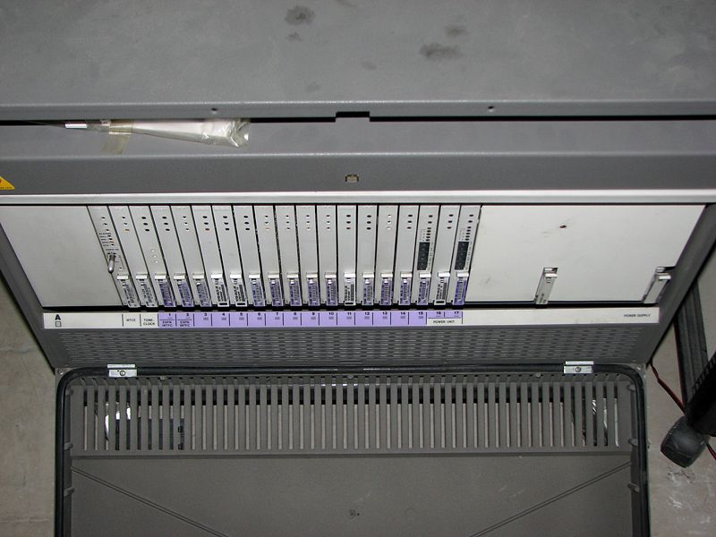
PBX (Private Branch Exchange)

A PBX connects the internal telephones of a company

That saves money on intra-company calls

Link Ch 608

Dial-up Access to a PBX

Consoles used to be hard-wired to a PBX

PBX vendors usually tell their customers that they need dial-in access for external support

But it is often done insecurely, leaving a modem always on and connected to the PBX

It should be turned off except when needed

Voicemail Hacking

Voicemail is often important, confidential, and poorly secured

Top executives often neglect to pick an unique code for voicemail

Brute-force ASPECT scripts work well
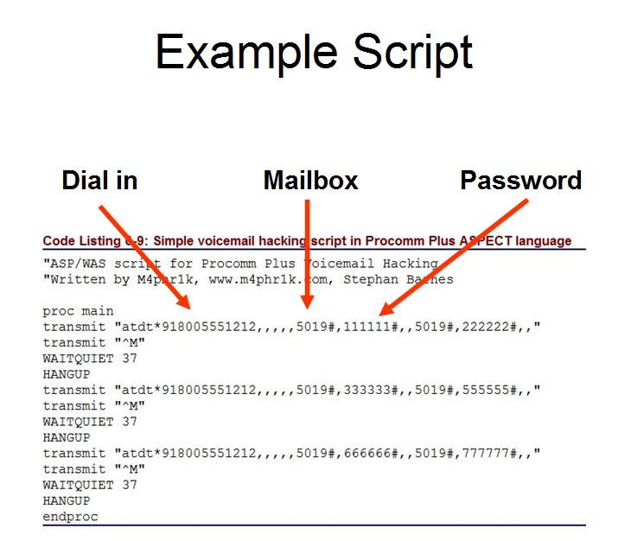
Example Script

Common Voicemail Passwords

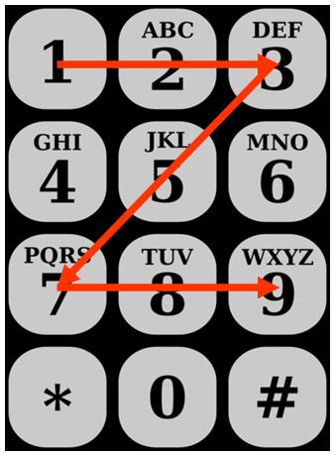
People often use simple geometrical patterns on the keypads

Virtual Private Network (VPN) Hacking

Virtual Private Network (VPN)

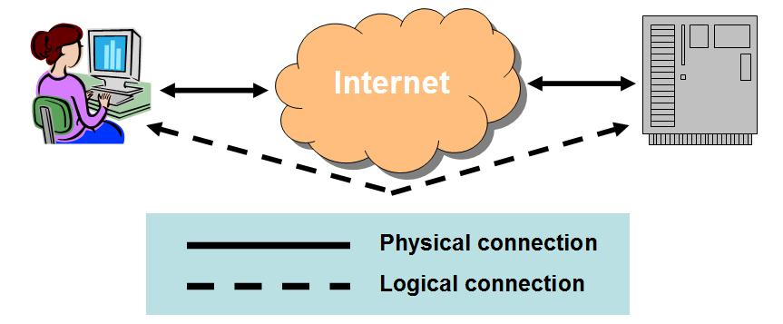
A VPN connects two computers securely over an insecure network (usually the Internet), using tunneling

Tunneling

An Ethernet frame is encapsulated in an IP packet, so it can be sent over the Internet

It can be done with other protocols too

Usually the frame is also encrypted, so that only the intended recipient can read it

The end result is like you used a long cable to connect the two computers

Cost Savings

You could use a T-1 line or a POTS phone call with a modem, to make a secure connection between two computers

But a VPN is much cheaper, requiring only an Internet connection at each end

VPN Standards

The modern way

IP Security (IPSec) and the Layer 2 Tunneling Protocol (L2TP)

Older techniques

Point-to-Point Tunneling Protocol (PPTP)

Microsoft proprietary

Layer 2 Forwarding (L2F)

An obsolete Cisco protocol

For more details, see link Ch 611

Breaking Microsoft PPTP

Microsoft's secure authentication protocol, MS-CHAP, uses LM Hashes

Easily cracked with Ophcrack

Session keys and encryption are poorly implemented and vulnerable to attacks

The control channel is open to snooping and denial of service

PPTP clients could act as a backdoor into the network

See links Ch 612 & 613

Fixing PPTP

Microsoft patched PPTP in Win NT Service Pack 4 by using MS-CHAPv2

And it's really much better (link Ch 614)

Win 2000 and later also offer IPSec and L2TP, which is safer

"In our opinion, IPSec is too complex to be secure" -- Schneier and Ferguson (link Ch 615)

But it's the best IP security available now

Voice Over IP (VoIP) Attacks

Voice over IP (VoIP)

Voice on an IP Network

Most VoIP solutions rely on multiple protocols, at least one for signaling and one for transport of the encoded voice traffic

The two most common signaling protocols are H.323 and Session Initiation Protocol (SIP)

Their role is to manage call setup, modification, and closing

H.323

H.323 is a suite of protocols

Defined by the International Telecommunication Union (ITU

The deployed base is larger than SIP

Encoding is ASN.1 – different than text, a bit like C++ Data Structures (link Ch 618)

Designed to make integration with the public switched telephone network (PSTN) easier

Session Initiation Protocol (SIP)

The Internet Engineering Task Force (IETF) protocol

People are migrating from H.323 to SIP

Used to signal voice traffic, and also other data like instant messaging (IM)

Similar to the HTTP protocol

The encoding is text (UTF8)

SIP uses port 5060 (TCP/UDP) for communication

Real-time Transport Protocol (RTP)

Transports the encoded voice traffic

Control channel for RTP is provided by the Real-time Control Protocol (RTCP)

Consists mainly of quality of service (QoS) information (delay, packet loss, jitter, and so on)

Timing is more critical for VoIP than other IP traffic

Most Common VoIP Attacks

Denial of Service

Send a lot of SIP INVITE packets, initiating calls

Flood a phone with unwanted IP traffic

Spoofing the CLID (Caller ID)

Swatting is a popular and dangerous attack, spoofing caller ID and calling police (link Ch 619)

Injecting data into an established call

Altering the phone's configuration

Connect to the phone via Telnet or HTTP

Sometimes no password is needed

Or upload malicious code with your own DHCP and TFTP servers

When a phone boots, it can upload updated firmware with TFTP

Attacking though services linked to VoIP

Advanced voicemail

Instant messaging

Calendar services

User management

Attacks may use XSS (cross-site scripting), client-side JavaScript alteration, SQL injection, and so on

Accessing repository of recorded calls

Making free calls through a company's VoIP-to-PSTN gateway

Interception Attack

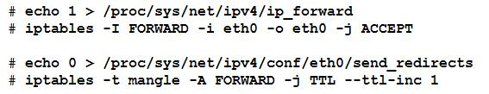
Sniff the IP Packets

With ARP poisoning

Attacker is set to route traffic, but not decrement the TTL

Captured RTP Traffic

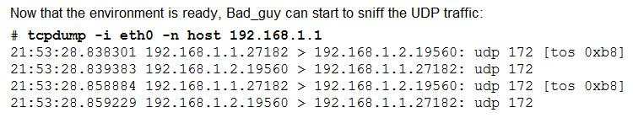

It's compressed with a codec

Common codecs

G.711 (uses up a lot of bandwidth)

G.729 (uses less bandwidth)

VOMIT

vomit - voice over misconfigured internet telephones

Converts G.711 to WAV

It works because many IP phones don't or can't encrypt traffic

Link Ch 620

Scapy is an even better tool, plays traffic from eth0 right out the speakers

Link Ch 621

Interception Countermeasures

Turn on the security features available for your phones, such as encryption

They are often left turned off, to get higher quality or just through laziness
Summary

Remote access is dangerous!

Enforce strong password policy for remote users

Consider two-factor authentication

Don't neglect dial-up security—perform wardialing

Find and remove unauthorized remote control software (such as pcAnywhere)

Educate support personnel to require some other form of identification, such as a personnel number, to receive any support for remote access issues

VPNs are vulnerable

Don't believe vendor security claims easily

Last modified 3-8-08

