Discovery

Detecting Network Devices

Port Scanning

traceroute, netcat, nmap, and SuperScan

dig

An undated replacement for nslookup in Unix/Linux

If it's not installed by default in your Ubuntu (or andLinux), use

apt-get install dnsutils

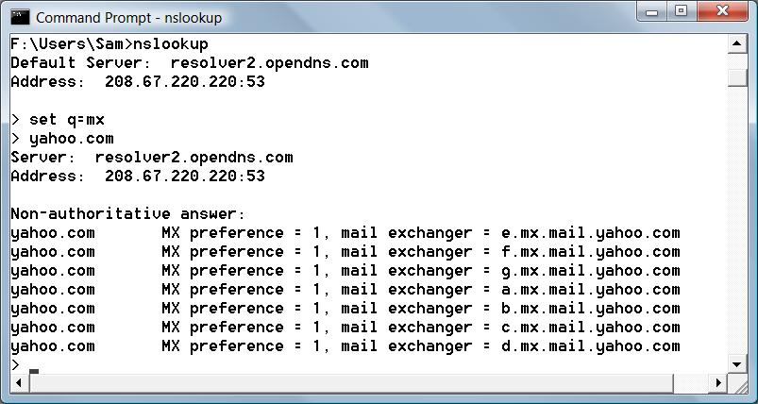
Finding Mail Exchanges with nslookup

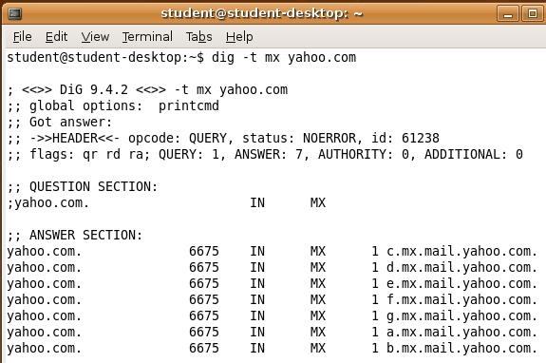

Finding Mail Exchanges with dig

Types of DNS Records

A – maps a hostname to an IPv4 address

AAAA - maps a hostname to an IPv6 address

CNAME - Canonical name - an alias of one name to another

MX - mail exchange record

PTR - maps an IPv4 address to the canonical name for that host (allows reverse DNS lookups)

Types of DNS Records

SOA - start of authority record – the authoritative DNS server for a domain

SRV - a generalized service location record, used for VoIP SIP servers

See link Ch 705

For more about DNS Records, see link Ch 704 (Wikipedia)

dig Countermeasures

Secure your DNS infrastructure

Block or restrict zone transfers

Leave hosts out of your DNS records unless you want direct traffic to them from the Internet

traceroute

Tracert in Windows uses ICMP packets

Traceroute in Unix/Linux uses UDP packets

The packets have low TTLs, starting with 1

When the packet traverses a router, its TTL is decreased by 1

If the TTL ever hits zero, the packet is dropped

A notification is sent back to the originating source host in the form of an ICMP error packet

Finding Routing Devices at CCSF

Hops 10 and 11 both appear to be routing devices on campus
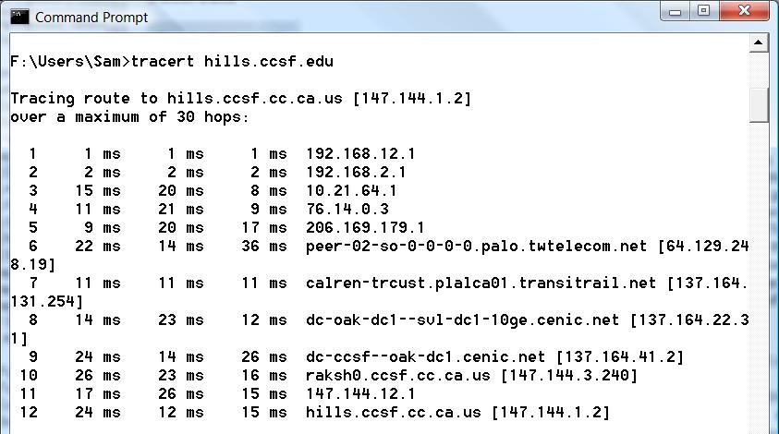

traceroute Countermeasures

Stop your routers from responding to TTL-exceeded packets

Deny all traffic specifically addressed to a router

Permit ICMP only from the LAN, not from the Internet
Autonomous System Lookup

Autonomous Systems

Autonomous System (AS)

A collection of gateways (routers) that controlled by one organization

Autonomous System Number (ASN)

a numerical identifier for networks participating in Border Gateway Protocol (BGP)

Border Gateway Protocol (BGP)

A protocol used to advertise routes worldwide

traceroute with ASN Information

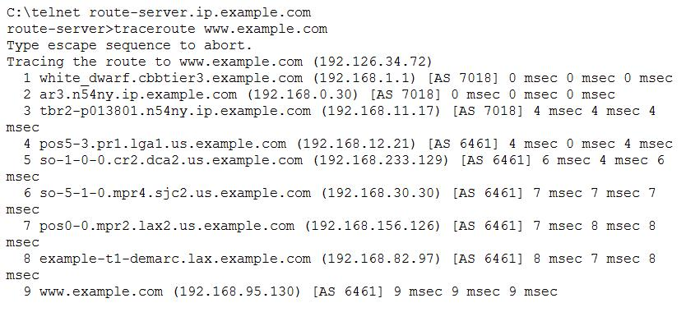
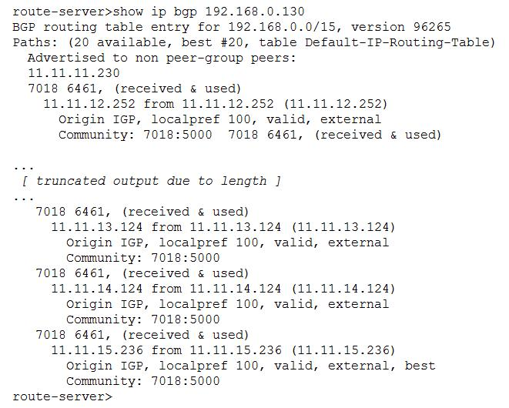
Run traceroute from a Cisco router participating in BGP to see the ASNs

Hop 8 is a T-1; hops 4-9 all same company

Demo

Public Looking Glass sites let you test routing from various servers
See Links 724-727

show ip bgp

From a Cisco router, we can find the other possible network paths

Public Newsgroups

Careless Postings

Careless admins may announce network vulnerabilities on newsgroups

Countermeasures:

Be wary of what you say and where you say it

Service Detection

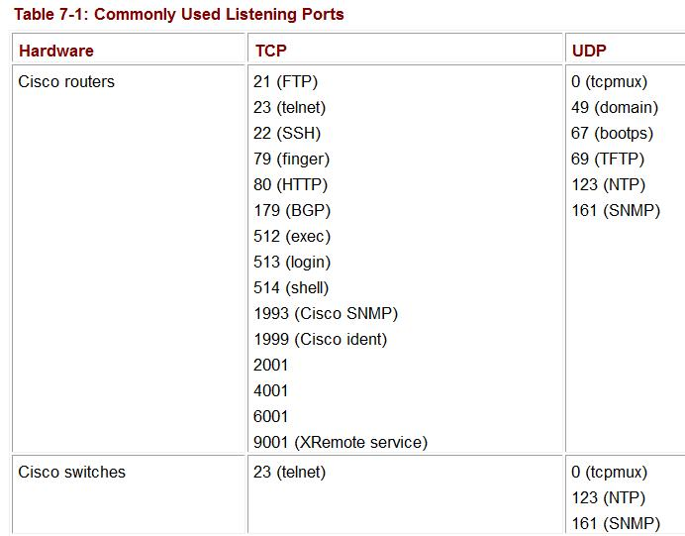
Port Scanning

Common ports are known for each device

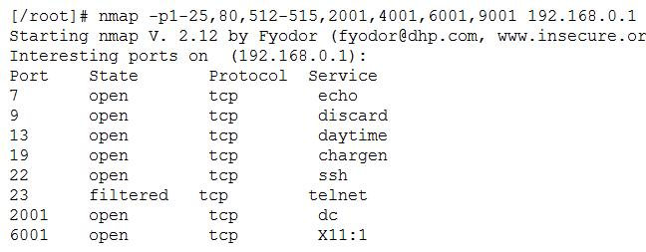

Nmap Results

Nmap also does OS detection, as we discussed in a previous chapter

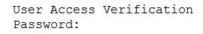
Familiar Prompts

If Telnet is enabled on a Cisco router, you will see this prompt

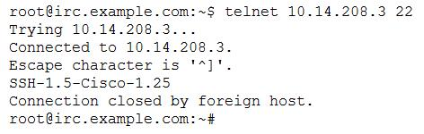
A Cisco router configured for SSH still shows a banner to Telnet

Service Detection Countermeasures

Deny all unwanted traffic at network borders

PortSentry will detect port scans and block traffic from that IP

But PortSentry itself could be used to perform a DoS attack if you don't check for spoofed packets

Network Vulnerability

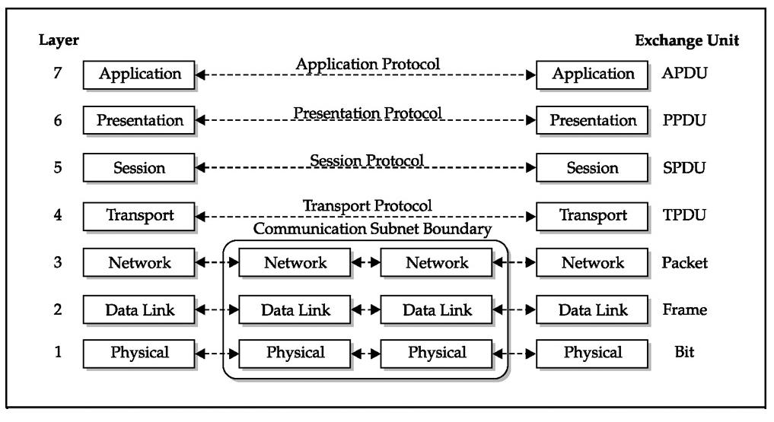
The OSI Model

Data Units

APDU - Application Protocol Data Unit

PPDU - Presentation Protocol Data Unit

SPDU - Session Protocol Data Unit

TPDU - Transport Protocol Data Unit

But our focus is on the first 3 layers

OSI Layer 1: Physical

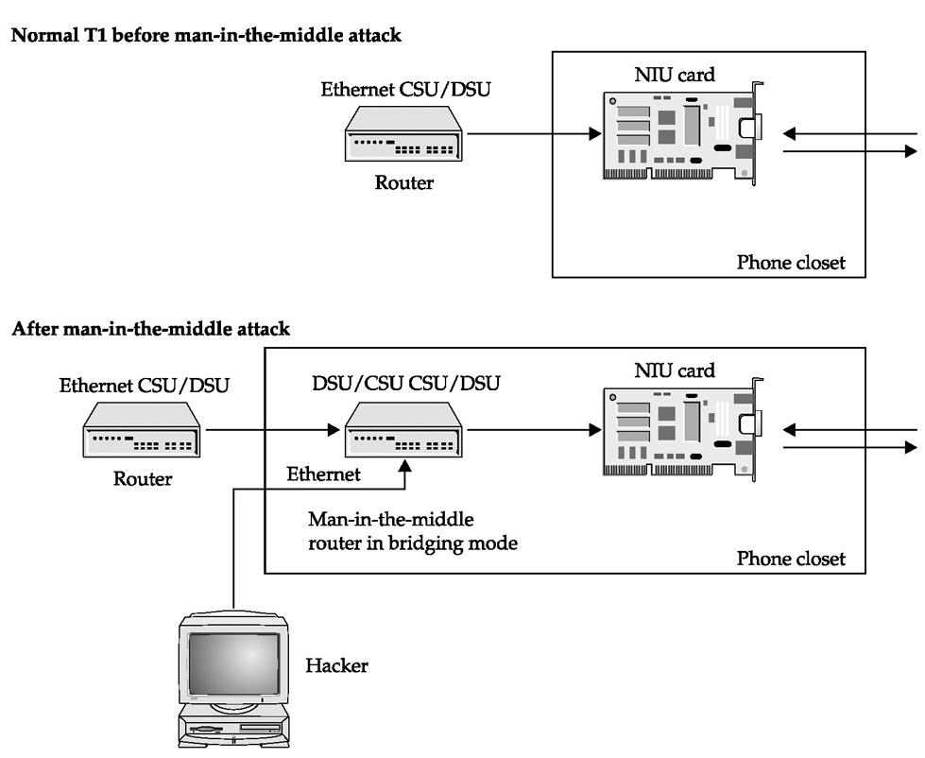
Physical media that carry data: usually copper or fiber optics

Traffic can be intercepted with a physical man-in-the-middle attack

The figure to the right shows a T1 man-in-the-middle attack (copper lines)

Fiber Optic Physical MITM Attack

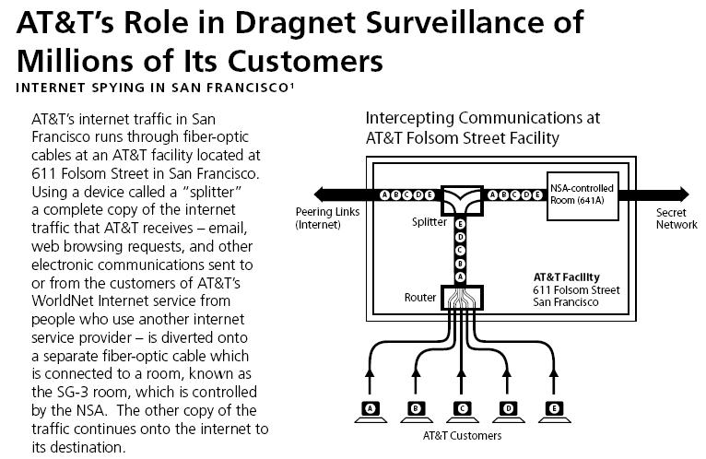
See link Ch 709

OSI Layer 2: Data Link

Layer 2 is the layer where the electrical impulses from Layer 1 have MAC addresses associated with them

Early Ethernet sent traffic to every node connected to the hub or backbone

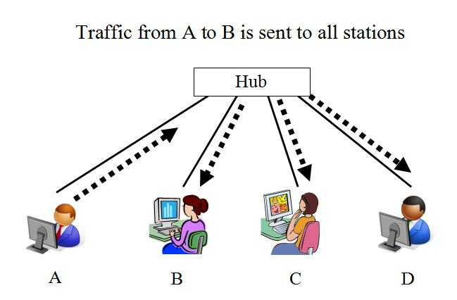
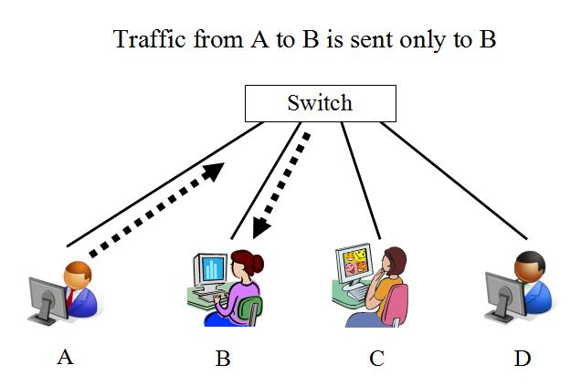
Modern switched networks don't do that

Unswitched Ethernet

Most wired networks use switches instead of hubs now

Wi-Fi networks still work this way

Switched Ethernet

Switches make sniffing harder

They also make networks faster

Switch Sniffing

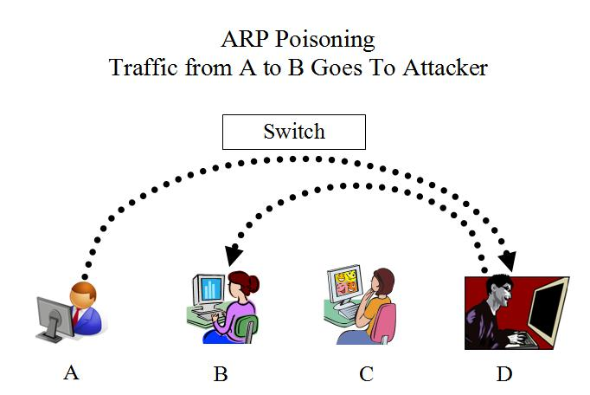
Some switches allow an administrator to monitor all traffic on a special port

ARP cache poisoning is the most common way to sniff traffic on a switch

ARP Poisoning Countermeasures

Use static ARP routes, with manually entered MAC addresses

This prevents abuse of ARP redirection, but it is a LOT of tedious work

Every time you change a NIC, you need to manually add the new MAC address to the tables

Broadcast Sniffing

Connect to a port

It doesn't matter what your IP address is

Just sniff for broadcast packets

Using Wireshark or any other sniffer

DHCP Packets

Give out IP addresses, and may also contain brand of router

DEMO:

Start Wireshark

Open Command Prompt

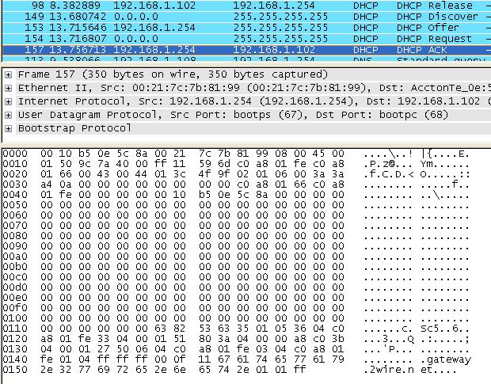
ipconfig /release

ipconfig /renew

ARP Packets

These give you IP addresses and MAC addresses

WINS Packets

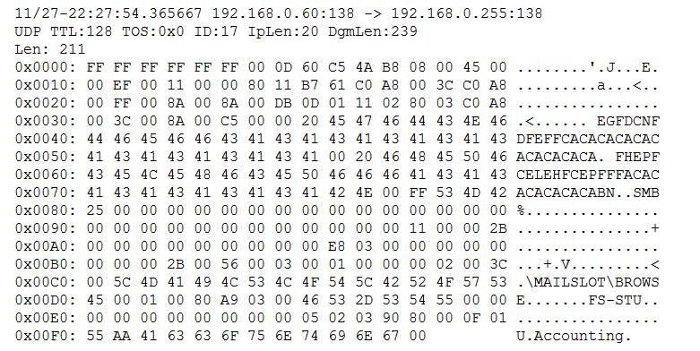
Note Computer Description field at the end "Accounting"

Broadcast Sniffing Countermeasures

To limit broadcasts, split your network into different segments

Use VLANS – Virtual Local Area Networks

Switches add a VLAN tag to each frame

Broadcasts only reach machines on the same VLAN

Link Ch 710

VLANs

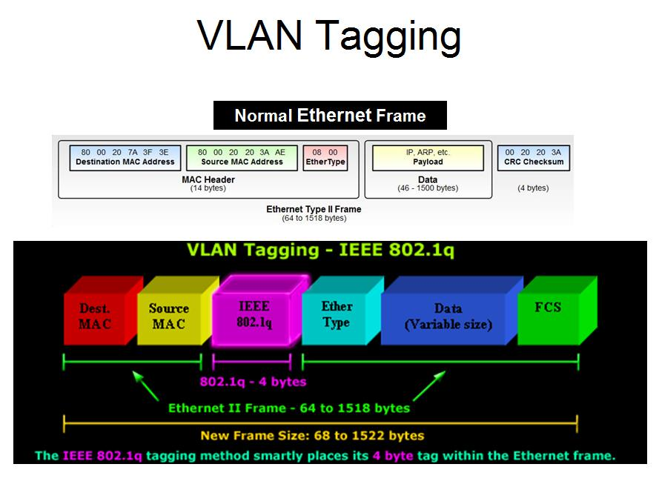
Virtual LANs are logically separate LANs on the same physical medium

Each VLAN has its own VLAN Number

802.1q is the standard for VLAN Tagging

VLAN Tagging

Links Ch 712, 713

Port-Based VLANs

Each port on the switch is assigned to a VLAN by the administrator

The clients send in normal Ethernet frames, and the VLAN tag is added by the switch

When tagged frames are received, the switch removes the VLAN tags

This is the most secure method

Native VLANs

Suppose you want to use a single network link to carry traffic from multiple VLANs?

For example, a long line connecting two buildings

One VLAN can be defined as the "Native VLAN" or "Management VLAN"

Frames belonging to the "Native VLAN" are not modified—no VLAN header is added to them, or removed

VLAN Jumping

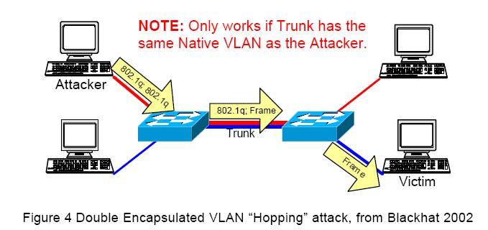
This allows an attacker to craft a frame with two VLAN tags

The first switch removes one tag

The second switch sees the extra tag, so the frame hops from one VLAN to another

VLAN Jumping Countermeasures

Don't trust VLANS to enforce network security boundaries

Restrict access to the native VLAN port (VLAN ID 1)

We'll skip these sections

Internetwork Routing Protocol Attack Suite (IRPAS) and Cisco Discovery Protocol (CDP)

Spanning Tree Protocol (STP) Attacks

VLAN Trunking Protocol (VTP) Attacks

OSI Layer 3

Internet Protocol Version 4 (IPv4)

Has no built-in security measures

TCP Sequence Numbers

Example: tcpdump showing a Telnet connection

S = SYN, A = ACK; note increasing Sequence and Acknowledgement numbers; the ACK number is one more than the corresponding SYN number

Demonstration of Sequence Numbers

Use Ubuntu

In one Terminal window:

sudo apt-get install tcpdump

sudo tcpdump –tnlS | tee capture

(no timestamps, numerical IP addresses, line buffered, absolute sequence numbers)

In another Terminal window:

telnet 147.144.1.2

In first Terminal window:

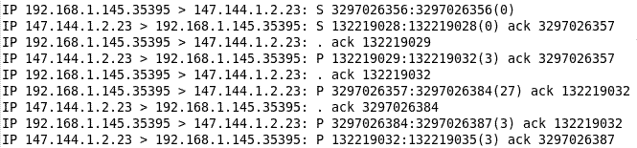
pico capture

tcpdump Results

This has been cleaned up somewhat

Note increasing Sequence and Acknowledgement numbers

The ACK number is one more than the corresponding SYN number

Attacks Using Sequence Numbers

Non-Blind Spoofing

Attacker is on the target's LAN

Sequence and acknowledgement numbers can be sniffed

Session can be hijacked with a simple man-in-the-middle attack, such as ARP cache poisoning

Blind Spoofing

Attacker not on the target's LAN

Attacker sends several packets to the target machine in order to sample sequence numbers

If the target machine's OS uses easily-predicted Initial Sequence Numbers, the attacker can forge packets and hijack a later session

Vulnerabilities to ISN Prediction

Windows NT4 SP3 Attack feasibility: 97.00%

Windows 98 SE Attack feasibility: 100.00%

Windows 95 Attack feasibility: 100.00%

AIX 4.3 Attack feasibility: 100%

HPUX11 Attack feasibility: 100%

Solaris 7 Attack feasability: 66.00%

MacOS 9 Attack feasability: 89.00%

See links Ch 718, 719, 720

IP Version 6 (IPv6)

Long addresses like this

ABCD:EF01:2345:6789:0123:4567:8FF1:2345

Native security

IPSec encryption framework has two modes:

Tunnel mode encrypts whole packet (most secure)

Transport mode just encrypts the data, not the IP header

Both modes are much more secure than IPv4

Sniffing Attacks

Steal passwords or hijack sessions

Generally require access to the LAN

Tools: Wireshark, tcpdump, Cain, ettercap, hamster, ferret

Older tools: dsniff, webmitm, mail snarf, webspy

Sniffing Countermeasures

Segment network with switches, routers, or VLANS

Use encrypted protocols like SSL/TLS

Misconfigurations

Read/Write MIB

Network devices that allow anyone with the community name to download the router or switch's configuration file via TFTP

To test, go to link Ch 722, open support.txt, look for OLDCISCO-SYS-MIB

If it's listed, you are probably vulnerable.

C2610 is vulnerable, but not C2950

Read/Write MIB Countermeasures for Cisco

Restrict the use of SNMP to approved hosts or networks

Use Read-Only SNMP

Turn off SNMP altogether

Cisco Weak Encryption

Cisco passwords are stored with a weak, easily broken encryption method

Cisco admits this, and does not see it as a problem or have plans to change it

"Customer demand for stronger reversible password encryption has been small"

Link Ch 723

Cisco Password Decryption Countermeasures

The "enable secret" command will hash passwords with MD5, which is much stronger

But it does not hash all passwords

TFTP Downloads

Almost all routers support the use of the Trivial File Transfer Protocol (TFTP)

This is a UDP-based file-transfer mechanism used for backing up and restoring configuration files, and it runs on UDP port 69

You can turn TFTP off on Cisco routers if you want to

We'll skip this section

Route Protocol Hacking

Last modified 12-30-08

