The Need for Firewalls

Putting a Web server on the Internet without a firewall is dangerous

Remember in CNIT 123 how a firewall protected your Web server from a DoS attack created with nmap

But a misconfigured firewall is not much use

Firewall Landscape

Two types of firewalls dominate the market today

Application proxies

More secure but slower

Packet-filtering gateways

Including Stateful packet-filtering gateways

How Safe is a Firewall?

A well-designed, -configured, and -maintained firewall is nearly impenetrable

Attackers will have to work around it by

Exploiting trust relationships

Finding weakest-link security vulnerabilities

Attacking through a VPN or dial-up account
Firewall Identification

Why Identify a Firewall?

An attacker wants to determine the type, version, and rules of every firewall on the network

To understand their weaknesses and exploit them

Firewall Identification Techniques

Port scanning

Firewalking

Banner grabbing,

Direct Scanning: The Noisy Technique

Some firewalls have obvious signatures

Check Point's FireWall-1 listens on TCP ports 256, 257, 258, and 259

Check Point NG listens on TCP ports 18210, 18211, 18186, 18190, 18191, and 18192 as well

Microsoft's Proxy Server usually listens on TCP ports 1080 and 1745

Ways to Conceal a Scan

Randomize target ports

Randomize target addresses

Randomize source ports

Distributed source scans

Using multiple computers on the Internet, each taking a small portion of the scanning targets

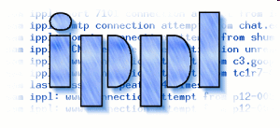
These techniques will fool most IDS systems with default rules

Direct Scanning Countermeasures

Block unneeded ICMP packets at your border router

Use an Intrusion Detection System, such as Snort

IPPL is a Linux daemon that detects port scans (link Ch 901)

Cisco routers have ACL rules to block scans

Route Tracing

In the traceroute below, hop 14 is probably a firewall

Because it's the point of NAT to the target network

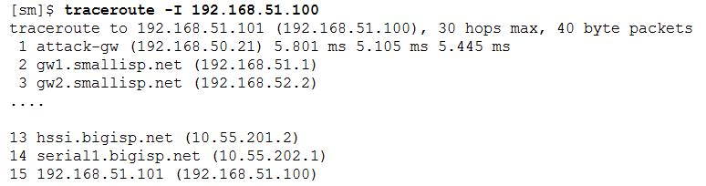
The –I switch sends ICMP Packets, not Linux's default of UDP
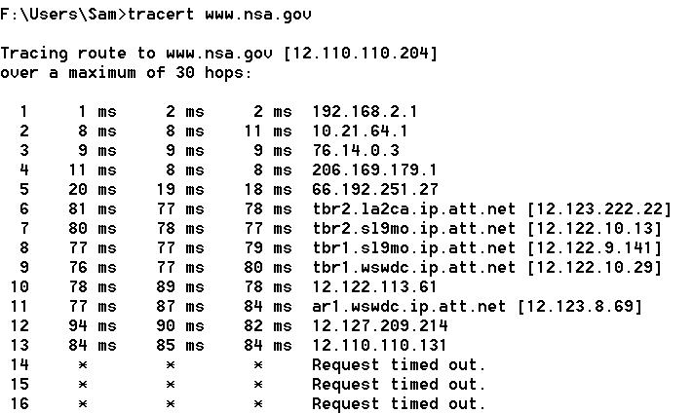

When ICMP is blocked

Hop 13 is obviously the firewall, or at least the first router that blocks ICMP

Route Tracing Countermeasure

Block ICMP TTL Expired packets

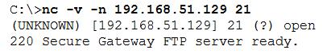

Banner Grabbing

Just find an open port and connect to it with netcat

Banner-Grabbing Countermeasures

Eliminate the open port on your firewall

A management port should not be open externally anyway

If you must leave the ports open on the external interface of your firewall

Change the banner to display a legal warning reminding the offender that all attempts to connect will be logged

Advanced Firewall Discovery

If a firewall can't be identified by port scanning, traceroute, or banner grabbing

Firewalls and their ACL rules can be deduced by probing targets and noticing the paths taken (or not taken) to get there

Simple Deduction with nmap

When nmap flags a port as "filtered", one of these conditions is true

No SYN/ACK packet was received

No RST/ACK packet was received

An ICMP type 3 message (Destination Unreachable) with code 13 (Communication Administratively Prohibited - [RFC 1812]) was received

Those ICMP messages reveal your firewall rules

Ports 23 and 111 are filtered
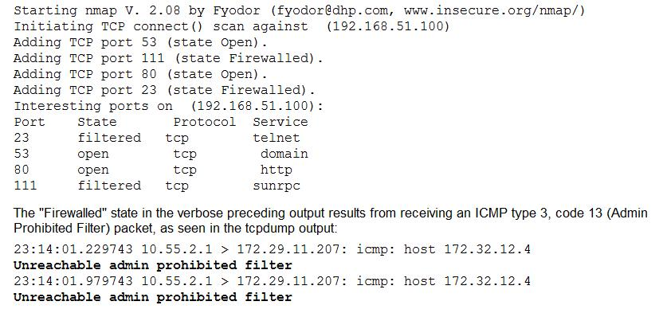

Simple Deduction with nmap Countermeasures

Block nmap scans with an Intrusion Prevention System

Disable IP Unreachable messages on your firewall

This prevents it from sending the ICMP type 3, code 13 (Admin Prohibited Filter) packets

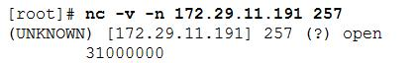
Port Identification

Some firewalls display a series of numbers when you connect to them

For example, Check Point will display a series of numbers when you connect to its SNMP management port, TCP 257.

Port Identification Countermeasure

Prevent connections to management ports by blocking them at your upstream routers

Scanning Through Firewalls

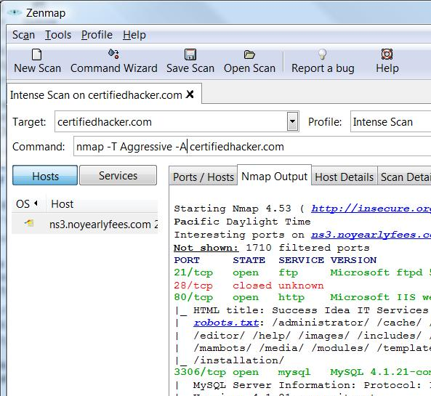
Raw Packet Tranismissions

hping2 can send ICMP, TCP, or UDP packets to a target and reports on what returns

That lets you interpret the results yourself, rather than relying on nmap's programmed analysis

Demo: Scan with nmap

Demo: Scan with hping2

From a Ubuntu VM (andLinux doesn't work)

sudo apt-get install hping2

–S switch sends a SYN packet

-c 1 sends only one packet

-p 21 specifies port 21

Open port returns flags=SA (SYN/ACK)
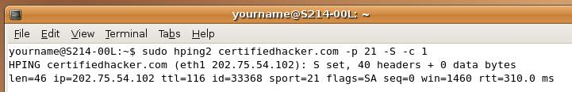

Closed port returns flags=RA (RST/ACK)
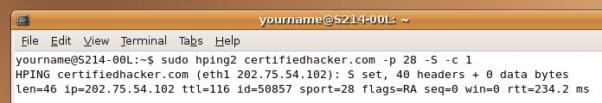

Filtered port returns nothing
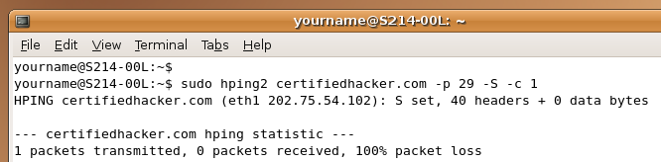

ICMP Type 13

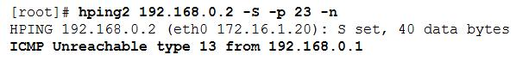
Some firewalls return ICMP Type 3 with code 13 packets, which inform you that the firewall blocked the connection

It's a good idea to block those ICMP Type 3 with code 13 packets
Firewalk

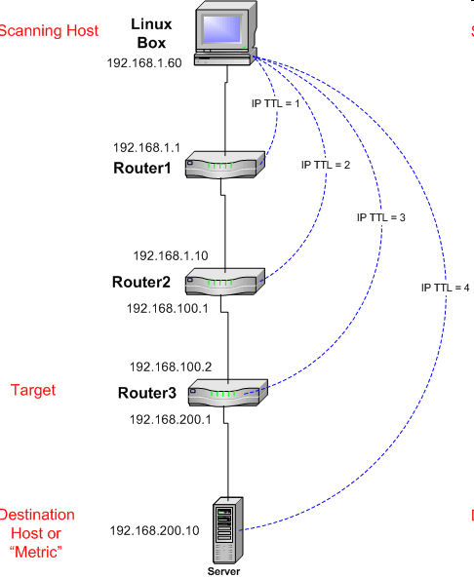
Firewalk Looks Through a Firewall

The target is Router3

We want to know which ports Router3 blocks, and which ports it allows through

Firewalk Phase 1: Hopcount Ramping

First Firewalk sends out a series of packets towards the destination with TTL=1, 2, 3, …

When the target (Router3) is reached, that determines the TTL for the next phase

In this example, the Target is at TTL=3, so all future packets will use TTL=4

Firewalk Phase 2: Firewalking

TCP or UDP paclets are sent from the scanning host to the Destination

They all have TTL=4

Firewalk Phase 2: Firewalking

If a packet reaches the Destination, it will send an "ICMP TTL expired in transit" message

If Router3 blocks the packet, there is no response

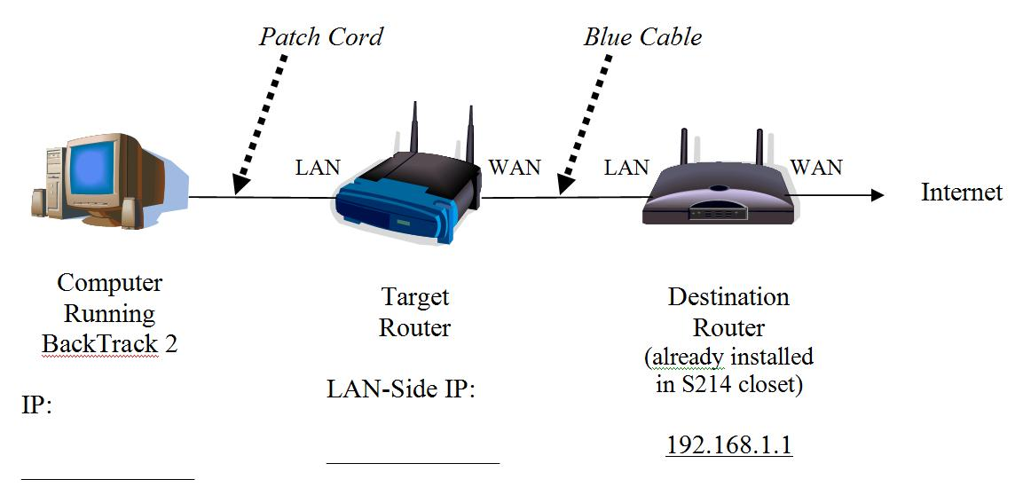

Demo: Firewalking

No Firewall
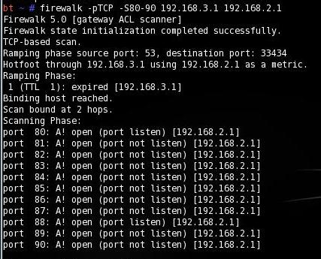
All ports are open (not blocked by a firewall)

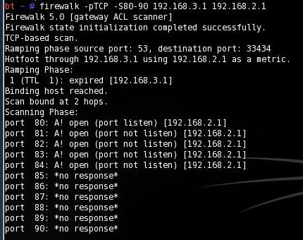

Firewall Blocking TCP Ports 85-90
Those ports give no response

Firewalk Countermeasures

You can block "ICMP TTL expired" packets at the gateway

But this may negatively affect its performance

Because legitimate clients connecting will never know what happened to their connection

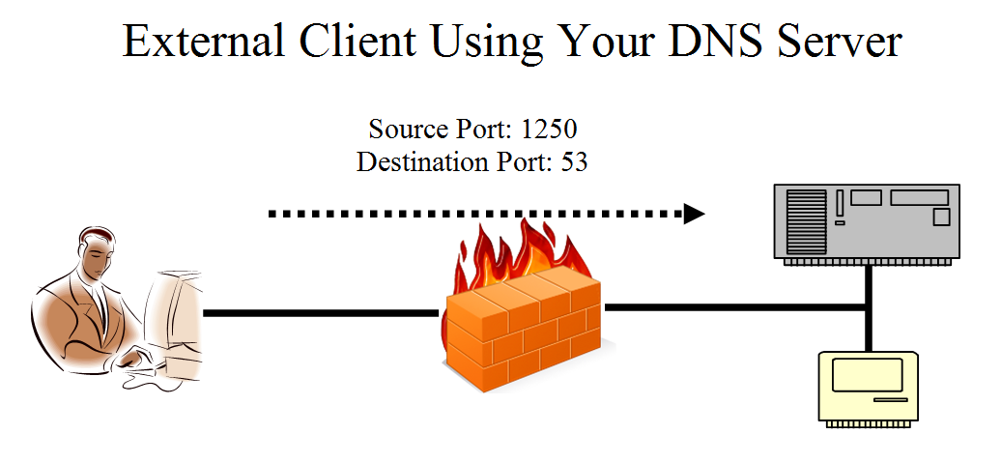
Source Port Scanning

Destination Ports

This is normal traffic into a company's DNS Server

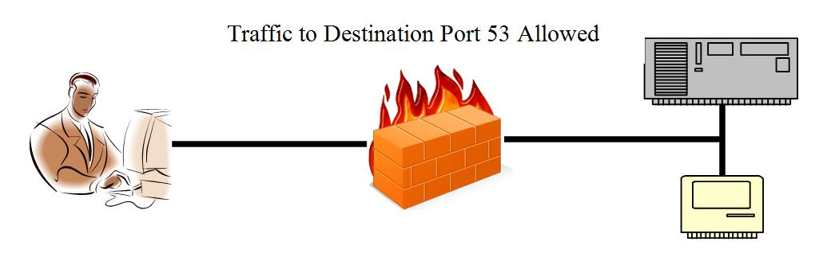

Destination Port Filtering

So a simple stateless firewall could be set up this way to protect that network

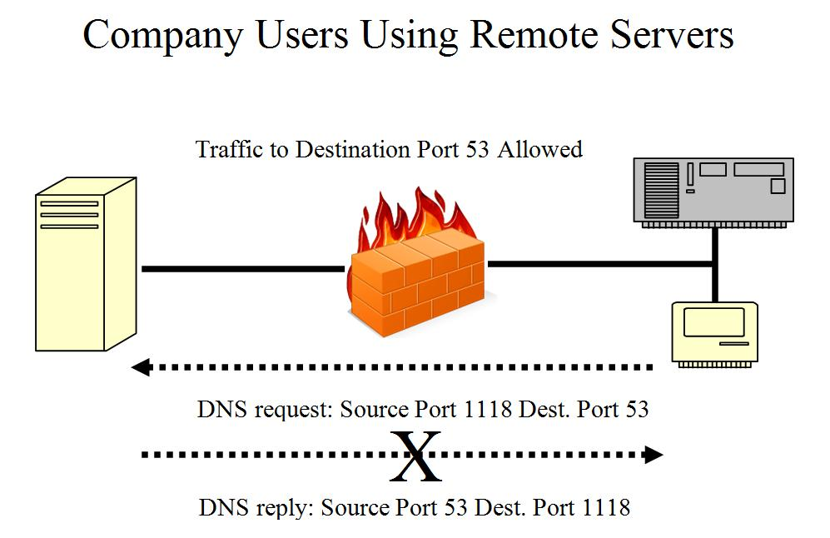

Destination Port Filtering

Company workers can't use DNS!

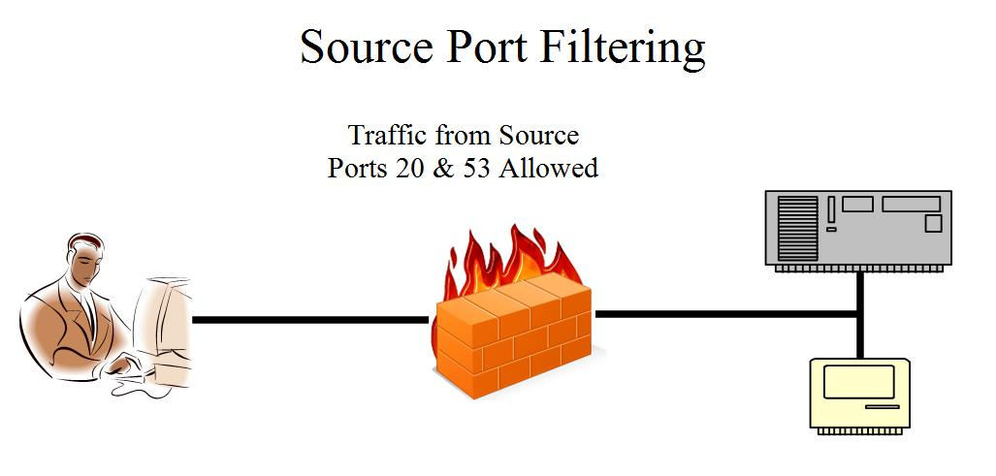

Source Port Filtering

Now users are happy, because they can use DNS and FTP servers

Spoofing Source Ports

The –g option in nmap can spoof any desired source port

This will scan right through stateless firewalls that use source port filtering

Source Port Scanning

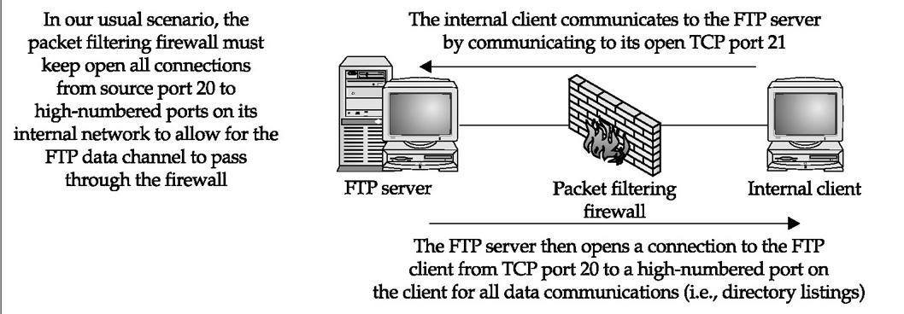
This is how normal FTP works

The Attack
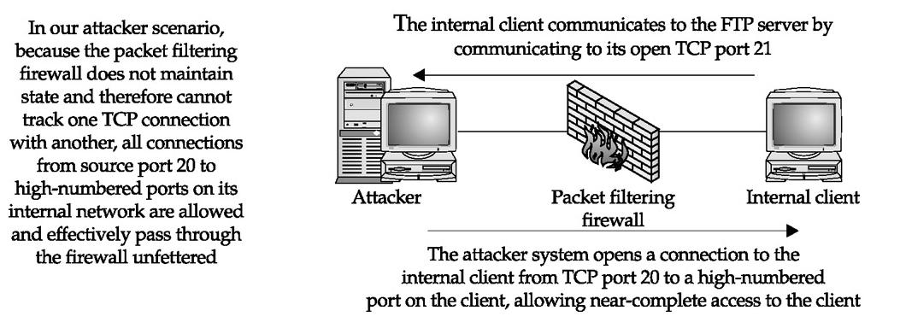

Fpipe

Allows any traffic to be redirected to any chosen port

So an attack could go through port 20, looking like FTP to the firewall

Loni Ch 904

Source Port Scanning Countermeasures

Switch to a stateful or application-based proxy firewall that keeps better control of incoming and outgoing connections, or

Disable any communications that require more than one port combination (such as traditional FTP)

And employ firewall-friendly applications such as Passive FTP that do not violate the firewall rules

Packet Filtering

Packet-Filtering Firewalls

These firewalls depend on access control lists (ACLs), even if they are stateful

Check Point's FireWall-1

Cisco's PIX

Cisco's IOS

Liberal ACLs

Poorly written ACLs allow unwanted traffic

If you want to allow your ISP to perform zone transfers

"Allow all activity from the TCP source port of 53"

Too liberal

"Allow activity from the ISP's DNS server with a TCP source port of 53 and a destination port of 53."

Check Point Trickery

Check Point 3.0 and 4.0 provide ports open by default

DNS lookups (UDP 53)

DNS zone transfers (TCP 53)

RIP (UDP 520)

Are all allowed from any host to any host and are not logged

Control Via Port 53

A compromised system can be controlled over port 53, right through the firewall

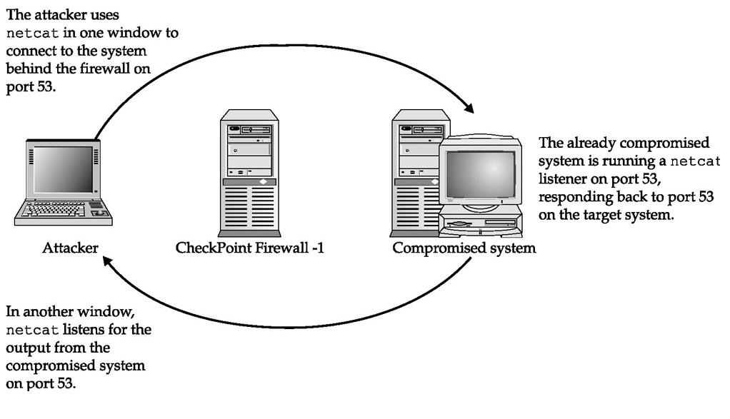
Check Point Trickery Countermeas-ures

Disable unnecessary traffic that was allowed by default

ICMP and UDP Tunneling

Wrapping real data in an ICMP header

This creates a covert channel

Many routers and firewalls that allow ICMP ECHO, ICMP ECHO REPLY, and UDP packets through will be vulnerable to this attack

Loki is a tool that does this (link Ch 2m)

ICMP and UDP Tunneling Countermeasure

Block ICMP packets at the firewall

You may break ICMP heartbeats

Application Proxy Vulnerabilities

Application Proxy

Also called an Application Gateway

An application program that runs on a firewall between two networks

No direct connections between the networks are allowed

Both sides must connect only to the proxy

The proxy makes all packet-forwarding decisions

Application Proxy

Application proxies are very secure, but require more memory and processor resources than to other firewall technologies, such as stateful inspection

Link Ch 906

Hostname: localhost

Some older UNIX proxies allowed a user to log directly into the proxy server itself with the user name "localhost"

The ideal countermeasure is to not allow localhost logins

Unauthenticated External Proxy Access

The firewall may restrict internal connections, but not access from the outside

This allows attacks like

Using your proxy to attack other systems

Gaining access to your intranet from the Web

Unauthenticated External Proxy Access Countermeasures


Disallow proxy access from the external interface of the firewall

Restrict incoming proxy traffic at your border routers

WinGate Vulnerabilities

WinGate is a proxy server and firewall

Very common in the 1990s for Internet connection sharing

Versions prior to 2.1d (1997) were notoriously insecure by default

Links Ch 907, Ch 908

Unauthenticated Browsing

WinGate proxies allowed outsiders to browse the Internet completely anonymously

Attackers could hack with little risk of getting caught

The unauthenticated SOCKS proxy (TCP 1080 is also vulnerable

Unauthenticated Browsing Countermeasure

Restrict the bindings of specific services

Only allow the internal interface to access the SOCKS and WWW services

Unauthenticated Telnet

WinGate servers also forwarded Telnet traffic anonymously

The cure is to bind Telnet to the local interfaces

File Browsing

Default WinGate 3.0 installations allow anyone to view files on the system through their management port (8010)

With a URL like this

http://192.168.51.101:8010/c:/

Countermeasure: upgrade to a newer version of Wingate

Last modified 4-11-08

