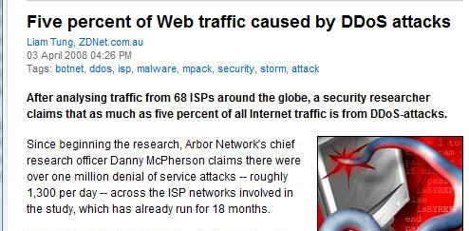
Overview

1990s - Ping of Death, Smurf, etc.

Crashed individual machines

Corrected with patches

2000

DDoS (Distributed Denial of Service)

Extortion

Zombie networks

2008

5% of Web traffic caused by DDoS Attacks

Link Ch 10c
Common DOS Attack Techniques

Old-School DoS: Vulnerabilities

Oversized packets

Ping of Death – a packet larger than 65,535 bytes

Fragmentation overlap

Sending TCP/IP fragments that cannot be properly reassembled

Attacks: teardrop, bonk, boink, and nestea

Loopback floods

Sends data back to the echo service, or

Send TCP/IP Packets with the same source and destination address

Creating an endless loop

Attacks: Land and LaTierra

Nukers

Sent out-of-band (OOB) packets (TCP segments with the URG bit set) to a system, causing it to crash

Extreme fragmentation

Forces target to waste time reassembling packets

Attack: Jolt2

NetBIOS/SMB

Buffer overflows and other issues

Combos

Send many DoS attacks at once

Attacks: targa and datapool

Old-School DoS: Countermeasures

Operating system patches have fixed these vulnerabilities

This type of threat is less important now

Modern DoS: Capacity Depletion

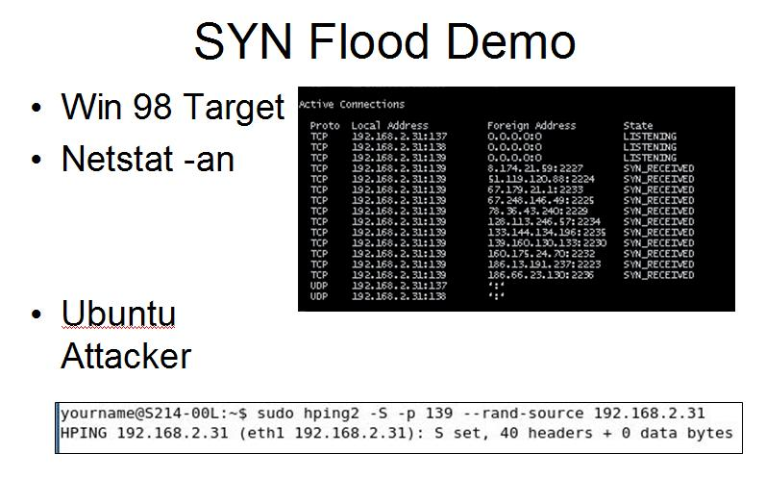
Infrastructure-Layer DoS

SYN Floods

Attacker sends SYN packets to a listening port, with a forged source address of a nonexistent system

Target sends back SYN/ACK packets and maintains half-open connections until it times out (75 sec. to 23 minutes)

This consumes resources (like RAM) on the target, often more than an established connection

Effects of the SYN Flood

Can completely stop a vulnerable server, even if the attacker has a low bandwidth

Stealthy – no packets have a source address that leads back to the attacker

SYN floods are still the primary capacity depletion method

UDP Floods

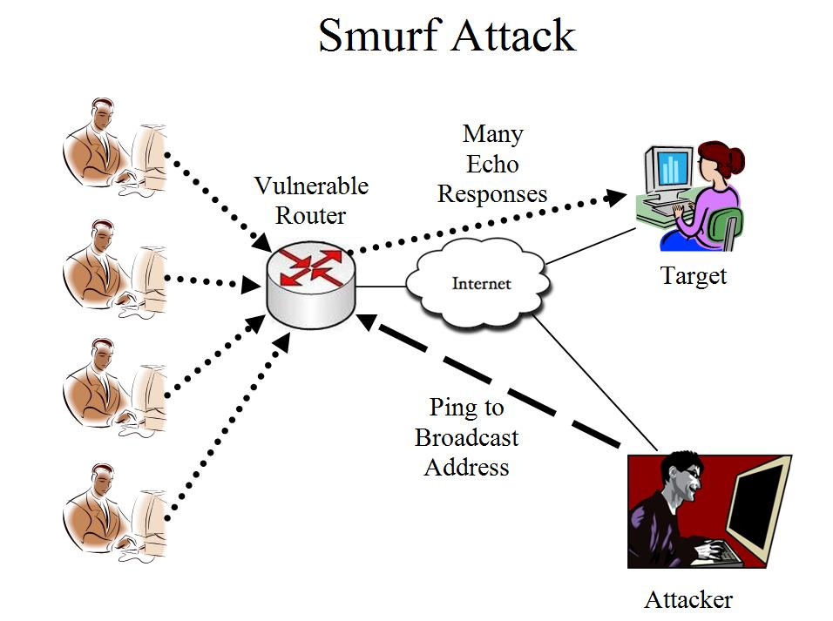
UDP is connectionless, so there is no handshake

Sending a lot of UDP packets burdens a system, but not as much as a SYN flood

UDP floods are rarely used

UDPFlood tool at link Ch 10a

Amplification: Smurf and Fraggle

Send pings to a broadcast address

Ending in .255 (for a class C network)

Put the victim as the source address

Many replies go to the victim

Fraggle uses UDP packets instead, resulting in many ICMP Echo packets

Not common anymore, because directed IP broadcasts are usually blocked now

Distributed Denial of Service (DDoS)

Poorly protected and unpatched systems under the control of a botmaster are called

Zombies or DDoS Clients or Bots

Early clients were Tribe Flood Network, Trinoo, and Stacheldraht

Most bots use IRC for Command & Control

DDoS Clients and Bots

Tribe Flood Network (TFN)

First Linux/UNIX-based distributed denial of service tool

Found mostly on Solaris and Red Hat computers

Could be used for ICMP, Smurf, UDP, and SYN floods

In addition to the attacking components of TFN, the product allows for a root shell bound to a TCP port

Trinoo

Similar to TFN

Uses UDP ports 27444 & 31335

WinTrinoo

Windows version of Trinoo

Trojan, named service.exe

Adds itself to the Run registry key to autostart

Uses TCP and UDP port 34555

Stacheldraht

Combines TFN and Trinoo

Encrypted telnet session between the slaves and the masters

Uses a combination of TCP and ICMP (ECHO reply) packets for Command & Control (client-server communication)

Can be remotely upgraded

TFN2K

Successor to TFN

Uses random ports for communication

Can't be stopped by blocking ports

Uses weak encryption (Base-64 encoding)

Can't be stopped by network-based IDS
Application-Layer DoS

Not in Book

From Hacktics presentation at OWASP (link Ch 10d)

Application-Layer DoS

Find small requests that consume a lot of server resources

Much easier for the attacker than DDoS

DoS can be achieved in various ways:

Application Crashing

Data Destruction

Resource Depletion

Memory

CPU

Bandwidth

Disk Space

Application Crashing

Send an input that causes an error in the application, causing it to crash

Buffer Overflows

Malformed data – causing parser exception

Terminating with error

SQL Injection (; shutdown --)

Data Destruction

One way to cause a DoS attack is by tampering with the data instead of the service itself

If a site is vulnerable to SQL Injection, for instance, it may be possible to DELETE all data from all tables

Although the Web site will keep being ‘online’, it will actually be useless without the information from the Database

Data Destruction – Example

Intentional User Lock

Any web application login page

Taking advantage of the application security mechanisms to cause DoS by abusing the login failure user lock mechanism

Intentionally failing multiple login attempts with each possible username, will eventually result in DoS, since all the application users will be locked

Resource Depletion

Classical Resource Depletion simply utilizes very large amounts of target resources

Sophisticated attacks pinpoint the weak points of the application to achieve maximum effect

Resource Depletion Examples

CPU Consumption

On a large forum

Create a complicated regular expression search

Use a script to launch the search over and over

Resource Depletion Examples

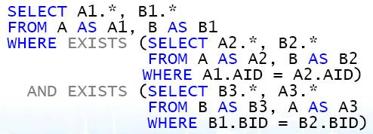
CPU Consumption – The SQL Injection version

When SQL Injection is possible – can be used for DoS even without permissions to Shutdown or Delete

Creating very intense nested queries does the trick:

Resource Depletion Examples

Memory Consumption

Attack Web Mail

Upload thousands of attachments, but never send them

Disk Consumption

Send a request that generates a large log record, try to fill system disk

Network Consumption

Send requests with large results (display all items)

Real-World Result

Hacktics, a security company, brought down a large corporate network with just three laptops in an authorized test

Global company with branches in Israel, Europe and the USA

Internet Connectivity – 3x50Mbps lines with load balancing. ISPs provide Cisco (Riverhead) based Anti DDoS solutions

High security network, 30+ Web servers, backend servers, Mail Relay, databases

Hacktics Results

DoS was successful to all systems but one

Two applications crashed completely after a few dozen requests only

Most other applications stopped responding after 5-15 minutes of script execution from up to three laptops (though with most a single laptop was sufficient)

Main cause of DoS was CPU exhaustion

Application-Layer DoS Countermeasures

At the code level

Perform thorough input validations. Expect for the worst!

Avoid highly CPU consuming operations

Avoid creating bottlenecks

Avoid operations which must wait for completion of large tasks to proceed

Split operations into chunks

Set timeout timers for unreasonable time

Application-Layer DoS Countermeasures

At the deployment level

Prepare for performance peaks

More Load Balancing

Caching

Always separate the data disks from the system disks
DoS Countermeasures

Practical Goals

DoS cannot be fully prevented

The goal of DoS mitigation is to maintain the best level of service for the largest number of customers

Security is defined as protecting

Confidentiality, Integrity, and Availability

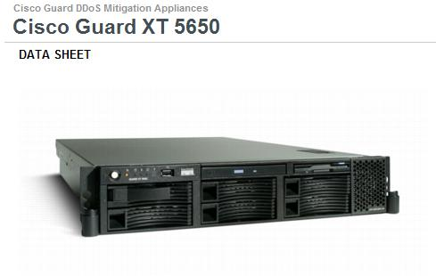
DoS attacks Availability, which is less valued politically in organizations

DoS Politics

Increasing availability is not seen as primarily a security issue

More a capacity and infrastructure issue

More servers, bandwidth, etc.

Application-layer DoS is new, and application designers are often unaware of it, and don't plan for it

Anti-DoS Products

Cisco Guard

Formerly from Riverhead

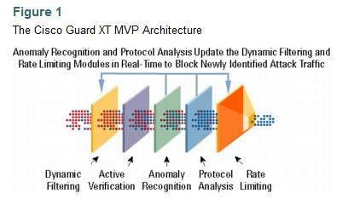
Has a multi-layer defense system to stop DDoS attacks

Link Ch 10e

Top Layer and Juniper sell anti-DDoS devices also

SYN Cookies

Instead of maintaining a list of half-open connections in RAM

A server chooses an Initial Sequence Number using a cryptographic function and a secret key

So the server can deduce from the ACK what the SYN must have been

This makes servers much less susceptible to SYN Floods

Used in some anti-DDoS devices

Link Ch 10f

Capacity Planning

Buy enough infrastructure to handle large loads

Work with Your Internet Service Provider (ISP)

Make sure they have DoS countermeasures, and DoS capacity planning

Hardening the Network Edge

Block ICMP and UDP

Except UDP 53 for DNS

Ingress filtering

Blocking obviously invalid inbound traffic, such as packets from private and reserved address ranges

Egress filtering

Stop spoofed IP packets from leaving your network—only allow packets with valid Source addresses

If more ISPs would simply implement egress filtering, DoS would probably be a much less significant threat

Disable directed IP broadcast

So you are not an amplifier for Smurf attacks

Implement Unicast Reverse Path Forwarding (RPF)

A router examines compares the source address and the source interface to make sure the source address is plausible

This removes Bogons—packets with obviously forged source addresses (link Ch 10h)

Rate limit

Limiting the rate of traffic you accept can prevent some DoS attacks, but if sloppily done it will block legitimate traffic

Authenticate routing updates

Most routing protocols, such as Routing Information Protocol (RIP) v1 and Border Gateway Protocol (BGP) v4, have no or very weak authentication

Attackers can alter legitimate routes, often by spoofing their source IP address, to create a DoS condition

Victims of such attacks will either have their traffic routed through the attackers' network or into a black hole, a network that does not exist

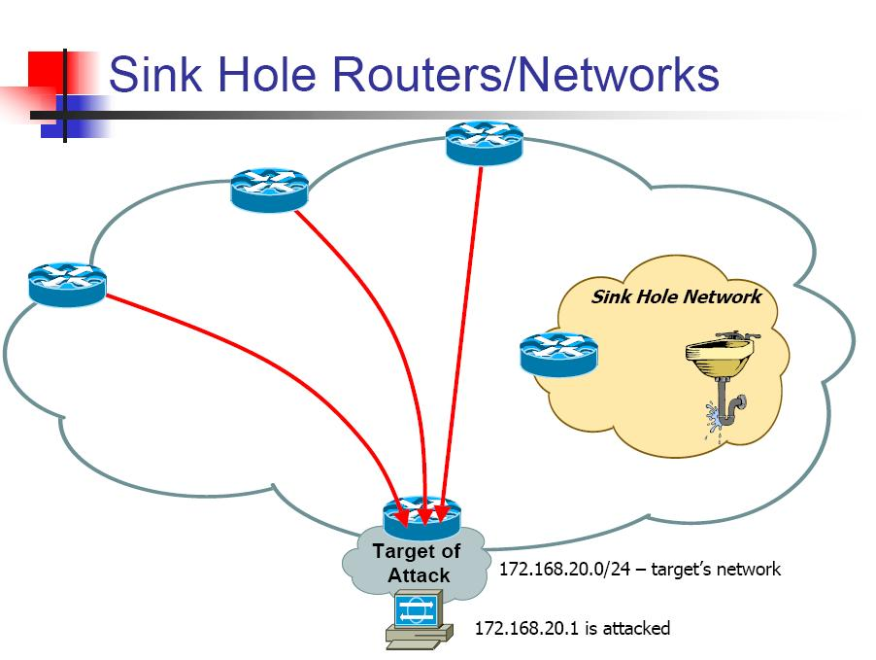
Implement sink holes

The network equivalent of a honey pot

A router that advertises routes to bogon addresses

Redirects attacks away from the customer

See link Ch 10i

Hardening Servers

Keep Up with Patches

System-Level SYN Protection

Operating system patches adjust SYN queue length, and timeout periods, to resist SYN floods

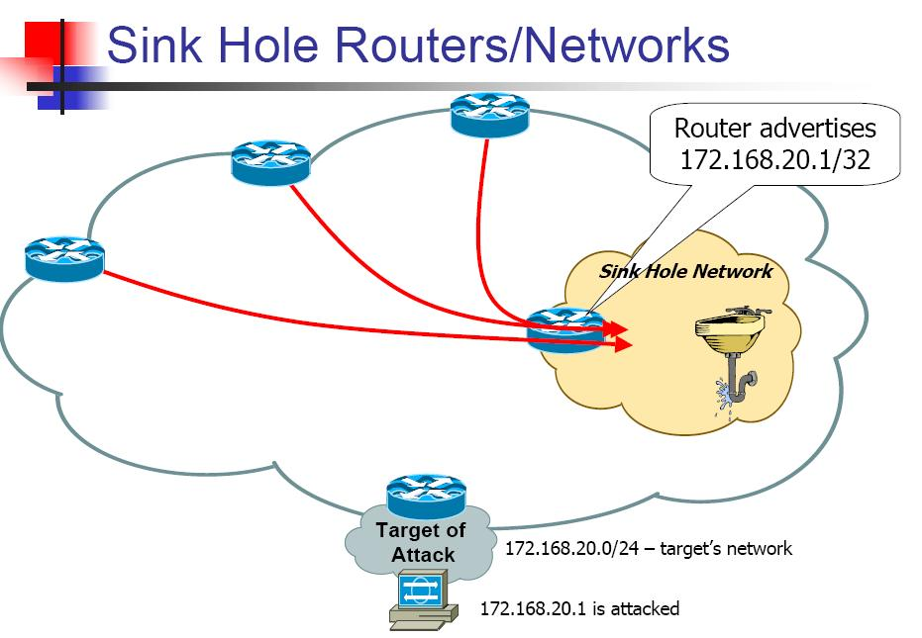
Linux kernels 2.0.30 and later employ SYN cookies (although they are turned off by default)

Windows can increase the SYN queue size dynamically

Disable responses to broadcast ECHO requests

DoS Testing

Get ethical hackers to test your network with DoS tests

DoS testing tools

WebLOAD (link Ch 10j)

Many tools compared at link Ch 10k

Read Current News About Malware

Subscribe to a good security newsletter, such as Bugtraq, or antivirus vendor information services

DoS Detection Technology and Techniques

Intrusion Detection Systems (IDS) aren't very good at stopping DoS attacks

Anomaly detection is better, like Peakflow from Arbor Networks (link Ch 10l)

The netstat -na command shows current connections

Many connections in a SYN_RECV state may indicate that a SYN attack is in progress

Scan for DoS Bots on Your Networks

Deploy antivirus on every machine

Tools to detect DoS bots

DDOSPing (link Ch 10m)

Finds Trinoo, Stacheldraht and Tribe Flood Network programs running with their default settings

Responding to DoS

Plan and Practice Your Response Process

Have fire drills

Prepare documented incident escalation procedures

See link Ch 10n

Key points:

Rapid escalation, aggressive triage, thorough investigation, carefully orchestrated communication through resolution, and collaborative post-mortem

Filter or Redirect Offending Traffic

Blocking based on source IP works only if the source addresses aren't spoofed

CiscoGuard uses multiple layers of filtering to weed out bad traffic from good

Deploy sink holes to redirect malicious DoS traffic

Call Your ISP and Initiate traceback

You or your ISP will have to work closely with the ISPs who are the source of the attack

They are best positioned to filter the traffic

Move the Target

When microsoft.com was heavily attacked, they

Changed the IP address in DNS to deflect static IP-targeted attacks

Shortened the time to live (TTL) on the targeted domain name so DNS clients would rapidly receive updates

Set up a CNAME entry in their DNS to point DoS attacks elsewhere

Removed an unneeded DNS name from the DNS entirely

Cut Over to Alternate Infrastructure or Application Modes

HTTP Caching services can handle traffic for you

Akamai (link Ch 10o)

Savvis (link Ch10p)

Switch to alternative pages or techniques to respond faster during heavy load

Pages often switch to simple HTML during a Digg storm, for example

Last modified 4-18-08 10 pm

