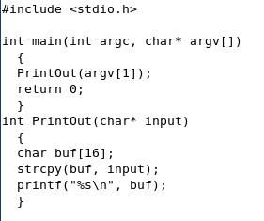
Common Exploit Techniques

Buffer Overflows and Design Flaws

History

Buffer over-runs in the mid-1990s

Then C library vulnerabilities

Then string vulnerabilities, off-by one buffer overruns, and database vulnerabilities

Then web-based attacks

Then integer overflow vulnerabilities

Mudge

Peiter C. Zatko (better known as Mudge)

Did early research on Buffer Overflows

Member of L0pht and CULT OF THE DEAD COW

Testified before a Senate committee in 1998

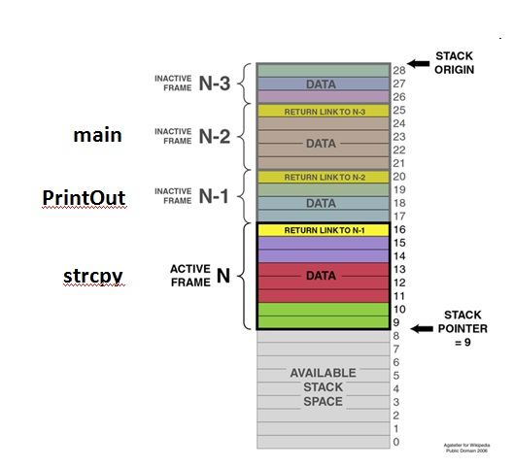
Links Ch 11a, 11b, 11c

Stack Buffer Overflows

Easiest and most devastating buffer overrun

The stack is simply computer memory used when functions call other functions

Example

When the strcpy function is called, the segments are as shown

Extended Instruction Pointer

The Extended Instruction Pointer (EIP) is the register used by the processor to indicate which command is being executed

The values marked "Return Link" in yellow on the figure are loaded into the EIP when a function returns

So if a hacker can control the EIP, they can execute arbitrary code (own the box)

Famous Buffer Overflows

Since 1995 there have been over a thousand buffer overflow vulnerabilities exposed to the public

Nimda (Windows)

Slammer (SQL Server)

Scalper (FreeBSD)

Slapper (Apache and OpenSSL)

Witty (ISS RealSecure)

Stack Buffer Overflow Countermeasures

Practice safe and secure coding standards

Validate data

Call functions properly

Check your code

Regular code audits

Especially for sprintf(), vsprintf(), strcat(), strcpy(), gets(), scanf(), etc.

Prohibit use of old, dangerous C functions like strcpy

Employ stack execution protection

Windows has had Data Execution Prevention since Win XP SP2

Available for other operating systems too

Use compiler tools to detect stack overruns

In Microsoft Visual C++, use the /GS option

For gcc, use StackShield or StackGuard or Libsafe

Demonstration

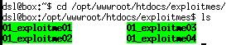
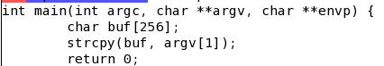
Damn Vulnerable Linux 1.0

01_exploitme01 application

Source code

Uses strcpy to copy user input to a buffer

No validation

Segmentation Faults

The 01_exploitme01 application crashes with no input, or with input too large

Gnu Debugger

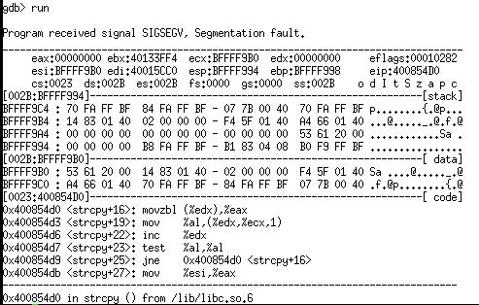
Registers: eax, ebx, … ebp, eip

Temporary storage of data

Most important for us is the eip

Extended Instruction Pointer

Address of the next instruction to be executed

If we can control this pointer, we can execute arbitrary code

We 0wn the box

Injecting a Long String

Fill stack with As

eip is 41414141 – four bytes of A in ASCII

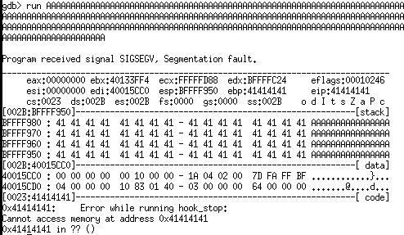

Controlling the EIP

This injection precisely targets the EIP with "CCCC" or 43434343

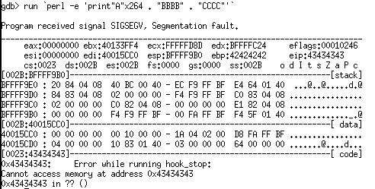

Finding the ESP

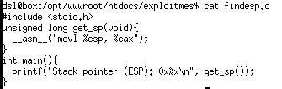
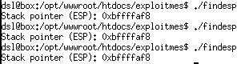
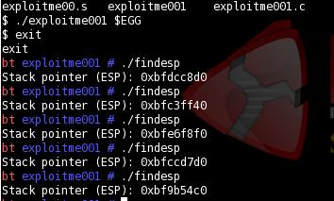
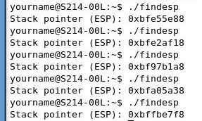
The Extended Stack Pointer is also needed for the exploit, so we can find the code we injected

This program finds the ESP

ESP on DVL 1.0

The ESP is always the same on a vulnerable operating system like Damn Vulnerable Linux 1.0 or 1.1

If you run the program several times, you get the same answer

ESP on DVL 1.4

The ESP is different each time

Buffer overflows will be much more diffcult to exploit

ESP on Ubuntu

A different ESP each time

Windows also has this "Address Space Layout Randomization" protection feature in Vista and Server 2008

Buffer Overflow Tutorial
http://mag.damnvulnerablelinux.org/2008/05/buffer-overflow-tutorial-by-preddy-rootshell-security-group/

Heap/BSS/Data Overflows

More difficult to write than stack overflows, but still dangerous

The heap is used by programs to allocate dynamic memory at runtime

There are no return function addresses to overwrite on the heap

These attacks depend on overwriting important variables or sensitive heap block structures that contain addresses

Example of Heap Overflows

Titan FTP Server for Windows

Bugtraq released August 30, 2004

Attacker passes a directory name longer than 20,480 bytes long to the CWD (change working directory) command

Attacker can execute arbitrary code

Exploit code at link Ch 11j

Heap overflow article at link Ch 11k

Heap/BSS/Data Overflow Countermeasures

Practice safe and secure coding standards

Validate data

Call functions properly

Check your code

Regular code audits

Some operating systems also add countermeasures to the heap

Windows Server 2003 and Windows XP SP2 check whether sensitive data in the heap blocks is correctly formed

Format String Attacks

The correct way to use the printf function is this:

printf("Hello world. My name is: %s\n", my_name);

The %s is a format string, telling C to print the my_name variable as a string

Hello world. My name is: Stuart McClure

Missing Format String

A sloppy programmer can do this:

printf(my_name);

So an attacker can add format strings like %s, %d, %u in the my_name variable, and read the contents of memory, or even write to memory

Link Ch 11l

Format String Countermeasures

Validate input before using it

Always include the format specifier explicitly in functions, like this

printf("Hello world. My name is: %s\n", my_name);

Off-by-One Errors

Here's an OpenSSH vulnerability discovered in 2002

The programmer wrote

if (id < 0 || id > channels_alloc)

The only allowed values are from 0 to channels_alloc-1.

The case id=channels_alloc was incorrectly handled, allowing privilege escalation

Off-by-One Countermeasures

Audit code! The correct line was this:

if (id < 0 || id >= channels_alloc)

Input Validation Attacks

Ways to sneak malicious input past input validation

Canonicalization Attacks

Canonicalization is converting input into its standard form, or canonical form

Example: the backslash character \

\ in ASCII

%2f in hexadecimal

%2f or %c0%af in Unicode

URL Directory Traversal

This URL would be blocked by a Web server because it has ../ characters

http://10.1.1.3/scripts/../../../../winnt/system32/cmd.exe?/c+dir

This one might be allowed

http://10.1.1.3/scripts/..%c0%af..%c0%af..%c0%af../winnt/system32/cmd.exe?/c+dir

Other Canonical-Form Exploits

There are many others, here are some examples

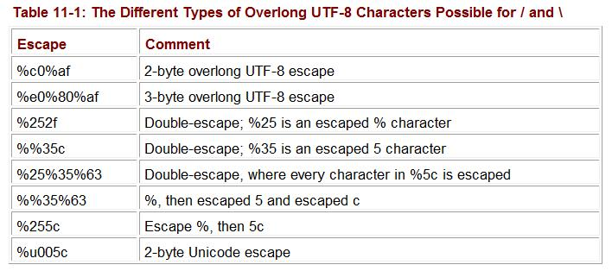
Normalize Before Validation

Canonicalization attacks work because code is scanned for illegal characters before it is converted to canonical form

Convert it first, and check for illegal characters afterwards

Canonicalization Countermeasures

This script will prevent some canonicalization attacks against ASP.NET applications
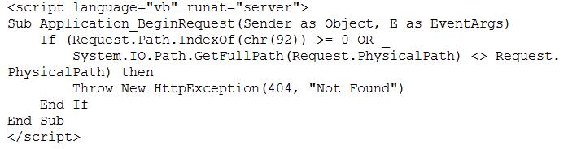

URLScan

Prevents malicious URLs from reaching an IIS Web server

Built into IIS 6 and later versions

Web Application and Database Attacks

SQL Injection and many more

Coming up in the next chapter

Countermeasure: sanitize input before using it

Common Countermeasures

People: Changing the Culture

Process: Security in the Development Lifecycle (SDL)

Threat Modeling

Code Audits, both manual and automated

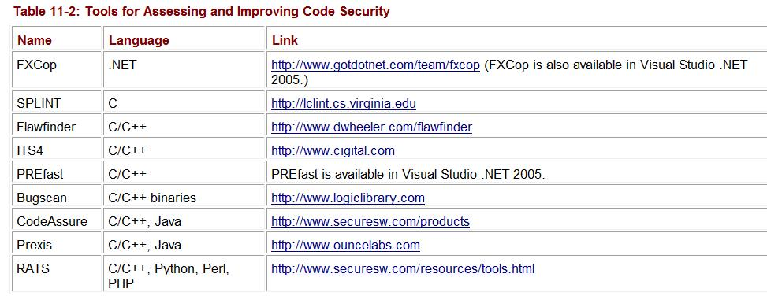
Tools

Security Testing

Fuzzing

Generating random and crafted input to test software

This is how David Maynor 0wned the Mac via Wi-Fi (link Ch 11m)

Pen Testing

Experienced attackers testing application

Audits & Maintenance

Audit or Final Security Review

Check products before shipping

Maintenance

Reports of vulnerabilities

Patches and hotfixes

Last modified 11-12-08

