Web Server Hacking

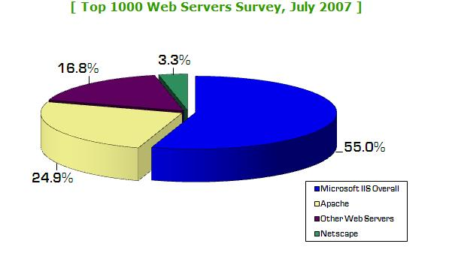
Popular Web Servers

Microsoft IIS/ASP/ASP.NET

LAMP (Linux/Apache/MySQL/PHP)

BEA WebLogic

Link Ch 12j

IBM WebSphere

Link Ch 12k

Popularity

Links Ch 12l, 12m

Attacking Web Server Vulnerabilities

An attacker with the right set of tools and ready-made exploits can bring down a vulnerable web server in minutes

Some of the most devastating Internet worms have historically exploited these kinds of vulnerabilities

Code Red and Nimda attacked IIS vulnerabilities

Why the Risk is Decreasing

The risk of such attacks is decreasing, because:

Newer versions of Web servers are less vulnerable

System administrators are better at configuring the platforms

Vendor's "best practices" documents are better

Patches come out more rapidly

Countermeasures are available, such as:

Sanctum/Watchfire's AppShield

A Web application firewall (link Ch_12n)

Microsoft's URLScan

Built in to IIS 6 and IIS 7

Link Ch_12o

Automated vulnerability-scanning products and tools are available

Web Server Vulnerabilities

Sample files

Source code disclosure

Canonicalization

Server extensions

Input validation (for example, buffer overflows)

Sample files

Sample scripts and code snippets to illustrate creative use of a platform

In Microsoft's IIS 4.0

Sample code was installed by default

showcode. asp and codebrews.asp

These files enabled an attacker to view almost any file on the server like this:

http://192.168.51.101/msadc/Samples/SELECTOR/showcode.asp?source=/../.. /../../../boot.ini

http://192.168.51.101/iissamples/exair/howitworks/codebrws.asp?source= /../../../../../winnt/repair/setup.log

Sample Files Countermeasure

Remove sample files from production webservers

If you need the sample files, you can get patches to improve them

ColdFusion Expression Evaluator patch

Link Ch 12p

Source Code Disclosure

IIS 4 and 5 could reveal portions of source code through the HTR vulnerability (link Ch 12q)

Apache Tomcat and BEA WebLogic had similar issues

Attack URLs:

http://www.iisvictim.example/global.asa+.htr

http://www.weblogicserver.example/index.js%70

http://www.tomcatserver.example/examples/jsp/num/
numguess.js%70

Source Code Disclosure Countermeasures

Apply patches (these vulnerabilities were patched long ago)

Remove unneeded sample files

Never put sensitive data in source code of files

You can never be sure source code is hidden

Canonicalization Attacks

There are many ways to refer to the same file

C:\text.txt

..\text.txt

\\computer\C$\text.txt

The process of resolving a resource to a standard (canonical) name is called canonicalization

ASP::$DATA Vulnerability

Affected IIS 4 and earlier versions

Just adding ::DATA to the end of an ASP page's URL revealed the source code

http://xyz/myasp.asp::$DATA

Link Ch 12r

Unicode/Double Decode Vulnerabilities

Strings like %c0%af could be used to sneak characters like \ past URL filters

Attack URL example:

http://10.1.1.3/scripts/
..%c0%af..%c0%af..%c0%af..
/winnt/system32/cmd.exe?/c+dir

Exploited by the Nimda worm

Canonicalization Attack Countermeasures

Patch your Web platform

Compartmentalize your application directory structure

Limit access of Web Application user to minimal required

Clean URLs with URLScan and similar products

Remove Unicode or double-hex-encoded characters before they reach the server

New IIS 7 Security Measures (not in book)

Application Pool Isolation

Each Web application runs as a process named w3wp.exe, and under the user identity IUSRS

But a different SID is injected into the w3wp.exe process for each Web application NTFS permissions allow each Web application process access to only its own files and folders

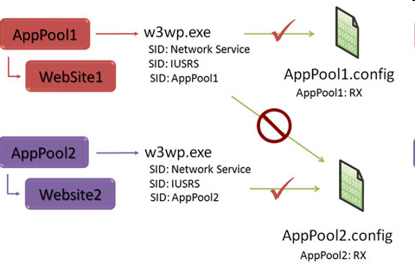
Application Pool Isolation

See link Ch 12s

URL Authorization

In IIS 7 you can assign access controls to a specific URL by user name or group

This is far more flexible and convenient than applying NTFS permissions to files and folders

Especially when Web files are moved from one machine to another

Link Ch 12t

URL Authorization
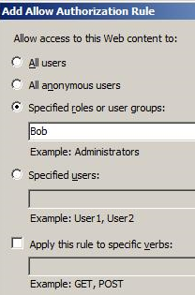
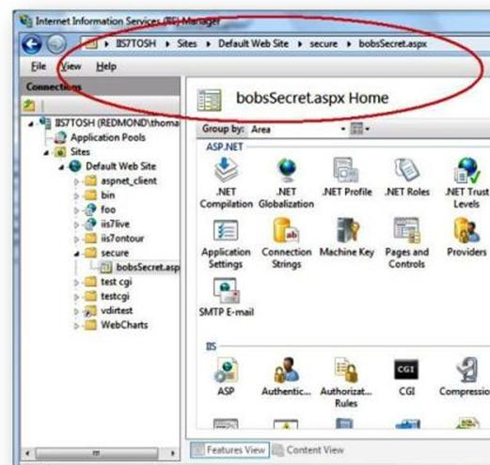

Server Extensions

Code libraries tacked on to the core HTTP engine to provide extra features

Dynamic script execution (for example, Microsoft ASP)

Site indexing

Internet Printing Protocol

Web Distributed Authoring and Versioning (WebDAV)

Secure Sockets Layer (SSL)

Each of these extensions has vulnerabilities, such as buffer overflows

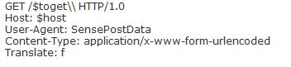
Microsoft WebDAV Translate: f problem

Add "translate: f" to header of the HTTP GET request, and a \ to the end of the URL

Reveals source code

Links Ch 12u, v

Server Extensions Exploitation Countermeasures

Patch or disable vulnerable extensions

The Translate: f problem was patched long ago

Buffer Overflows

Web servers, like all other computers, can be compromised by buffer overflows

The Web server is easy to find, and connected to the Internet, so it is a common target

Famous Buffer Overflows

IIS HTR Chunked Encoding Transfer Heap Overflow

Affects Microsoft IIS 4.0, 5.0, and 5.1

Leads to remote denial of service or remote code execution at the IWAM_ MACHINENAME privilege level

IIS's Indexing Service extension (idq.dll)

A buffer overflow used by the infamous Code Red worm

Internet Printing Protocol (IPP) vulnerability

Apache mod_ssl vulnerability

Also known as the Slapper worm

Affects all versions up to and including Apache 2.0.40


Results in remote code execution at the super-user level

Apache also suffered from a vulnerability in the way it handled HTTP requests encoded with chunked encoding

Resulted in a worm dubbed "Scalper"

Thought to be the first Apache worm

Buffer Overflow Countermeasures

Apply software patches

Scan your server with a vulnerability scanner

Web Server Vulnerability Scanners

Nikto checks for common Web server vulnerabilities

It is not subtle—it leaves obvious traces in log files

Link Ch 12z01

Whisker is another Web server vulnerability scanner

Nikto version 2 uses LibWhisker 2, so it may replace Whisker

Nikto Demonstration

Scan DVL Web Server with Nikto

Results

Info.php tells far too much information

The TRACE method can be used to reveal information about cookies, and to defeat some Microsoft IE 6 security measures

The attack is somewhat esoteric

See link Ch 12z02
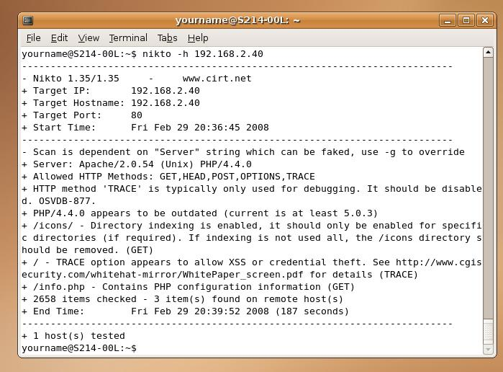

Web Application Hacking

Attacks on applications themselves, as opposed to the web server software upon which these applications run

The same techniques

Input-validation attacks

Source code disclosure attacks

etc.

Finding Vulnerable Web Apps with Google

You can find unprotected directories with searches like this:

"Index of /admin"

"Index of /password"

"Index of /mail"

You can find password hints, vulnerable Web servers with FrontPage, MRTG traffic analysis pages, .NET information, improperly configured Outlook Web Access (OWA) servers…

And many more

Link Ch 1a

Web Crawling

Examine a Web site carefully for Low Hanging Fruit

Local path information

Backend server names and IP addresses

SQL query strings with passwords

Informational comments

Look in static and dynamic pages, include and other support files, source code

Web-Crawling Tools

wget is a simple command-line tool to download a page, and can be used in scripts

Available for Linux and Windows

Link Ch 12z03

Offline Explorer Pro

Commercial Win32 product

Web Application Assessment

Once the target application content has been crawled and thoroughly analyzed

Probe the features of the application

Authentication

Session management

Database interaction

Generic input validation

Tools for Web Application Assessment

Achilles proxy server

Allows user to intercept and alter HTTP and HTTPS traffic

Runs on Windows

Paros proxy server

Requires Java Runtime Engine (JRE)

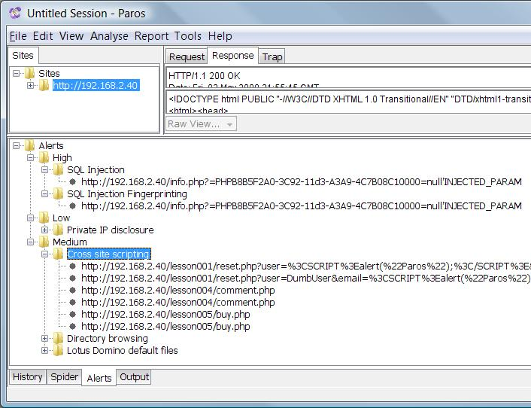
Scans for vulnerabilities

Spiders sites

Runs on Windows or Linux/Unix

Link Ch 12z04

Paros Scan of the DVL Website

WebSleuth

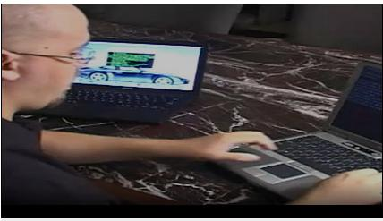
A web application security-testing tool built into a browser, and it's available for Win32 and Linux

HTTP/Cookie session ID brute forcer

SQL injection tester

HTTP brute forcer

Other Tools

SPIKE

A fuzzer – throws random data at a Web form

Examines the results for signs of vulnerability

This is how Jon Elich and David Maynor pwned the Mac at Blackhat 2006

Link Ch 12z05

WebInspect Cookie Cruncher Plug-In

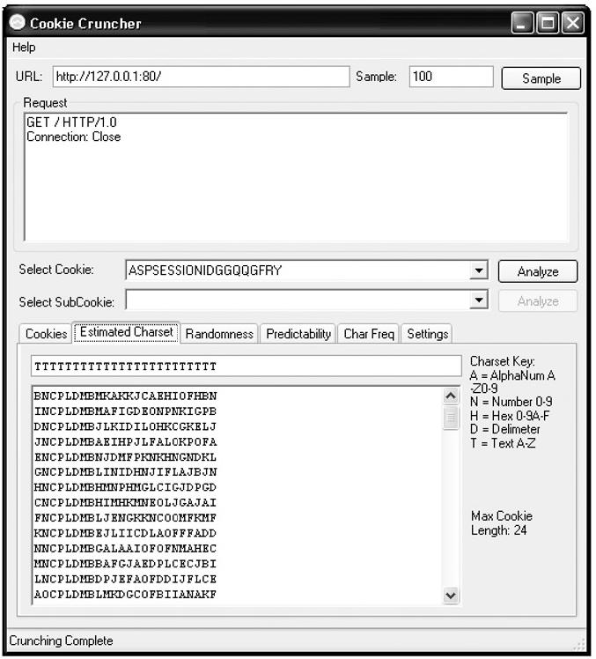
Tests character set

Randomness

Predictability

Character frequency

Another Commercial Tool

Sanctum/Watchfire AppScan/WebMX

Expensive tool for large networks

Automated web privacy, security, and regulatory compliance

There were dizzyingly many more at the RSA conference

Common Web Application Vulnerabilities

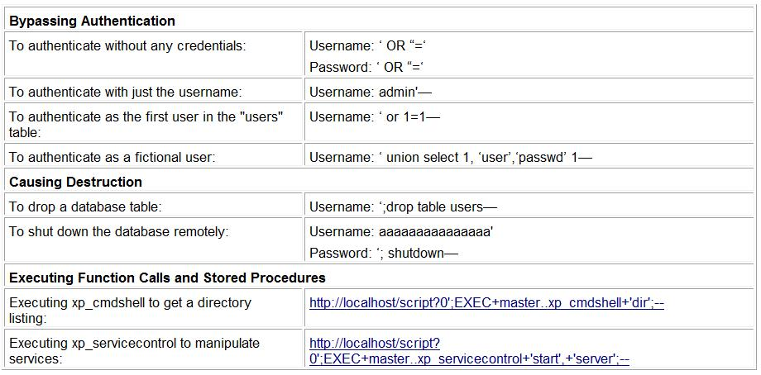
SQL Injection

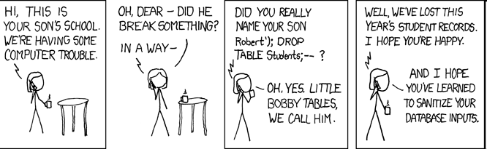
xkcd.org – a great comic

Link Ch 11i

Automated SQL Injection Tools

Wpoison

Runs on Linux

SPIKE Proxy

mieliekoek.pl

SQL insertion crawler that tests all forms on a website for possible SQL insertion problems

SPI Dynamics' SPI Toolkit

Contains SQL Injector that automates SQL injection testing

SQL Injection Countermeasures

Perform strict input validation

Replace direct SQL statements with stored procedures, prepared statements, or ADO command objects

That way they can't be modified

Implement default error handling

Use a general error message for all errors

Lock down ODBC

Disable messaging to clients. Don't let regular SQL statements through. This ensures that no client, not just the web application, can execute arbitrary SQL.

Lock down the database server configuration

Specify users, roles, and permissions, so even if SQL statements are injected, they can't do any harm

Cross-Site Scripting (XSS) Attacks

One user injects code that attacks another user

Common on guestbooks, comment pages, forums, etc.

Caused by failure to filter out HTML tags

These characters < > ( ) # &

Also watch out for hex-encoded versions

%3c instead of <

%3e instead of >

%22 instead of "

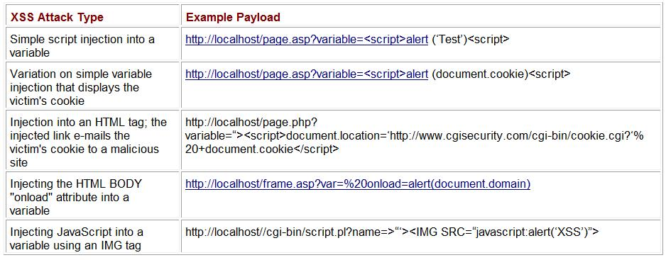
Common XSS Payloads

See link Ch 12z06

Cross-Site Scripting Countermeasures

Filter out < > ( ) # & and the variants of them

HTML-encode output, so a character like < becomes &lt; -- that will stop scripts from running

In IE 6 SP1 or later, an application can set HttpOnly Cookies, which prevents them from being accessed by scripts

Although the TRACE method can defeat this security measure

Analyze your applications for XSS vulnerabilities

Fix the errors you find

Last modified 12-30-08

