Definition

Scanning identifies live hosts and running services

Enumeration probes the identified services more fully for known weaknesses

Enumeration is more intrusive, using active connections and directed queries

Enumeration will usually be logged and noticed

Goals of Enumeration

User account names

to inform subsequent password-guessing attacks

Oft-misconfigured shared resources

for example, unsecured file shares

Older software versions with known security vulnerabilities

such as web servers with remote buffer overflows

Pen-Test Video

Link Ch 3a: Droop's Box: Simple Pen-test Using Nmap, Nikto, Bugtraq, Nslookup and Other Tools by IronGeek
Banner Grabbing

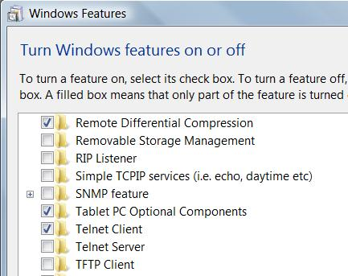
Telnet in Vista and Windows 7

First you need to install Telnet

In Control Panel, Programs and Features, Turn Windows Features on or off, check Telnet Client

Banner Grabbing

Connecting to remote applications and observing the output

Simple way, at a command prompt

telnet www.ccsf.edu 80

On the next blank screen type in

GET / HTTP/1.1

Press Enter twice

Making Characters Visible

In Windows XP and Vista, you can't see what you type in the Telnet session. To fix that, do this:

At a command prompt, type

telnet hills.ccsf.edu 80

Press Enter. Press Ctrl+]. Then type

set localecho

Press Enter twice

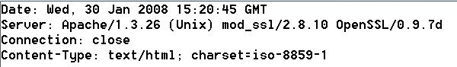
Link Ch 3z11

Example Banners

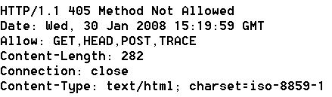
www.ccsf.edu tells you too much

cnn.com is better

Netcat Banner Grabs

Get Netcat for Windows at link Ch 3d
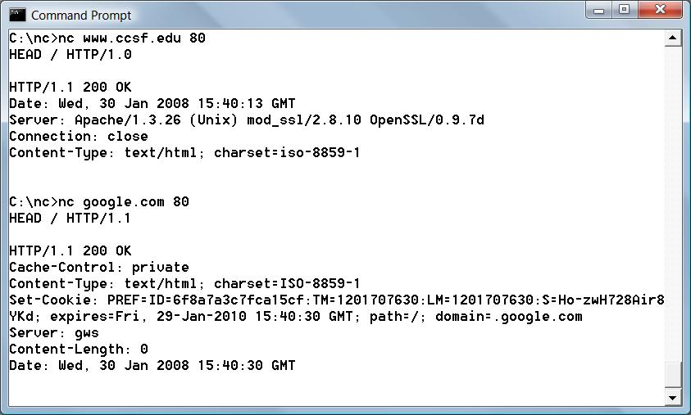

Banner-Grabbing Countermeasures

Turn off unnecessary services

Disable the presentation the vendor and version in banners

Audit yourself regularly with port scans and raw netcat connects to active ports

Enumerating Common Network Services

FTP Enumeration, TCP 21

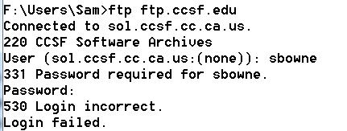
CCSF doesn't give away much information

FTP is becoming obsolete, see ftp.sun.com

FTP passwords are sent in the clear

Don't allow anonymous uploads

Turn it off, use secure FTP instead

Googling for FTP Servers

Search for

intitle:"Index of ftp://"

Here's an overly informative HTTP banner
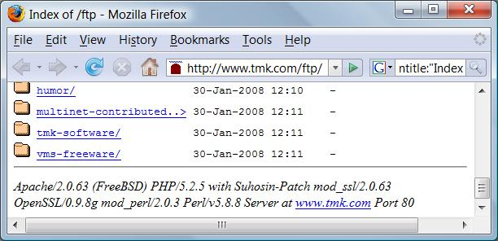

FTP Banner

Here's the corresponding overly informative FTP banner

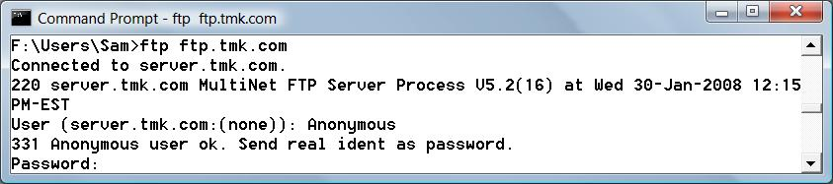

Enumerating SMTP, TCP 25

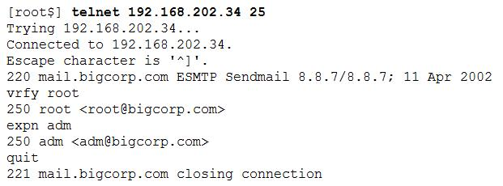
SMTP can be enumerated with Telnet, using these commands

VRFY confirms names of valid users

EXPN reveals the actual delivery addresses of aliases and mailing lists

Antivirus Note

McAfee antivirus blocks telnets to port 25

"Prevent mass mailing worms from sending mail"

SMTP Enumeration Countermeasures

Disable the EXPN and VRFY commands, or restrict them to authenticated users

Sendmail and Exchange both allow that in modern versions

DNS Zone Transfers, TCP 53

Zone transfers dump the entire contents of a given domain's zone files

Restricted to authorized machines on most DNS servers now

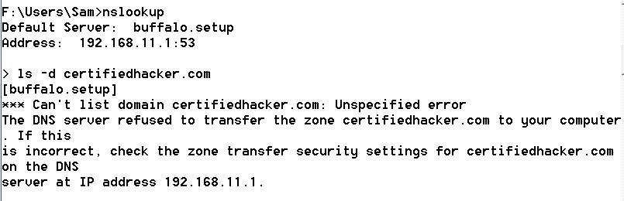

Enumerating TFTP, TCP/UDP 69

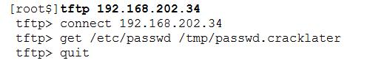
TFTP is inherently insecure

Runs in cleartext

No authentication at all

Anyone can grab any file

Used in routers and VoIP Telephones to update firmware

TFTP Enumeration Countermeasures

Wrap it to restrict access

Using a tool such as TCP Wrappers

TCP Wrappers is like a software firewall, only allowing certain clients to access a service

Links Ch 3e, 3f

Limit access to the /tftpboot directory

Make sure it's blocked at the border firewall
Finger, TCP/UDP 79

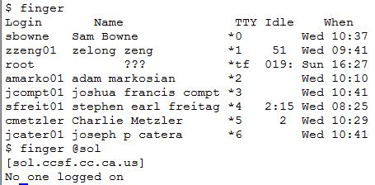
Shows users on local or remote systems, if enabled

Useful for social engineering

Countermeasure: block remote access to finger

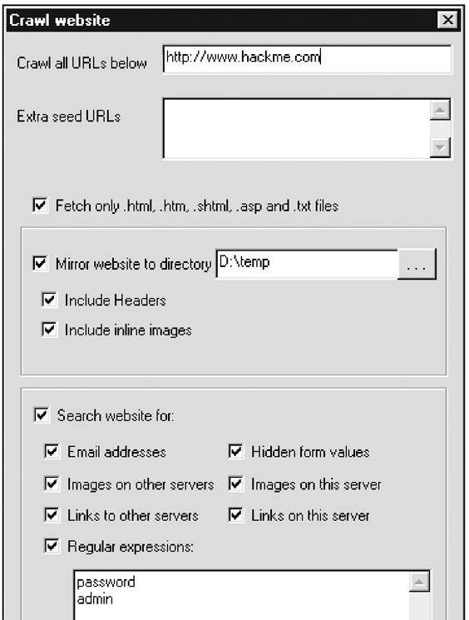
Enumerating HTTP, TCP 80

Grab banners with netcat or telnet

Crawl Web sites with Sam Spade

HTTP Enumeration Countermeasures

Change the banner on your web servers

URLScan for IIS v 4 and later

Link Ch 3h

Microsoft RPC Endpoint Mapper (MSRPC), TCP 135

Remote Procedure Call (RPC) endpoint mapper (or portmapper) service on TCP 135

Querying this service can yield information about applications and services available on the target machine

epdump

Shows services bound to IP addresses

It takes some research to interpret the results

Link Ch 3n

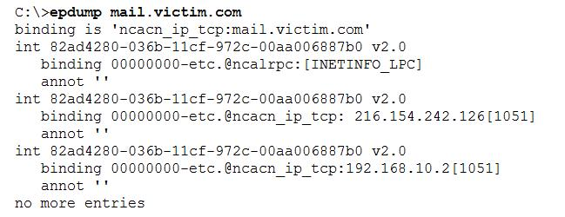
rpcdump

On the Backtrack 2 CD

Start, Backtrack, Vulnerability Identification, All, RPCDump

Similar results

MSRPC Enumeration Countermeasures

Block port 135 at the firewall, if you can

But some Microsoft Exchange configurations require access to the endpoint mapper

You can avoid that by using Virtual Private Networks, or

Outlook Web Access (OWA) which works over HTTPS

NetBIOS Name Service, UDP 137

NetBIOS Name Service (NBNS) is Microsoft's name service, an alternative to DNS

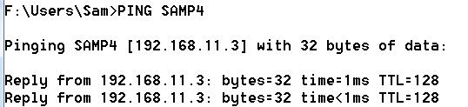
What is Name Resolution?

Suppose you issue a command that refers to a computer by name, such as PING

Name Resolution

Windows needs to change a computer name to an IP address to send data packets

Windows uses two naming systems:

DNS (the preferred method)

NetBIOS Name Resolution (still used by all versions of Windows)

See link Ch 3v

Standard Name Resolution Methods

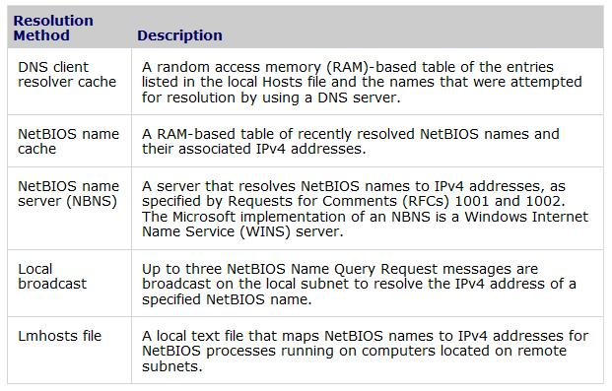
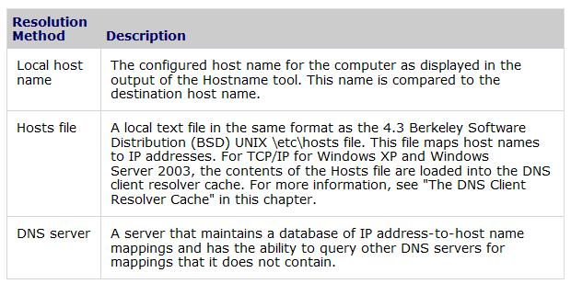

Charts from link Ch 3v

Additional Name Resolution Methods

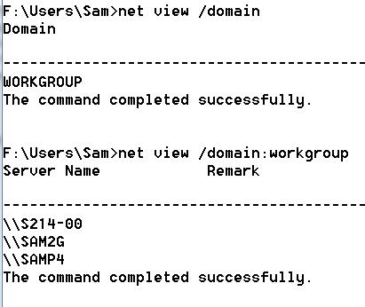
NET VIEW

NET VIEW can list the domains, or the computers in each domain

NBNS over TCP/IP

Normally NBNS only works on the local network segment

It is possible to route NBNS over TCP/IP, allowing enumeration from a remote system

Other Tools to Enumerate NBNS

NLTEST and NETDOM can find domain controllers

NETVIEWX finds specific services

NBTSTAT collects information from a single system

NBTSCAN scans a whole range of addresses, and dumps the whole NetBIOS name table

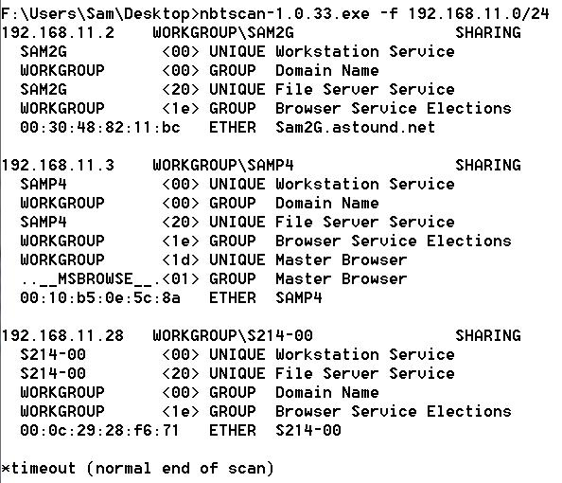
Link Ch 3w

NBTSCAN

Stopping NetBIOS Name Services Enumeration

All the preceding techniques operate over the NetBIOS Naming Service, UDP 137

Block UDP 137 at the firewall, or restrict it to only certain hosts

To prevent user data from appearing in NetBIOS name table dumps, disable the Alerter and Messenger services on individual hosts

Blocking UDP 137 will disable NBNS name authentication, of course

NetBIOS Session, TCP 139

These are the notorious Null Sessions

The Windows Server Message Block (SMB) protocol hands out a wealth of information freely

Null Sessions are turned off by default in Win XP and Server 2003, but open in Win 2000 and NT

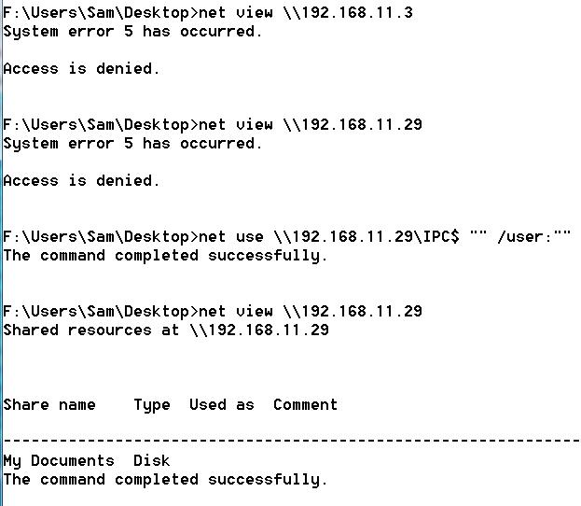
They aren't available in Win 95, 98, or Me

Link Ch 3x, 3y, 3z00, 3z01

Null Session Against Win 2000

Information Available

Null sessions on Win 2000 and NT provide information about:

Shares

User accounts

Password policies

DumpSec

Free from link Ch 3z02

Runs on Vista (and earlier Windows)

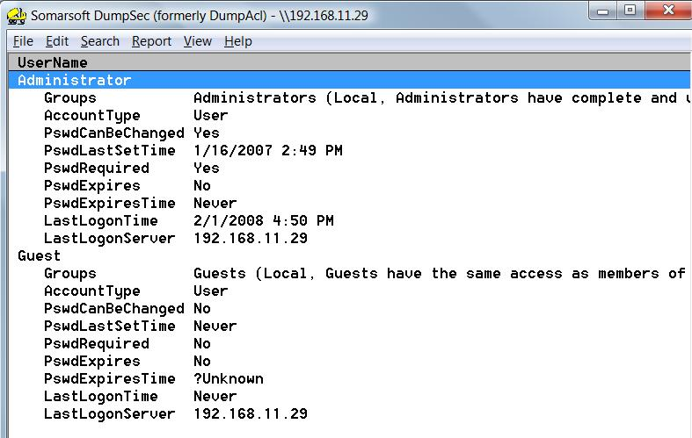

Registry Enumeration


The Registry can be viewed remotely

Requires Administrator privileges by default on Windows servers

You can't do it with null sessions

Gary McKinnon used remote registry access to hack into the Pentagon

Link Ch 3z03

user2sid/sid2user

These utilities can get user account names and SIDs remotely, even if the registry key RestrictAnonymous is set to 1

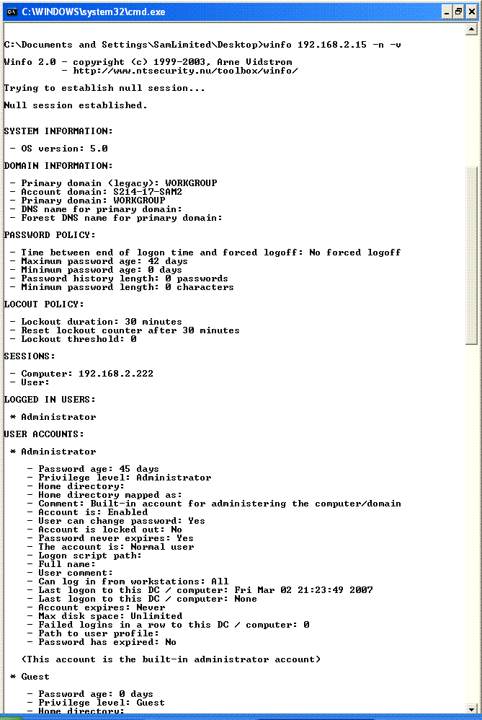
They can find the Administrator's account name, even if it's renamed, by changing the last 3 numbers of another account's SID to 500

Works against Win 2003, but not Win XP SP2

See link Ch 3z04

All-in-One Null Session Enumeration Tools

Winfo

Newer tool:

NBTEnum 3.3

Link Ch 3z15

SMB Null Session Countermeasures

Block TCP 139 and 445 at the router

Set the RestrictAnonymous registry key to 1 or 2

HKLM\SYSTEM\CurrentControlSet\Control\LSA

Ensure the Registry Is Locked Down

SNMP, UDP 161

Simple Network Management Protocol (SNMP) is intended for network management and monitoring

Administrators use SNMP to remotely manage routers and other network devices

But it has many security vulnerabilities

See links Ch 3z06, 3z07, 3z08

Community Strings

SNMP is not a very secure protocol.

It has a minimal security system called SNMP Community Strings

Community strings act like passwords

There are three kinds of SNMP Community strings: Read-Only, Read-Write, and Trap (Trap is rarely used)

But the community strings are often left at obvious defaults like "public" and "private"

Management Information Bases (MIBs)

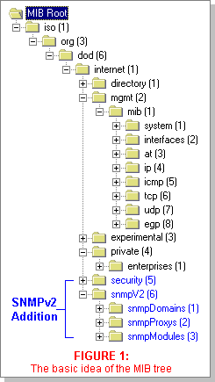
The MIB contains a SNMP device's data in a tree-structured form, like the Windows Registry

Vendors add data to the MIB

Microsoft stores Windows user account names in the MIB

Image from link Ch 3z07

Data Available Via SNMP Enumeration

Running services

Share names

Share paths

Comments on shares

Usernames

Domain name

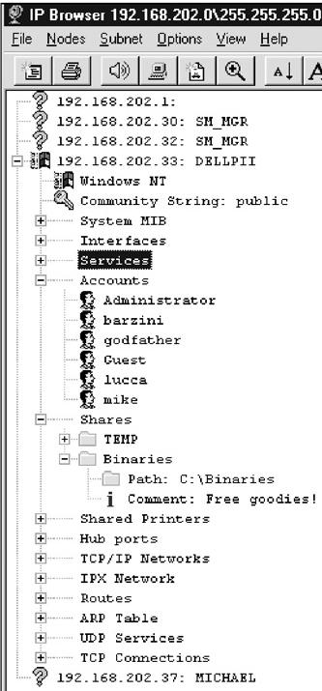

SNMP Enumeration Tools

snmputil from the Windows NT Resource Kit

snmpget or snmpwalk for Unix

IP Network Browser

Part of the Engineer's Toolset, link Ch 2d

Worse than Enumeration

Attackers who guess the SNMP community string may be able to remotely control your network devices

That can be used for DoS attacks, or other attacks

SNMP Enumeration Countermeasures

Remove or disable unneeded SNMP agents

Change the community strings to non-default values

Block access to TCP and UDP ports 161 (SNMP GET/SET)

Restrict access to SNMP agents to the appropriate management console IP address

Use SNMP V3—much more secure than V1

Provides enhanced encryption and authentication mechanisms

Adjust Win NT registry keys to make SNMP less dangerous

BGP, TCP 179

Border Gateway Protocol (BGP) is the de facto routing protocol on the Internet

Used by routers to help them guide packets to their destinations

It can be used to find all the networks associated with a particular corporation

That may give you more targets to attack

A small risk, but there is no countermeasure
Windows Active Directory LDAP, TCP/UDP 389 and 3268

Active Directory contains all user accounts and other information on Windows domain controllers

If the domain is made compatible with earlier versions of Windows, such as Win NT Server, any domain member can enumerate Active Directory

Active Directory Enumeration Countermeasures

Filter access to ports 389 and 3268 at the network border

Use "Native" domains—don't allow Win NT4 Domain Controllers
Other Services Vulnerable to Enumeration

Novell NetWare Enumeration, TCP 524 and IPX

UNIX RPC Enumeration, TCP/UDP 111 and 32771

rwho (UDP 513) and rusers (RPC Program 100002)

NIS Enumeration, RPC Program 100004

SQL Resolution Service Enumeration, UDP 1434

NFS Enumeration, TCP/UDP 2049

Last modified 1-30-09

