Reasons for Windows Security Problems

Popularity & Complexity

Backward Compatibility

Very important at businesses

Enabled by default

Causes many security problems

Proliferation of features

Windows is Improving

Windows XP SP2 was a giant improvement in security

Windows Firewall

Data Execution Prevention

Vista is even more secure

User Account Control

BitLocker Drive Encryption
Unauthenticated Attacks

Four Vectors

Authentication Spoofing

Network Services

Client Vulnerabilities

Device Drivers
Authentication Spoofing Attacks

Services to Attack

Server Message Block (SMB)

TCP ports 445 and 139

Microsoft Remote Procedure Call (MSRPC)

TCP port 135

Terminal Services

TCP port 3389

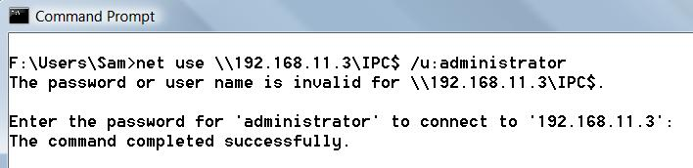
SQL

TCP 1443 and UDP 1434

SharePoint and other Web services

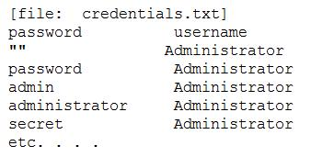
TCP 80 and 443

Password Guessing from the Command Line

Accounts may lock out after too many guesses

A Password Guessing Script

Put password – user name pairs in a file named credentials.txt

Tools: enum, Brutus, TSGrinder, many more

Link Ch 4a1

Password-Guessing Countermeasures

Use a network firewall to restrict access to SMB services on TCP 139 and 445

Use host-resident features of Windows to restrict access to SMB

IPSec filters (Restricts by source IP – link Ch4b)

Windows Firewall

Disable SMB services (on TCP 139 and 445)

Enforce the use of strong passwords using policy

Set an account-lockout threshold and ensure that it applies to the built-in Administrator account

Enable audit account logon failures and regularly review Event Logs

Security Policy

SECPOL.MSC at a Command Prompt
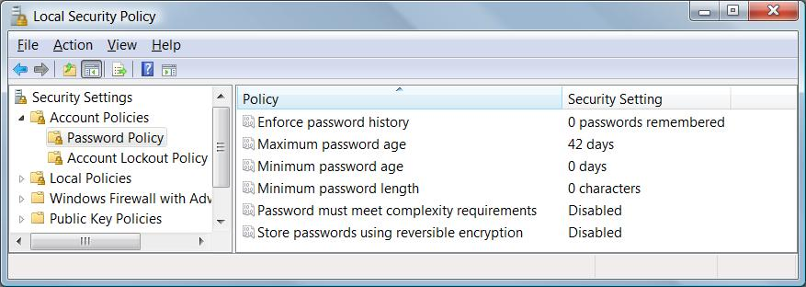

Audit Policy

Use a log analysis tool to check the logs

For even better security, use Intrusion Detection/Intrusion Prevention software
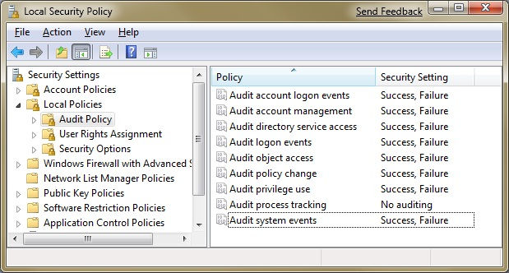

Eavesdropping on Network Password Exchange

You can sniff password challenge-response hashes with Cain

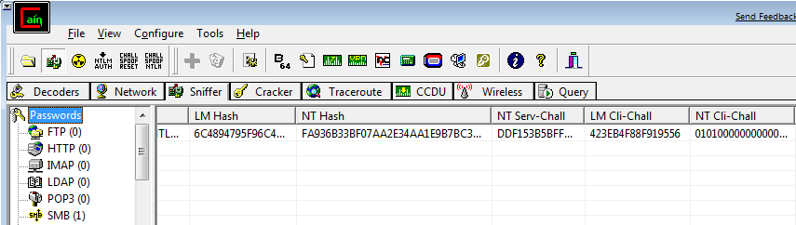
Use NTLM, not LM

The old LM Hashes are easily cracked

The newer NTLM hashes are harder to crack, although they can be broken by dictionary attacks

Elcomsoft has a new tool that cracks NTLM hashes by brute force, clustering many computers together

See link Ch 4f

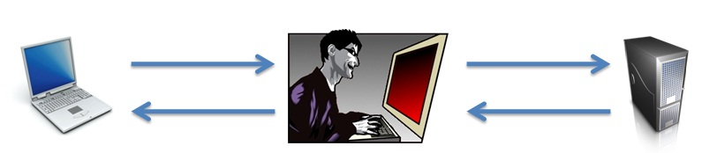
Man In The Middle Attacks

SMBRelay and SMBProxy pass authentication hashes along get authenticated access to the server, on Windows versions before XP

MITM Attack on Terminal Server

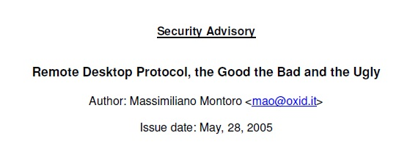
Cain can sniff Remote Desktop sessions unencrypted and get administrative credentials

For Windows XP and Windows Server 2003

Because Microsoft made a private key public (link Ch 4f1)

Microsoft Remote Procedure Call (MSRPC) vulnerabilities

The MSRPC port mapper is advertised on TCP and UDP 135 by Windows systems

It cannot be disabled without drastically affecting the core functionality of the operating system

MSRPC interfaces are also available via other ports, including TCP/UDP 139, 445 or 593, and can also be configured to listen over a custom HTTP port via IIS or COM Internet Services

MITM Countermeasures

Attacker usually has to be on your LAN

Use authenticated and encrypted protocols

Enforce them with Group Policy and firewall rules
Remote Unauthenticated Exploits

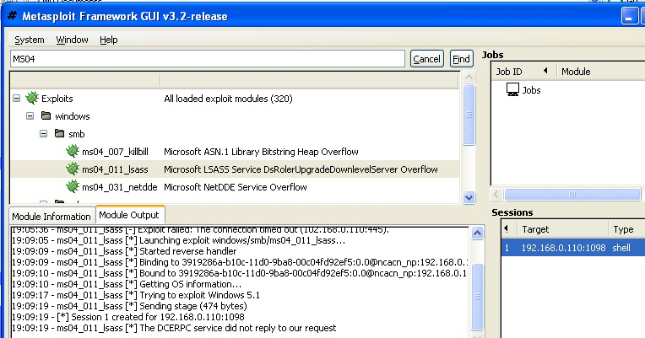
Metasploit

Easily exploits network services

Typically a couple of months behind Microsoft alerts

CORE IMPACT and Canvas are expensive, but better (Link Ch 4f2)

Network Service Exploit Countermeasures

Apply patches quickly

Use workarounds for unpatched vulnerabilities

Log and monitor traffic

Have an incident response plan

End-user Application Exploits

Often the weakest link, especially on Vista, because the OS itself is more secure

Countermeasures

Use a firewall to limit outbound connections

Patches

Antivirus

Run with least privilege

Use software security options, such as plaintext email and IE Security Zones

Device Driver Exploits

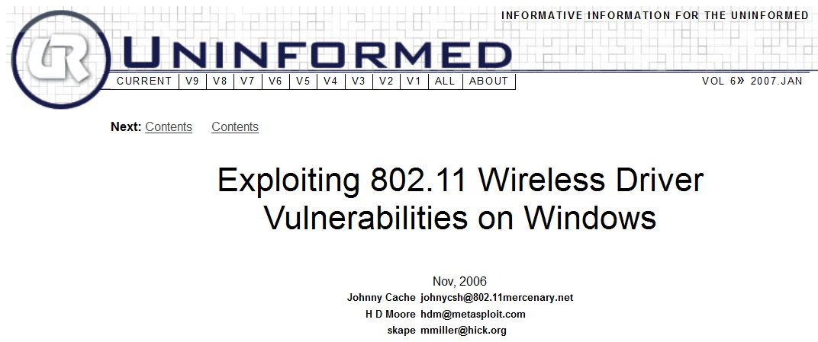
There are buffer overflows in wireless device drivers

It is possible to 0wn every vulnerable machine in range just with a beacon frame--no connection required

Link Ch 4z18

Driver Exploit Countermeasures

Apply vendor patches

Disable wireless networking in high-risk environments

Using Microsoft Logo-tested drivers MIGHT make you safer…

But does Microsoft really thoroughly test drivers, with fuzzers?

Fuzzing for 5 seconds was enough for Cache et al. to find a vulnerability

Authenticated Attacks

Privilege Escalation

Once a user can log on to a Windows machine as a Guest or Limited User, the next goal is to escalate privileges to Administrator or SYSTEM

Getadmin was an early exploit (link Ch 4r)

There have been many others, including a buffer overrun MS03-013 (link Ch 4s)

SYSTEM status

The SYSTEM account is more powerful than the Administrator account

The Administrator can schedule tasks to be performed as SYSTEM

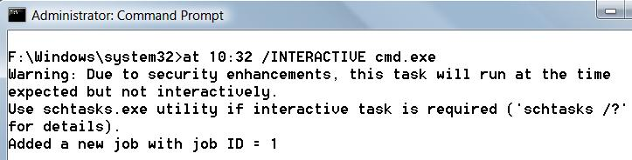
It's more complicated in Vista, but still possible

Making a SYSTEM Task in Vista

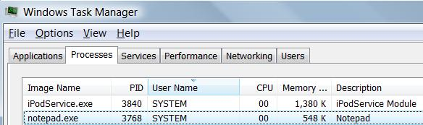
Start, Task Scheduler

Action, Create Task

Change User or Group, select SYSTEM

Fill in wizard, notepad.exe

You can see it in Task Manager, but it's not interactive (see link Ch 4t)

Preventing Privilege Escalation

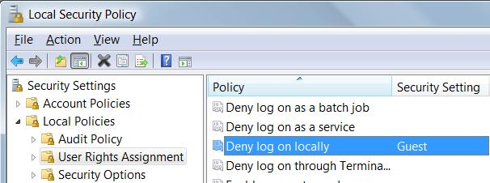
Keep machines patched

Restrict interactive logon to trusted accounts

Start, secpol.msc

Deny log on locally

Extracting and Cracking Passwords

Once Administrator-equivalent status has been obtained on one machine

Attackers often want to penetrate deeper into the network, so they want passwords

Grabbing the Password Hashes

Stored in in the Windows Security Accounts Manager (SAM) under NT4 and earlier, and

In the Active Directory on Windows 2000 and greater domain controllers (DCs)

The SAM contains the usernames and hashed passwords of all users

The counterpart of the /etc/passwd file from the UNIX world
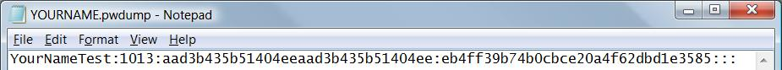

Obtaining the Hashes

NT4 and earlier stores password hashes in %systemroot%\system32\config\SAM

It's locked as long as the OS is running

It's also in the Registry key HKEY_LOCAL_MACHINE\ SAM

On Windows 2000 and greater domain controllers, password hashes are kept in the Active Directory

%windir%\WindowsDS\ntds.dit

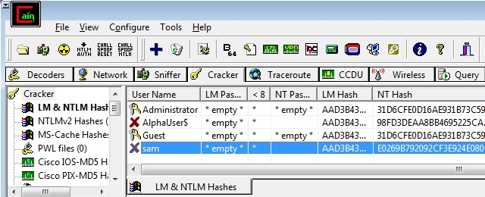
How to Get the Hashes

Easy way: Just use Cain

Cracker tab, right-click, "Add to List"

How Cain Works

Injects a DLL into a highly privileged process in a running system

That's how pwdump, Cain, and Ophcrack do it

Link Ch 4x

Other Ways to Get the Hashes

Boot the target system to an alternate OS and copy the files to removable media

Copy the backup of the SAM file created by the Repair Disk Utility

But this file is protected by SYSKEY encryption, which makes it harder to crack (perhaps impossible)

Links Ch 4u, 4v, 4w

Sniff Windows authentication exchanges

pwdump2 Countermeasures

There is no defense against pwdump2, 3, 4, Cain, Ophcrack, etc.

But the attacker needs local Administrative rights to use them

Cracking Passwords

The hash is supposed to be really difficult to reverse

NTLM hashes are really hard to break

But Windows XP and earlier still use LM Hashes for backwards compatibility

They are turned off by default in Vista

No Salt!

To make hashing stronger, add a random "Salt" to a password before hashing it

Windows doesn't salt its hash!

Two accounts with the same password hash to the same result, even in Windows 7 Beta!

This makes it possible to speed up password cracking with precomputed Rainbow Tables

Demonstration

Here are two accounts on a Windows 7 Beta machine with the password 'password'

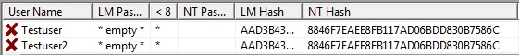

This hash is from a different Windows 7 Beta machine

Linux Salts its Hashes

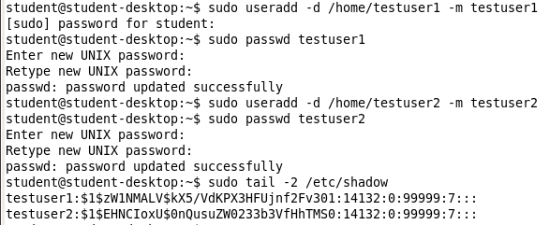

Brute Force v. Dictionary

There are two techniques for cracking passwords

Brute Force

Tries all possible combinations of characters

Dictionary

Tries all the words in a word list, such as able, baker, cow…

May try variations such as ABLE, Able, @bl3, etc.

Password-Cracking Countermeasures

Strong passwords – not dictionary words, long, complex

Add non-printable ASCII characters like (NUM LOCK) ALT255 or (NUM LOCK) ALT-129

Ways to Speed Cracks

Rainbow tables trade time for memory with precomputed hashes

Elcomsoft Distributed Password Recovery

Uses many machines together, and their graphics cards, to make cracking 100x faster

Link Ch 4f

Dumping Cached Passwords

Local Security Authority (LSA) Secrets

Contains unencrypted logon credentials for external systems

Available under the Registry subkey of HKEY_LOCAL_MACHINE\SECURITY\Policy\Secrets

Encrypted when the machine is off, but decrypted and retained in memory after login

Contents of LSA Secrets

Service account passwords in plaintext.

Accounts in external domains

Cached password hashes of the last ten users to log on to a machine

FTP and web-user plaintext passwords

Remote Access Services (RAS) dial-up account names and passwords

Computer account passwords for domain access

Scary Demo

Boot Win XP, log in with your usual Admin acct

Change your password

Use Cain to dump the LSA Secrets – your password is just right there in the DefaultPassword

Log in as a different Administrator user

The LSA Secrets show your other account's password!

Link Ch 4z01

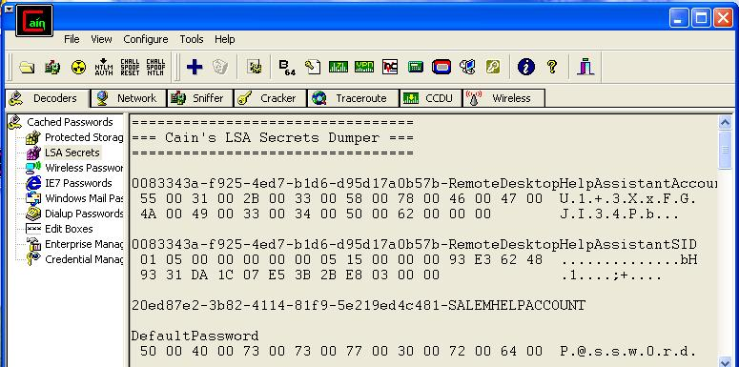
Win XP Password in LSA Secrets

LSA Secrets Countermeasures

There's not much you can do—Microsoft offers a patch but it doesn't help much

Microsoft KB Article ID Q184017 (link Ch 4z02)

Vista seems far less vulnerable

Local Admin rights can lead to compromise of other accounts that machine has logged in to

Previous Logon Cache Dump

If a domain member cannot reach the domain controller, it performs an offline logon with cached credentials

The last ten domain logons are stored in the cache, in an encrypted and hashes form

The tool CacheDump can reverse the encryption and get the hashed passwords

Download it at link Ch 4z03

More info at links Ch 4z04, 4z05

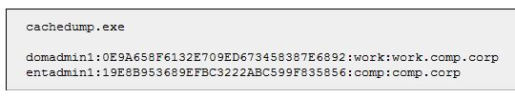
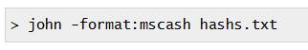
CacheDump Results

John the Ripper can crack these hashes with brute-force and dictionary attacks

Another cracking tool is cachebf (link Ch z06)

Previous Logon Cache Dump Countermeasures

You need Administrator or SYSTEM privileges to get the hashes

You can also adjust the Registry to eliminate the cached credentials

But then users won't be able to log in when a when a domain controller is not accessible

Remote Control and Back Doors

Command-line Remote Control Tools

Netcat for Windows


Download it at link Ch 3d

Use this syntax to listen on port 8080, and execute cmd

Add –d for stealth mode (no interactive console)

Obviously this is very dangerous—remote control with no logon

Connecting to the nc Listener

On another machine connect with

TELNET IP 8080

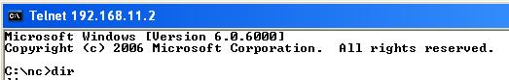
You get a shell on the other machine

Works on Vista

PsExec

From SysInternals (now part of Microsoft)

Allows remote code execution (with a username and password)

Link Ch 4z07

Graphical Remote Control

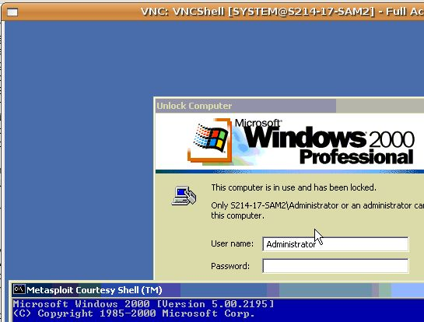
The Windows Built-in Terminal Services (aka Remote Desktop) listens on port 3389

It's not on by default

VNC is free and very commonly used for graphic remote control

Can easily be installed remotely

Link Ch 4z08

VNC as used in MetaSploit

Remote Access Tools

TeamViewer (link Ch 4z19)

My favorite, easy to use, free & safe

Poison Ivy (link Ch 4z09)

GoToMyPC (link Ch 4z10)

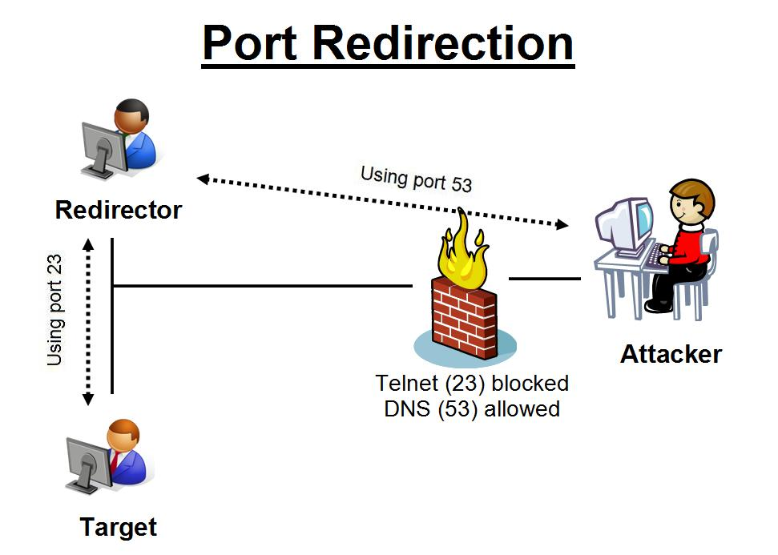
LogMeIn Hamachi (link Ch 4z11)

Port Redirection

Fpipe is a port redirection tool from Foundstone

Link Ch 4z12
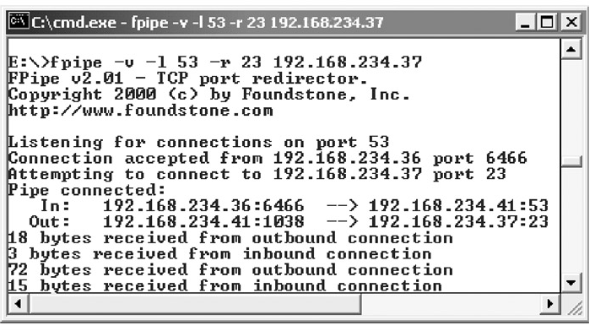

Covering Tracks

Once intruders have Administrator or SYSTEM-equivalent privileges, they will:

Hide evidence of intrusion

Install backdoors

Stash a toolkit to use for regaining control in the future and to use against other systems

Disabling Auditing

The auditpol /disable command will stop auditing

Auditpol /enable will turn it back on again

Auditpol is included in Vista

Part of the Resource Kit for earlier versions (XP, NT, 2000 Server)

Clearing the Event Log

ELsave – command-line log clearing tool

Written for Windows NT

Link Ch 4z15

Hiding Files

Attrib +h filename

Sets the Hidden bit, which hides files somewhat

Alternate Data Streams

Hide a file within a file

A NT feature designed for compatibility with Macintosh

Demonstration of ADS

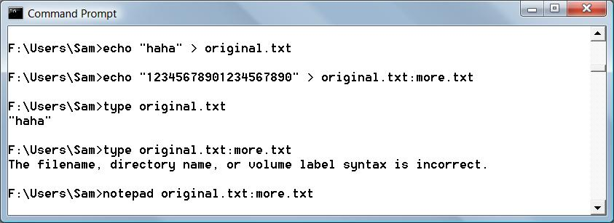

ADS With Binary Files

You need the cp command (supposedly in the Resource Kit, although I can't find it available free online)

To detect alternate data streams, use LADS (link Ch 4z16)

Rootkits

Rootkits are the best way to hide files, accounts, backdoors, network connections, etc. on a machine

More on rootkits in a later chapter

General Countermeasures to Authenticated Compromise

Once a system has been compromised with administrator privileges, you should just reinstall it completely

You can never be sure you really found and removed all the backdoors

But if you want to clean it, here are techniques:

Suspicious Files

Known dangerous filenames like nc.exe

Run antivirus software

Use Tripwire or other tools that identify changes to system files

Link Ch 4z13

Suspicious Registry Entries

Look for registry keys that start known backdoors like"

HKEY_USERS\.DEFAULT\Software\
ORL\WINVNC3

HKEY_LOCAL_MACHINE\SOFTWARE\
Net Solutions\NetBus Server

A Back-Door Favorite: Autostart Extensibility Points (ASEPs)

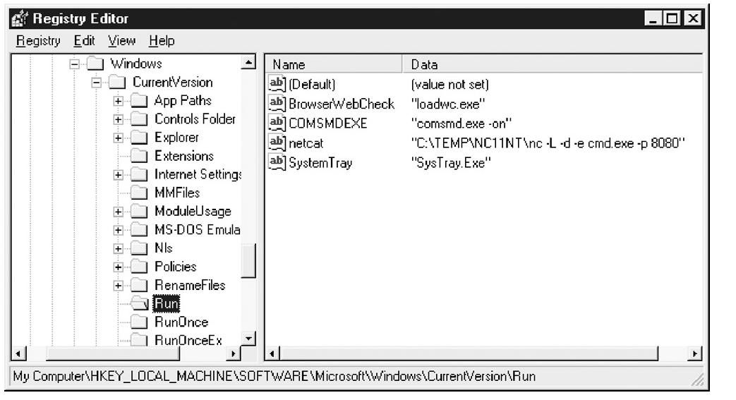
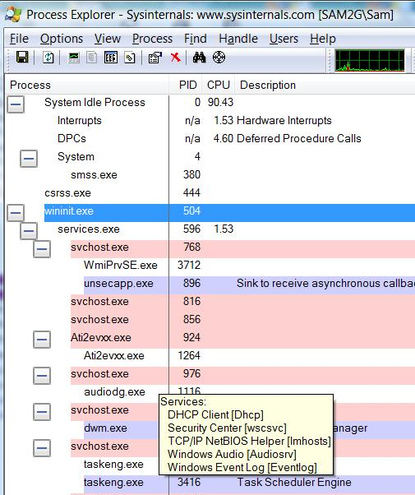

Ways to Make a Program Run at Startup in Vista

Registry keys

Run or RunOnce or Policies\Explorer\Run

Load value

RunServices or RunServicesOnce

Winlogon or BootExecute

Scheduled Tasks

Win.ini

Group Policy

Shell service objects

Logon scripts

Suspicious Processes

Process Explorer

Link Ch 4z14

Suspicious Ports

Use netstat -aon to view network connections

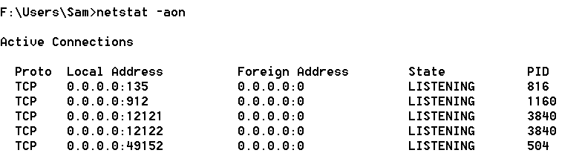

Software Explorer

Part of Windows Defender in Vista
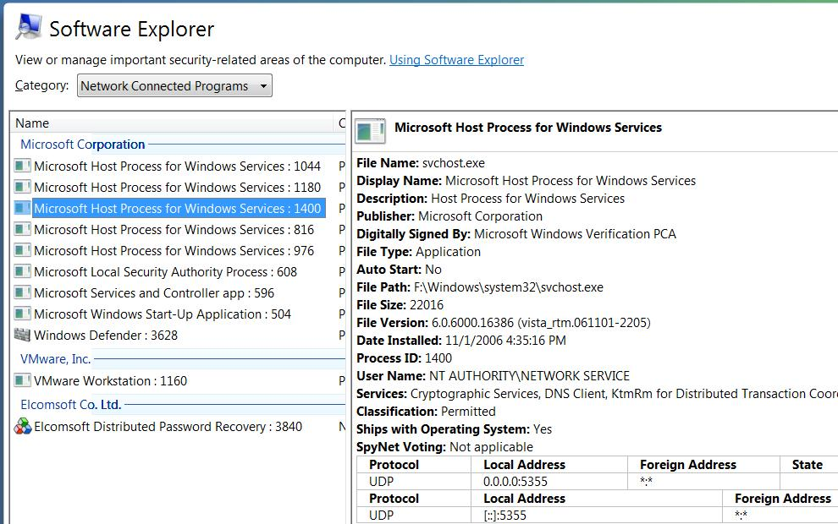

Windows Security Features

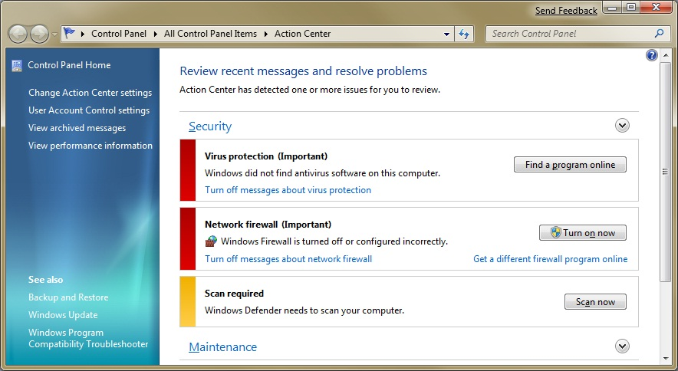
Windows Firewall

Automated Updates

Security Center (Action Center in Windows 7 Beta)

Group Policy

Allows customized security settings in domains

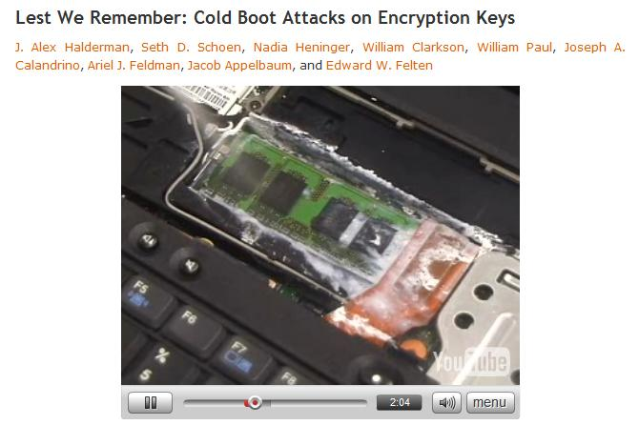
Encryption: BitLocker and EFS

EFS encrypts folders

BitLocker encrypts the whole hard drive

In Windows 7 Beta, BitLocker can encrypt removable USB devices

Video: Hacking BitLocker

Least Privilege

Most Windows users use an Administrative accout all the time

Very poor for security, but convenient

For XP, 2003, and earlier: log on as a limited user, use runas to elevate privileges as needed

For Vista and later versions, this process is automated by User Account Control

Last modified 2-5-09

