Virtual Private Network (VPN) Hacking

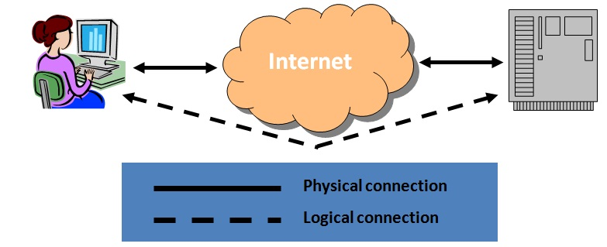
Virtual Private Network (VPN)

A VPN connects two computers securely over an insecure network (usually the Internet), using tunneling

Tunneling

An Ethernet frame is encapsulated in an IP packet, so it can be sent over the Internet

It can be done with other protocols too

Usually the frame is also encrypted, so that only the intended recipient can read it

The end result is like you used a long cable to connect the two computers

Cost Savings

You could use a T-1 line or a POTS phone call with a modem, to make a secure connection between two computers

But a VPN is much cheaper, requiring only an Internet connection at each end

VPN Standards

The modern way

IP Security (IPSec) and the Layer 2 Tunneling Protocol (L2TP)

Older techniques

Point-to-Point Tunneling Protocol (PPTP)

Microsoft proprietary

Layer 2 Forwarding (L2F)

An obsolete Cisco protocol

For more details, see link Ch 611

Breaking Microsoft PPTP

Microsoft's secure authentication protocol, MS-CHAP, uses LM Hashes

Easily cracked with Ophcrack

Session keys and encryption are poorly implemented and vulnerable to attacks

The control channel is open to snooping and denial of service

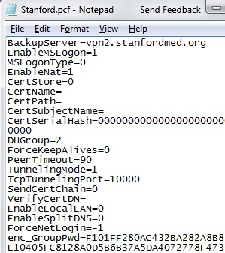
PPTP clients could act as a backdoor into the network

See links Ch 612 & 613

Fixing PPTP

Microsoft patched PPTP in Win NT Service Pack 4 by using MS-CHAPv2

And it's really much better (link Ch 614)

Win 2000 and later also offer IPSec and L2TP, which is safer

"In our opinion, IPSec is too complex to be secure" -- Schneier and Ferguson (link Ch 615)

But it's the best IP security available now

Google Hacking for VPN

Search for filetype:pcf

Stored profile settings for the Cisco VPN client

You get encrypted passwords in this file

I truncated the hash in this example

Cracking VPN Password with Cain

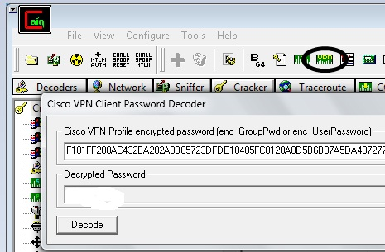
It cracked instantly for me

Password removed from figure

The encryption algorithm is easily reversible

Link Ch 625, 627

Attacking IKE

IPSec VPNs use Internet Key Exchange (IKE) to establish the session

The faster, less secure, "Aggressive mode" IKE is vulnerable to an offline brute force attack

Tool: IKECrack (link Ch 626)
Voice Over IP (VoIP) Attacks

Voice over IP (VoIP)

Voice on an IP Network

Most VoIP solutions rely on multiple protocols, at least one for signaling and one for transport of the encoded voice traffic

The two most common signaling protocols are H.323 and Session Initiation Protocol (SIP)

Their role is to manage call setup, modification, and closing

H.323

H.323 is a suite of protocols

Defined by the International Telecommunication Union (ITU

The deployed base is larger than SIP

Encoding is ASN.1 – different than text, a bit like C++ Data Structures (link Ch 618)

Designed to make integration with the public switched telephone network (PSTN) easier

Session Initiation Protocol (SIP)

The Internet Engineering Task Force (IETF) protocol

People are migrating from H.323 to SIP

Used to signal voice traffic, and also other data like instant messaging (IM)

Similar to the HTTP protocol

The encoding is text (UTF8)

SIP uses port 5060 (TCP/UDP) for communication

Real-time Transport Protocol (RTP)

Transports the encoded voice traffic

Control channel for RTP is provided by the Real-time Control Protocol (RTCP)

Consists mainly of quality of service (QoS) information (delay, packet loss, jitter, and so on)

Timing is more critical for VoIP than other IP traffic

Most Common VoIP Attacks

Denial of Service

Send a lot of SIP INVITE packets, initiating calls

Flood a phone with unwanted IP traffic

Spoofing the CLID (Caller ID)

Swatting is a popular and dangerous attack, spoofing caller ID and calling police (link Ch 619)

Injecting data into an established call

Altering the phone's configuration

Connect to the phone via Telnet or HTTP

Sometimes no password is needed

Or upload malicious code with your own DHCP and TFTP servers

When a phone boots, it can upload updated firmware with TFTP

Attacking though services linked to VoIP

Advanced voicemail

Instant messaging

Calendar services

User management

Attacks may use XSS (cross-site scripting), client-side JavaScript alteration, SQL injection, and so on

Accessing repository of recorded calls

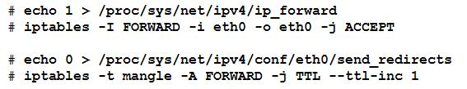
Making free calls through a company's VoIP-to-PSTN gateway

Interception Attack

Sniff the IP Packets

With ARP poisoning

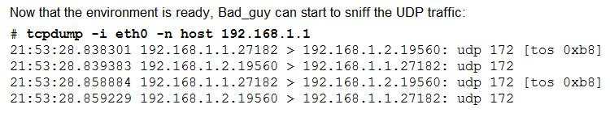
Attacker is set to route traffic, but not decrement the TTL

Captured RTP Traffic

It's compressed with a codec

Common codecs

G.711 (uses up a lot of bandwidth)

G.729 (uses less bandwidth)

vomit - voice over misconfigured internet telephones

Converts G.711 to WAV

It works because many IP phones don't or can't encrypt traffic

Link Ch 620

Scapy is an even better tool, plays traffic from eth0 right out the speakers

Link Ch 621

Interception Countermeasures

Turn on the security features available for your phones, such as encryption

They are often left turned off, to get higher quality or just through laziness

VoIP Projects

Project 16: VoIP

Set up a free Windows-based VoIP server

Install a free software phone

Sniff RTP streams with Wireshark and replay them

Project 17: Fuzzing X-Lite with VoIPer

Project 18: SIPVicious scanning 3CX and Asterix PBX Servers

Last modified 3-18-09

